Data supplement

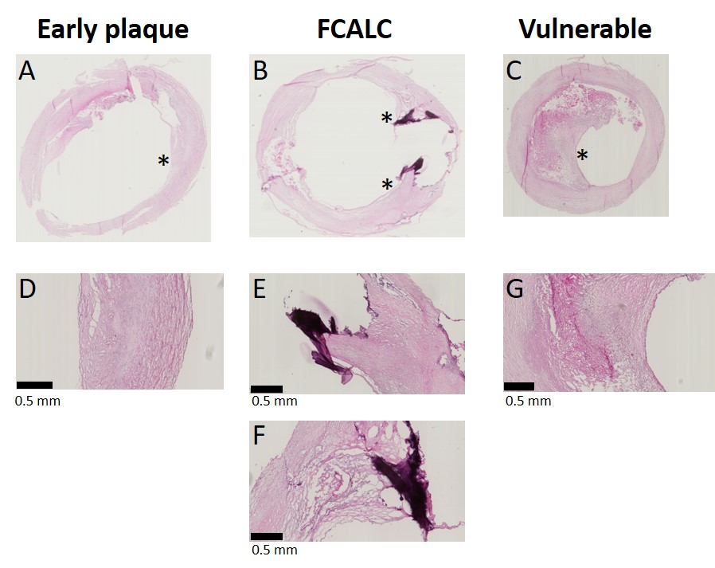
Supplemental Figure 1: Haematoxylin-eosin stained plaque sections of typical examples of A) early plaque; B) fibro-calcific (FCALC) as stable plaque; and C) phenotypically vulnerable plaque. Asterisks indicate the location of the magnifications in D-G. D) Magnification of A, in which lipid accumulations without a clear fibrous cap or necrotic core are visible. E) Shows a magnification of B, in which a collagen rich fibrous cap is visible, as well as a location where a large calcification has been pushed out of the section during sectioning. F) Magnification of B, in which a small area of necrosis is visible. G) Shows a magnification of C, where a thin cap with an underlying necrotic core is visible.

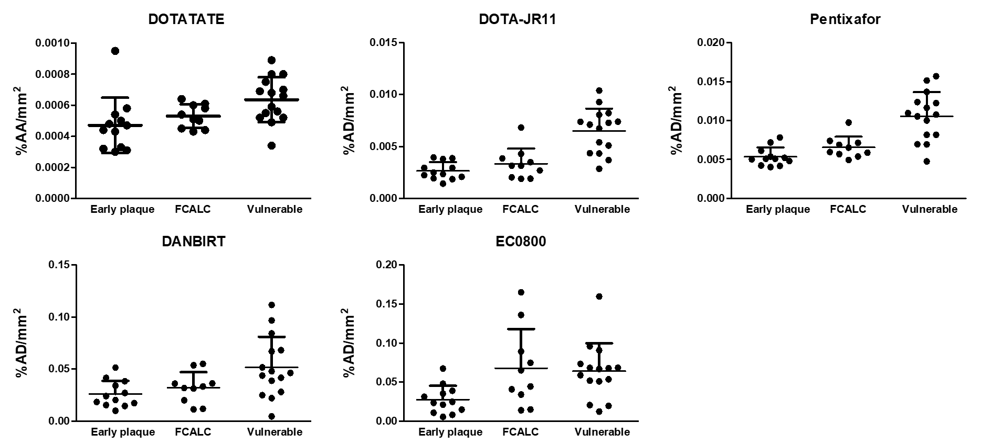
Supplemental Figure 2: Displays the individual data points depicted in Figure 2 for the % added activity/mm² (%AA/mm²) in plaque sections for each radioligand across plaque categories. Note that the graphs are not uniformly scaled. DOTATATE, DOTA-JR11, DANBIRT, and EC0800 were labelled with Indium-111, Pentixafor was labelled with Gallium-67. Bars indicate mean with standard deviation.

Supplemental Table 1: Digital light units/mm² (DLU/mm²) for blocked sections (incubated with 10⁻⁹ M labelled compound+10⁻⁶ M unlabelled compound) versus unblocked sections (incubated with 10⁻⁹ M labelled compound), ± standard deviation. Data were tested for normality, and paired t-test or Wilcoxon signed rank test was used to test if blocking significantly reduced binding.

aVERAGE DLU/mm² IN BLOCKED AND NON-BLOCKED SECTIONS
 | Average non blocked | Average blocked | Difference significant?
DOTATATE | 58 x10³ ± 6.6 x10³ | 44.9 x10³ ± 3.5 x10³ | ***
JR11 | 306.6 x10³ ± 44.8 x10³ | 196.6 x10³ ± 30.6 x10³ | **
Pentixafor | 155.1 x10³ ± 22.9 x10³ | 80.5 x10³ ± 19.9 x10³ | **
DANBIRT | 1116 x10³ ± 259.8 x10³ | 463.1 x10³ ± 53.3 x10³ | *
EC0800 | 2143.1 x10³ ± 380.6 x10³ | 58.7 x10³ ± 11.1 x10³ | **

