Supplementary Information
[¹²³I]MIBG is a better early marker of anthracycline cardiotoxicity than [¹⁸F]FDG: a preclinical SPECT/CT and simultaneous PET/MR study
A Oudot, A Courteau, M Guillemin, JM Vrigneaud, PM Walker, F Brunotte, A Cochet, B Collin

Supplementary Fig S1. Representative view of [¹²³I]MIBG cardiac uptake image analysis method
Representative SPECT-CT coronal image of cardiac [¹²³I]MIBG uptake showing in white the delineation of cardiac region of interest and in green the mediastinal region of interest used for image analyses.
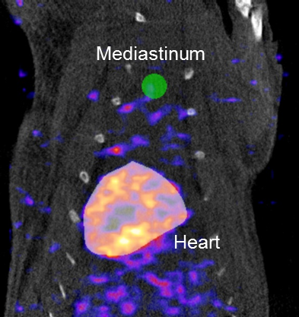

Supplementary Fig S2. Evaluation of cardiac [¹⁸F]FDG uptake in vehicle and doxorubicin-treated rats measured on SPECT images.
Cardiac [¹⁸F]FDG uptake monitoring during the 6 weeks of experimental protocol. Data are expressed as %ID and as mean ± SEM.
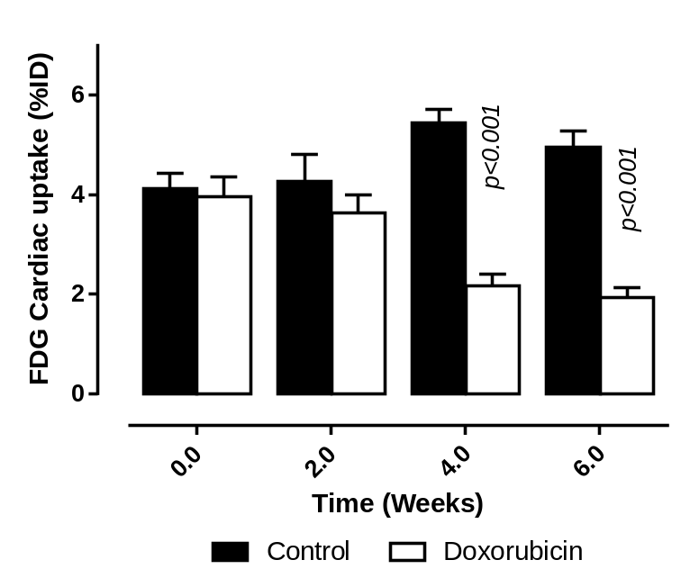

Supplementary Fig S3. Evaluation of cardiac [¹²³I]MIBG uptake in vehicle and doxorubicin-treated rats measured on SPECT images.
Cardiac [¹²³I]MIBG uptake monitoring during the 6 weeks of experimental protocol. Data are expressed as %ID and as mean ± SEM.
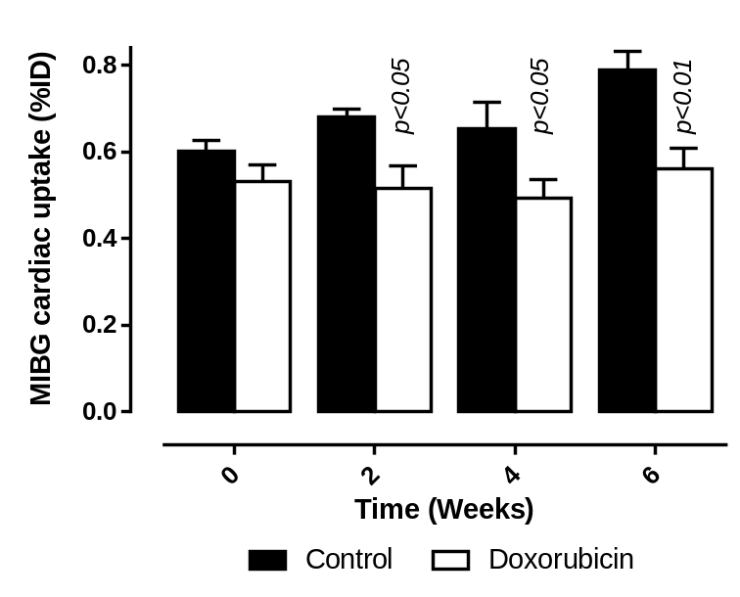

Supplementary Table 1. [^{99m}Tc]- sestamibi cardiac uptake (%ID)
% ID values | Control | Doxorubicin | P value
Baseline  Week 2  Week 4  Week 6 | 1.70 ± 0.11  1.45 ± 0.25  1.15 ± 0.19  1.11 ± 0.15 | 1.37 ± 0.16  1.18 ± 0.21  1.35 ± 0.15  1.16 ± 0.06 | ns  ns  ns  ns
Quantifications were performed on SPECT-CT images after 150 MBq [^{99m}Tc]-Sestamibi intravenous injection and corrected to injected dose corrected to radioactive decay. Experimental groups and treatments were similar than those described in the main manuscript. ns: not significant. Results are expressed as mean ± SEM.

