Supplementary material

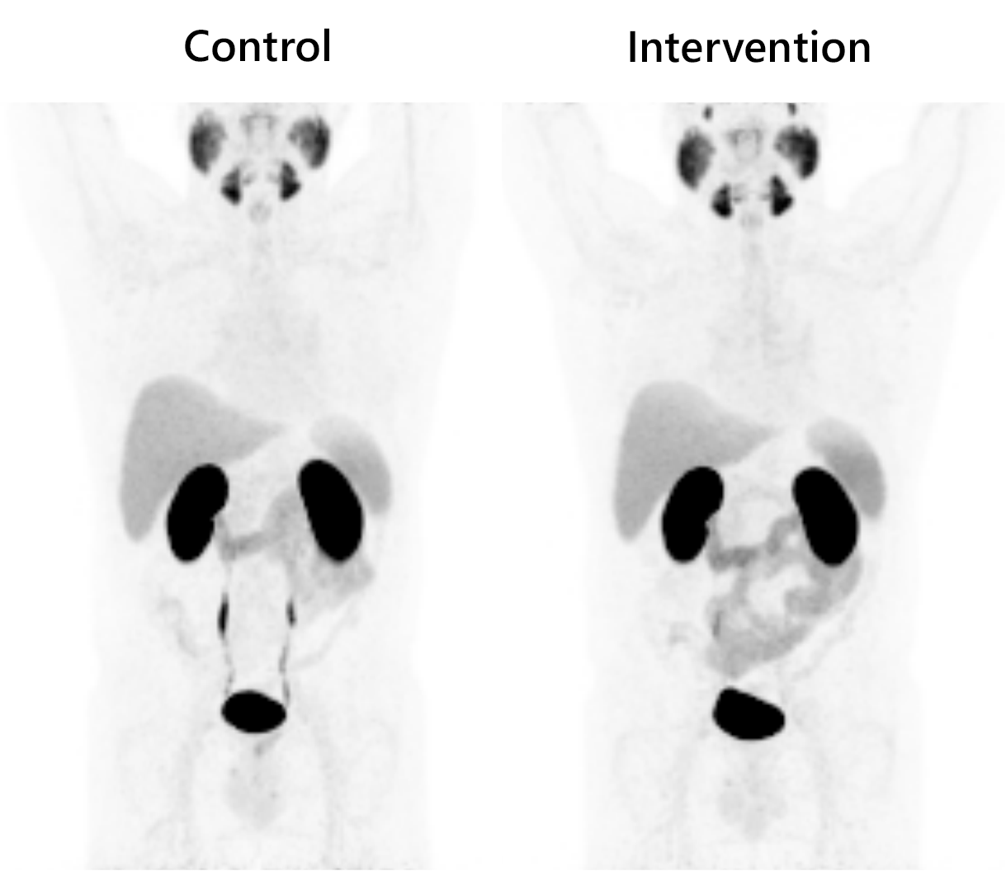

Suppl. Fig. 1 Total body coronal maximum intensity projections of the control and intervention [¹⁸F]DCFPyl PET scans of patient number 1. All investigated tissues are clearly visible.

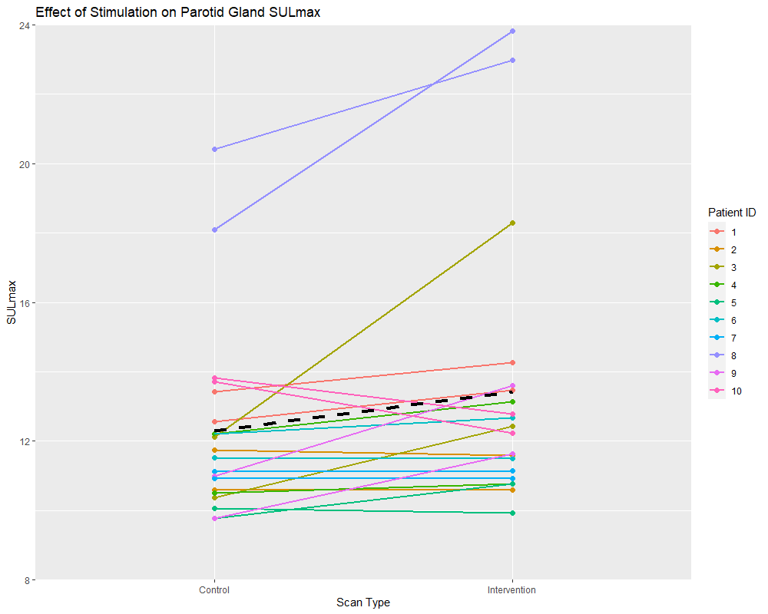 Suppl. Fig. 2 Effect of gustatory stimulation on parotid gland SUL_{max}. Each patient is represented by a unique colour. The patients have two lines, one for the right parotid and one for the left parotid. The black dashed line depicts the overall population effect for all parotid glands of all patients.

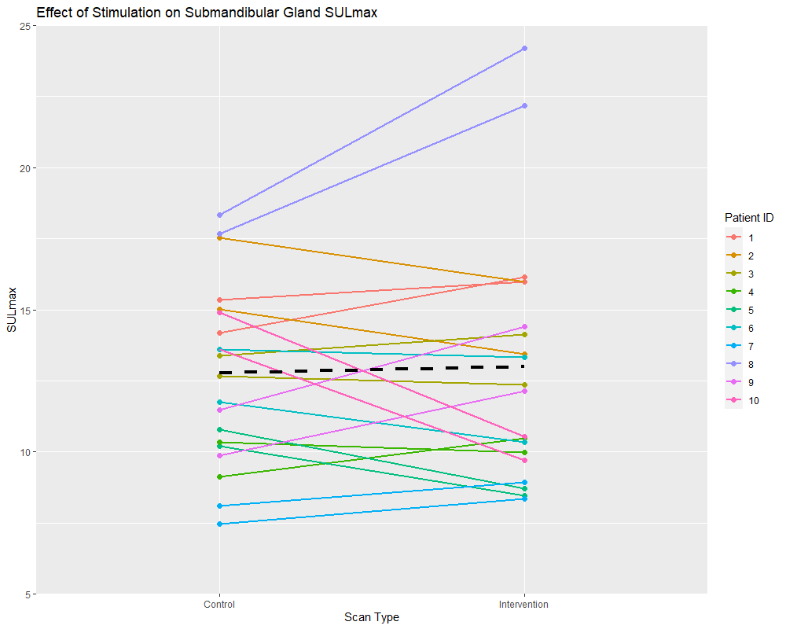 Suppl. Fig. 3 Effect of gustatory stimulation on submandibular gland SUL_{max}. Each patient is represented by a unique colour. The patients have two lines, one for the right parotid and one for the left parotid. The black dashed line depicts the overall population effect for all submandibular glands of all patients.

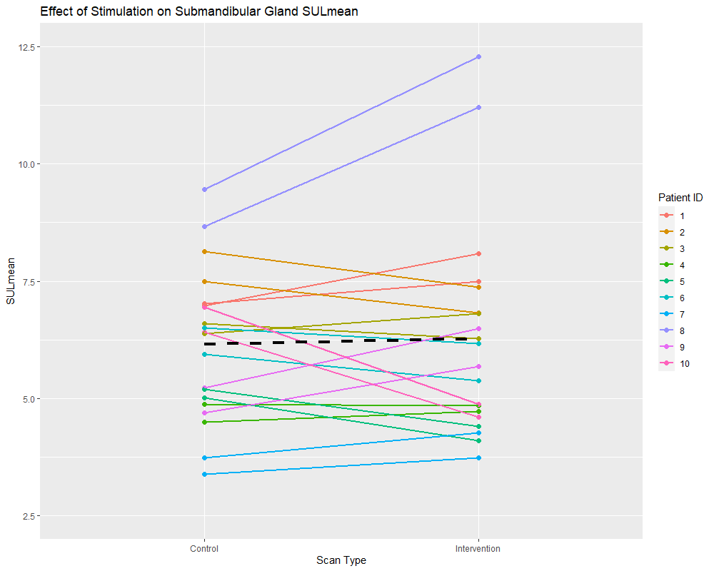

Suppl. Fig. 4 Effect of gustatory stimulation on submandibular gland SUL_{mean}. Each patient is represented by a unique colour. The patients have two lines, one for the right parotid and one for the left parotid. The black dashed line depicts the overall population effect for all submandibular glands of all patients.

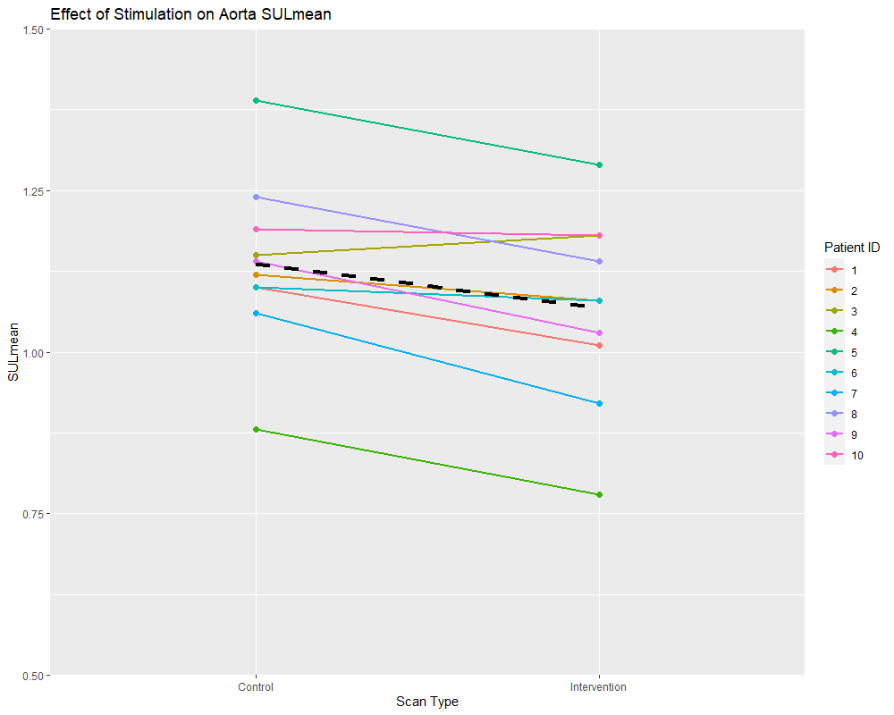 Suppl. Fig. 5 Effect of gustatory stimulation on aorta SUL_{mean}. Each patient is represented by a unique colour. The black dashed line depicts the overall population effect.

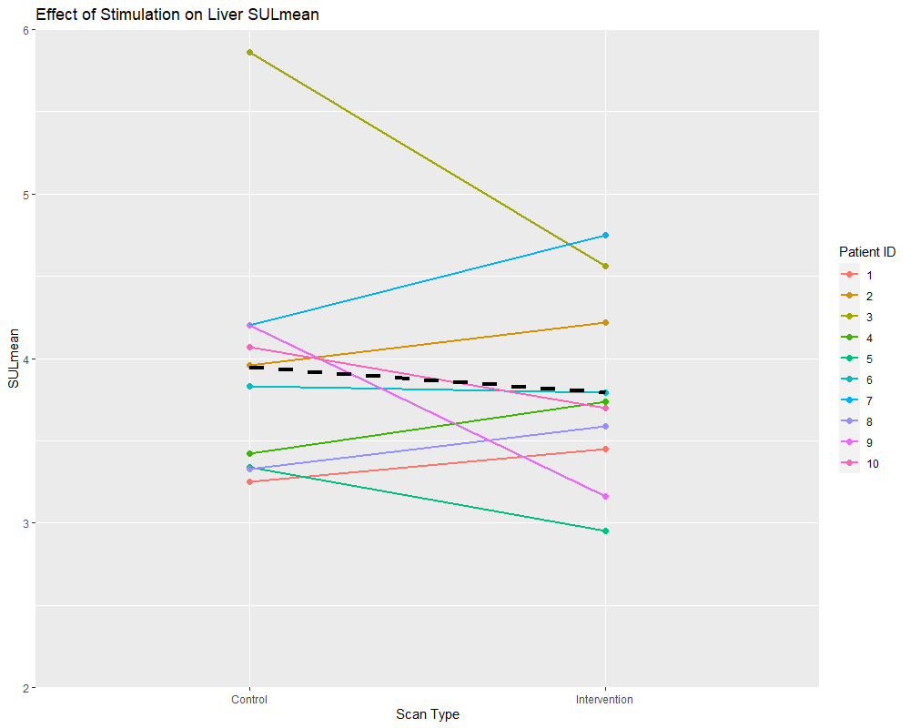 Suppl. Fig. 6 Effect of gustatory stimulation on liver SUL_{mean}. Each patient is represented by a unique colour. The black dashed line depicts the overall population effect.

