Additional file 1: Dose escalation biodistribution, positron emission tomography/computed tomography imaging and dosimetry of a highly specific radionuclide-labeled non-blocking nanobody

Authors
Yanling Yang¹, Chao Wang², Yan Wang³, Yan Sun², Xing Huang⁴, Minzhou Huang³, Hui Xu¹, Huaying Fan¹, Daquan Chen¹, Feng Zhao¹
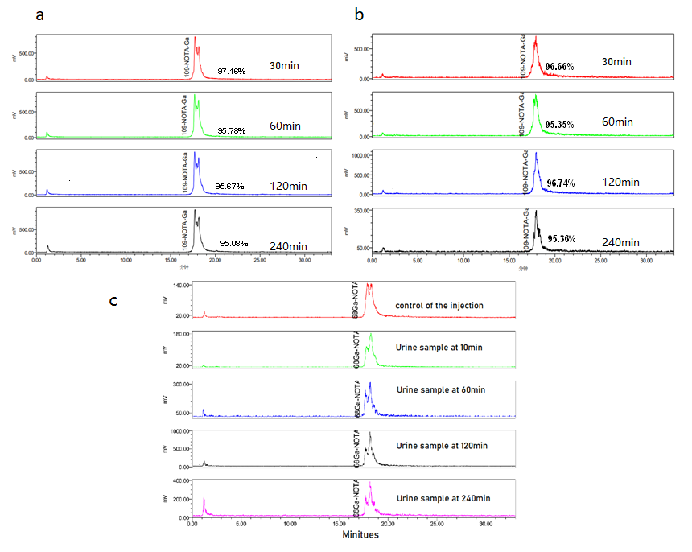Supplemental Figure 1 In vitro and in vivo stability determined by radio-HPLC of ⁶⁸Ga-NOTA-Nb109. (a) In human serum (in vitro); (b) In 0.9% NaCl solution; (c) In urine of ICR mice (in vivo).

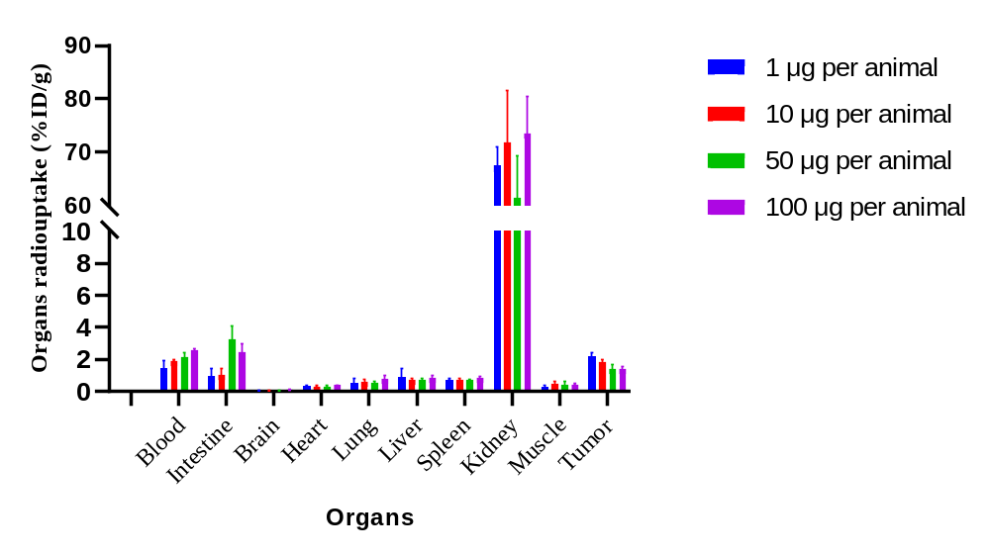
Supplemental Figure 2 Biodistribution analysis at 1.5 h post-injection of ⁶⁸Ga-NOTA-Nb109 in C57-hPD-L1 tumor-bearing transgenic mice.

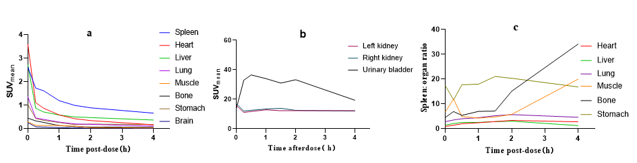
Supplemental Figure 3 Radioactivity in the ROI in images of female cynomolgus monkeys was quantified as SUV mean. (a) Time-activity curves of the spleen, heart, liver, lungs, muscles, bones, stomach, and brain; (b) Time-activity curves of the kidneys and urinary bladder; (c) Spleen: organ (heart, liver, lungs, muscles, bones, and stomach) ratio curves at different time intervals.

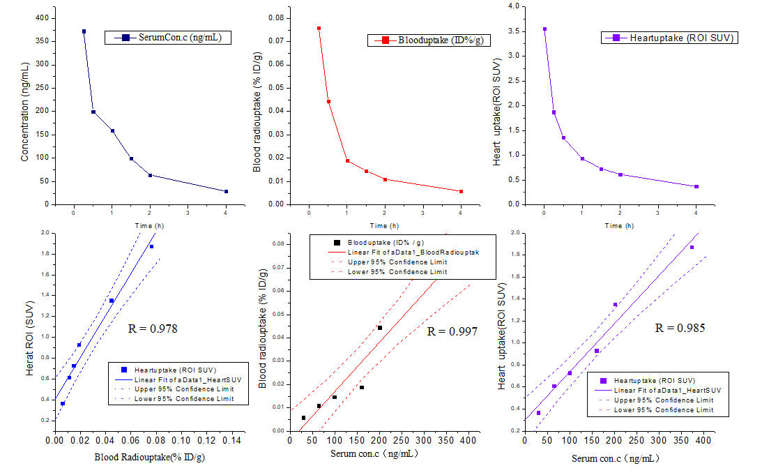
Supplemental Figure 4. Pharmacokinetic analysis in the cynomolgus monkey. (a-c) Curves show the serum concentration, blood, and heart uptake over time, analyzed by ELISA, gamma counter, and PET/CT imaging, respectively. (d-f) Pearson’s correlation analysis showed linear correlations among the above three indexes.

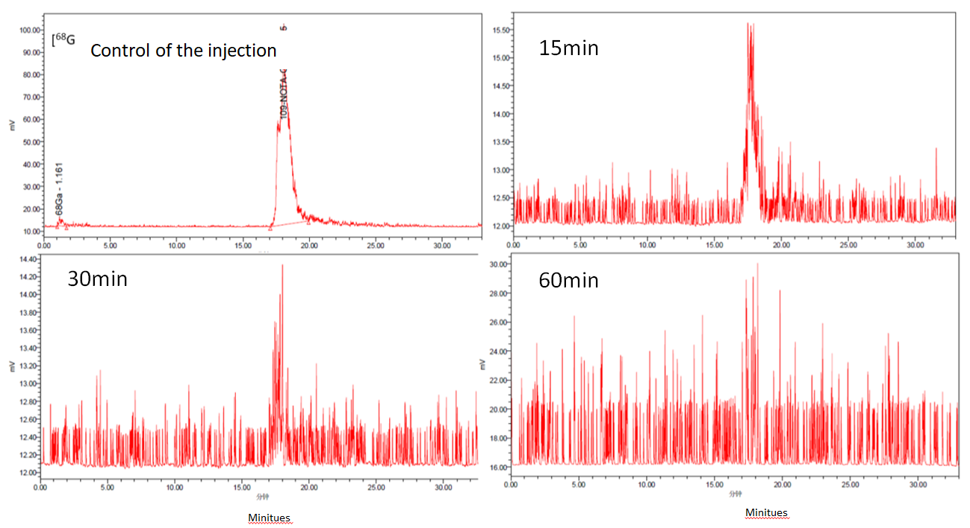
Supplemental Figure 5 Serum radio-HPLC and radio-TLC analysis of cynomolgus monkeys after a single intravenous injection of ⁶⁸Ga-NOTA-Nb109.

Supplemental Table 1 Pharmacokinetic parameters for cynomolgus monkeys
Parameters | t1/2 (h) | C₀ | AUC_{0–last} | AUC_{0–inf} | MRT_{last}
Protein concentration (ng/mL) | 1.24 | 693.16 | 493.23 | 544.96 | 1.00
Blood (ID%/g) | 1.81 | 0.13 | 0.09 | 0.10 | 0.95
Heart (SUV) | 2.57 | 3.56 | 3.39 | 4.75 | 1.30
Note: Apparent terminal elimination half-life (t1/2); Initial concentration (C₀), the area under the concentration–time curve (AUC) from time 0 to the time when the final concentration was measured (AUC_{0–last}), and AUC was extrapolated to infinity (AUC_{0–inf}), mean residence time from time 0 to the time at which the lowest serum drug concentration can be detected (MRT_{last}).

