Additional file 1

Supplemental Figures
Fig. S1 Representative views of the ten regions of interest.
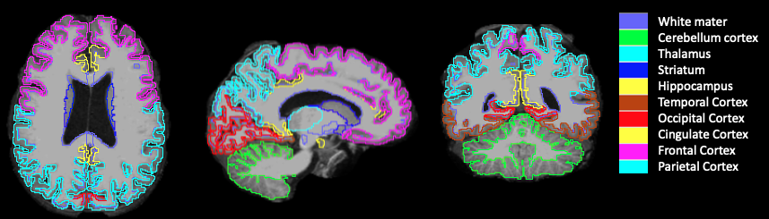

Fig. S2 ¹¹C-CPPC total distribution volume (V_{T}) values across the human brain (N=8). Representative skull-stripped MRI (top), ¹¹C-CPPC V_{T} map (middle), and fused (lower) data are shown. The individual V_{T} map from each participant was first normalized to the SPM8 standard template and then averaged to obtain the mean ¹¹C-CPPC V_{T} map. V_{T} was estimated from 90 min data using Logan graphical analysis with the metabolite-corrected arterial input function. V_{T} is in units of mL cm⁻³.
