Automatic healthy liver segmentation for holmium-166 radioembolization dosimetry
Supplemental material
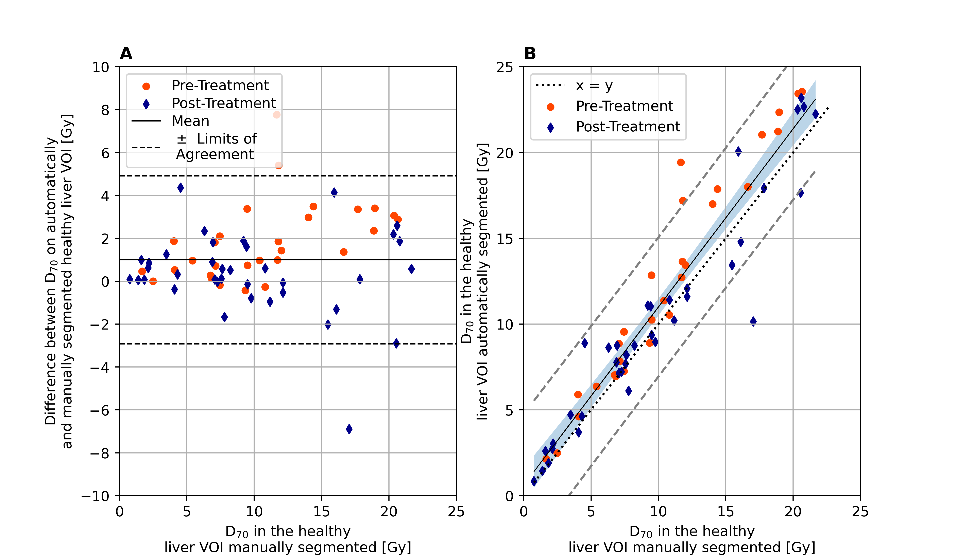
S.1
Panel A: Bland-Altman plot on difference between D₇₀; D₇₀ in the healthy liver VOI automatically and manually segmented against D₇₀ in the healthy liver VOI manually segmented. Mean of difference is depicted by the black solid line, while black dashed lines define ± limits of agreement. Panel B: linear correlation plot between manual and automatic segmentation of the healthy liver VOI with respect to the D₇₀. The solid line depicts linear regression, while the dashed lines indicate the ± 95% confidence intervals. Dotted line represents the x = y line. ¹⁶⁶Ho pre-treatment images were scaled considering the therapeutic activity.
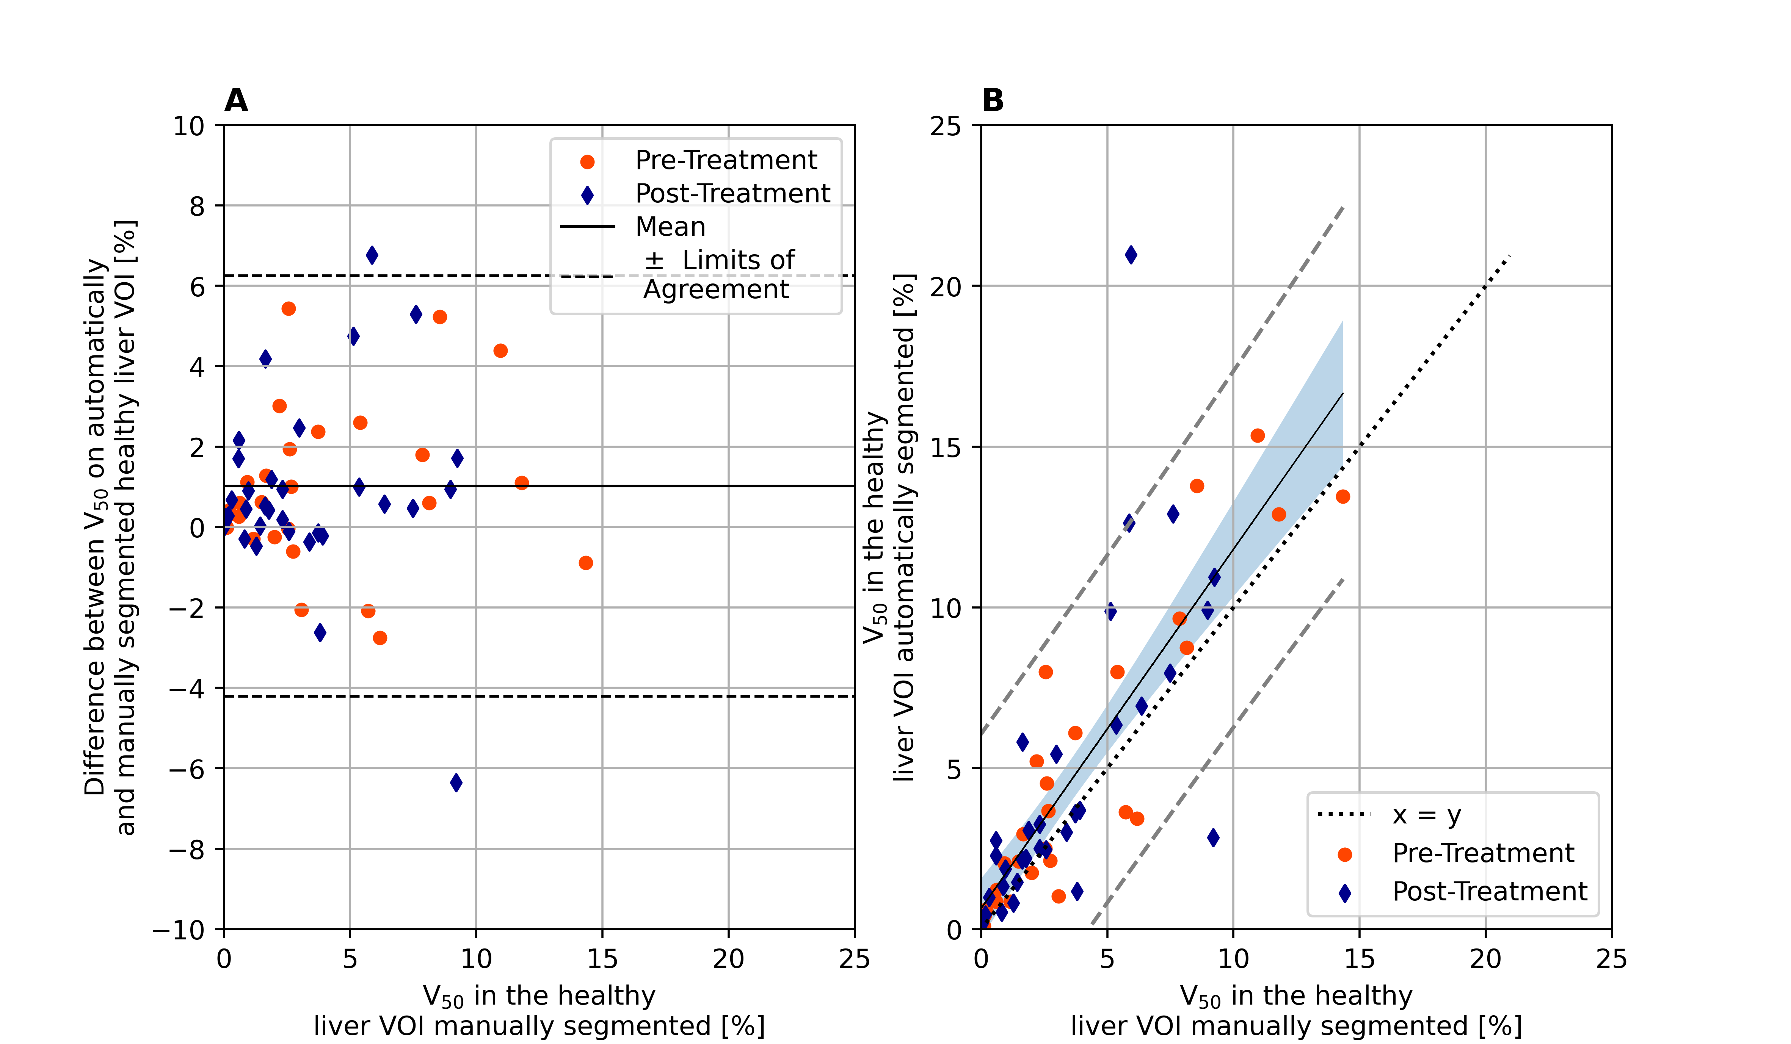
S.2
Panel A: Bland-Altman plot on difference between V₅₀; V₅₀ in the healthy liver VOI automatically and manually segmented against V₅₀ in the healthy liver VOI manually segmented. Mean of difference is depicted by the black solid line, while black dashed lines define ± limits of agreement. Panel B: linear correlation plot between manual and automatic segmentation of the healthy liver VOI with respect to the V₅₀. The solid line depicts linear regression, while the dashed lines indicate the ± 95% confidence intervals. Dotted line represents the x = y line. ¹⁶⁶Ho pre-treatment images were scaled considering the therapeutic activity.

