Investigation of the Structure-Activity Relationship at the N-terminal part of Minigastrin Analogs

- Supplementary Materials -

Nadine Holzleitner^{1,#,}*, Thomas Günther^{1, #,}*, Amira Daoud-Gadieh¹, Constantin Lapa² and Hans-Jürgen Wester¹
¹ Technical University of Munich, Department of Chemistry, 85748 Garching, Germany
² University Hospital Augsburg, Nuclear Medicine, 86156 Augsburg, Germany
# both authors contributed equally
* Corresponding author: Thomas Günther, thomas.guenther@tum.de, Technical University of Munich, Department of Chemistry, Garching, Germany
Nadine Holzleitner, nadine.holzleitner@tum.de, Technical University of Munich, Department of Chemistry, Garching, Germany

Corresponding authors:
Thomas Günther and Nadine Holzleitner
Phone: +49.89.289.12203
Technical University of Munich,
Chair of Pharmaceutical Radiochemistry,
Walther-Meissner-Str. 3
85748 Garching
GERMANY
Fax: +49.89.289.12204
E-Mail: thomas.guenther@tum.de and nadine.holzleitner@tum.de
ORCID: https://orcid.org/0000-0002-7412-0297 (TG) and https://orcid.org/0000-0001-8258-3526 (NH)

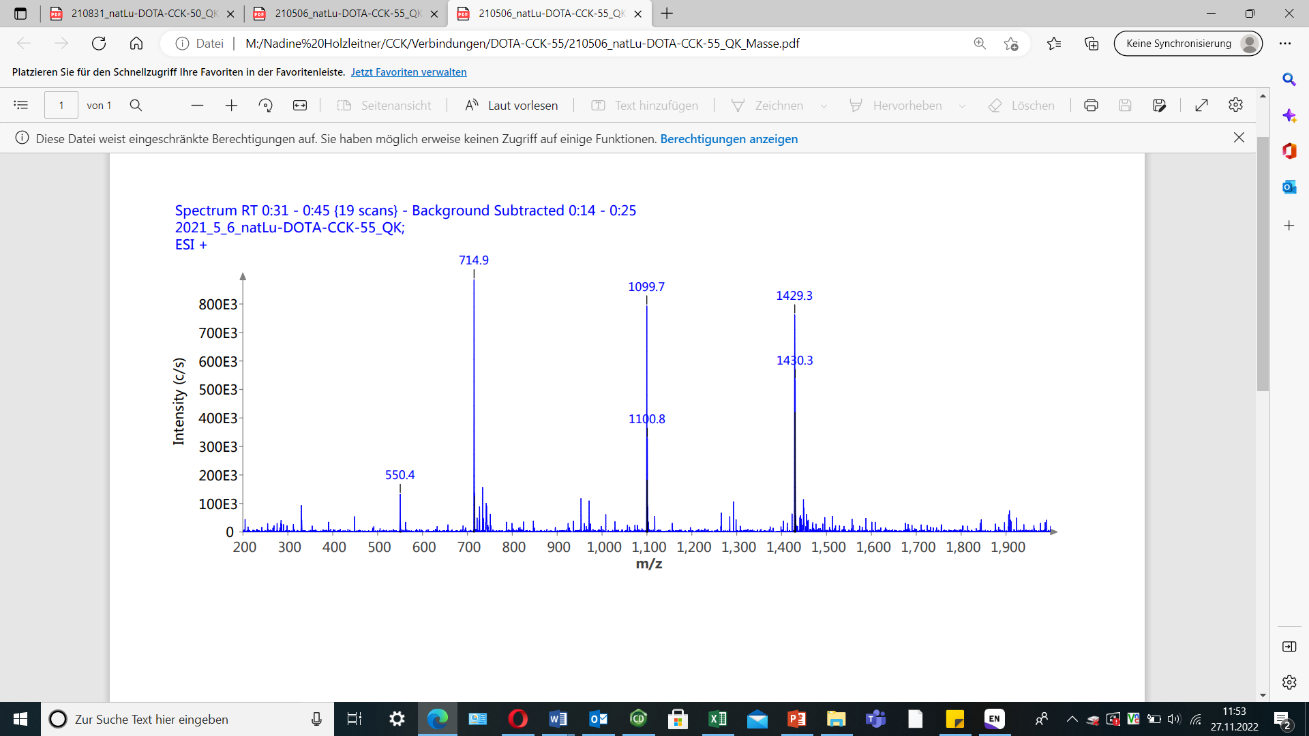
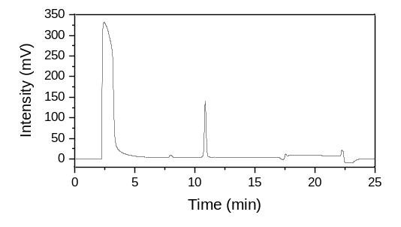
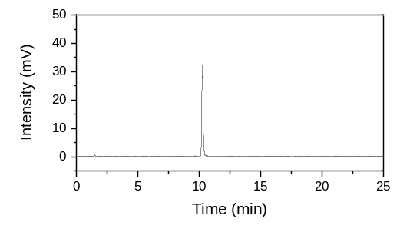
Analytical data of ^{nat/177}Lu-labeled minigastrin analogs
(a)
(b)
(c)

Figure S1. Confirmation of peptide identity and integrity for (a) [^{nat}Lu]Lu-DOTA-CCK-55 and (b) [¹⁷⁷Lu]Lu-DOTA-CCK-55 as analyzed by analytical (radio-)RP-HPLC (MultoKrom 100-5 C18, 5 μm, 125 × 4.6 mm, CS Chromatographie GmbH, Langerwehe, Germany; 10→70% MeCN in H₂O + 0.1% TFA in 15 min). (c) Mass spectrum of [^{nat}Lu]Lu-DOTA-CCK-55.
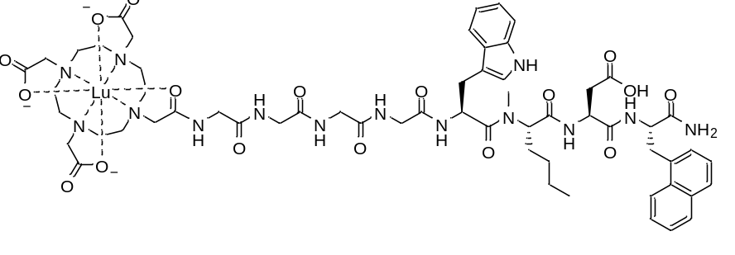
[^{nat}Lu]Lu-DOTA-CCK-55: RP-HPLC (10→70% MeCN in H₂O with 0.1% TFA, 15 min, λ = 220 nm): t_{R} = 10.9 min, K’ = 5.46; MS (ESI, positive): m/z calculated for C₅₉H₇₇LuN₁₄O₁₇: 1429.3, found: m/z = 1429.3 [M+H]⁺, 714.9 [M+2H]²⁺.

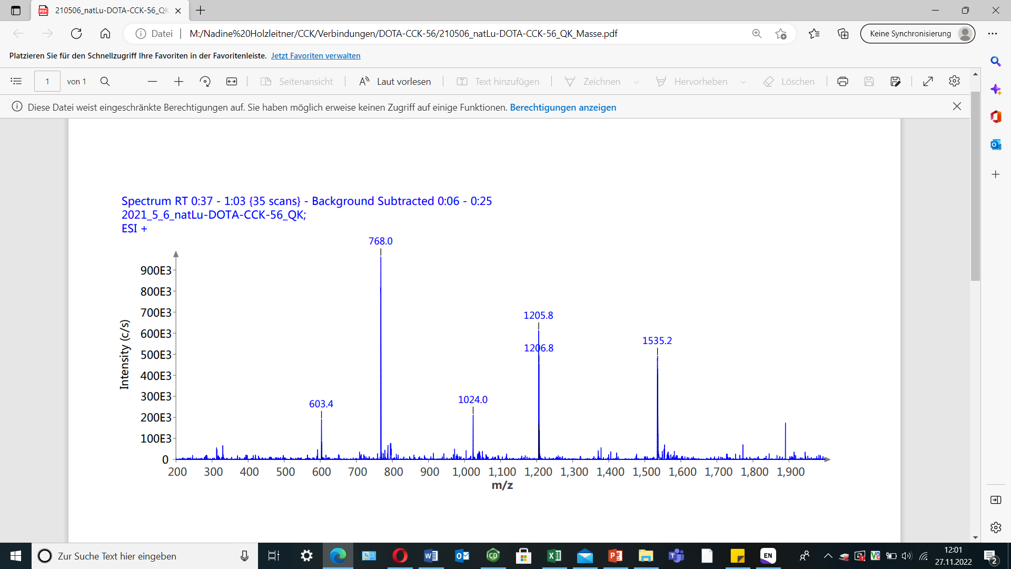
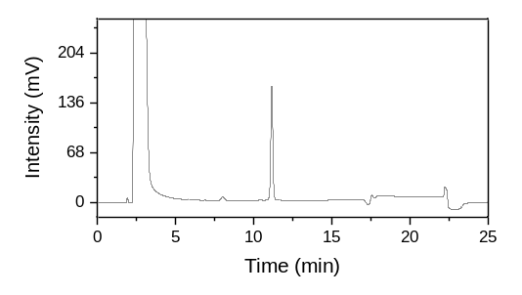
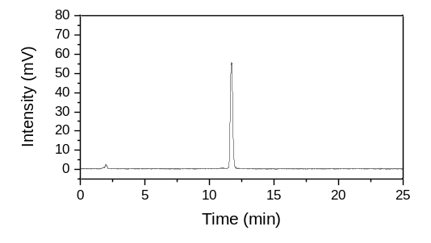
(a)
(b)
(c)

Figure S2. Confirmation of peptide identity and integrity for (a) [^{nat}Lu]Lu-DOTA-CCK-56 and (b) [¹⁷⁷Lu]Lu-DOTA-CCK-56 as analyzed by analytical (radio-)RP-HPLC (MultoKrom 100-5 C18, 5 μm, 125 × 4.6 mm, CS Chromatographie GmbH, Langerwehe, Germany; 10→70% MeCN in H₂O + 0.1% TFA in 15 min). (c) Mass spectrum of [^{nat}Lu]Lu-DOTA-CCK-56.
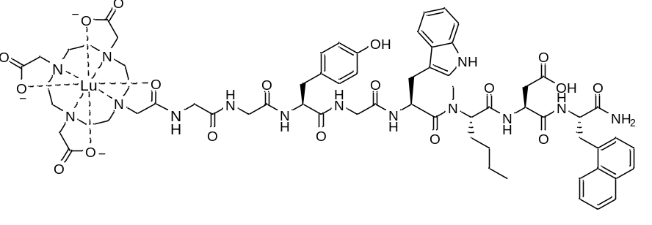
[^{nat}Lu]Lu-DOTA-CCK-56: RP-HPLC (10→70% MeCN in H₂O with 0.1% TFA, 15 min, λ = 220 nm): t_{R} = 11.1 min, K’ = 5.58; MS (ESI, positive): m/z calculated for C₅₆H₈₃LuN₁₄O₁₈: 1535.4, found: m/z = 1535.2 [M+H]⁺, 768.0 [M+2H]²⁺.

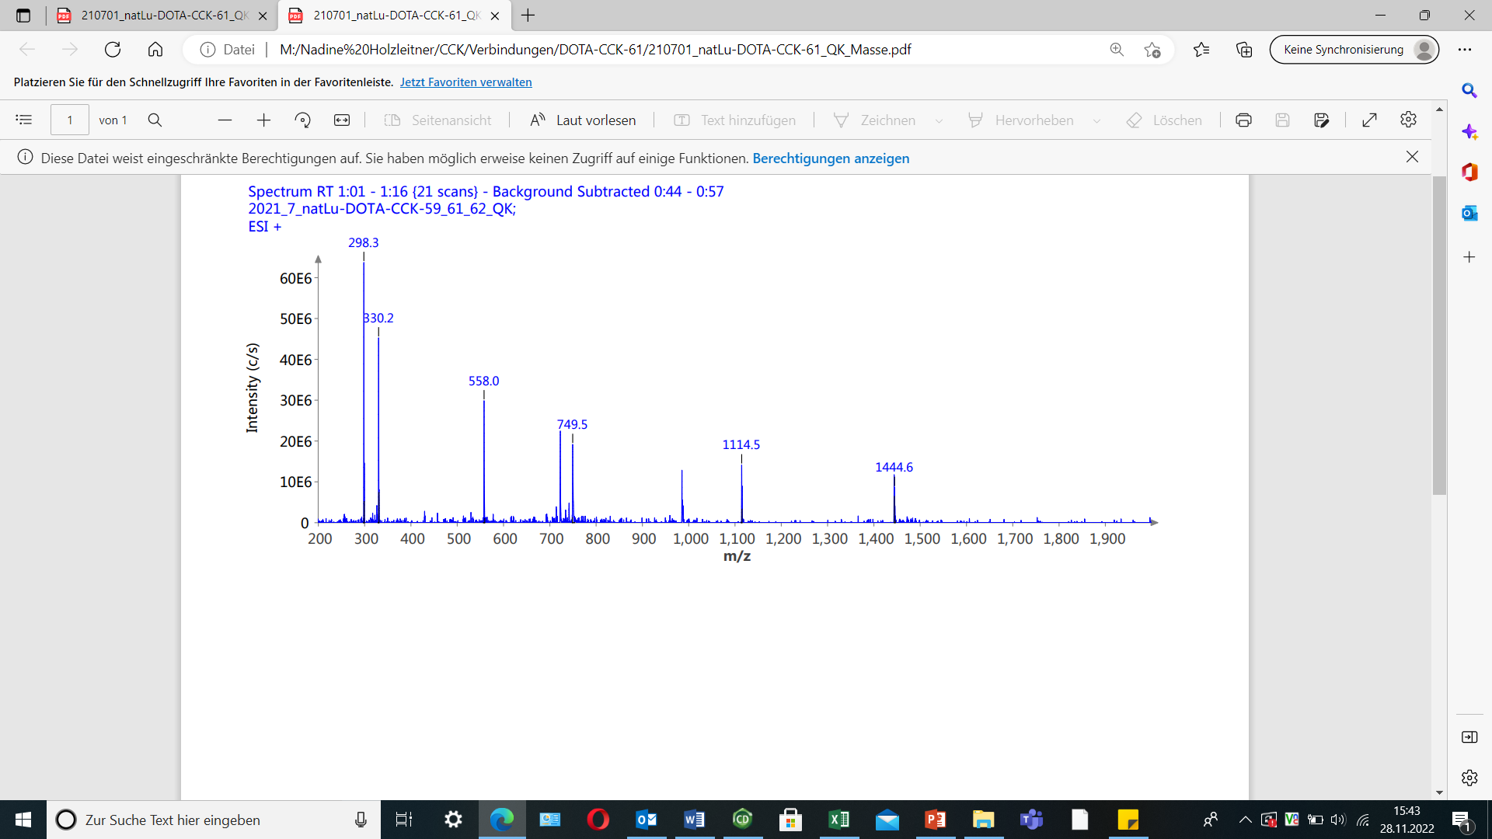
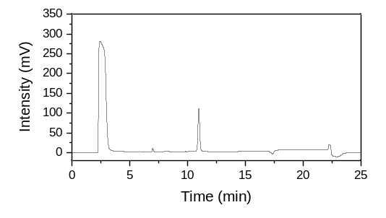
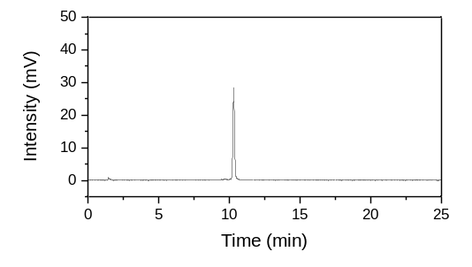
(a)
(b)
(c)

Figure S3. Confirmation of peptide identity and integrity for (a) [^{nat}Lu]Lu-DOTA-CCK-57 and (b) [¹⁷⁷Lu]Lu-DOTA-CCK-57 as analyzed by analytical (radio-)RP-HPLC (MultoKrom 100-5 C18, 5 μm, 125 × 4.6 mm, CS Chromatographie GmbH, Langerwehe, Germany; 10→70% MeCN in H₂O + 0.1% TFA in 15 min). (c) Mass spectrum of [^{nat}Lu]Lu-DOTA-CCK-57.
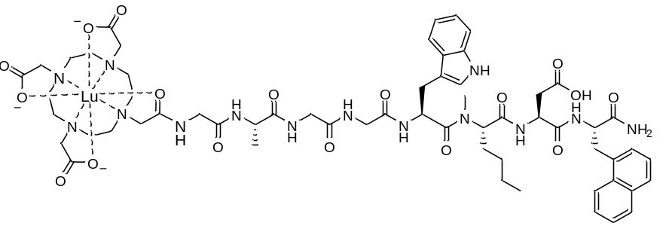
[^{nat}Lu]Lu-DOTA-CCK-57: RP-HPLC (10→70% MeCN in H₂O with 0.1% TFA, 15 min, λ = 220 nm): t_{R} = 11.0 min, K’ = 5.52; MS (ESI, positive): m/z calculated for C₆₀H₇₉LuN₁₄O₁₇: 1443.3, found: m/z = 1444.6 [M+H]⁺.

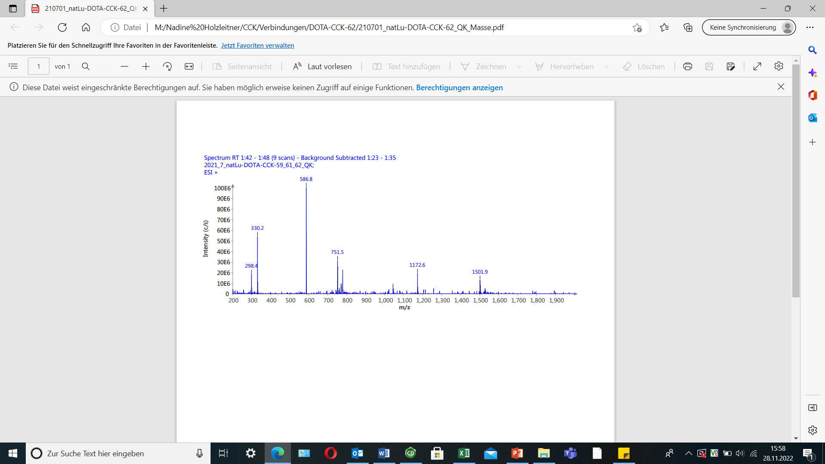
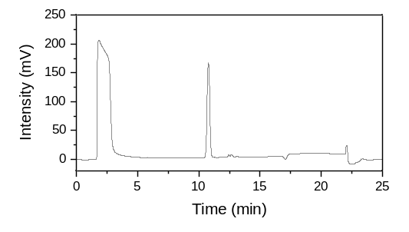
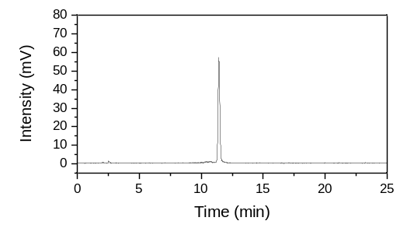
(a)
(b)
(c)

Figure S4. Confirmation of peptide identity and integrity for (a) [^{nat}Lu]Lu-DOTA-CCK-58 and (b) [¹⁷⁷Lu]Lu-DOTA-CCK-58 as analyzed by analytical (radio-)RP-HPLC (MultoKrom 100-5 C18, 5 μm, 125 × 4.6 mm, CS Chromatographie GmbH, Langerwehe, Germany; 10→70% MeCN in H₂O + 0.1% TFA in 15 min). (c) Mass spectrum of [^{nat}Lu]Lu-DOTA-CCK-58.
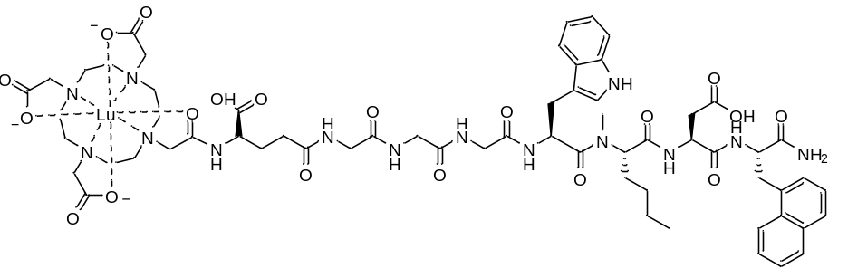
[^{nat}Lu]Lu-DOTA-CCK-58: RP-HPLC (10→70% MeCN in H₂O with 0.1% TFA, 15 min, λ = 220 nm): t_{R} = 10.8 min, K’ = 5.40; MS (ESI, positive): m/z calculated for C₆₂H₈₁LuN₁₄O₁₉: 1501.4, found: m/z = 1501.9 [M+H]⁺, 751.5 [M+2H]²⁺.

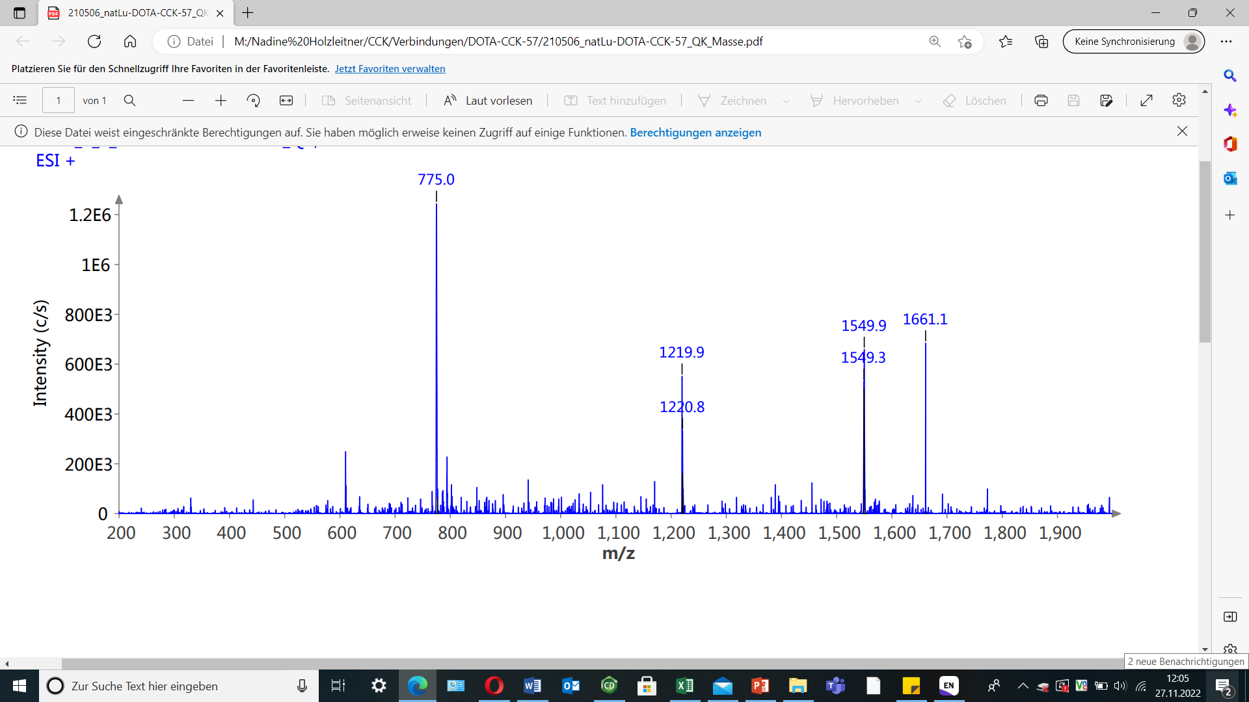
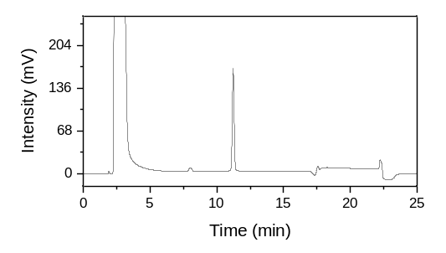
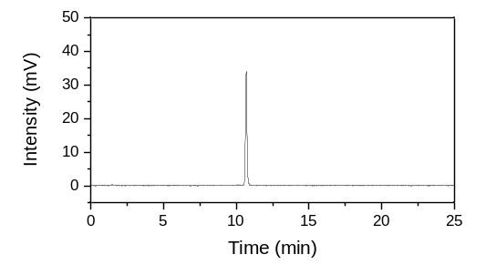
(a)
(b)
(c)

Figure S5. Confirmation of peptide identity and integrity for (a) [^{nat}Lu]Lu-DOTA-CCK-59 and (b) [¹⁷⁷Lu]Lu-DOTA-CCK-59 as analyzed by analytical (radio-)RP-HPLC (MultoKrom 100-5 C18, 5 μm, 125 × 4.6 mm, CS Chromatographie GmbH, Langerwehe, Germany; 10→70% MeCN in H₂O + 0.1% TFA in 15 min). (c) Mass spectrum of [^{nat}Lu]Lu-DOTA-CCK-59.
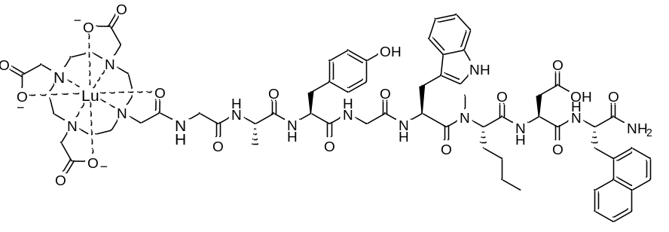
[^{nat}Lu]Lu-DOTA-CCK-59: RP-HPLC (10→70% MeCN in H₂O with 0.1% TFA, 15 min, λ = 220 nm): t_{R} = 11.2 min, K’ = 5.64; MS (ESI, positive): m/z calculated for C₆₇H₈₅LuN₁₄O₁₈: 1549.5, found: m/z = 1549.9 [M+H]⁺, 775.0 [M+2H]²⁺.

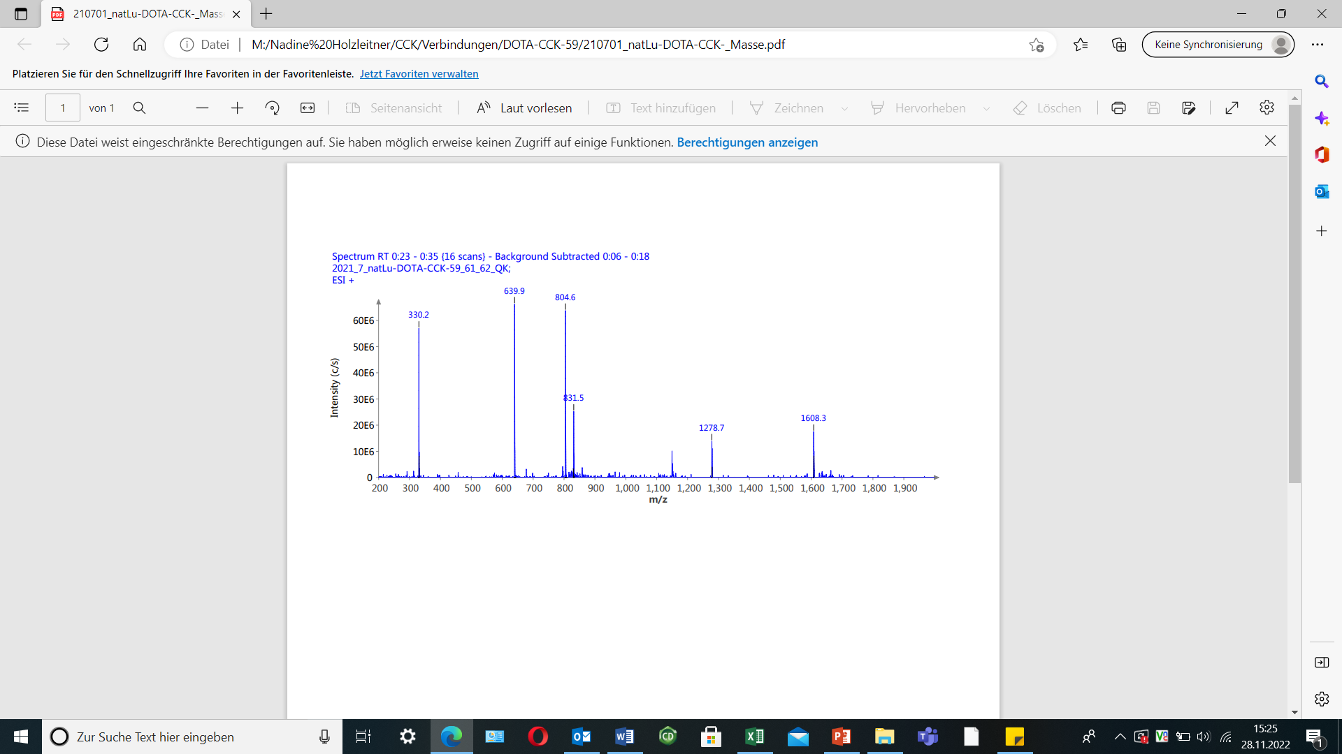
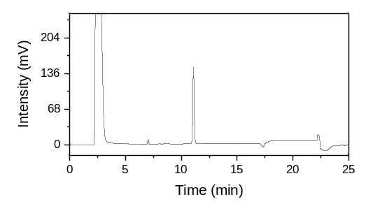
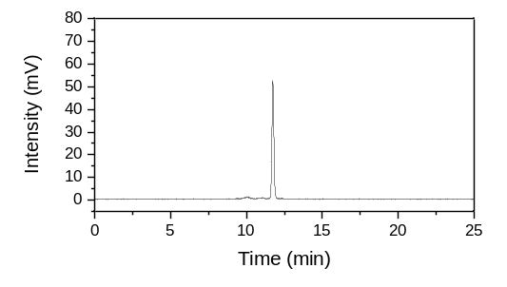
(a)
(b)
(c)

Figure S6. Confirmation of peptide identity and integrity for (a) [^{nat}Lu]Lu-DOTA-CCK-60 and (b) [¹⁷⁷Lu]Lu-DOTA-CCK-60 as analyzed by analytical (radio-)RP-HPLC (MultoKrom 100-5 C18, 5 μm, 125 × 4.6 mm, CS Chromatographie GmbH, Langerwehe, Germany; 10→70% MeCN in H₂O + 0.1% TFA in 15 min). (c) Mass spectrum of [^{nat}Lu]Lu-DOTA-CCK-60.
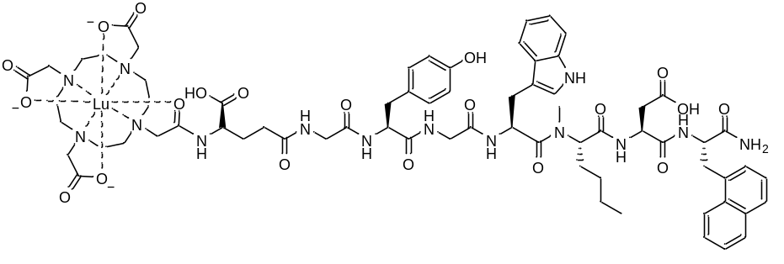
[^{nat}Lu]Lu-DOTA-CCK-60: RP-HPLC (10→70% MeCN in H₂O with 0.1% TFA, 15 min, λ = 220 nm): t_{R} = 11.1 min, K’ = 5.58; MS (ESI, positive): m/z calculated for C₆₉H₈₇LuN₁₄O₂₀: 1607.5, found: m/z = 1608.3 [M+H]⁺, 804.6 [M+2H]²⁺.

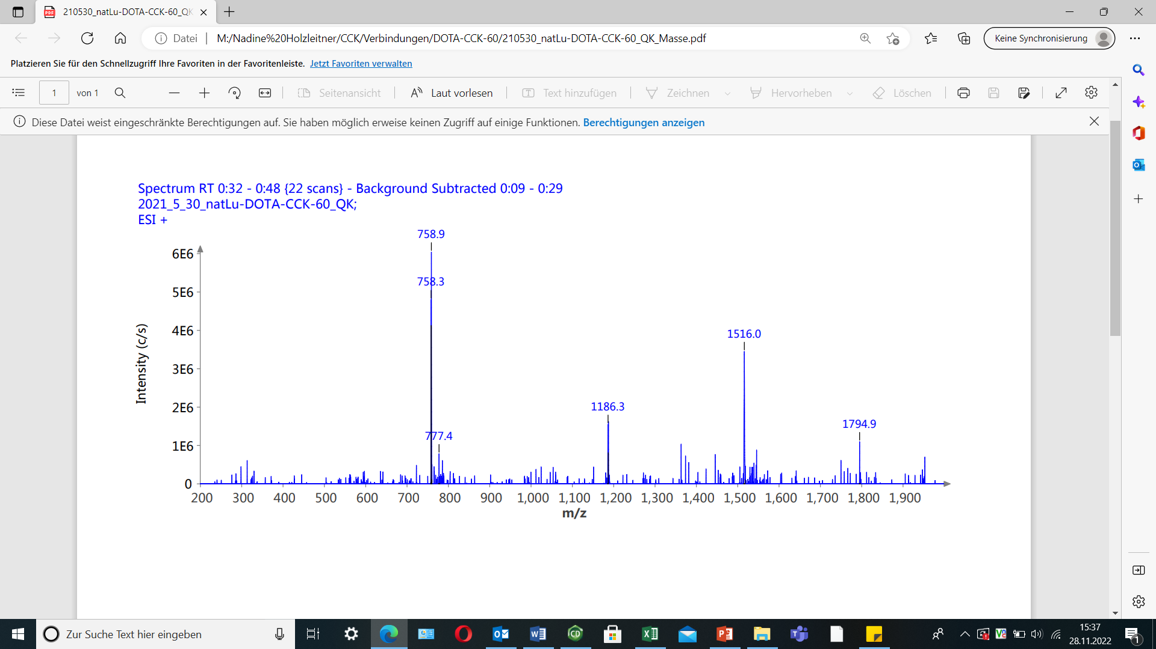
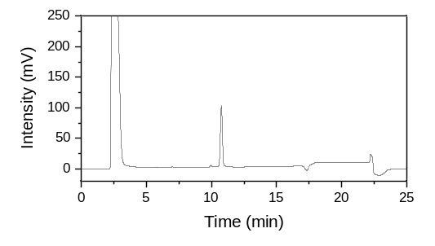
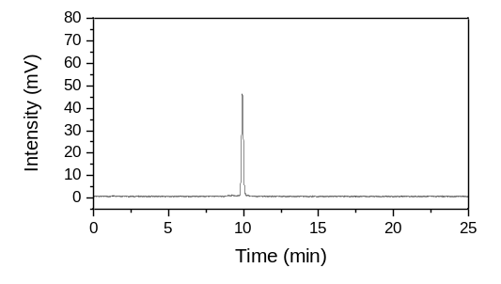
(a)
(b)
(c)

Figure S7. Confirmation of peptide identity and integrity for (a) [^{nat}Lu]Lu-DOTA-CCK-61 and (b) [¹⁷⁷Lu]Lu-DOTA-CCK-61 as analyzed by analytical (radio-)RP-HPLC (MultoKrom 100-5 C18, 5 μm, 125 × 4.6 mm, CS Chromatographie GmbH, Langerwehe, Germany; 10→70% MeCN in H₂O + 0.1% TFA in 15 min). (c) Mass spectrum of [^{nat}Lu]Lu-DOTA-CCK-61.
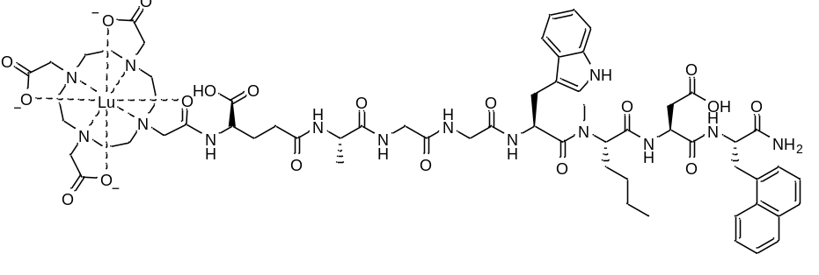
[^{nat}Lu]Lu-DOTA-CCK-61: RP-HPLC (10→70% MeCN in H₂O with 0.1% TFA, 15 min, λ = 220 nm): t_{R} = 10.8 min, K’ = 5.40; MS (ESI, positive): m/z calculated for C₆₃H₈₃LuN₁₄O₁₉: 1515.4, found: m/z = 1516.0 [M+H]⁺, 758.9 [M+2H]²⁺.

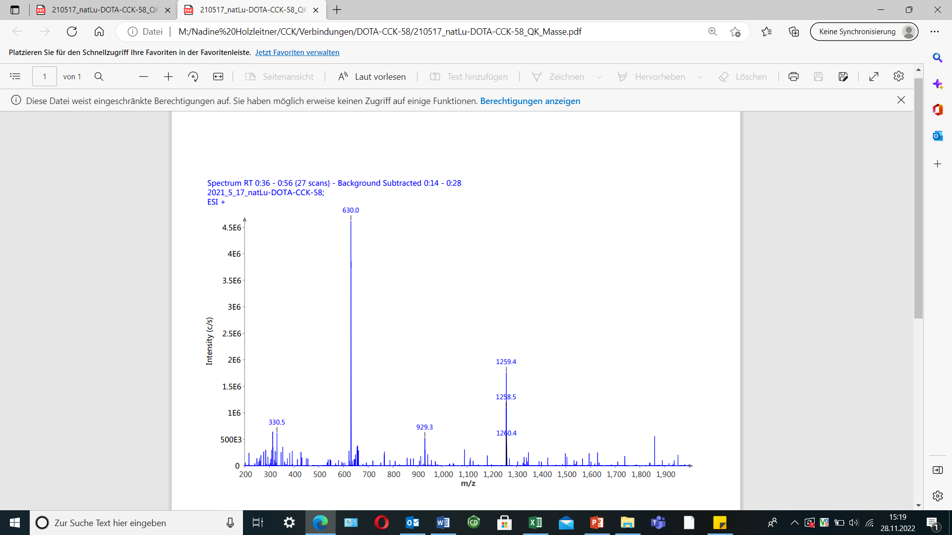
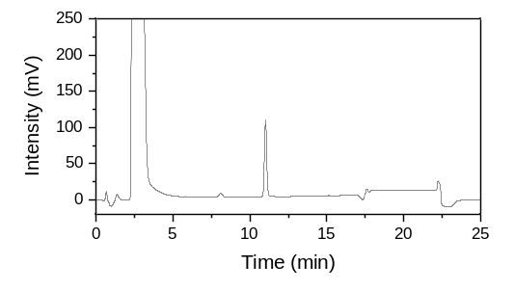
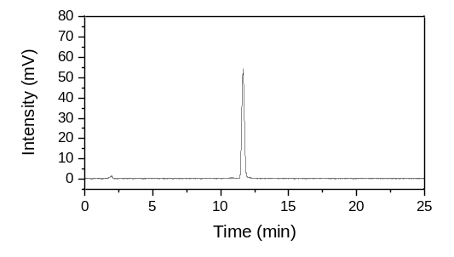
(a)
(b)
(c)

Figure S8. Confirmation of peptide identity and integrity for (a) [^{nat}Lu]Lu-DOTA-CCK-62 and (b) [¹⁷⁷Lu]Lu-DOTA-CCK-62 as analyzed by analytical (radio-)RP-HPLC (MultoKrom 100-5 C18, 5 μm, 125 × 4.6 mm, CS Chromatographie GmbH, Langerwehe, Germany; 10→70% MeCN in H₂O + 0.1% TFA in 15 min). (c) Mass spectrum of [^{nat}Lu]Lu-DOTA-CCK-62.
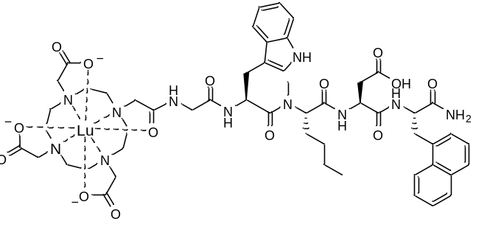
[^{nat}Lu]Lu-DOTA-CCK-62: RP-HPLC (10→70% MeCN in H₂O with 0.1% TFA, 15 min, λ = 220 nm): t_{R} = 11.0 min, K’ = 5.52; MS (ESI, positive): m/z calculated for C₅₃H₆₈LuN₁₁O₁₄: 1258.2, found: m/z = 1259.4 [M+H]⁺, 630.0 [M+2H]²⁺.

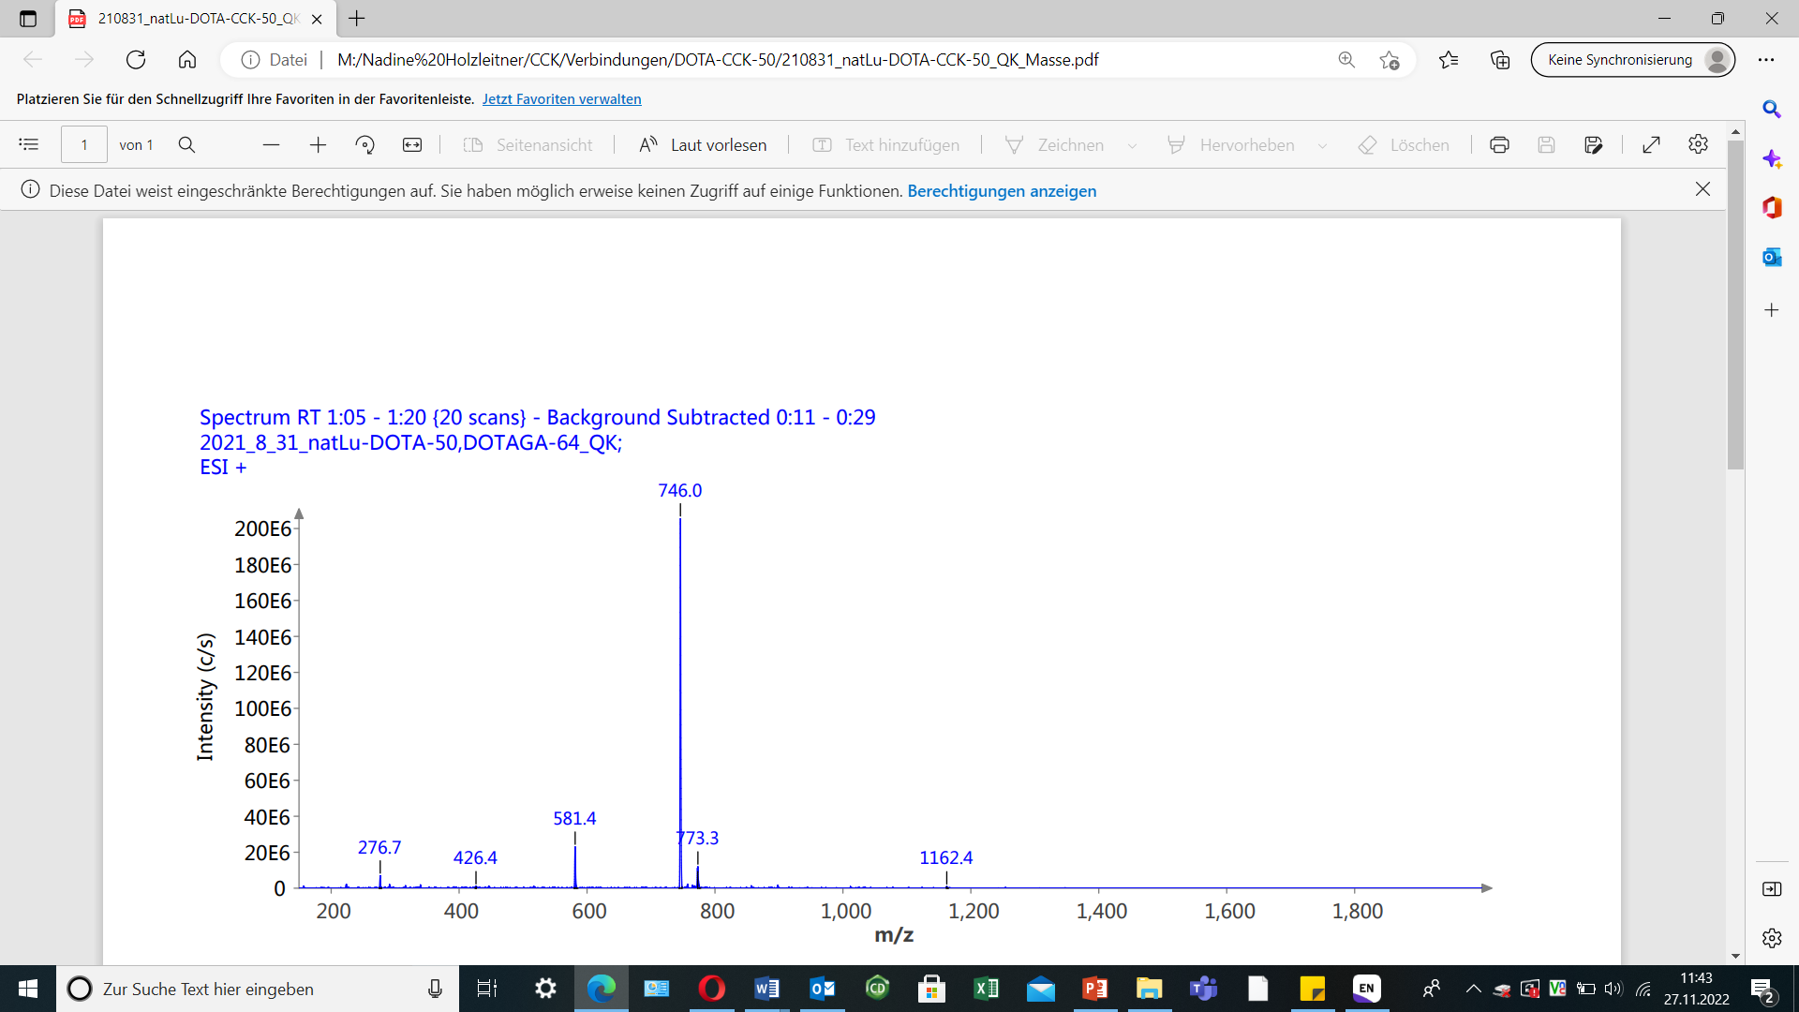
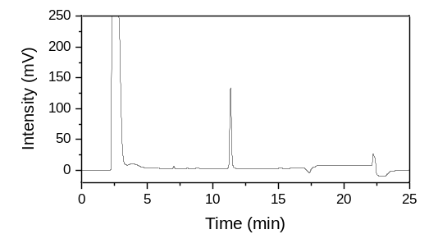
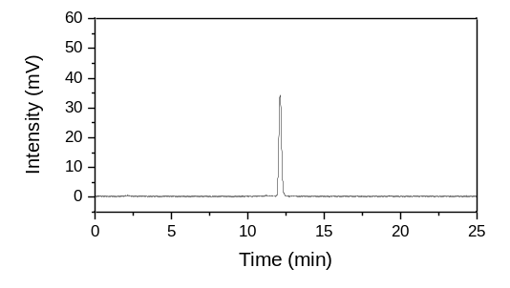
(a)
(b)
(c)

Figure S9. Confirmation of peptide identity and integrity for (a) [^{nat}Lu]Lu-DOTA-CCK-63 and (b) [¹⁷⁷Lu]Lu-DOTA-CCK-63 as analyzed by analytical (radio-)RP-HPLC (MultoKrom 100-5 C18, 5 μm, 125 × 4.6 mm, CS Chromatographie GmbH, Langerwehe, Germany; 10→70% MeCN in H₂O + 0.1% TFA in 15 min). (c) Mass spectrum of [^{nat}Lu]Lu-DOTA-CCK-63.

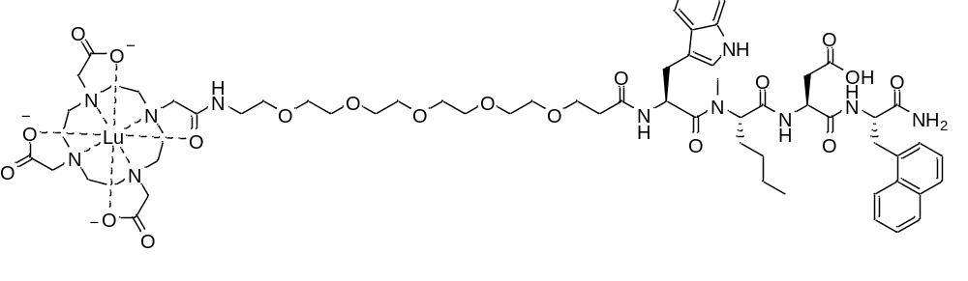
[^{nat}Lu]Lu-DOTA-CCK-63: RP-HPLC (10→70% MeCN in H₂O with 0.1% TFA, 15 min, λ = 220 nm): t_{R} = 11.3 min, K’ = 5.70; MS (ESI, positive): m/z calculated for C₆₄H₉₀LuN₁₁O₁₉: 1491.6, found: m/z = 746.0 [M+2H]²⁺.

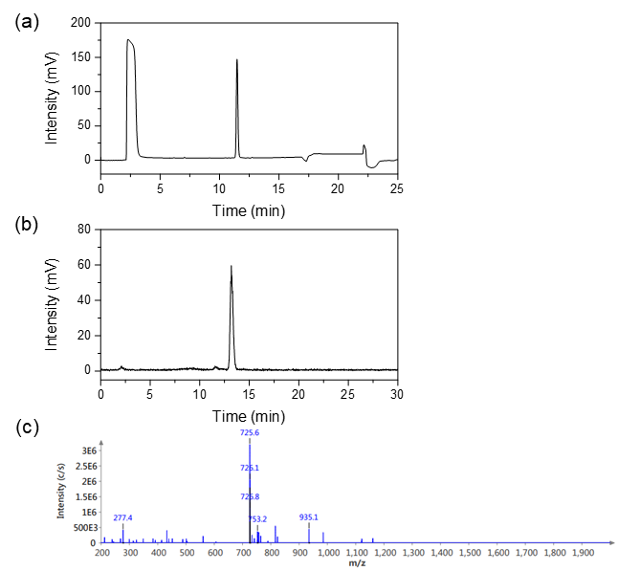
Figure S10. Confirmation of peptide identity and integrity for (a) [^{nat}Lu]Lu-DOTA-CCK-64 as analyzed by analytical RP-HPLC (MultoKrom 100-5 C18, 5 μm, 125 × 4.6 mm, CS Chromatographie GmbH, Langerwehe, Germany; 10→70% MeCN in H₂O + 0.1% TFA in 15 min) and (b) [¹⁷⁷Lu]Lu-DOTA-CCK-64 as analyzed by analytical radio-RP-HPLC (10→30% MeCN in H₂O + 0.1% TFA in 5 min; 30→60% MeCN in H₂O + 0.1% TFA in 15 min). (c) Mass spectrum of [^{nat}Lu]Lu-DOTA-CCK-64.
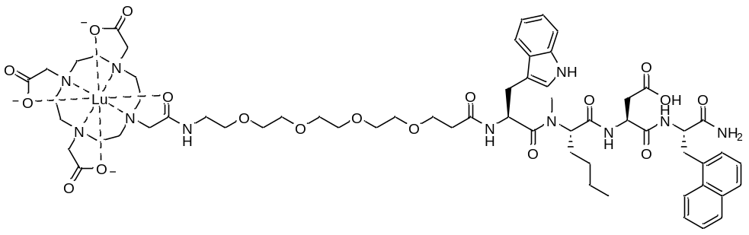

[^{nat}Lu]Lu-DOTA-CCK-64: RP-HPLC (10→70% MeCN in H₂O with 0.1% TFA, 15 min, λ = 220 nm): t_{R} = 11.5 min, K’ = 5.80; MS (ESI, positive): m/z calculated for C₆₂H₈₆LuN₁₁O₁₈: 1448.4, found: m/z = 725.6 [M+2H]²⁺.

Analytical data of tetrapeptidic sequences
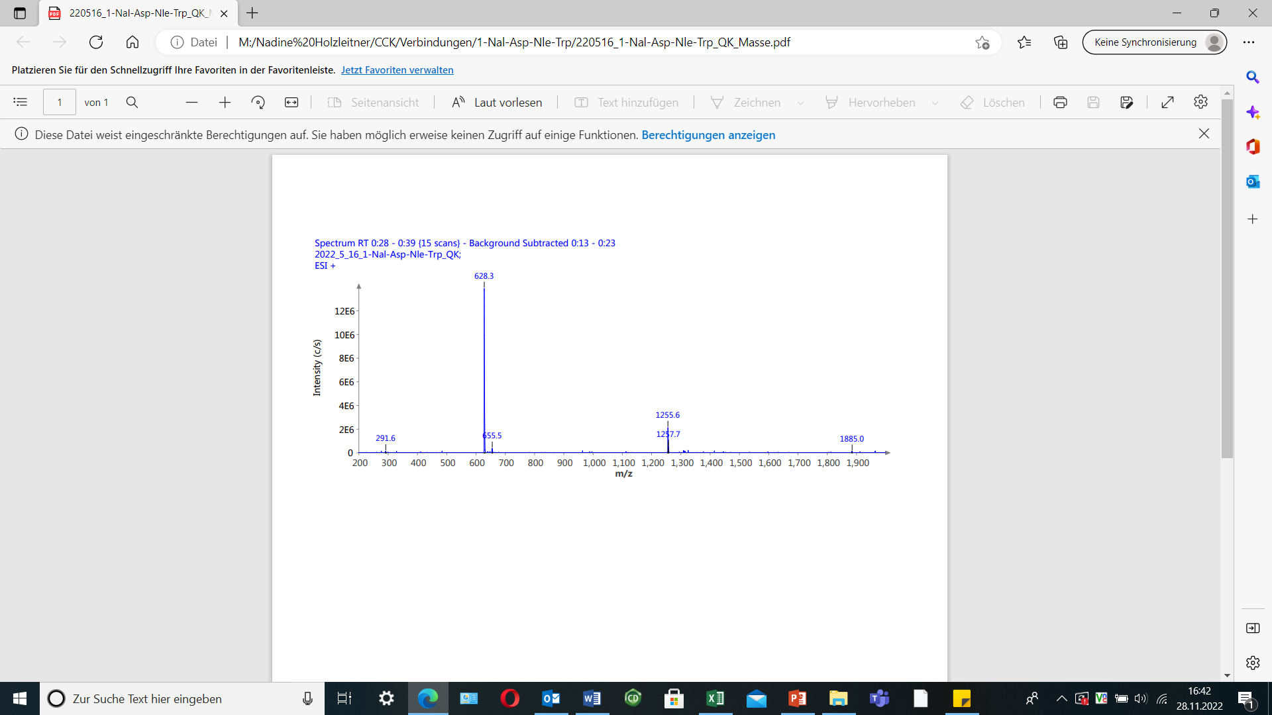
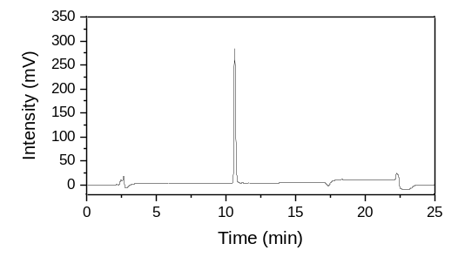
(a)
(b)

Figure S11. Confirmation of peptide identity and integrity for (a) H-Trp-Nle-Asp-1-Nal-NH₂ as analyzed by analytical RP-HPLC (MultoKrom 100-5 C18, 5 μm, 125 × 4.6 mm, CS Chromatographie GmbH, Langerwehe, Germany; 10→70% MeCN in H₂O + 0.1% TFA in 15 min). (b) Mass spectrum of H-Trp-Nle-Asp-1-Nal-NH₂.
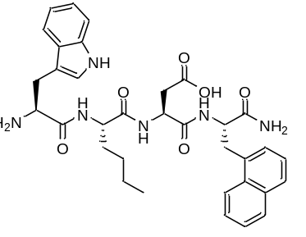
H-Trp-Nle-Asp-1-Nal-NH₂ (B1): RP-HPLC (10→70% MeCN in H₂O with 0.1% TFA, 15 min, λ = 220 nm): t_{R} = 10.6 min, K’ = 5.28; MS (ESI, positive): m/z calculated for C₃₄H₄₀N₆O₆: 628.3, found: m/z = 1255.6 [2M+H]⁺, 628.3 [M+H]⁺.

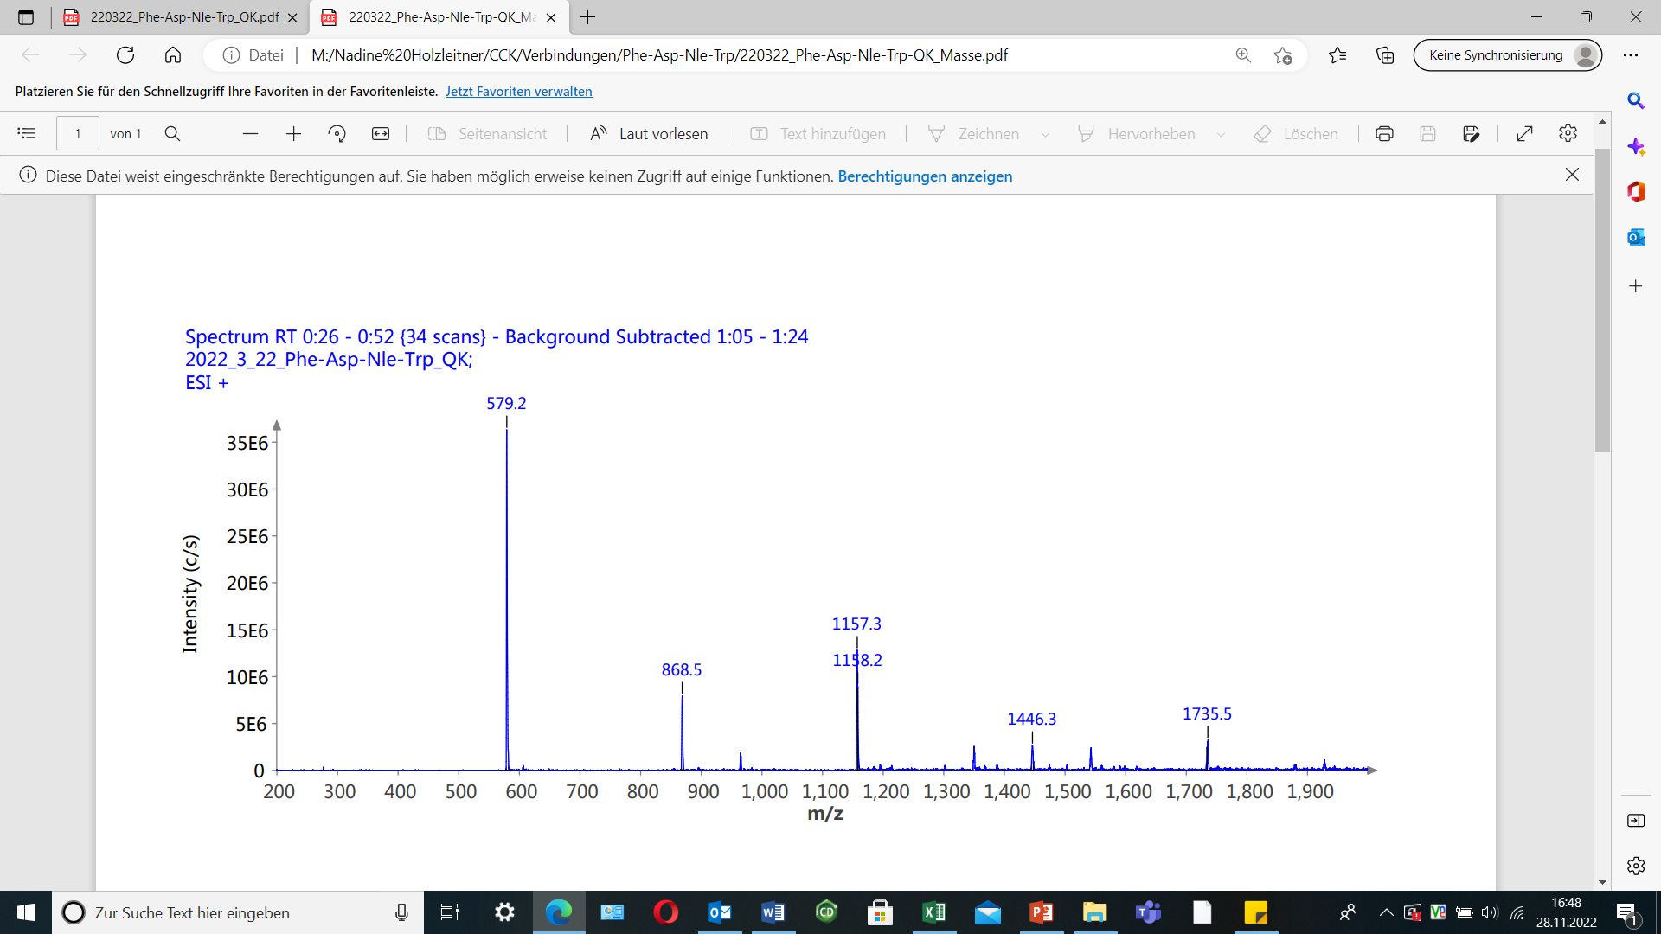
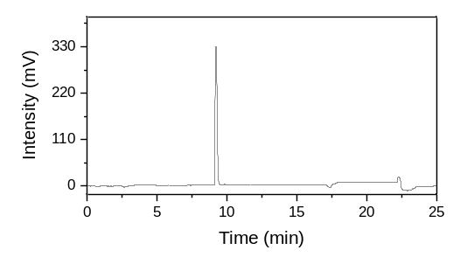
(a)
(b)

Figure S12. Confirmation of peptide identity and integrity for (a) H-Trp-Nle-Asp-Phe-NH₂ as analyzed by analytical RP-HPLC (MultoKrom 100-5 C18, 5 μm, 125 × 4.6 mm, CS Chromatographie GmbH, Langerwehe, Germany; 10→70% MeCN in H₂O + 0.1% TFA in 15 min). (b) Mass spectrum of H-Trp-Nle-Asp-Phe-NH₂.
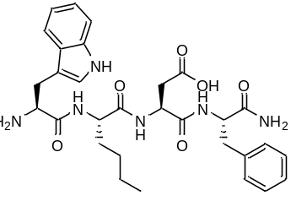
H-Trp-Nle-Asp-Phe-NH₂ (B2): RP-HPLC (10→70% MeCN in H₂O with 0.1% TFA, 15 min, λ = 220 nm): t_{R} = 9.2 min, K’ = 4.45; MS (ESI, positive): m/z calculated for C₃₀H₃₈N₆O₆: 578.3, found: m/z = 1157.3 [2M+H]⁺, 579.2 [M+H]⁺.

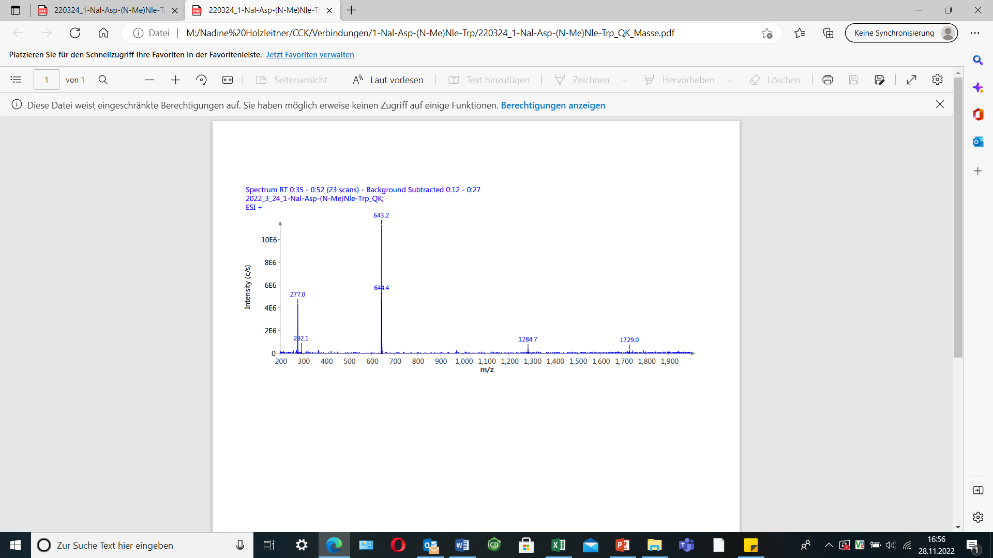
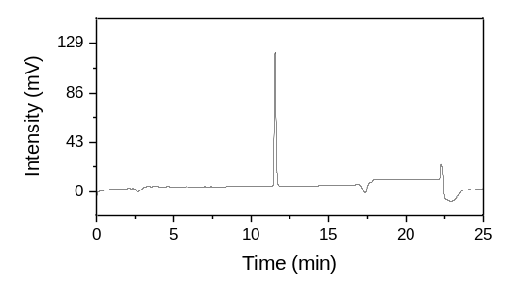
(a)
(b)

Figure S13. Confirmation of peptide identity and integrity for (a) H-Trp-(N-Me)Nle-Asp-1-Nal-NH₂ as analyzed by analytical RP-HPLC (MultoKrom 100-5 C18, 5 μm, 125 × 4.6 mm, CS Chromatographie GmbH, Langerwehe, Germany; 10→70% MeCN in H₂O + 0.1% TFA in 15 min). (b) Mass spectrum of H-Trp-(N-Me)Nle-Asp-1-Nal-NH₂.
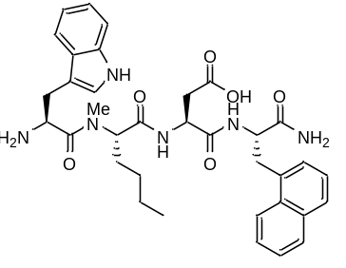
H-Trp-(N-Me)Nle-Asp-1-Nal-NH₂ (B3): RP-HPLC (10→70% MeCN in H₂O with 0.1% TFA, 15 min, λ = 220 nm): t_{R} = 11.5 min, K’ = 5.82; MS (ESI, positive): m/z calculated for C₃₅H₄₂N₆O₆: 642.3, found: m/z = 1284.7 [2M+H]⁺, 643.2 [M+H]⁺.

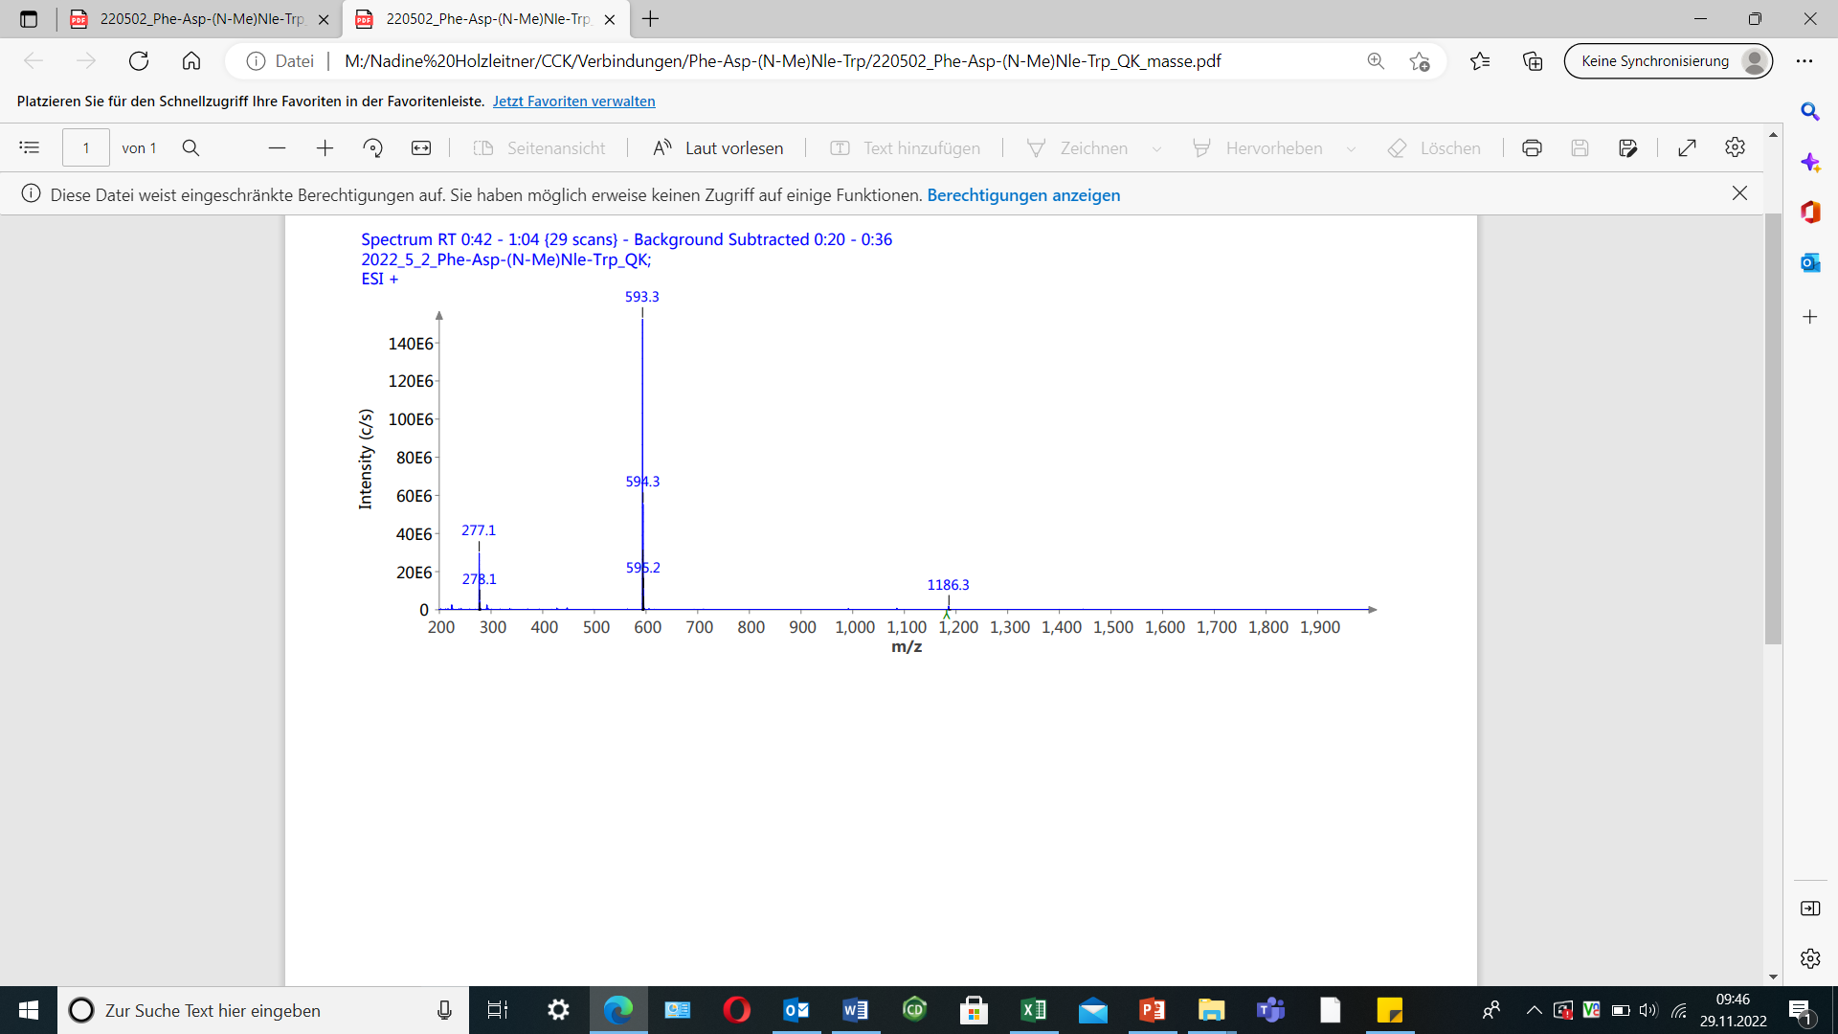
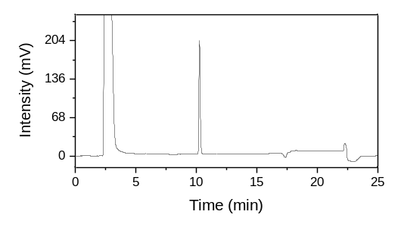
(a)
(b)

Figure S14. Confirmation of peptide identity and integrity for (a) H-Trp-(N-Me)Nle-Asp-Phe-NH₂ as analyzed by analytical RP-HPLC (MultoKrom 100-5 C18, 5 μm, 125 × 4.6 mm, CS Chromatographie GmbH, Langerwehe, Germany; 10→70% MeCN in H₂O + 0.1% TFA in 15 min). (b) Mass spectrum of H-Trp-(N-Me)Nle-Asp-Phe-NH₂.
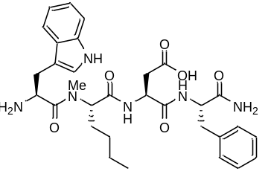
H-Trp-(N-Me)Nle-Asp-Phe-NH₂ (B4): RP-HPLC (10→70% MeCN in H₂O with 0.1% TFA, 15 min, λ = 220 nm): t_{R} = 10.3 min, K’ = 5.11; MS (ESI, positive): m/z calculated for C₃₁H₄₀N₆O₆: 592.3, found: m/z = 1186.3 [2M+H]⁺, 593.3 [M+H]⁺.

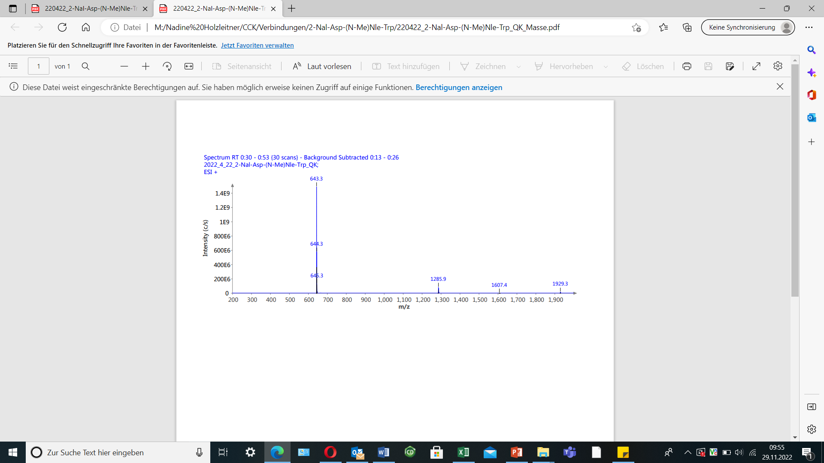
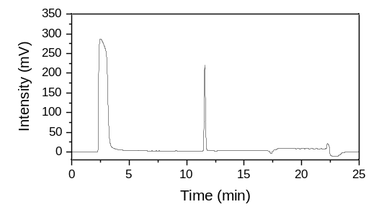
(a)
(b)

Figure S15. Confirmation of peptide identity and integrity for (a) H-Trp-(N-Me)Nle-Asp-2-Nal-NH₂ as analyzed by analytical RP-HPLC (MultoKrom 100-5 C18, 5 μm, 125 × 4.6 mm, CS Chromatographie GmbH, Langerwehe, Germany; 10→70% MeCN in H₂O + 0.1% TFA in 15 min). (b) Mass spectrum of H-Trp-(N-Me)Nle-Asp-2-Nal-NH₂.
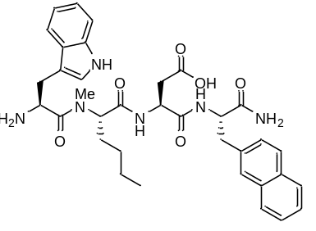
H-Trp-(N-Me)Nle-Asp-2-Nal-NH₂ (B5): RP-HPLC (10→70% MeCN in H₂O with 0.1% TFA, 15 min, λ = 220 nm): t_{R} = 11.6 min, K’ = 5.88; MS (ESI, positive): m/z calculated for C₃₅H₄₂N₆O₆: 642.3, found: m/z = 1285.9 [2M+H]⁺, 643.3 [M+H]⁺.

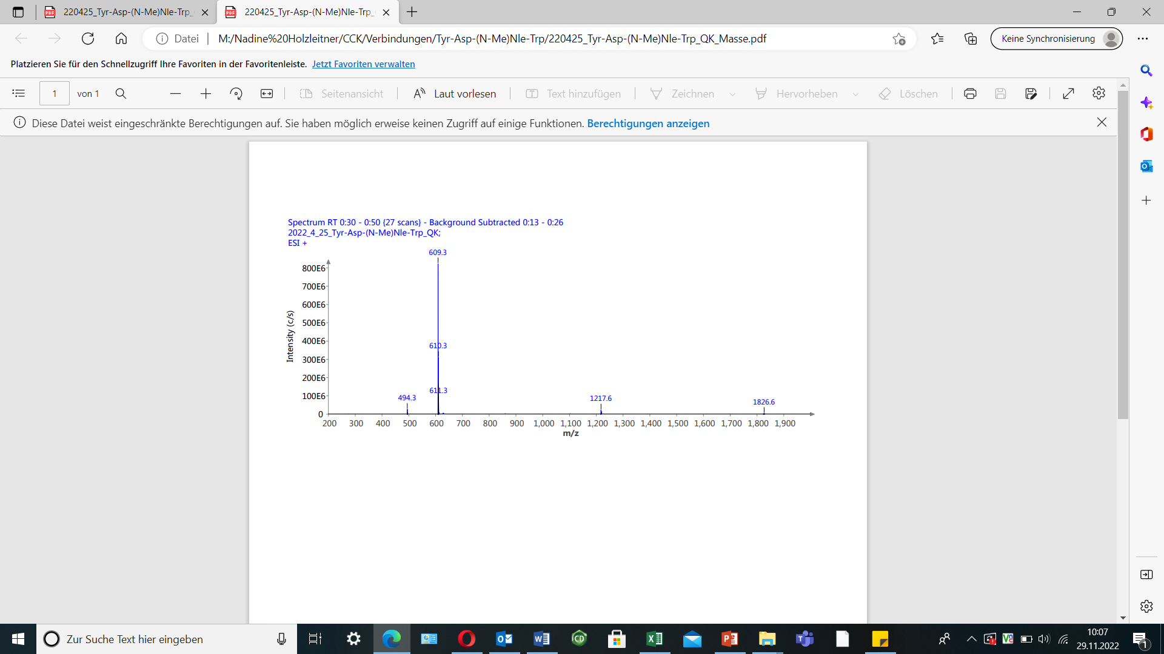
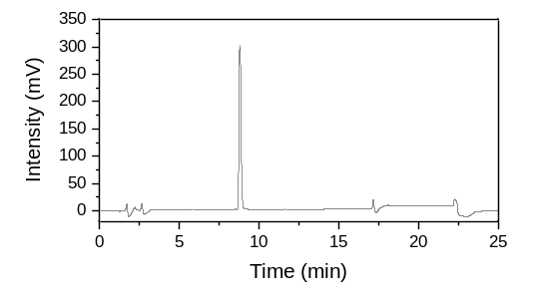
(a)
(b)

Figure S16. Confirmation of peptide identity and integrity for (a) H-Trp-(N-Me)Nle-Asp-1-Tyr-NH₂ as analyzed by analytical RP-HPLC (MultoKrom 100-5 C18, 5 μm, 125 × 4.6 mm, CS Chromatographie GmbH, Langerwehe, Germany; 10→70% MeCN in H₂O + 0.1% TFA in 15 min). (b) Mass spectrum of H-Trp-(N-Me)Nle-Asp-1-Tyr-NH₂.
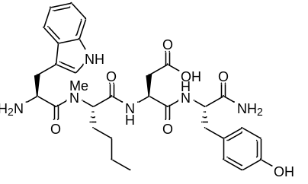
H-Trp-(N-Me)Nle-Asp-1-Tyr-NH₂ (B6): RP-HPLC (10→70% MeCN in H₂O with 0.1% TFA, 15 min, λ = 220 nm): t_{R} = 8.8 min, K’ = 4.21; MS (ESI, positive): m/z calculated for C₃₁H₄₀N₆O₇: 608.3, found: m/z = 1217.6 [2M+H]⁺, 609.3 [M+H]⁺.

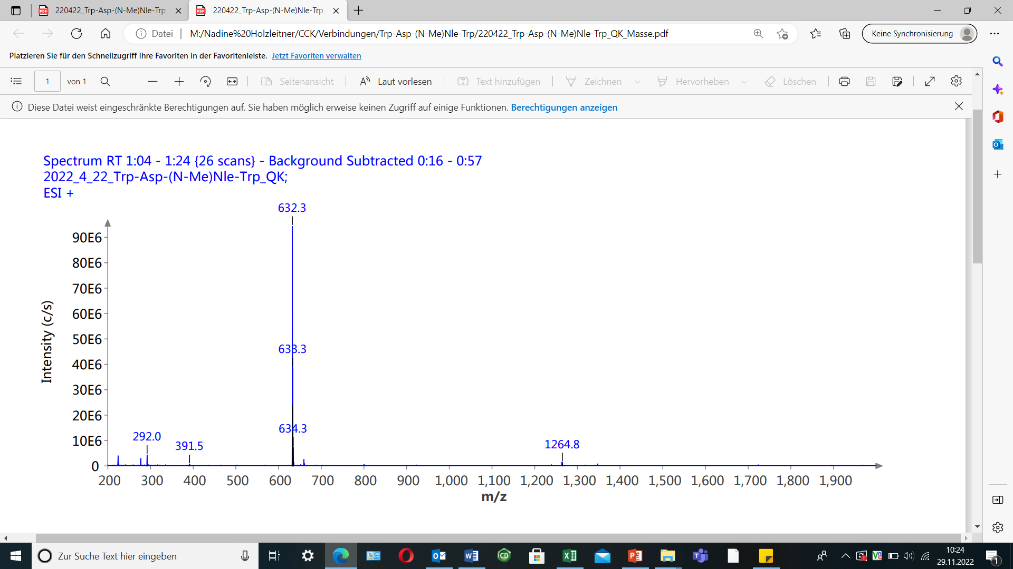
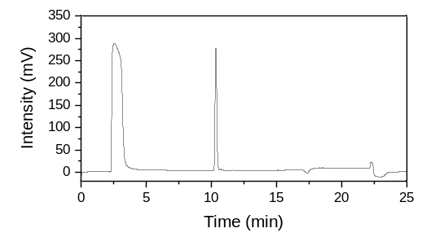
(a)
(b)

Figure S17. Confirmation of peptide identity and integrity for (a) H-Trp-(N-Me)Nle-Asp-Trp-NH₂ as analyzed by analytical RP-HPLC (MultoKrom 100-5 C18, 5 μm, 125 × 4.6 mm, CS Chromatographie GmbH, Langerwehe, Germany; 10→70% MeCN in H₂O + 0.1% TFA in 15 min). (b) Mass spectrum of H-Trp-(N-Me)Nle-Asp-Trp-NH₂.
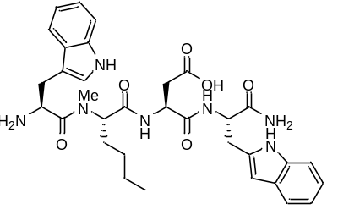
H-Trp-(N-Me)Nle-Asp-Trp-NH₂ (B7): RP-HPLC (10→70% MeCN in H₂O with 0.1% TFA, 15 min, λ = 220 nm): t_{R} = 10.3 min, K’ = 5.11; MS (ESI, positive): m/z calculated for C₃₃H₄₁N₇O₆: 631.3, found: m/z = 1264.8 [2M+H]⁺, 632.3 [M+H]⁺.

¹⁷⁷Lu-Labeling
For ¹⁷⁷Lu-labeling experiments, [¹⁷⁷Lu]LuCl₃ dissolved in hydrochloric acid (0.04 M, 40 GBq/mL) was acquired from ITM Isotope Technologies Munich SE (Garching, Germany). Radiolabeling of the peptide precursor (1 nmol) was performed at 90°C for 15 min in a NaOAc-buffered (1 M, pH = 5.5) hydrochloric acid (0.04 M) solution. After radiolabeling, a sodium ascorbate (1 M in H₂O) was added to prevent radiolysis and radiochemical purity was determined via radio-RP-HPLC and radio-TLC (instant thin layer chromatography paper impregnated with silica gel (iTLC-SG, Agilent Technologies Inc., Folsom, CA, United States); sodium citrate × 1.5 H₂O (0.1 M)).

Table S1. CCK-2R affinity and lipophilicity data of the compounds evaluated. Affinity data were determined on AR42J cells (2.0 x 10⁵ cells/well/mL) and [¹⁷⁷Lu]Lu-DOTA-PP-F11N (0.3 pmol/well) as radiolabeled reference (3 h, 37°C, RPMI 1640, 5 mM L-Gln, 5 mL non-essential amino acids (100x), 10% FCS + 5% BSA (v/v)).
Peptide | IC₅₀ [nm] | logD_{7.4}
[^{nat/177}Lu]Lu-DOTA-CCK-55 | 8.51 ± 1.16 | −2.09 ± 0.07
[^{nat/177}Lu]Lu-DOTA-CCK-56 | 4.92 ± 0.79 | −1.38 ± 0.07
[^{nat/177}Lu]Lu-DOTA-CCK-57 | 9.67 ± 1.74 | −1.94 ± 0.06
[^{nat/177}Lu]Lu-DOTA-CCK-58 | 8.21 ± 1.33 | −2.66 ± 0.06
[^{nat/177}Lu]Lu-DOTA-CCK-59 | 5.61 ± 0.48 | −1.26 ± 0.08
[^{nat/177}Lu]Lu-DOTA-CCK-60 | 4.16 ± 0.47 | −2.63 ± 0.05
[^{nat/177}Lu]Lu-DOTA-CCK-61 | 7.85 ± 0.43 | −2.56 ± 0.09
[^{nat/177}Lu]Lu-DOTA-CCK-62 | 98.9 ± 8.4 | −1.34 ± 0.08
[^{nat/177}Lu]Lu-DOTA-CCK-63 | 8.84 ± 1.25 | −2.13 ± 0.05
[^{nat/177}Lu]Lu-DOTA-CCK-64 | 7.64 ± 0.86 | −2.21 ± 0.07
[^{nat/177}Lu]Lu-DOTA-γ-MGS5 | 4.90 ± 0.78 | −2.24 ± 0.04
H-Trp-Nle-Asp-1-Nal-NH₂ (B1) | 297 ± 15 | not determined (n.d.)
H-Trp-Nle-Asp-Phe-NH₂ (B2) | 466 ± 88 | n.d.
H-Trp-(N-Me)Nle-Asp-1-Nal-NH₂ (B3) | 5.88 ± 0.52 | n.d.
H-Trp-(N-Me)Nle-Asp-Phe-NH₂ (B4) | 4.49 ± 0.56 | n.d.
H-Trp-(N-Me)Nle-Asp-2-Nal-NH₂ (B5) | 102 ± 9 | n.d.
H-Trp-(N-Me)Nle-Asp-Tyr-NH₂ (B6) | 5.70 ± 0.48 | n.d.
H-Trp-(N-Me)Nle-Asp-Trp-NH₂ (B7) | 18.8 ± 0.5 | n.d.

Table S2. In vitro stability of [¹⁷⁷Lu]Lu-DOTA-CCK-55, [¹⁷⁷Lu]Lu-DOTA-CCK-62, [¹⁷⁷Lu]Lu-DOTA-CCK-63 and [¹⁷⁷Lu]Lu-DOTA-γ-MGS5 after incubation for 24 h at 37°C in human serum. Values are depicted in percent of intact peptide as analyzed by radio-RP-HPLC (MultoKrom 100-5 C18, 5 μm, 125 × 4.6 mm, CS Chromatographie GmbH, Langerwehe, Germany; 10→30% MeCN in H₂O + 0.1% TFA in 5 min; 30→60% MeCN in H₂O + 0.1% TFA in 5 min).
Compound | Intact Peptide (%)
[¹⁷⁷Lu]Lu-DOTA-CCK-55 | 87.5 ± 1.9
[¹⁷⁷Lu]Lu-DOTA-CCK-62 | 97.9 ± 1.8
[¹⁷⁷Lu]Lu-DOTA-CCK-63 | 57.4 ± 3.7
[¹⁷⁷Lu]Lu-DOTA-CCK-64 | 43.8 ± 2.3
[¹⁷⁷Lu]Lu-DOTA-γ-MGS5 | 96.8 ± 2.8

