Supplementary Information
Title:
⁸⁹Zr-labeled ImmunoPET Targeting the Cancer Stem Cell Antigen CD133 using Fully-Human Antibody Constructs

Authors:
Kevin Wyszatko†, Nancy Janzen†, Luis Rafael Silva†, Luke Kwon§, Teesha Komal§, Manuela Ventura§, Chitra Venugopal||, Sheila Singh||,#, John F. Valliant†, Saman Sadeghi†*

Affiliations
† Department of Chemistry and Chemical Biology, McMaster University, Hamilton, Ontario, Canada
§ Spatio-Temporal Targeting and Amplification of Radiation Response (STTARR) Innovation Centre, University Health Network, Toronto, ON, Canada
||Centre for Discovery in Cancer Research, McMaster University, Hamilton, Ontario, Canada;
#Department of Surgery, McMaster University, Hamilton, Ontario, Canada
*Corresponding author: Saman Sadeghi, sadegs10@mcmaster.ca, Department of Chemistry and Chemical Biology, McMaster University, Hamilton, Ontario, Canada

Supplementary 1. Conugation and MALDI-MS Charaterization
Description for Table S1-1
To characterize the number of DFO conjugated per RW03_{IgG} or RW03_{scFv-Fc}, Matrix-Assisted Laser Desorption Ionization Mass Spectrometry (MALDI-MS) was performed using a Bruker UltrafleXtreme TOF/TOF in positive mode to determine the molecule weight of the parent antibody and conjugate. Samples (triplicate) were formulated at concentration of 1 mg/mL in phosphate buffer (0.02 M, pH 7.4) and then diluted 1x with a saturated solution of sinapinic acid in TA30 solvent (70 (v/v) acetonitrile:0.1% TFA in water solvent). From this mixture 1 µL was spotted on a steel target and left to dry before laser ablation. A solution of bovine serum albumen (BSA) was prepared and used as an external standard.
Table S1-1. MALDI-MS characterization used for C/A determination of DFO-RW03_{IgG} or DFO-RW03_{scFv-Fc} conjugates. Calculation of C/A was performed using molecular weight of 752.95 g/mol per addition of 1 molecule p-SCN-Bn-DFO.
Sample | Molar Excess of  NCS-DFO in reaction | m/z (n = 3) |  | m/z Increase |  | C/A (n = 3) |  | Mass yield (%)
Sample | Molar Excess of  NCS-DFO in reaction | Mean | SD | Mean | SEM | Mean | SEM | Mass yield (%)
RW03_{IgG} |  | 150040 | 80
DFO-RW03_{IgG} | 5 | 150600 | 100 | 560 | 80 | 0.7 | 0.1 | 72 ± 5
DFO-RW03_{IgG} | 30 | 152300 | 200 | 2260 | 220 | 3.0 | 0.3 | 33 ± 10
RW03_{scFv-Fc} |  | 105600 | 100
DFO-RW03_{scFv-Fc} | 10 | 107800 | 200 | 2200 | 200 | 2.9 | 0.3 | 80 ± 6

Description for Figure S1-1
SEC-HPLC characterization of a commercial isotype IgG, the native RW03_{IgG}, the native scFv-Fc scaffold, and conjugates were performed on Waters 1525 Binary HPLC using a Yarra 3um SEC 3000 (300 × 7.8 mm) with a mobile phase of phosphate buffer (0.02 M, pH 6.7). Samples were analyzed using Bioscan 2489 Waters 2489 UV/Vis (λ = 280 nm). Spectra were recorded and processed on Empower 2 software (Waters).
HPLC chromatograms are shown in Fig. S1-1. In Fig. S1-1 (a) an isotype IgG is presented to demonstrate the resolution afforded by the column. It is worth noting that we were initially uncertain how the relatively high proportion of scFv-Fc dimer in solution (20 - 30 %) (Fig. S1-1 d) would impact immunoPET probes made from this scaffold. As seen in the chromatogram for DFO-RW03_{scFv-Fc} (Fig. S1-1e), conjugation with DFO-NCS to generate DFO-RW03_{scFv-Fc} (C/A = 2.9) reduced the propensity for this scaffold to multimerize.
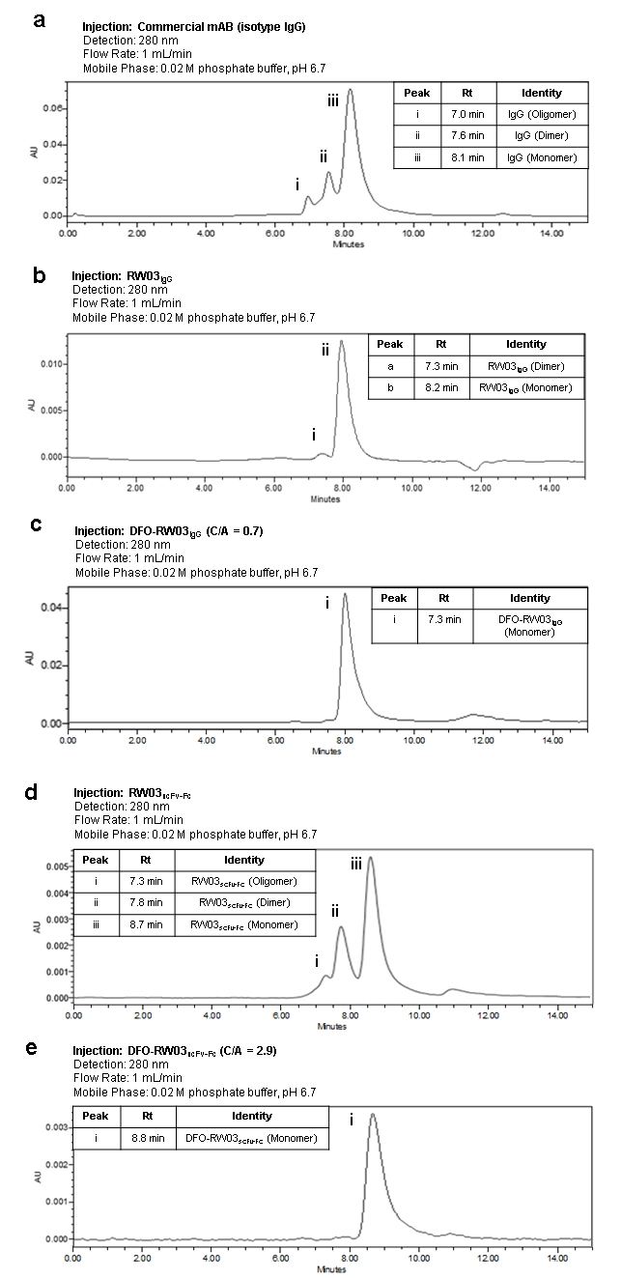

Figure S1-1. SEC-HPLC chromatograms for a) an isotype control IgG (150 µg), b) native RW03_{IgG} (20 µg), c) DFO-RW03_{IgG} (CA = 0.7 ± 0.1) (150 µg), d) native RW03_{scFv-Fc} (10 µg), e) DFO-RW03_{scFv-Fc} (CA = 2.9 ± 0.3) (7.5 µg). In d) multiple peaks are observed for the native RW03_{scFv-Fc}, which reduced to a single peak in e) after conjugation with DFO-NCS.

Online Resource 2. Radiochemistry
Description for Table S2-1 and Figure S2-1, 2-2
Table S2-1 and Figures S2-1 to S2-2 used radio-iTLC to monitor [⁸⁹Zr]-DFO-RW03_{IgG} (C/A = 0.7, 3.0) [⁸⁹Zr]-DFO-RW03_{scFv-Fc} (C/A = 2.9) radiolabeling reaction progress and radiochemical purity. Radio-iTLCs were performed using iTLC-SG glass microfiber chromatography paper (SGI0001, Agilent Technologies) plates with sodium citrate buffer (0.1 M, pH 5) as the eluent. Radio-iTLCs were analyzed using a Bioscan AR-2000 Imaging Scanner.

Table S2-1. Reaction progress and isolated RCY for zirconium-89 radiolabeling of DFO-RW03_{IgG/scFv-Fc} conjugates. Isolated RCY represents the activity collected after PD-10 column purification and sterile filtration relative to the activity added to the reaction.
 | [⁸⁹Zr]-DFO-RW03_{IgG}  (C/A = 0.7) |  | [⁸⁹Zr]-DFO-RW03_{IgG}  (C/A = 3.0) |  | [⁸⁹Zr]-DFO-RW03_{scFv-Fc}  (C/A = 2.9)
Time (min) | RCY (%) | SD |  |  | RCY (%) | SD
0 | 9 | 8 | 42 | 11 | 29 | 21
20 | 15 | 10 | 89 | 7 | 78 | 18
40 | 32 | 8 | 93 | 6 | 84 | 14
60 | 42 | 5 | 97 | 2 | 86 | 12
Isolated | 30 | 1 | 80 | 3 | 39 | 13

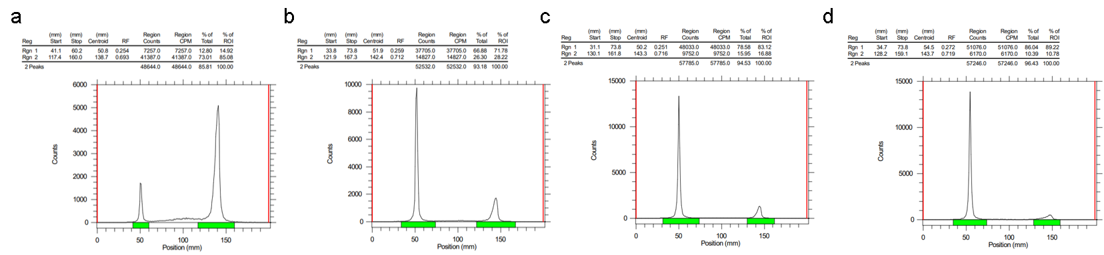
Figure S2-1. Representative radio-iTLC traces for zirconium-89 radiolabeling of DFO-RW03_{scFc-Fc} (C/A = 2.9 ± 0.3). Sampling peformed at a) t= 0 min, b) t = 20 min, c) t = 40 min, d) t = 60 min.
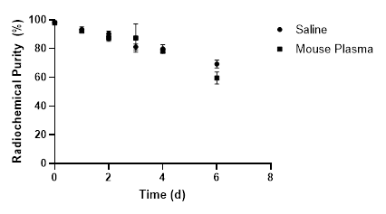
Figure S2-2. Radio-iTLC determination of [⁸⁹Zr]-DFO-RW03_{scFv-Fc} (C/A = 2.9 ± 0.3) stability in saline and mouse serum.

Supplementary 3. In Vitro Characterization
Description for Figure S3-1 and Table S3-1
Flow cytometry was used to measure changes in the EC₅₀ of native RW03_{IgG} and RW03_{scFv-Fc} after conjugation with DFO-NCS (Fig. S3-1). The EC₅₀ values were taken as the half-maximal concentration required to induce a decrease in MFI which occurred when ligand concentrations > 10 nM (Table S3-1).
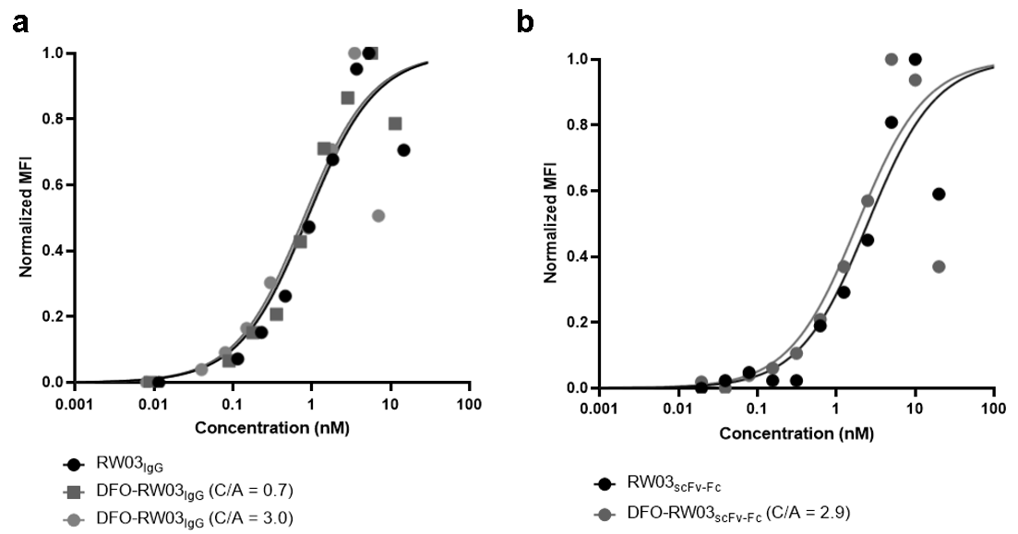
Figure S3-1. Flow cytometry saturation binding of a) RW03_{IgG}, DFO-RW03_{IgG} (C/A = 0.7), DFO-RW03_{IgG} (C/A = 3.0) and b) RW03_{scFv-Fc} and DFO-RW03_{scFv-Fc} (C/A =2.9). Data presented as the normalized mean fluorescence intensity (MFI).
Table S3-1. EC₅₀ values for RW03_{IgG}, RW03_{scFv-Fc} and conjugates. The data was normalized and concentrations > 10 nM were excluded from the fit.
 | RW03_{IgG} |  | DFO-RW03_{IgG}  (C/A = 0.7) |  | DFO-RW03_{IgG}  (C/A = 3.0) | RW03_{scFv-Fc} | DFO-RW03_{scFv-Fc} (C/A = 2.9)
Best-fit values

EC50 | 0.89 nM |  | 0.79 nM |  | 0.85 nM | 2.2 nM | 1.6 nM
95% CI
EC50 | 0.6 to 1.3 nM |  | 0.6 to 1.1 nM |  | 0.3 to 1.9 nM | 1.5 to 3.3 nM | 1.1 to 2.3 nM
Goodness of Fit
R squared | 0.95 |  | 0.96 |  | 0.79 | 0.94 | 0.95

Supplementary 4. Additional Biodistribution and Imaging Data
Description for Tables S4-1 to S4-6
Biodistribution tables for Fig 1. & Fig. 2.
Table S4-1. Ex vivo biodistribution of [⁸⁹Zr]-DFO-RW03_{IgG} (C/A = 0.7) (0.16 ± 0.02 MBq, 5 ± 0.7 µg) in HT-29 xenograft BALB/c nu/nu mice. Uptake is expressed as mean percentage injected dose per gram tissue (%ID/g).
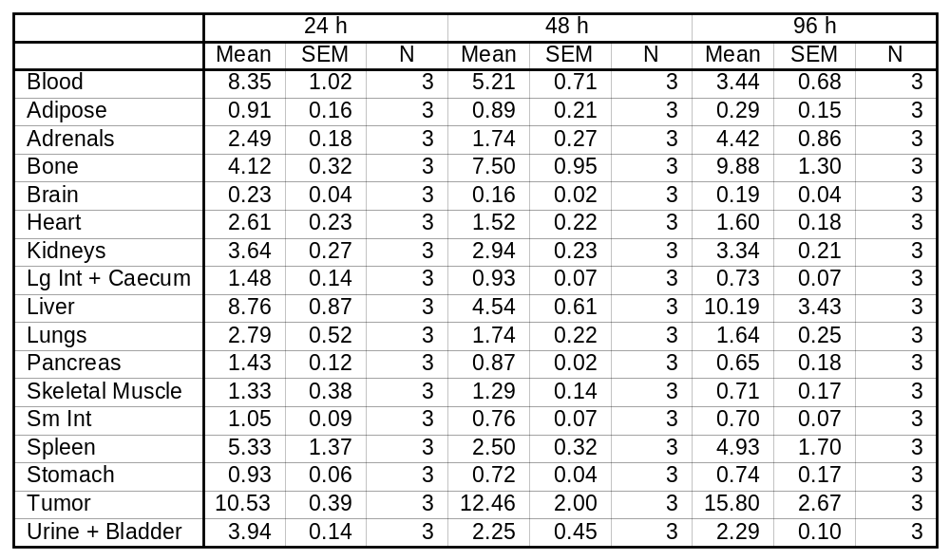
Table S4-2. Ex vivo biodistribution of [⁸⁹Zr]-DFO-RW03_{IgG} (C/A = 0.7) (0.16 ± 0.02 MBq, 5 ± 0.7 µg) in HT-29 xenograft BALB/c nu/nu mice. Uptake is expressed as mean percentage injected dose per organ (%ID/O).
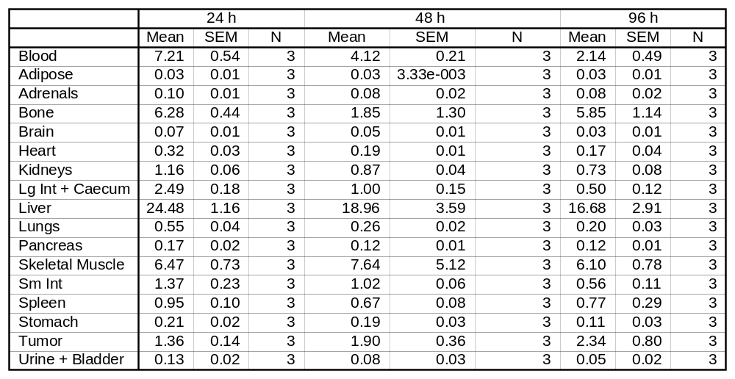
Table S4-3. Ex vivo biodistribution of [⁸⁹Zr]-DFO-RW03_{IgG} (C/A = 3.0) (0.14 ± 0.03 MBq, 1 ± 0.3µg) in HT-29 xenograft BALB/c nu/nu mice. Uptake is expressed as mean percentage injected dose per gram tissue (%ID/g).
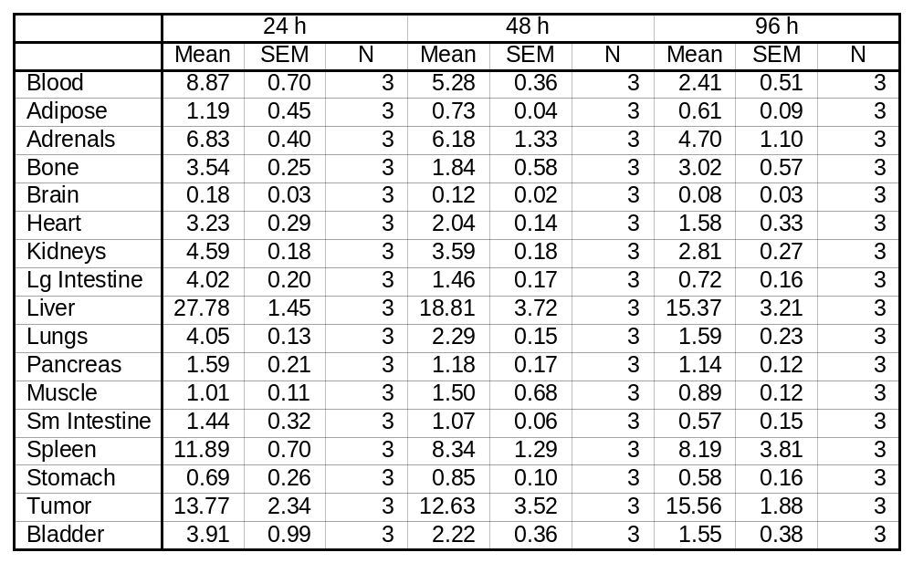
Table S4-4. Ex vivo biodistribution of [⁸⁹Zr]-DFO-RW03_{IgG} (C/A = 3.0) (0.14 ± 0.03 MBq, 1 ± 0.3µg) in HT-29 xenograft BALB/c nu/nu mice. Uptake is expressed as mean percentage injected dose per organ (%ID/O).
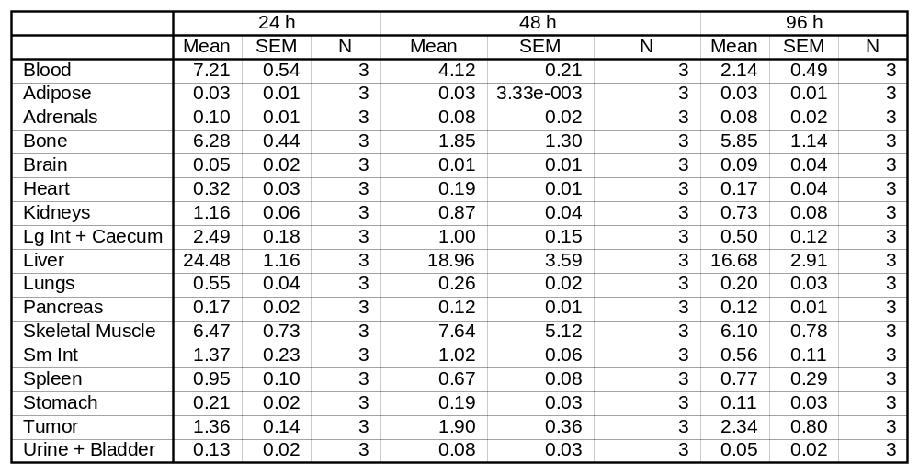
Table S4-5. Ex vivo biodistribution of [⁸⁹Zr]-DFO-RW03_{scFv-Fc} (0.09 ± 0.02 MBq, 1.2 ± 0.2 µg) in HT-29 xenograft BALB/c nu/nu mice. The blocked cohort received [⁸⁹Zr]-DFO-RW03_{scFv-Fc} (0.09 ± 0.02 MBq, 1 ± 0.2 µg) and excess RW03_{IgG} (400 µg). Uptake is expressed as mean percentage injected dose per gram tissue (%ID/g).
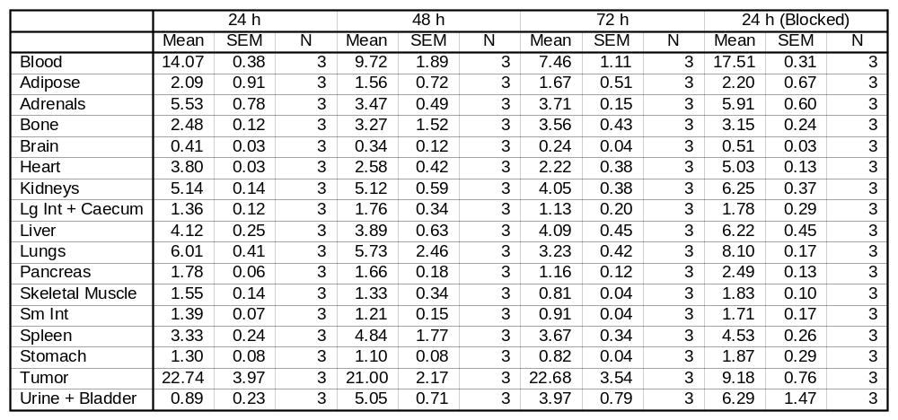
Table S4-6. Ex vivo biodistribution of [⁸⁹Zr]-DFO-RW03_{scFv-Fv} (0.09 ± 0.02 MBq, 1.0 ± 0.2 µg) in HT-29 xenograft BALB/c nu/nu mice. The blocked cohort received [⁸⁹Zr]-DFO-RW03_{scFv-Fc} (0.09 ± 0.02 MBq, 1 ± 0.2 µg) and excess RW03_{IgG} (400 µg). Uptake is expressed as mean percentage injected dose per organ (%ID/O).
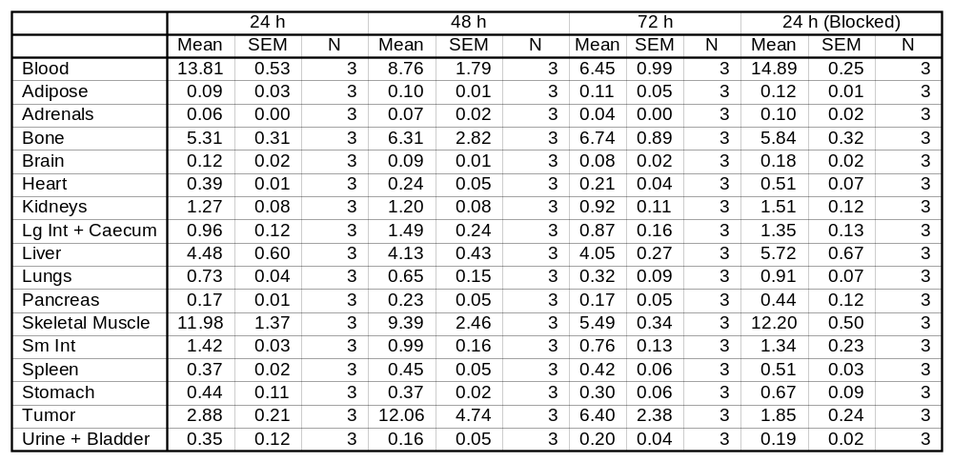
Description for Table S4-7 to S4-11
ROI analysis tables and ex vivo biodistribution tables for Fig. 2.
Table S4-7. PET image ROI table. In vivo PET image ROI analysis of [⁸⁹Zr]-DFO-RW03_{IgG} (C/A = 0.7) (1.27 ± 0.03 MBq, 10 ± 0.2 ug) in HT-29 xenograft BALB/c nu/nu mice. Uptake is expressed as mean radioactivity per mL tissue volume (%ID/cc). Data expressed as mean ± SEM.
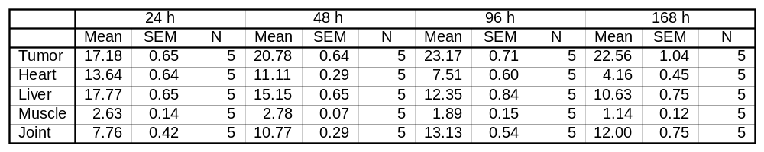
Table S4-8. PET image ROI table. In vivo PET image ROI analysis of [⁸⁹Zr]-DFO-RW03_{IgG} (C/A = 3.0) (5.2 ± 0.4 MBq, 27 ± 2 µg) in HT-29 xenograft BALB/c nu/nu mice. Uptake is expressed as mean radioactivity per mL tissue volume (%ID/cc). Data expressed as mean ± SEM.
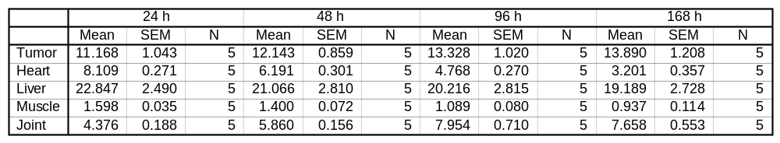
Table S4-9. PET image ROI table. In Vivo PET image ROI analysis of [⁸⁹Zr]-DFO-RW03_{scFv-Fc} (C/A=2.8) (1.2±0.1 MBq, 16±2 µg) in HT-29 xenograft BALB/c nu/nu mice. Uptake is expressed as mean radioactivity per mL tissue volume (%ID/cc). Data expressed as mean±SEM.
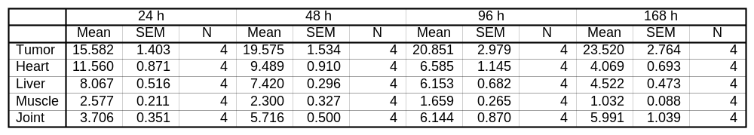
Table S4-10. Ex vivo biodistribution tables from PET imaging study of [⁸⁹Zr]-DFO-RW03_{IgG} (C/A = 0.7) (1.27 ± 0.03 MBq, 10 ± 0.2 ug), [⁸⁹Zr]-DFO-RW03_{IgG} (C/A = 3.0) (5.2 ± 0.4 MBq, 27 ± 2 µg), and [⁸⁹Zr]-DFO-RW03_{scFv-Fc} (C/A=2.8) (1.2±0.1 MBq, 16±2 µg) in HT-29 xenograft BALB/c nu/nu mice at 168 h. Uptake is expressed as mean percentage injected dose per gram tissue (%ID/g).
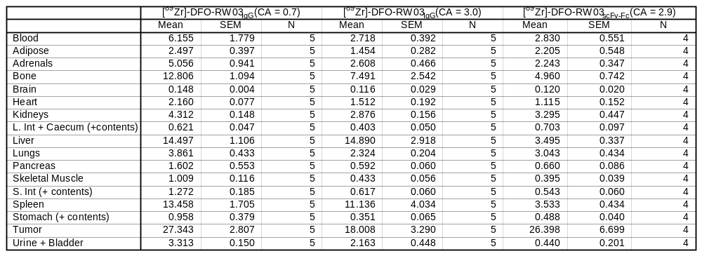
Table S4-11. Ex vivo biodistribution tables from PET imaging study of [⁸⁹Zr]-DFO-RW03_{IgG} (C/A = 0.7) (1.27 ± 0.03 MBq, 10 ± 0.2 ug), [⁸⁹Zr]-DFO-RW03_{IgG} (C/A = 3.0) (5.2 ± 0.4 MBq, 27 ± 2 µg), and [⁸⁹Zr]-DFO-RW03_{scFv-Fc} (C/A=2.8) (1.2±0.1 MBq, 16±2 µg) in HT-29 xenograft BALB/c nu/nu mice at 168 h. Uptake is expressed as mean percentage injected dose per gram tissue (%ID/O).
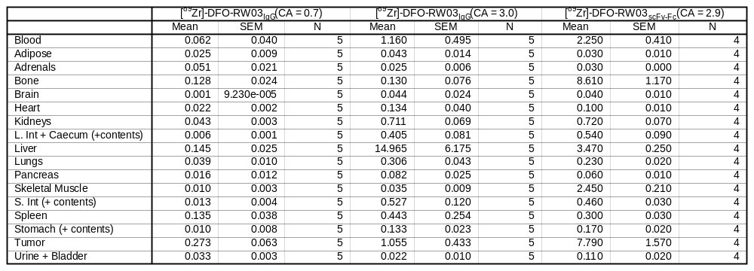
Description for Table S4-12 to S4-15
ROI analysis tables and ex vivo biodistribution tables for Fig. 3.
Table S4-12. ROI analysis of [⁸⁹Zr]-DFO-RW03_{scFv-Fc} (1.42 ± 0.07 MBq, 16.0 ± 0.2 µg) (non-blocked). Uptake is expressed as mean percentage injected dose per unit volume (%ID/cc).
 | 0.5 h |  | 24 h |  | 48 h |  | 72 h |  | 96 h |  | 168 h
 | Mean | SEM | Mean | SEM | Mean | SEM | Mean | SEM | Mean | SEM | Mean | SEM
Tumor | 2.6 | 0.6 | 15.6 | 0.5 | 18.4 | 0.3 | 20.3 | 0.5 | 21.2 | 0.9 | 22 | 2
Heart | 33 | 5 | 15.7 | 0.8 | 13.9 | 0.6 | 11.5 | 0.6 | 10.2 | 0.9 | 6.7 | 0.8
Liver | 19 | 3 | 10.5 | 0.5 | 10.5 | 0.4 | 9.5 | 0.4 | 9.1 | 0.3 | 7.5 | 0.4
Muscle | 2.1 | 0.4 | 3.0 | 0.4 | 2.5 | 0.1 | 2.2 | 0.1 | 2.0 | 0.3 | 1.8 | 0.4
Joint | 2.7 | 0.1 | 4.8 | 0.4 | 4.8 | 0.4 | 5.3 | 0.5 | 5.4 | 0.7 | 5.8 | 0.6

Table S4-13. ROI analysis of [⁸⁹Zr]-DFO-RW03_{scFv-Fc} (1.40 ± 0.09 MBq, 16.0 ± 0.3 µg) co-injected with RW03_{IgG} (500 µg) (blocked). Uptake is expressed as mean percentage injected dose per unit volume (%ID/cc).
 | 0.5 h |  | 24 h |  | 48 h |  | 72 h |  | 96 h |  | 168 h
 | Mean | SEM | Mean | SEM | Mean | SEM | Mean | SEM | Mean | SEM | Mean | SEM
Tumor | 2.5 | 0.2 | 10 | 1 | 12.6 | 0.5 | 10.9 | 0.5 | 9.6 | 0.4 | 6.4 | 0.6
Heart | 38 | 4 | 15.7 | 0.8 | 13.2 | 0.4 | 11.7 | 0.7 | 9.8 | 0.7 | 5.8 | 0.7
Liver | 20 | 1 | 9.7 | 0.6 | 10.4 | 0.1 | 9.9 | 0.3 | 9.5 | 0.4 | 7.6 | 0.4
Muscle | 2.0 | 0.2 | 3.0 | 0.2 | 2.4 | 0.1 | 2.4 | 0.3 | 2.1 | 0.2 | 1.5 | 0.2
Joint | 2.4 | 0.2 | 4.5 | 0.3 | 4.3 | 0.2 | 4.3 | 0.1 | 4.5 | 0.5 | 4.5 | 0.2

Table S4-14 Biodistribution table. Ex vivo biodistribution (168 h p.i.) of [⁸⁹Zr]-DFO-RW03_{scFv-Fc} (1.42 ± 0.07 MBq, 16.0 ± 0.2 µg) (Non-blocked), [⁸⁹Zr]-DFO-RW03_{scFv-Fc} (1.40 ± 0.09 MBq, 16.0 ± 0.3 µg) co-injected with RW03_{IgG} (0.5 mg) (blocked). Uptake is expressed as mean percentage injected dose per gram tissue (%ID/g).
 | Non-blocked |  |  | Blocked
 | Mean | SEM | N | Mean | SEM | N
Blood | 6.3 | 0.9 | 5 | 5.1 | 0.6 | 5
Adipose | 1.8 | 0.5 | 5 | 1.6 | 0.4 | 5
Adrenals | 5 | 1 | 5 | 4.3 | 0.4 | 5
Bone | 4.6 | 0.7 | 5 | 3.9 | 0.3 | 5
Brain | 0.26 | 0.02 | 5 | 0.22 | 0.02 | 5
Heart | 2.0 | 0.3 | 5 | 2.8 | 0.8 | 5
Kidneys | 4.5 | 0.3 | 5 | 4.5 | 0.5 | 5
L. Int + Caecum | 0.66 | 0.05 | 5 | 0.64 | 0.04 | 5
Liver | 5.1 | 0.2 | 5 | 6.4 | 0.4 | 5
Lungs | 5.0 | 0.4 | 5 | 3.4 | 0.7 | 5
Pancreas | 1.1 | 0.1 | 5 | 3 | 2 | 5
Skeletal Muscle | 0.7 | 0.1 | 5 | 1.6 | 0.8 | 5
S. Int | 0.7 | 0.1 | 5 | 0.9 | 0.3 | 5
Spleen | 4.9 | 0.9 | 5 | 7 | 3 | 5
Stomach | 0.58 | 0.03 | 5 | 0.6 | 0.1 | 5
Tumor | 18.2 | 0.7 | 5 | 5 | 1 | 5
Urine + Bladder | 2.1 | 0.8 | 5 | 5 | 1 | 5

Table S4-15. Biodistribution table. Ex vivo biodistribution (168 h p.i.) of [⁸⁹Zr]-DFO-RW03_{scFv-Fc} (1.42 ± 0.07 MBq, 16.0 ± 0.2 µg) (non-blocked), [⁸⁹Zr]-DFO-RW03_{scFv-Fc} (1.40 ± 0.09 MBq, 16.0 ± 0.3 µg) co-injected with RW03_{IgG} (0.5 mg) (blocked). Uptake is expressed as mean percentage injected dose per gram tissue (%ID/O).
 | Non-blocked |  |  | Blocked
 | Mean | SEM | N | Mean | SEM | N
Blood | 5.6 | 0.7 | 5 | 4.4 | 0.6 | 5
Adipose | 0.10 | 0.01 | 5 | 0.11 | 0.04 | 5
Adrenals | 0.05 | 0.01 | 5 | 0.042 | 0.004 | 5
Bone | 10 | 1 | 5 | 7.2 | 0.3 | 5
Brain | 0.09 | 0.01 | 5 | 0.08 | 0.01 | 5
Heart | 0.21 | 0.02 | 5 | 0.18 | 0.02 | 5
Kidneys | 1.13 | 0.02 | 5 | 1.1 | 0.1 | 5
L. Int + Caecum | 0.54 | 0.05 | 5 | 0.4 | 0.1 | 5
Liver | 5.8 | 0.2 | 5 | 7.0 | 0.7 | 5
Lungs | 0.64 | 0.05 | 5 | 0.39 | 0.03 | 5
Pancreas | 0.15 | 0.04 | 5 | 0.3 | 0.2 | 5
Skeletal Muscle | 5.2 | 0.5 | 5 | 6 | 1 | 5
S. Int | 0.63 | 0.04 | 5 | 0.6 | 0.1 | 5
Spleen | 0.44 | 0.03 | 5 | 0.7 | 0.3 | 5
Stomach | 0.18 | 0.01 | 5 | 0.2 | 0.0 | 5
Tumor | 4.1 | 0.7 | 5 | 2.2 | 0.5 | 5
Urine + Bladder | 0.25 | 0.03 | 5 | 0.20 | 0.03 | 5

