Point-by-Point Reply

08/08/2024

EJNMMI Research

Dear Reviewers and Professor Dr. Irene A. Burger:
We thank you for your dedicated work and constructive suggestions. When we finished this study, we left so many flaws. We will not make any excuses for our mistakes, and the attitudes of reviewers and editors toward academic research will have a great influence on our future work. Below are our responses to the reviewers.
Respond to Reviewer #1:
- - In the introduction it could be useful to better contextualize the aim of the research in the current scientific knowledge and to give a more detailed description of "muscles injuries".
Response:
Thank you very much for the suggestion. We have added the corresponding content in the Introduction (page 2).
- - Some more information of acquisition and reconstruction protocols of small-animals PET should be added.
Response:
We greatly appreciate the valuable suggestion and the corresponding content was added in this section (page 6).
- - Similarly to the previous point, the part "clinical study" of the methods is missing fundamental information, such as: type of PET/CT scanner, dose of the radiopharmaceuticals used, uptake time, acquisition and reconstruction parameters. In addition it is not described how the contouring of the uptake was made, the characteristics of the ROI and which threshold was used to calculate MTV (moreover the meaning of MTV was not specified).
Response:
Thank you for the comment, and we have made the corresponding corrections (page 7).
- - It was not specified how T/N was calculated and what structure was used as a background.
Response:
We thank the reviewer for comment pointing out such important issues, and we have added the corresponding content in the manuscript (page 6).
- - In the results no p-value or statistical data are presented, limiting therefore the quality of the presentation of your findings.
Response:
We thank the reviewer for comment pointing out such important issues, and we have added the corresponding content in the manuscript.
- - How many animal models have been studied? If a certain numbers of them have been included in the study, statistical analysis should be performed to strengthen and confirm your findings.
Response:
We thank the reviewer very much for pointing out this important issue, and we have added the corresponding content in the manuscript (page 4).
- - In the part "Performance characteristics of 18F-FDG and 68Ga-FAPI-04 in total hip arthroplasty" it is not clear what statistical analysis have been performed even though they are cited in the text.
Response:
Thank you for the comment, and we have made the corresponding corrections (page 7).
- - However, the results of 18F-FDG were unexpected. On day 1, the uptake of 18F-FDG on the surgical side was lower than that on the healthy side across all three groups and at most time points for the mild and severe repair failure groups": it could be useful to add a possible explanation of this finding.
Response:
We greatly appreciate the valuable suggestion. We have added the corresponding content (page 12).
- - In the discussion, it should be better discussed the possible clinical value of your findings and the their possible impact in clinical decision.
Response:
Thank you for the suggestion, and we have added the corresponding content.
- - I suggest to reshape the conclusion since FAPI has not been clearly compared to other diagnostic techniques, therefore its superior diagnostic value is not proved by this study. In particular, if compared to FDG, the findings presented in this paper are not strong enough to assert this.
Response:
Thank you very much for this valuable comment. We have made the corresponding corrections (page 13).
Respond to Reviewer #2:
We sincerely appreciate the reviewer’s recognition of our study. This research is just the beginning, and in future studies, we will delve deeper into the role of fibroblast activation protein (Fap) in skeletal muscle injury repair. From Zhang et al.'s single-cell sequencing data, we identified a subset of muscle stem cells, specifically mesenchymal fibro-adipogenic progenitors (mFAPs), which express Fap at significantly higher levels compared to other cell types (Figure 1A-B). GO and KEGG analyses of Fap+ mFAPs compared to Fap- mFAPs revealed enrichment in extracellular matrix synthesis and the PI3K signaling pathway (Figure 1C-E). These results suggest that Fap+ mFAPs might have more active metabolism and could play a crucial role in skeletal muscle injury repair.
We also performed sorting of mFAPs (Figure 2A, in animal models similar to this study) and observed that Fap expression in mFAPs increased early after injury (Figure 2B-D). This suggests that Fap initially promotes tissue repair and healing. In the later stages of repair, if Fap expression does not return to pre-injury levels or remains elevated, it may have a detrimental effect, leading to excessive extracellular matrix deposition and fibrosis. This supports the notion that Fap has a dual role in mFAPs.
Furthermore, we constructed Pdgfrα-CreERT2;R26-tdT gene knockout mice, which specifically label mFAPs in red. Using flow cytometry, we sorted Fap+ mFAPs and Fap- mFAPs (see Figure 2E). We chose Pdgfrα-CreERT2;R26-tdT gene knockout mice for specific red labeling of mFAPs, and sorted Fap+ and Fap- mFAPs as before. Finally, pathological examination of the normal repair group and the fibrosis group on day 14 revealed that the phosphorylation of Akt was significantly higher in the fibrosis group compared to the normal repair group. These results provide strong support for our subsequent research.
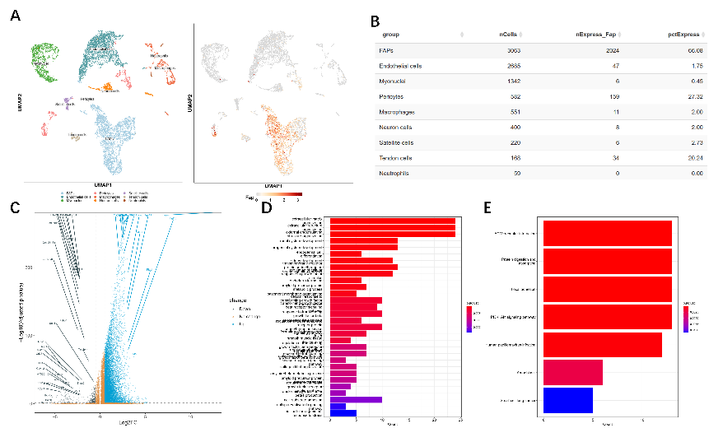

Figure 1 A-B. Percentage of Fap in resting mFAPs and other cell types (available at: https://mayoxz.shinyapps.io/Muscle/). C-E. Gene differential analysis, GO analysis, and KEGG analysis (data available at: https://www.ncbi.nlm.nih.gov/geo/query/acc.cgi?acc=GSE232106)."

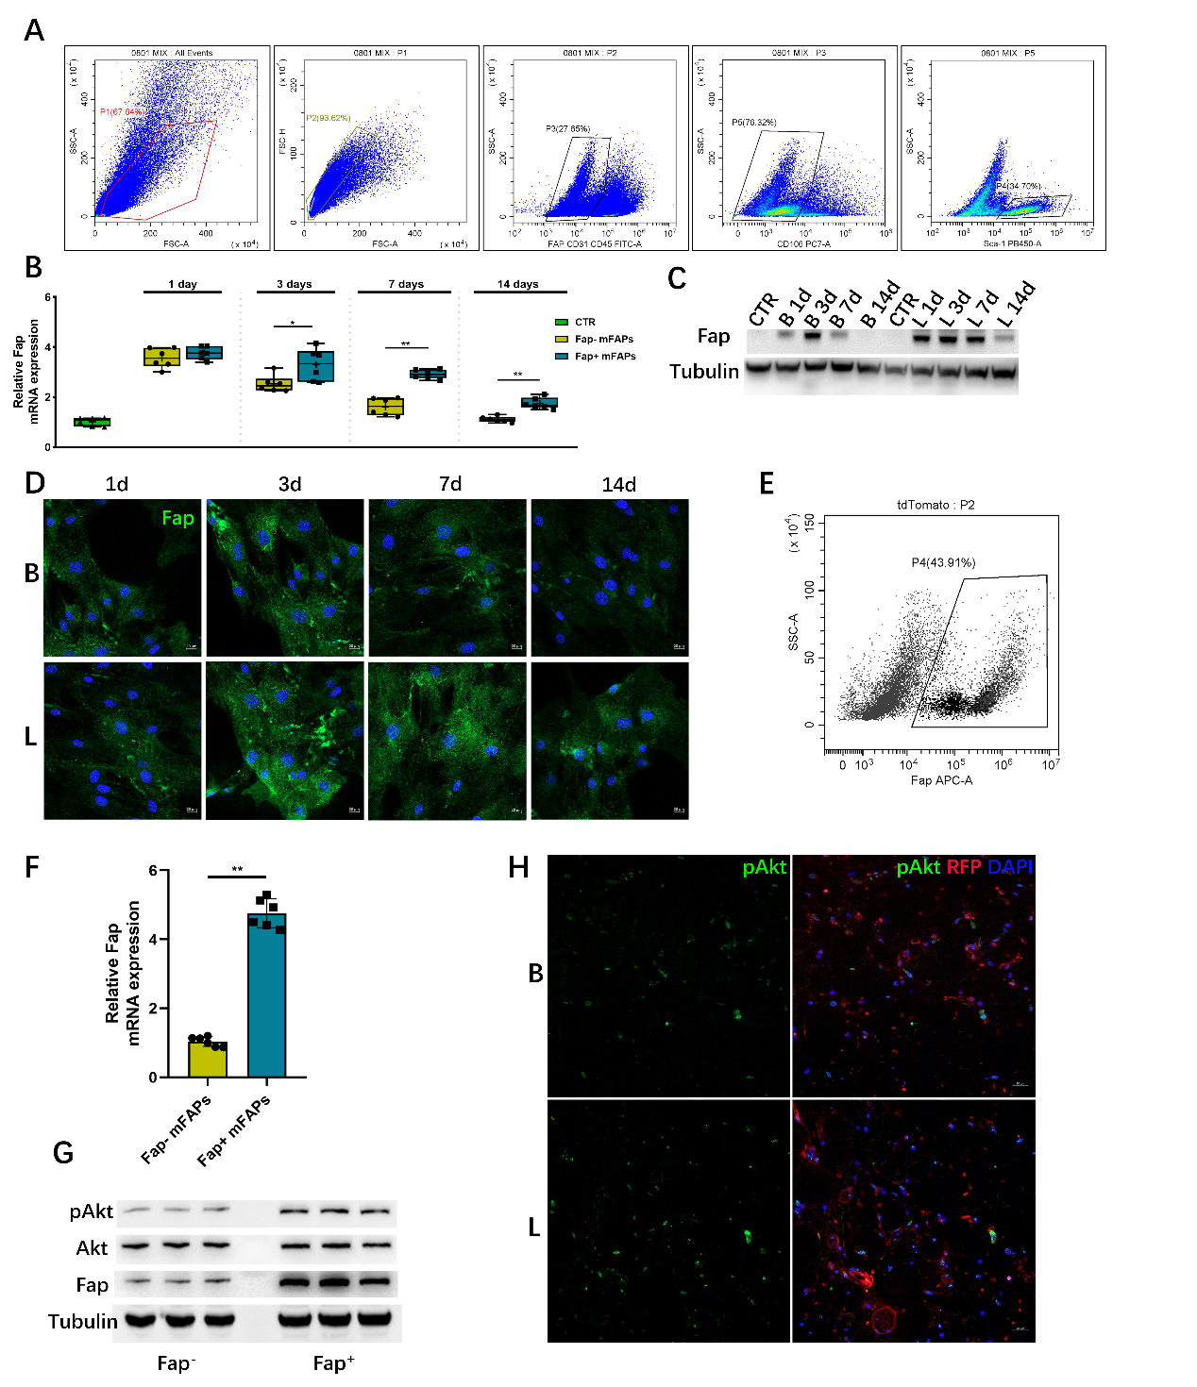
Figure 2 A. Flow sorting strategy for mFAPs. B-D. Expression of Fap in mFAPs at different time points. E. Sorting results of Fap+ mFAPs and Fap- mFAPs. F-G. Differential expression validation of Fap+ mFAPs and Fap- mFAPs. H. pAkt expression in the normal and fibrosis groups at day 14. Cell immunofluorescence scale bar = 20 μm; tissue immunofluorescence scale bar = 200 μm. Note: B denotes BaCl2; L denotes 0.2 M NaOH (low concentration). *, P < 0.05; **, P < 0.01.

