Supplementary material
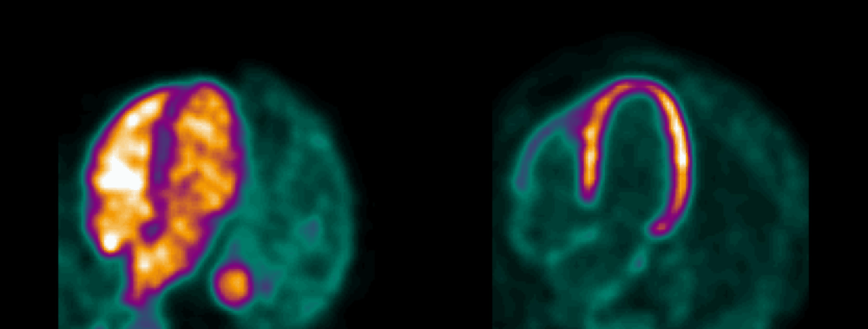
Supplementary figure 1 – Example of gated PET images from the same patient. Left panel shows a ¹⁵O-water gated scan with activity in the blood pool during the first 50 s of the scan. The right panel shows gating of corresponding ¹¹C-acetate retention images
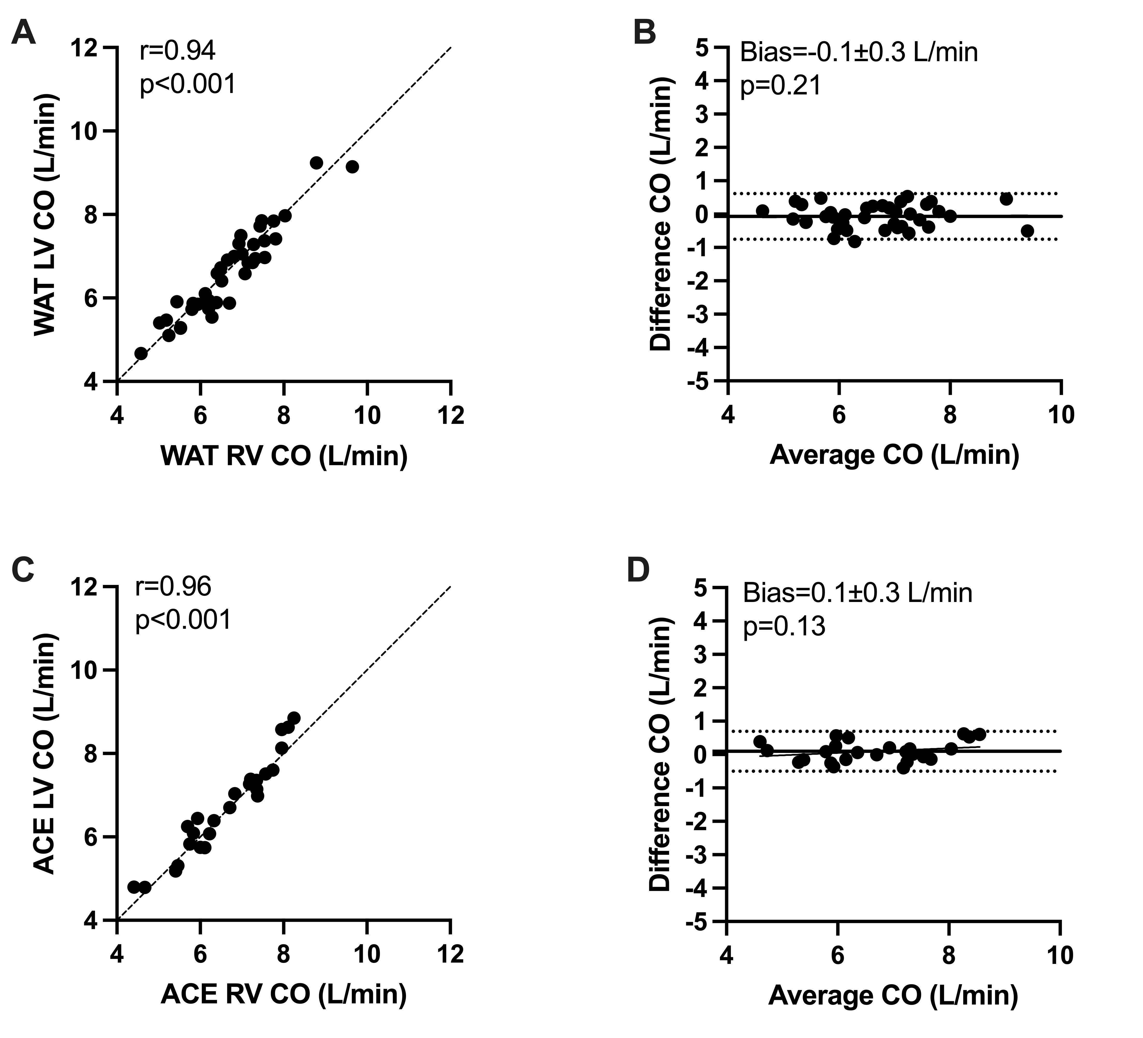
Supplementary figure 2 – Scatter plots and Bland-Altman plots comparing cardiac output (CO) calculated from left (LV) and right (RV) ventricular cavity input with ¹⁵O-water (WAT) (A, B) and ¹¹C-acetate (ACE) (C, D). Dashed lines are lines of identity (A, C), dotted lines are limits of agreement (B, D), and solid lines represent linear regression and mean bias (B, D)
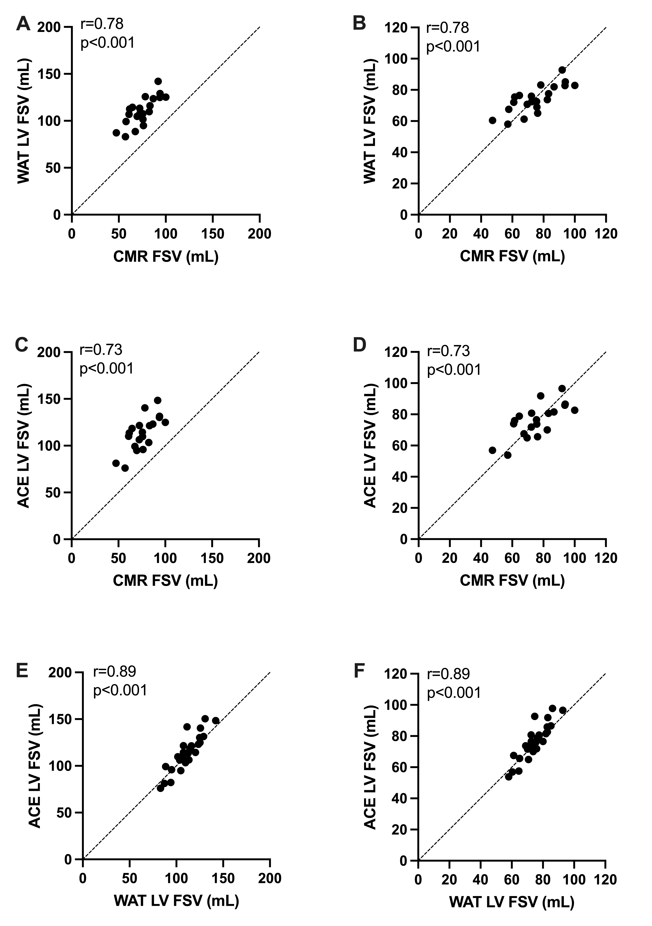
Supplementary figure 3 – Scatter plots of forward stroke volume (FSV) calculated with ¹⁵O-water, ¹¹C-acetate and cardiovascular magnetic resonance (CMR). Comparison between uncalibrated and calibrated PET values. Dashed lines are lines of identity

