Supplementary data

Supplementary Figure 1. Example of digital autoradiography analysis to determine the endocrine-exocrine ratio. Six ROIs were drawn in exocrine regions, especially in regions with low fat content (green boxes), and ten ROIs in endocrine regions (purple boxes). The background ROI is depicted by the yellow box.

Supplementary Figure 2. MicroSPECT/CT images of the resected pancreatic tissue of participant 14. The microSPECT/CT images in (A) sagittal, (B) coronal and (C) transverse planes show clear uptake of ¹¹¹In-labeled exendin in the resected pancreatic tissue of participant 14 who underwent a pancreaticoduodenectomy.

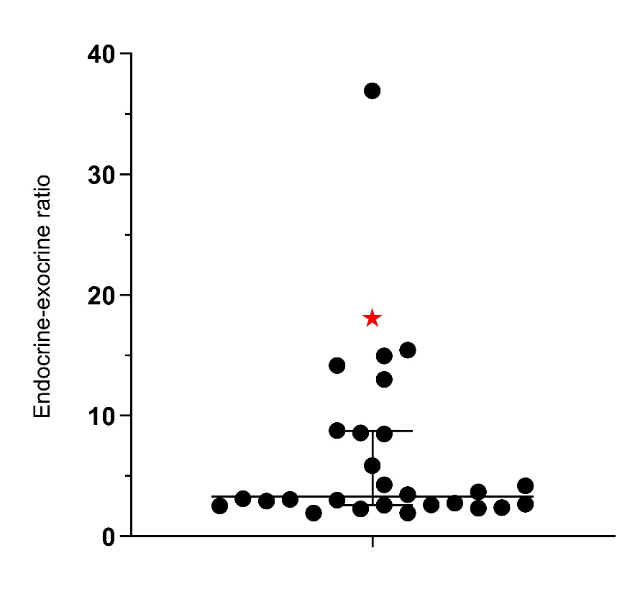
Supplementary Figure 3. Endocrine-exocrine ratio determined on digital autoradiography images The median exocrine-endocrine ratio of the tracer uptake in all pancreatic tissue samples of study participants was 3.1 [2.6-8.6]. This was based on all slides of the participants. The ratio determined with the sample of participant 1 is excluded because of insufficient image quality for reliable quantification (red star in graph).

