Supplementary Table 1. Global means of organs-at-risk variables concerning NET grade.
Variable | Organs-at-risk | Global means
Variable | Organs-at-risk | G1 NETs |  | G2 NETs |  | p-value
Variable | Organs-at-risk | Mean | 95%CI | Mean | 95%CI | p-value
Absorbed dose (Gy/GBq) * | Kidneys | 0.9 | 0.8 to 1 | 0.8 | 0.8 to 0.9 | 0.189
Absorbed dose (Gy/GBq) * | Red marrow | 27.3 | 23.7 to 31.4 | 27.2 | 24.6 to 30.2 | 0.992
Activity concentration (kBq/ml/GBq) | Kidneys | 105 | 93 to 118 | 96 | 88 to 105 | 0.264
Activity concentration (kBq/ml/GBq) | Red marrow | 1.5 | 1.2 to 1.8 | 1.4 | 1.2 to 1.6 | 0.582
Effective half-life (h) | Kidneys | 57 | 54 to 60 | 56 | 54 to 58 | 0.530
Effective half-life (h) | Red marrow | 49 | 45 to 53 | 54 | 51 to 57 | 0.077
*mGy/GBq for red marrow absorbed dose

Supplementary Table 2. Estimated values at cycle 1 and rates of change from the previous cycle for organs-at-risk variables concerning NET grade.
Variable | Organs-at-risk | Estimated values at cycle 1 |  |  |  |  | Rate of change between individual cycles
Variable | Organs-at-risk | G1 NETs |  | G2 NETs |  | p-value | G1 NETs |  | G2 NETs |  | p-value
Variable | Organs-at-risk | Mean | 95%CI | Mean | 95%CI | p-value | Mean | 95%CI | Mean | 95%CI | p-value
Absorbed dose (Gy/GBq) * | Kidneys | 0.9 | 0.8 to 1.0 | 0.8 | 0.7 to 0.8 | 0.045 | 0% | -3% to 4% | 5% | 2% to 7% | 0.071
Absorbed dose (Gy/GBq) * | Red marrow | 25.7 | 22.2 to 29.8 | 26.4 | 23.6 to 29.4 | 0.789 | 4% | 1% to 8% | 2% | 0% to 5% | 0.297
Activity concentration (kBq/ml/GBq) | Kidneys | 103 | 91 to 117 | 90 | 82 to 99 | 0.107 | 1% | -2% to 5% | 4% | 2% to 7% | 0.175
Activity concentration (kBq/ml/GBq) | Red marrow | 1.3 | 1.1 to 1.7 | 1.3 | 1.1 to 1.5 | 0.788 | 7% | 1% to 13% | 4% | 0% to 8% | 0.385
Effective half-life (h) | Kidneys | 58 | 54 to 61 | 55 | 52 to 57 | 0.190 | -1% | -4% to 1% | 1% | -1% to 3% | 0.148
Effective half-life (h) | Red marrow | 49 | 45 to 54 | 55 | 52 to 59 | 0.044 | 0% | -3% to 2% | -2% | -3% to 0% | 0.366
*mGy/GBq for red marrow absorbed dose

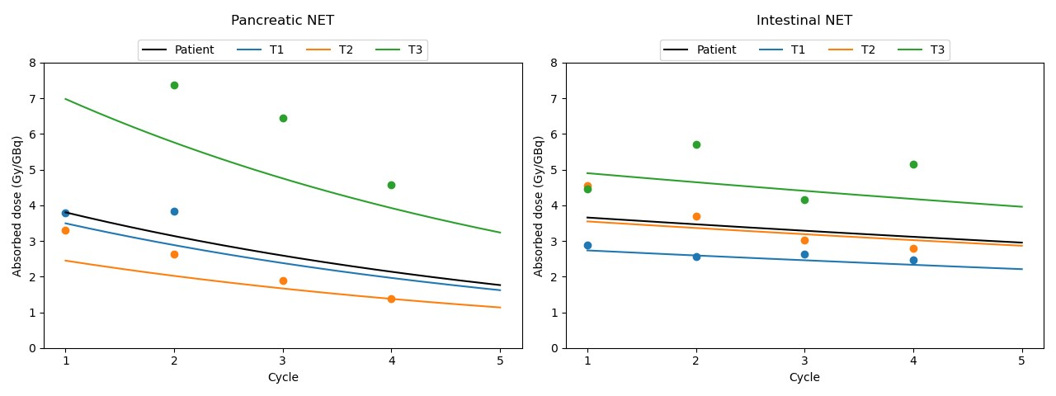
Supplementary Fig. 1 Tumor absorbed doses as a function of cycle number (dots) for a patient with pancreatic primary NET (left panel) and a patient with intestinal primary NET (right panel). The black solid lines result from combining fixed effects with patient-specific random effects. Colored solid lines, representing individual tumors, are derived from the combination of fixed effects with both patient-specific and tumor-specific random effects. Notably, for tumor T3 of the patient with pancreatic NET, the model exhibits a poor fit to the data. This poor fit can be attributed to the shrinkage, a well-known limitation of LMMs, which compels the estimated individual projection towards the population average.
Supplementary Table 3. Global means of tumor variables concerning NET grade.
Variable | Global means
Variable | G1 NETs |  | G2 NETs |  | p-value
Variable | Mean | 95%CI | Mean | 95%CI | p-value
Absorbed dose (Gy/GBq) | 3.4 | 2.4 to 4.9 | 4.0 | 3.2 to 5.0 | 0.448
Activity concentration (kBq/ml/GBq) | 255 | 186 to 349 | 310 | 255 to 377 | 0.293
Effective half-life (h) | 99 | 84 to 116 | 95 | 85 to 106 | 0.684

Supplementary Table 4. Estimated values at cycle 1 and rates of change from the previous cycle for tumor variables concerning NET grade.
Variable | Estimated values at cycle 1 |  |  |  |  | Rate of change between individual cycles
Variable | G1 NETs |  | G2 NETs |  | p-value | G1 NETs |  | G2 NETs |  | p-value
Variable | Mean | 95%CI | Mean | 95%CI | p-value | Mean | 95%CI | Mean | 95%CI | p-value
Absorbed dose (Gy/GBq) | 3.6 | 2.5 to 5.1 | 4.2 | 3.4 to 5.3 | 0.447 | -5% | -12% to 2% | -5% | -8% to -1% | 0.810
Activity concentration (kBq/ml/GBq) | 261 | 191 to 356 | 326 | 269 to 396 | 0.234 | -2% | -9% to 4% | -4% | -7% to -1% | 0.637
Effective half-life (h) | 103 | 87 to 121 | 95 | 86 to 106 | 0.462 | -3% | -7% to 0% | 0% | -3% to 2% | 0.191
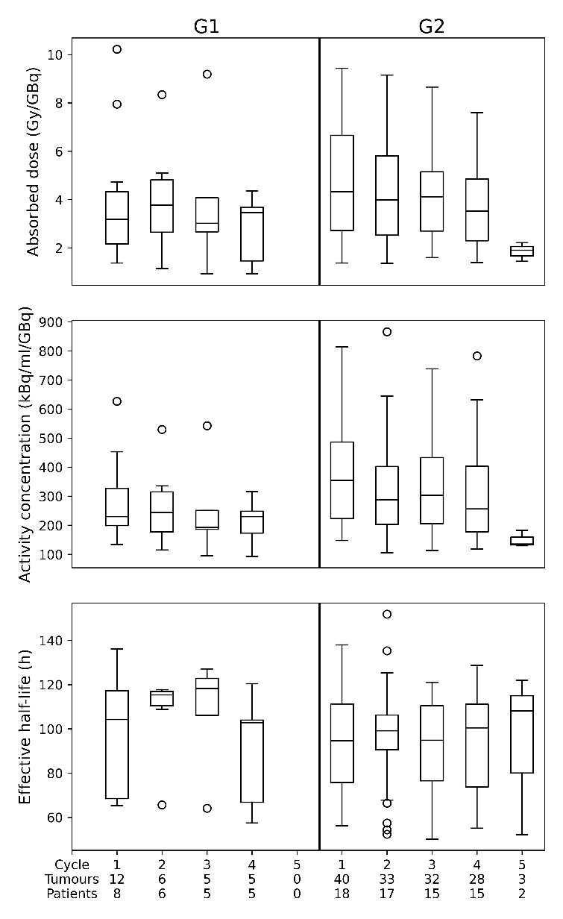
Supplementary Fig. 2 Tumour dosimetric variables as a function of treatment cycle for patients with G1 NET (left) and G2 NET (right).
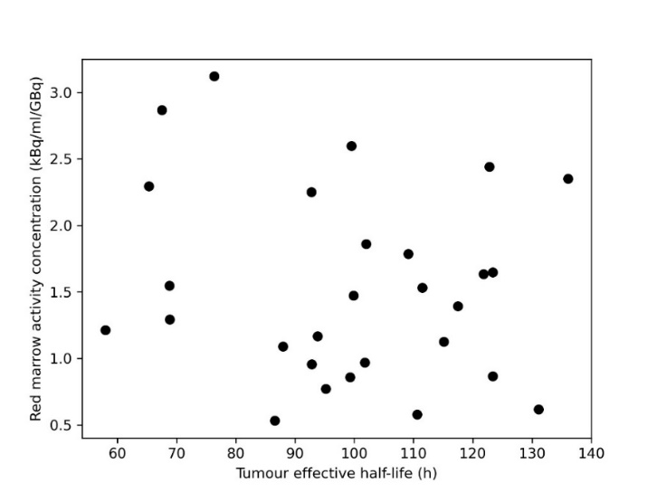
Supplementary Fig. 3 Activity concentration in the red marrow as a function of the tumor's effective half-life. The median tumor half-life was plotted for patients in which multiple tumors were investigated.

