SUPPLEMENTARY FIGURES AND TABLES

FIGURE 1. For all primary gliomas Kaplan Meier Survival plots of OS and PFS dichotomized at SUVmax 0.69 analyzed at time 40-60 min after tracer injection.

FIGURE 2. For all primary HGG Kaplan Meier Survival plots of OS and PFS dichotomized at SUVmax 1.065 analyzed at time 40-60 min after tracer injection.

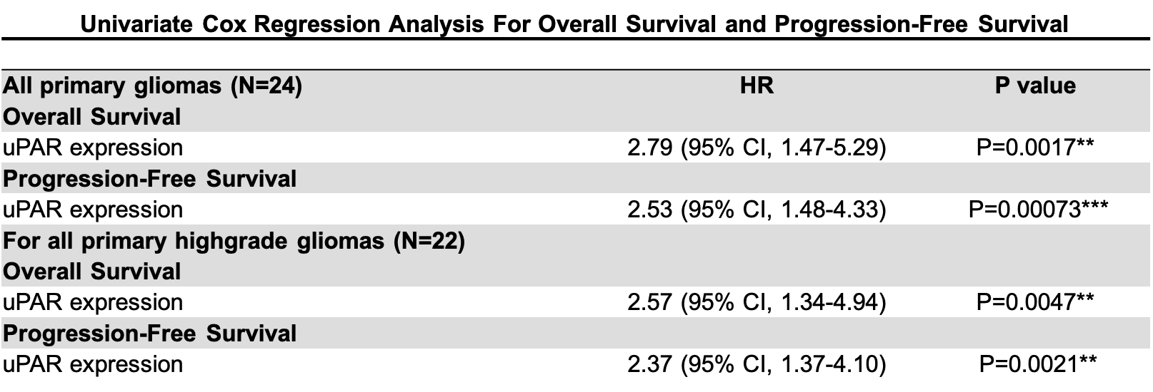
TABLE 1. Univariate Cox regression analysis performed on the groups all primary glioma (N=24) and HGG (N=22) with uPAR expression as a continuous variable analyzed on images from time 40-60min after tracer injection.

