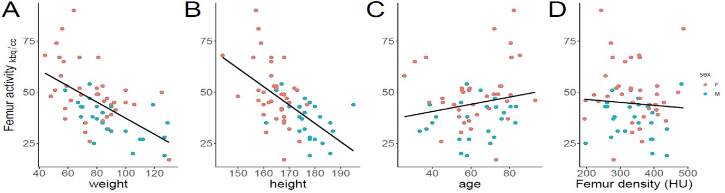
Supp 1. Scatterplots of femur-activity in kBq/cc and body weight, height, age and HU. A simple linear regression line (femur activity ~ x) is included for orientation, there was a weak positive correlation for age (r =0.04, p =0.76). Density had no correlation (r=-0.01, p =0.96).

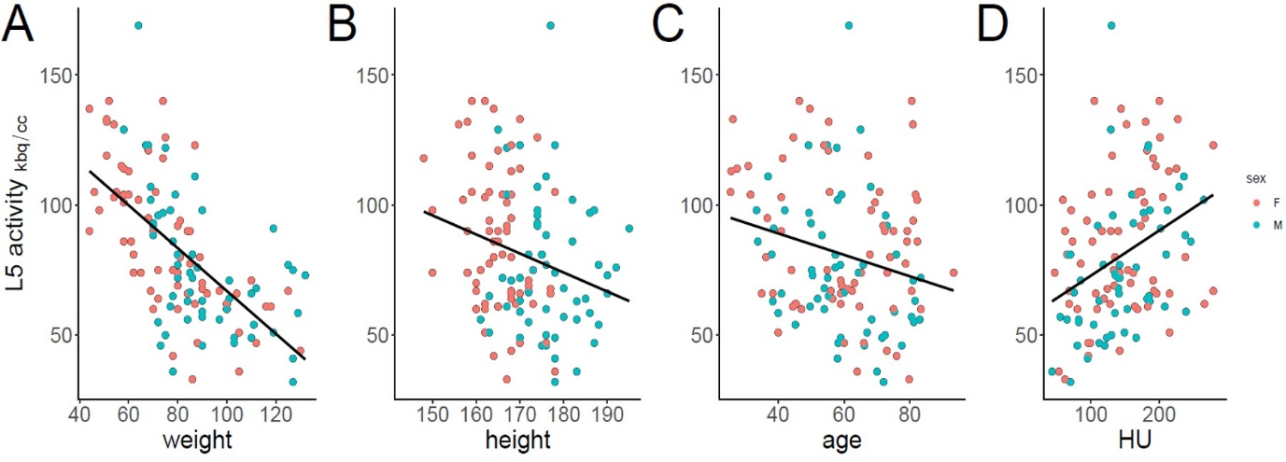
Supp 2. Scatterplots of L5-activity in kBq/cc and body weight, height, age and HU. A simple linear regression line (L5-activity ~ x) is included for orientation, again the strongest correlation was found for body weight (r =-0.67, p<0.001), compared to an only weak correlation for height (r =-0.29, p =0.001) and age (r =-0.32, p <0.001).

