SUPPLEMENTARY DATA
PET imaging of GABA_{A} receptors in pancreatic islets by [¹¹C]flumazenil

Supplementary Figure Legends
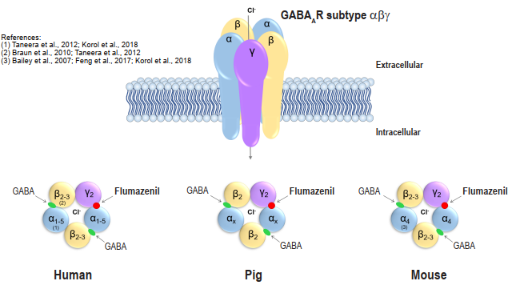Suppl. Figure S1: The structure of GABA_{A} receptor subtypes in human, pig and mouse endocrine pancreas, and the location of the binding site of relevant ligands including flumazenil.
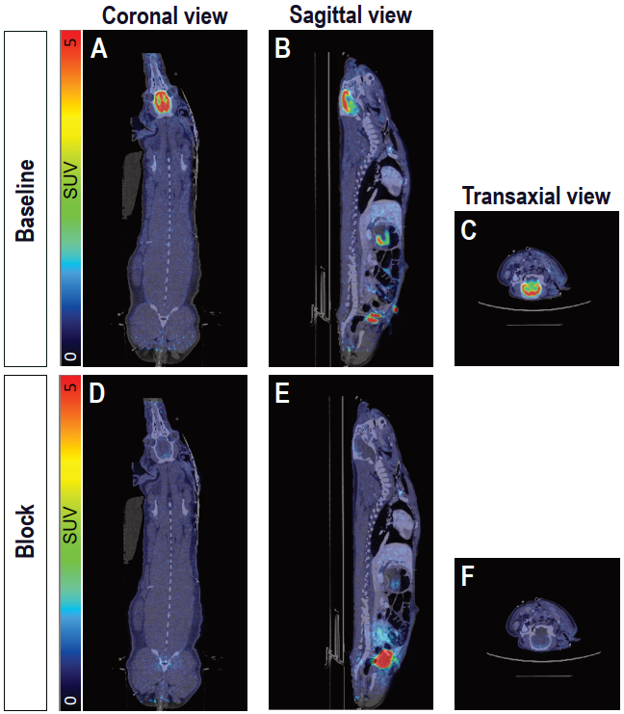
Suppl. Figure S2: Whole body PET/CT imaging of GABA_{A}Rs availability in pig using [¹¹C]FMZ. Coronal (A,D), sagittal (B,E) and transaxial (C,F) views of fused PET/CT scans from [¹¹C]FMZ-injected pig (SUV=5) (A-F) showing the averaged signal from 60-90 min after [¹¹C]FMZ injection, in the whole body at baseline (A-C) and after blocking with cold flumazenil (D-F).
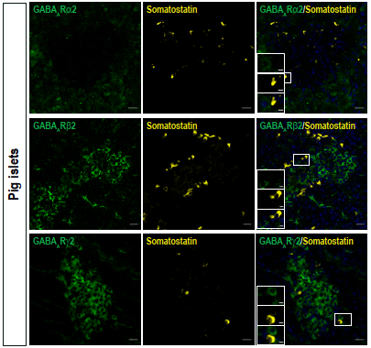
Suppl. Figure S3: Expression profile of GABA_{A}R α2, β2, γ2 subunits in pancreatic islet δ cells of control pigs. Pancreatic tissue from control pigs (n=4) was co-stained with antibodies for GABA_{A}R subunits α2 (top panel), β2 (middle panel), γ2 (bottom panel) (green), somatostatin (yellow), nuclei (blue). Scale bar 20 µm and 5 µm for magnification.
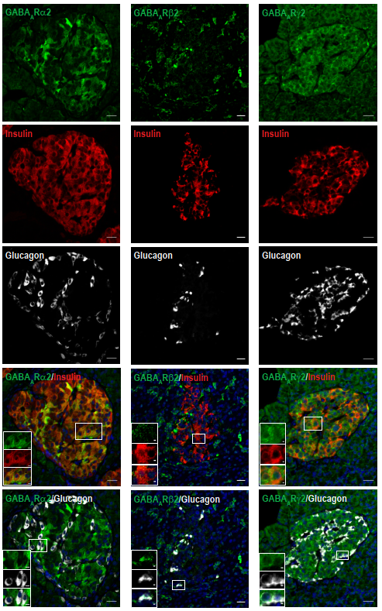

Suppl. Figure S4: Expression profile of GABA_{A}R α2, β2, γ2 subunits in ND human pancreatic islet β and α cells. Human pancreatic tissue from non-diabetic organ donors (n= 3) was co-stained with antibodies staining GABA_{A}R subunits α2 (left panel), β2 (middle panel), γ2 (right panel) (green), insulin (red), glucagon (white), nuclei (blue). Scale bar 20 µm and 5 µm for magnification.
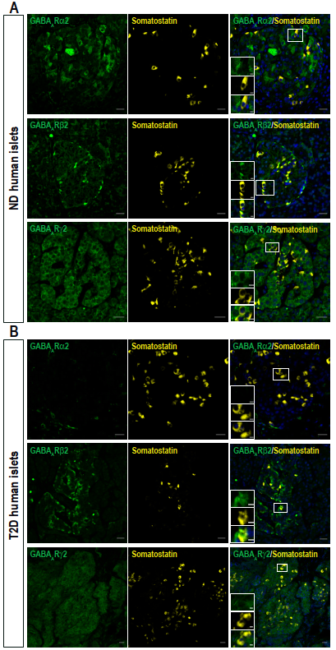
Suppl. Figure S5: Expression profile of GABA_{A}R α2, β2, γ2 subunits in ND and T2D human pancreatic islet δ cells. Human pancreatic tissue sections from healthy donors (n= 3) (A) and two different T2D donors (n=1 for α2 and γ2 and n=1 for β2).) (B), were co-stained with antibodies staining GABA_{A}R subunits α2 (top panel), β2 (middle panel), γ2 (bottom panel) (green), somatostatin (yellow), nuclei (blue) . Scale bar 20 µm and 5 µm for magnification.
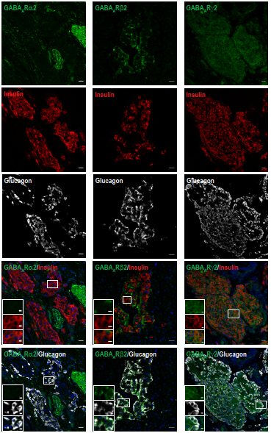
Suppl. Figure S6: Expression profile of GABA_{A}R α2, β2, γ2 subunits in T2D human pancreatic islet β and α cells. Human pancreatic tissue from T2D donors was co-stained with antibodies staining GABA_{A}R subunits α2 (left panel), β2 (middle panel), γ2 (right panel) (green), insulin (red), glucagon (white), nuclei (blue). Pancreatic sections from two different T2D donors were used for the immunohistochemistry (n=1 for α2 and γ2 and n=1 for β2). Scale bar 20 µm and 5 µm for magnification.
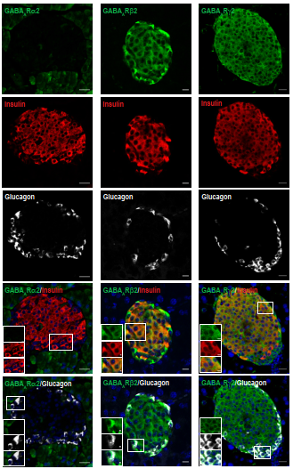
Suppl. Figure S7: Expression profile of GABA_{A}R α2, β2, γ2 subunits in mouse pancreatic islet β and α cells. Mouse pancreatic tissue (n=6) was co-stained with antibodies staining GABA_{A}R subunits α2 (left panel), β2 (middle panel), γ2 (right panel) (green), insulin (red), glucagon (white), nuclei (blue). Scale bar 20 µm and 5 µm for magnification.
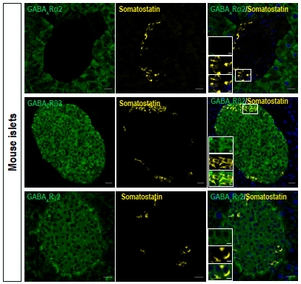
Suppl. Figure S8: Expression profile of GABA_{A}R α2, β2, γ2 subunits in mouse pancreatic islet δ cells. Mouse pancreatic tissue sections (n= 6) were co-stained with antibodies staining GABA_{A}R subunits α2 (top panel), β2 (middle panel), γ2 (bottom panel) (green), somatostatin (yellow), nuclei (blue). Scale bar 20 µm and 5 µm for magnification.
Supplementary Tables
Supplementary Table S1. Donor pancreatic tissue and isolated islets characteristics
Donor # | Specimen | Age  (y) | Gender | BMI  (kg/m²) | Diabetes  state | HbA1c  (mmol/mol)
1 | pancreas | 59 | male | 26.1 | Non-diabetic | _
2 | pancreas | 41 | female | 22.9 | Non-diabetic | 38.0
3 | pancreas | 52 | female | 33.0 | T2D | 65.0
4 | pancreas | 78 | female | 22.9 | T2D | 65.0
5 | islets + exocrine tissue | 61 | female | 24.7 | Non-diabetic | 25.0
6 | pancreas | 61 | female | 24.7 | Non-diabetic | 25.0
7 | pancreas | 52 | male | 26.9 | Non-diabetic | 37.0
8 | pancreas | 54 | male | 35.1 | T2D | 47.0
9 | islets + exocrine tissue | 49 | male | 23.6 | Non-diabetic | 33.0
10 | islets + exocrine tissue | 58 | male | 32.8 | Non-diabetic | _
11 | islets + exocrine tissue | 37 | female | 44.4 | Non-diabetic | 42.0
12 | islets + exocrine tissue | 67 | female | 29.0 | Non-diabetic | 33.0
13 | islets + exocrine tissue | 53 | female | 18 | Non-diabetic | 36.0

Supplementary Table S2. Primary and secondary antibodies used for immunohistochemistry

Antigen | Species | Supplier | Dilution
GABA_{A}Rα2 | Rabbit | Synaptic Systems, # 224 103 | 1:200
GABA_{A}Rβ2 | Rabbit | Abcam, # ab186875 | 1:100
GABA_{A}Rγ2 | Rabbit | Synaptic Systems, # 224 003 | 1:100
Glucagon | Mouse | Sigma-Aldrich; # G2654 | 1:300
Insulin | Guinea pig | Fitzgerald, Acton, MA, USA; # 20-IP30 | 1:500
Somatostatin | Rat | Bio-Rad; # 8330 | 1:200
Alexa Fluor® 594 AffiniPure Donkey Anti-Guinea Pig IgG (H+L) |  | Jackson ImmunoResearch; 706-585-148 | 1:300
Alexa Fluor® 488 AffiniPure Donkey Anti-Rabbit IgG (H+L) |  | Jackson ImmunoResearch; 711-545-152 | 1:300
Alexa Fluor® 647 AffiniPure Donkey Anti-Mouse IgG (H+L) |  | Jackson ImmunoResearch; 715-605-150 | 1:300
Alexa Fluor® 647 AffiniPure Donkey Anti-Rat IgG (H+L) |  | Jackson ImmunoResearch; 712-607-003 | 1:300

Supplementary Table S3. Distribution of GABA_{A}R α2, β2, γ2 subunits in endocrine pancreas from different species
 | Glucagon-producing α cell | Insulin-producing β cell | Somatostatin-producing δ cell
Pig | β2, γ2 | β2, γ2 | /
ND donors | β2, γ2 | α2, β2, γ2 | β2, γ2
T2D donors | β2, γ2 | γ2 | β2
Mouse | β2, γ2 | β2, γ2 | β2, γ2

