SUPPLEMENTARY INFORMATION

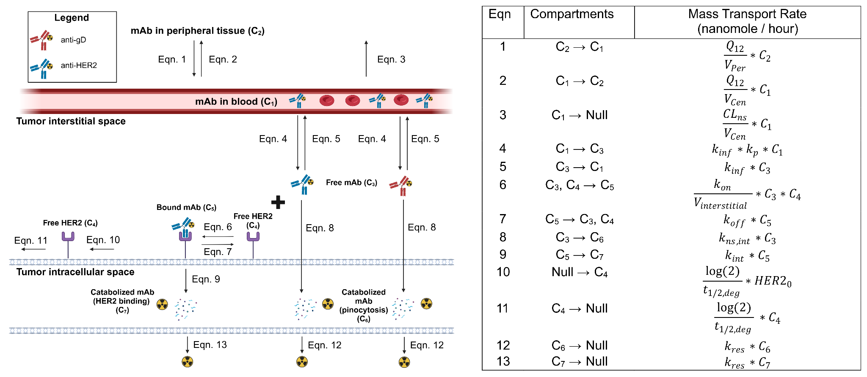
Supplementary Figure 1. Model equations are shown with respect to model diagram, where units of all compartments are in nanomoles and mass transport equations are nanomole/hour.
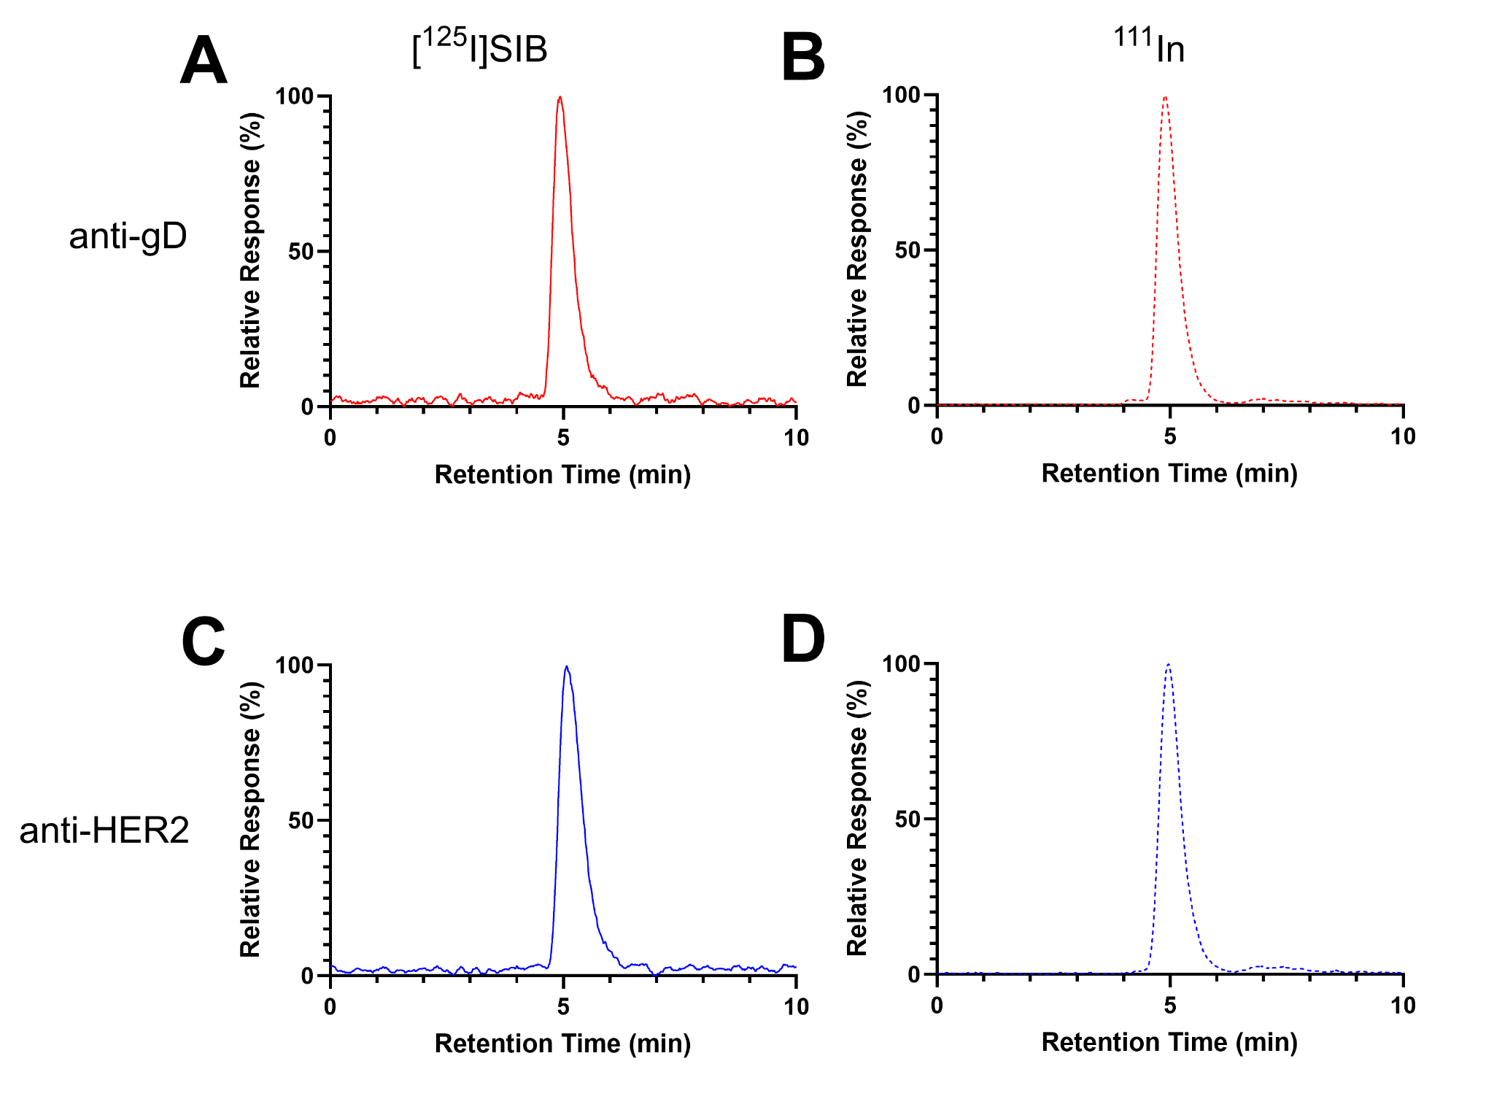
Supplementary Figure 2. Representative size exclusion HPLC of A) [¹²⁵I]SIB-anti-gD B) ¹¹¹In-DOTA-anti-gD C) [¹²⁵I]SIB-anti-HER2 D) ¹¹¹In-DOTA-anti-HER2 used in imaging study.

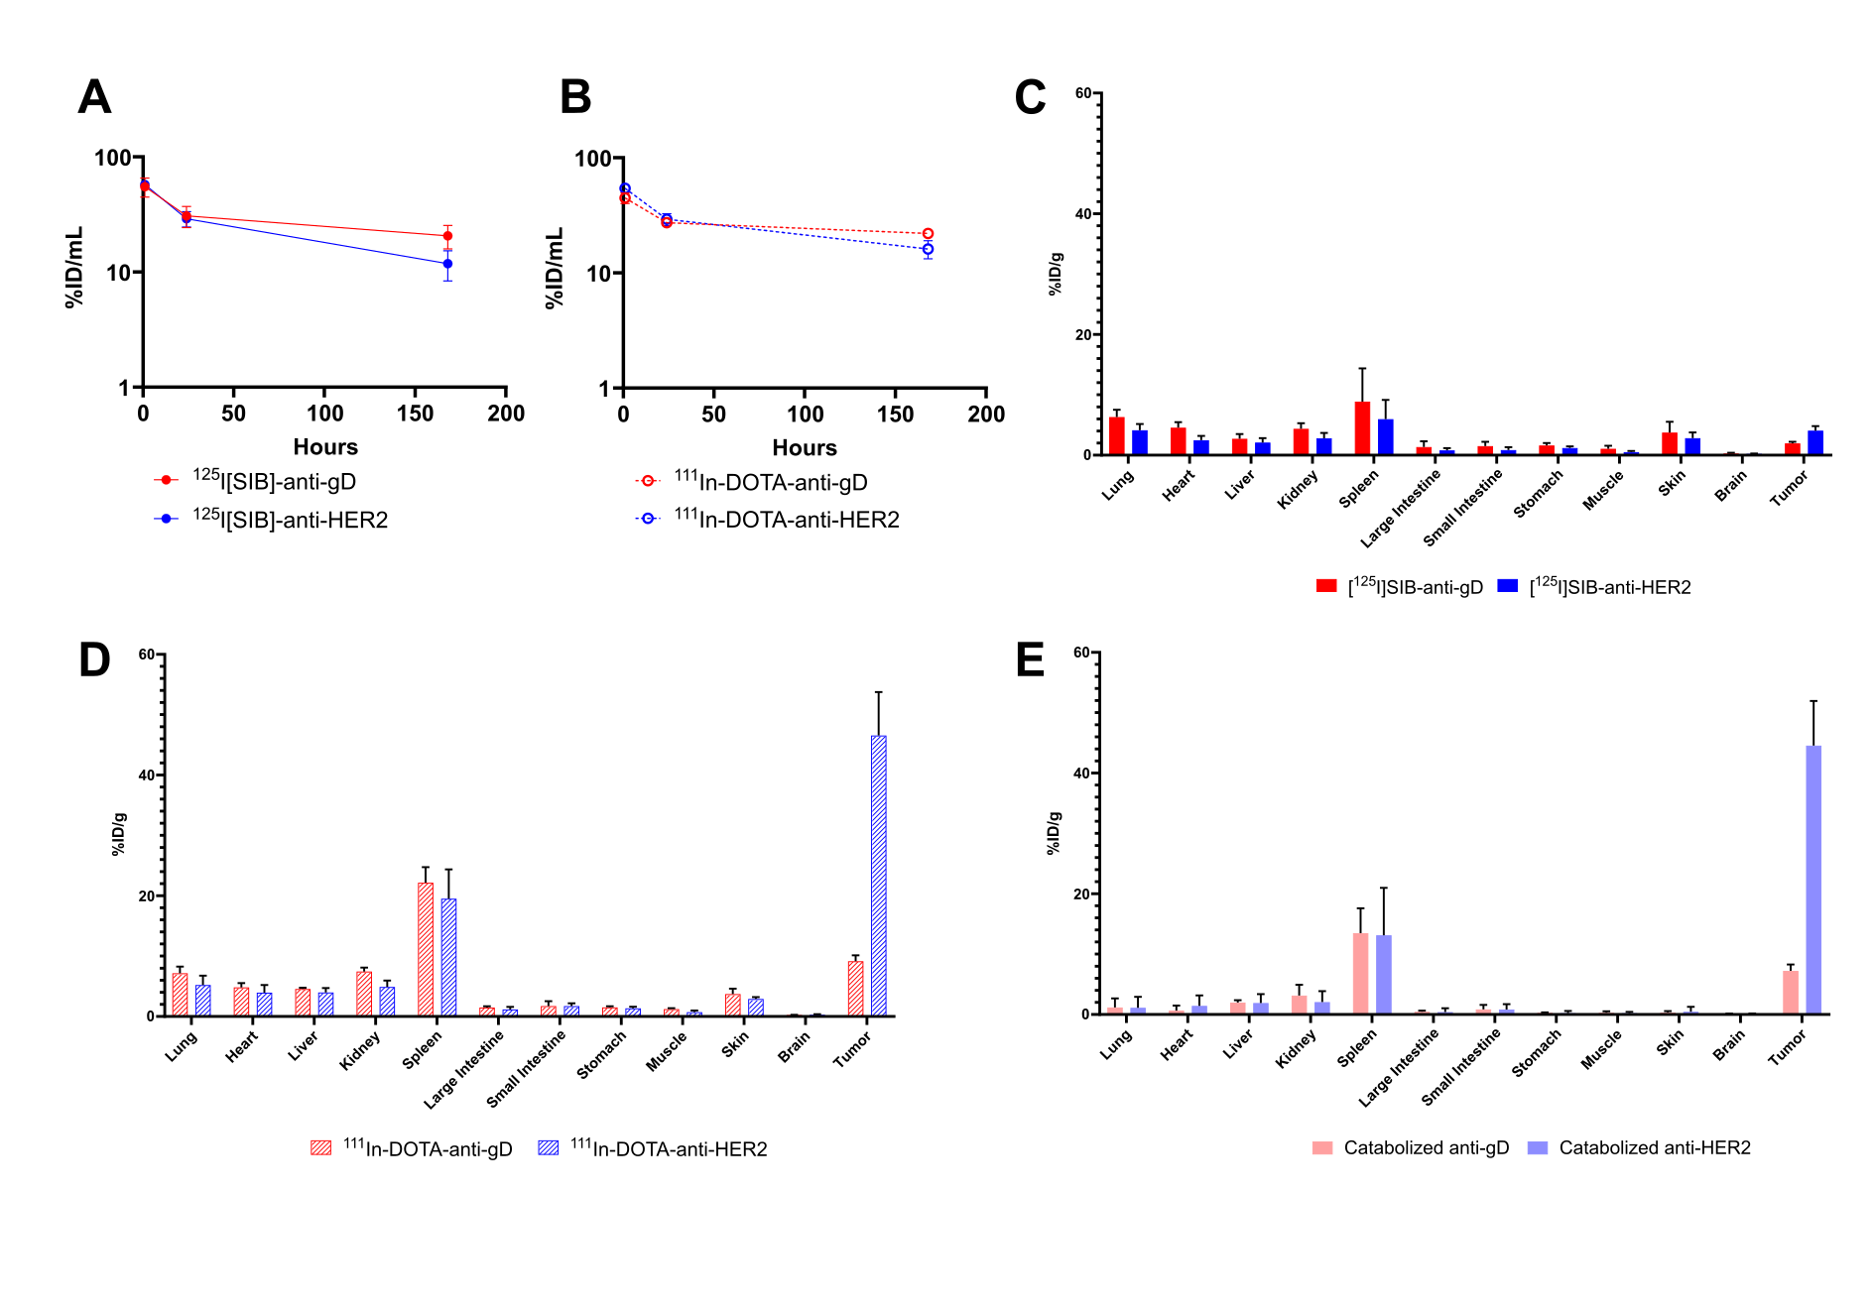
Supplementary Figure 3. Gamma counted whole blood from mice at 1, 24 and 168 hours following injection with single intravenous bolus dose of A) [¹²⁵I]SIB-labeled and B) ¹¹¹In-DOTA-labeled anti-gD and anti-HER2 antibodies. Tissue concentrations of C) [¹²⁵I]SIB-labeled, D) ¹¹¹In-DOTA-labeled and E) catabolized anti-gD and anti-HER2 antibodies (defined as %ID/g) at 168 hours. Catabolized antibody values were calculated as the difference between concentrations of ¹¹¹In-DOTA- and [¹²⁵I]SIB-labeled mAbs (%ID/g ¹¹¹In - %ID/g ¹²⁵I). All graphs show mean ± SD error bars of each group with n = 3.
Supplementary Table 1. Fold differences in tumor %ID/g values calculated from SPECT imaging and gamma counting at 168 hours post administration of [¹²⁵I]SIB-labeled, ¹¹¹In-DOTA-labeled and catabolized anti-gD and anti-HER2
 | $$\frac{\%ID/g{ [}^{125}I]SIB-anti-HER2}{{\%ID/g [}^{125}I]SIB-anti-gD}$$ | $$\frac{{\%ID/g }^{111}In-DOTA-anti-HER2}{{\%ID/g }^{111}In-DOTA-anti-gD}$$ | $$\frac{{\%ID/g }^{111}In-DOTA-anti-gD}{{\%ID/g [}^{125}I]SIB-anti-gD}$$ | $$\frac{{\%ID/g }^{111}In-DOTA-anti-HER2}{{\%ID/g [}^{125}I]SIB-anti-HER2}$$ | $$\frac{ Catabolized anti-HER2}{Catabolized anti-gD}$$
SPECT | 1.5 | 3.6 | 2.1 | 5.0 | 5.3
Gamma Counting @ 168 hours | 2.0 | 5.0 | 4.7 | 11.6 | 6.1

Supplementary Table 2. Whole tissue to plasma ratios of intact anti-gD and anti-HER2 from tissue distribution at 168 hours post administration in current paper compared to two previously published sets of data. Plasma concentrations were estimated from blood concentrations via mouse hematocrit ratio.
Tissue | anti-gD % (Mean ± SD) | anti-HER2 % (Mean ± SD) | Shah et al. 2013 (%) | Rafidi et al. 2023 (%)
Lung | 16.4 ± 4.0 | 19.5 ± 4.2 | 14.9 | 12-14
Heart | 11.6 ± 1.6 | 11.7 ± 3.3 | 10.2 | 9-14
Liver | 6.9 ± 0.2 | 9.5 ± 1.6 | 12.1 | 9-11
Kidney | 11.6 ± 1.6 | 12.7 ± 1.4 | 13.7 | 10-11
Adipose Tissue | 9.2 ± 4.3 | 6.9 ± 1.6 | 4.78 | 4-5
Spleen | 21.2 ± 8.3 | 26.8 ± 8.6 | 12.8 | 10-13
Large Intestine | 3.2 ± 1.3 | 3.7 ± 1.1 | 5.22 | 4-6
Small Intestine | 3.7 ± 1.2 | 3.8 ± 1.9 | 5.03 | 4-6
Stomach | 4.1 ± 0.8 | 5.5 ± 0.7 | 4.98 | 4-5
Muscle | 2.5 ± 0.9 | 2.6 ± 1.5 | 3.97 | 3-4
Skin | 9.0 ± 1.5 | 12.9 ± 1.9 | 16.7 | 9-11
Brain | 0.7 ± 0.2 | 1.0 ± 0.1 | 0.351 | 0.9
Tumor | 5.2 ± 1.8 | 20.1 ± 7.6 | - | -

