Supplementary Figures
Supplemental Figure 1: Box plots showing the change in post-treatment PSMA PET quantitative parameters: SUVmean, SUVmax, Total lesion PSMA uptake (TL-PSMA) and Total Tumor volume (TTV) for PSA responders and PSA non-responders.
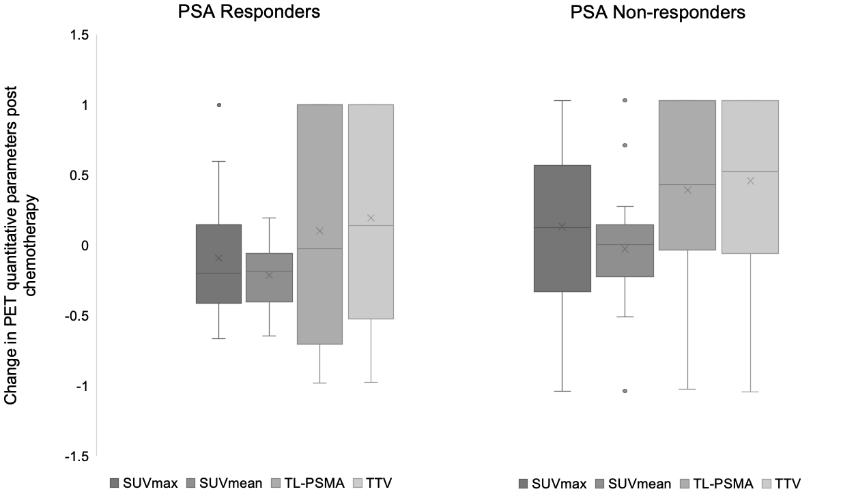

Supplemental Figure 2: Scatter plot showing relationship between PSA and TL-PSMA at baseline and at time of post-chemotherapy PET.

