Supporting Information For
A heterodimeric radioligand Labeled with Gallium-68 targeting fibroblast activation protein
Chengde Xie¹, Lei Peng², Hui Nie², Tianhong Yang², Renbo Wu², Dake Zhang², Fuhua Wen², Junyu Chen¹, Lingyu Xue², Xiangsong Zhang², Zhihao Zha²†, Jianjun Wang¹†
Affiliation: ¹MOE Key Laboratory of Resources and EnvironmentalSystems Optimization, College of Environmental Scienceand Engineering, North China Electric Power University. Beijing, 102206, China. ²Department of Nuclear Medicine, The First Affiliated Hospital of Sun Yat-sen University, 58# Zhongshan Er Road, Guangzhou, 510080, Guangdong Province, China.
†Address correspondence to: Zhihao Zha (zhazhh@mail.sysu.edu.cn) Department of Nuclear Medicine, The First Affiliated Hospital of Sun Yat-Sen University, 58# Zhongshan Er Road, Guangzhou, 510080, Guangdong Province, China. FAX: +86-020-87766335. Jianjun Wang (wangij2016@ncepu.edu.cn). MOE Key Laboratory of Resources and EnvironmentalSystems Optimization, College of Environmental Scienceand Engineering, North China Electric Power University. Beijing, 102206, China.

1.General procedure for preparation of BiFAPI
Compounds 1 and 2 were synthesized based on previously reported methodologies ^{[1, 2]}. Upon completion of the synthesis of compound 1, the peptide was cleaved from the resin using trifluoroacetic acid (TFA) for a duration exceeding four hours. The resulting filtrate was evaporated to dryness, and cold ether was subsequently added to precipitate the crude peptide, which was then collected via filtration. N-Fmoc-6-aminohexanoic acid was reacted with dicyclohexylcarbodiimide (DCC), hydroxysuccinimide (HOSu), and diisopropylethylamine (DIPEA) in dimethylformamide (DMF), followed by the addition of compound 1. The resultant mixture was treated with 20% piperidine in DMF, and the product was purified using semi-preparative high-performance liquid chromatography (HPLC) to yield compound 3. Compound 2 was reacted with Fmoc-Glu(OT-Bu)-OH in the presence of DCC, 1-hydroxybenzotriazole (HOBt), and N-methylmorpholine (NMM) in DMF. Ethyl acetate (EtOAc) was introduced into the mixture, which was then washed with water and brine. The organic phase was collected, and the solvent was removed under reduced pressure. The residue was treated with TFA, leading to the formation of compound 4, which was subsequently purified by semi-preparative HPLC. Compounds 3 and 4 were condensed in the presence of DCC, HOSu, DIPEA, and DMF, followed by the removal of the Fmoc protecting group through the addition of 20% piperidine in DMF. Compound 5 was purified via semi-preparative HPLC, and then reacted with DOTA-tri(tert-butyl ester) in the presence of DCC, HOSu, DIPEA, and DMF, followed by deprotection with TFA. The final product, BiFAPI, was purified using semi-preparative HPLC. Further characterization of the peptide was conducted using analytical HPLC and online electrospray ionization mass spectrometry (LC-MS, Waters, Milford, MA, USA). The peptides exhibited a purity of over 95% as determined by HPLC (Fig. S1). High-resolution mass spectrometry (HRMS) analysis (Fig. S2) yielded the following results: calculated for C₁₀₁H₁₄₂F₂N₂₀O₂₆S₃ (M + 2H)⁺²/2, 1092.46; found 1092.46.
Scheme. S1 Synthesis of BiFAPI

- Supplemental Figures
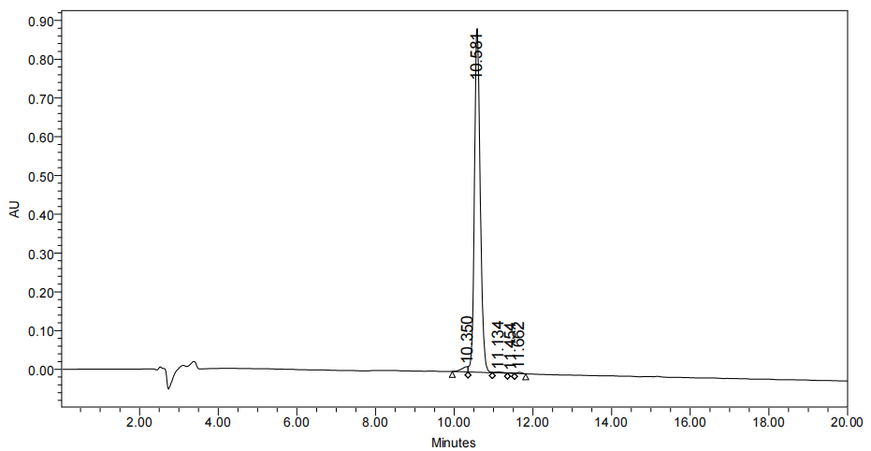
Fig. S1 HPLC trace of nonradioactive probe BiFAPI

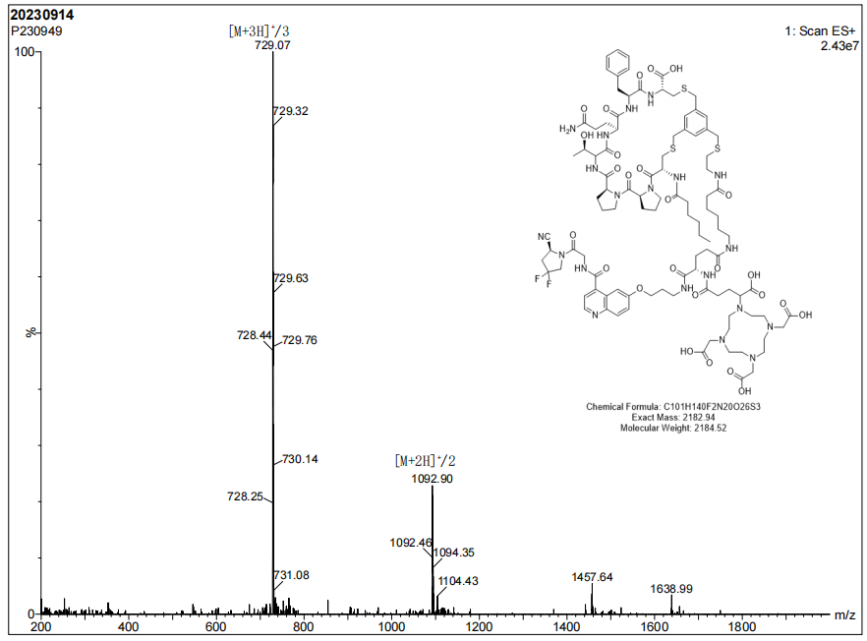
Fig. S2 LC-MS of nonradioactive probe BiFAPI

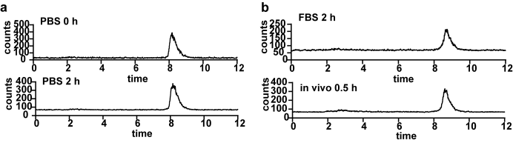
Fig. S3 In vitro and in vivo stability of [⁶⁸Ga]Ga-BiFAPI.

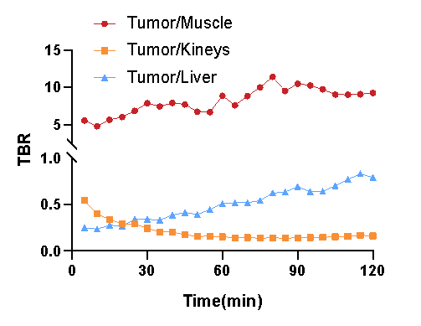
Fig. S4 Time-activity curves of the tumor-to-background ratio from dynamic imaging in FTC-133 tumor-bearing mice

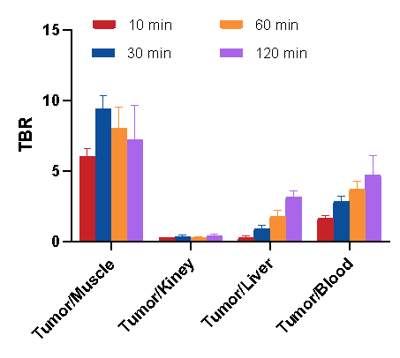
Fig. S5 Tumor-to-background ratio of at 10 min, 30 min, 60 min, 120 min pi in biodistribution study

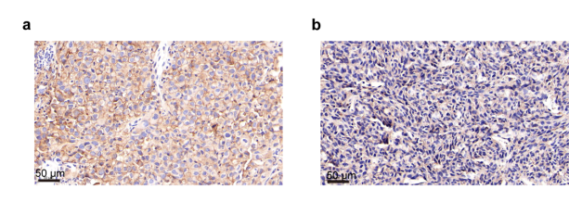
Fig. S6 IHC staining of FAP expression in FTC-133 (a) and HT1080 xenograft (b)

References
[1] Lindner T, Loktev A, Altmann A, Giesel F, Kratochwil C, Debus J, Jäger D, Mier W, Haberkorn U. Development of Quinoline-Based Theranostic Ligands for the Targeting of Fibroblast Activation Protein. J Nucl Med. 2018;59(9):1415-1422.
[2] Zboralski D, Hoehne A, Bredenbeck A, Schumann A, Nguyen M, Schneider E, et al. Preclinical evaluation of FAP-2286 for fibroblast activation protein targeted radionuclide imaging and therapy. Eur J Nucl Med Mol Imaging. 2022;49(11):3651-3667.

