Whole-body and Site Specific [¹⁸F]FDG Uptake Patterns on PET/CT have Limited Value in Differentiating between Polymyalgia Rheumatica and Other Inflammatory Diseases – Two Cohorts of Treatment-naïve Suspected Polymyalgia Rheumatica
Andreas Wiggers Nielsen^{1,2,3}, Gijs van Praagh⁴, , Kornelis S.M. van der Geest ⁵, Ib Tønder Hansen^{1,2}, Berit Dalsgaard Nielsen^{1,2,7}, Søren Geill Kjær³, Jesper Blegvad-Nissen³, Kate Rewers⁸, Christian Møller Sørensen⁷, Elisabeth Brouwer⁵, Ellen-Margrethe Hauge^{1,2}, Lars Christian Gormsen ^{2,9}, Riemer H.J.A Slart^{4,10}, Kresten Krarup Keller ^{1,2}
- Department of Rheumatology, Aarhus University Hospital, Aarhus, Denmark
- Department of Clinical Medicine, Aarhus University, Aarhus, Denmark
- Diagnostic Centre, Silkeborg Regional Hospital, Silkeborg, Denmark
- Department of Nuclear Medicine and Molecular Imaging, University Medical Centre Groningen, Groningen, Netherlands
- Department of Rheumatology and Clinical Immunology, University of Groningen, University Medical Center Groningen, Groningen, Netherlands
- Bioinformatics Research Center (BiRC), Aarhus University, Aarhus
- Department of Internal Medicine, Horsens Regional Hospital, Horsens, Denmark
- Department of Nuclear Medicine and PET, Odense University Hospital, Odense, Denmark
- Department of Nuclear Medicine and PET, Aarhus University Hospital, Aarhus, Denmark
- Biomedical Photonic Imaging Group, Faculty of Science and Technology, University of Twente, 7522 NB Enschede, The Netherlands.

Corresponding author: Andreas Wiggers Nielsen, Led- og Bindevævssygdomme, Palle Juul-Jensens Boulevard 59, 8200 Aarhus, Denmark. Mail: andrenie@rm.dk. Orchid ID: https://orcid.org/0000-0001-8180-6871

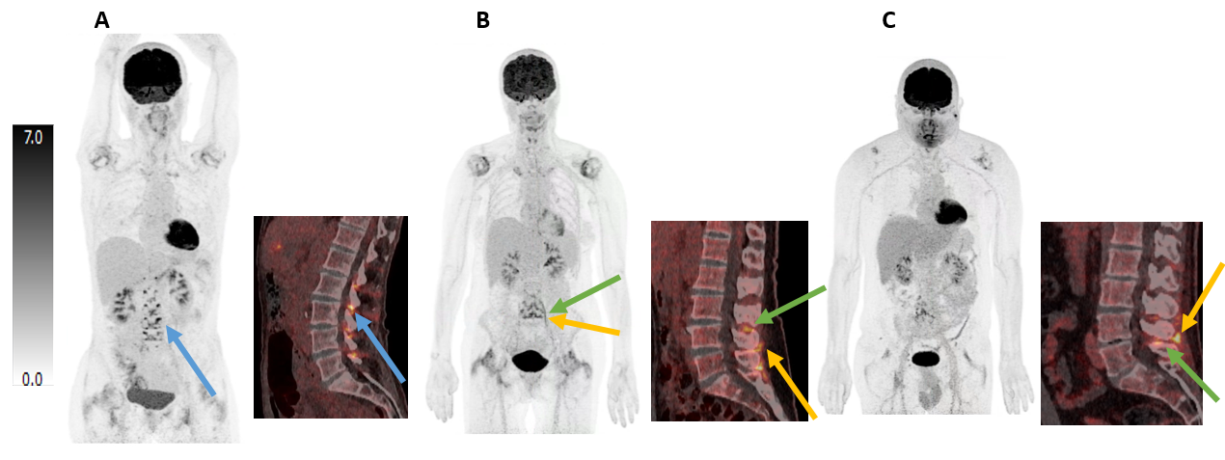
Supplementary Figure S1 – [¹⁸F]FDG uptake location around the spinal processes in patients with PMR and a patient with a reactive condition
A: Whole-body PET scan of patient with PMR and a sagittal PET/CT of the lumbar spine of the same patient. Blue arrows mark [¹⁸F]FDG uptake corresponding to intervertebral foramina. B: Whole-body PET scan of patient with PMR and a sagittal PET/CT of the lumbar spine of the same patient. Green arrows mark [¹⁸F]FDG uptake caudal to the spinous process and the yellow arrows mark [¹⁸F]FDG uptake posterior to the spinal process. C: Whole-body PET scan of patient with a reactive condition following COVID-19 vaccine and a sagittal PET/CT of the lumbar spine of the same patient. Green arrows mark [¹⁸F]FDG uptake caudal to the spinous process and the yellow arrows mark [¹⁸F]FDG uptake posterior to the spinal process. CT, computed tomography; [¹⁸F]FDG, 2-[18F]fluoro-2-deoxy-D-glucose; PET, Positron emission tomography; PMR, Polymyalgia rheumatica

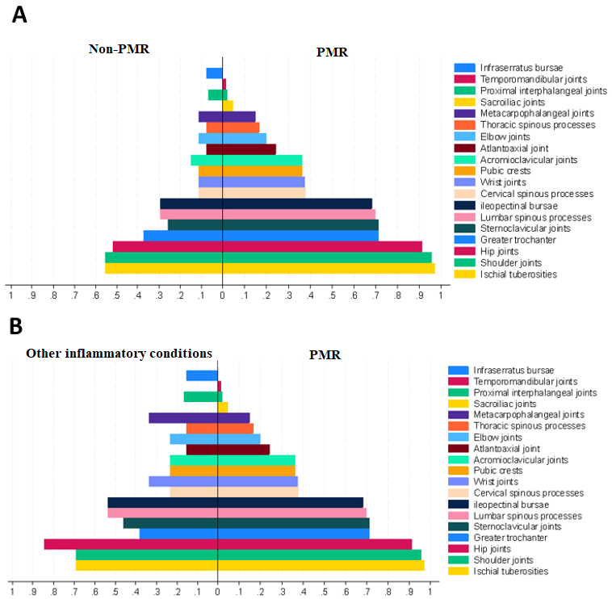
Supplementary Figure S2 – Proportion of suspected PMR patients with bilateral [¹⁸F]FDG uptake – Danish cohort
A: Bar plot displaying the proportion of bilateral [¹⁸F]FDG uptake above liver for symmetrical sites (visual summed score of 3 or above) and [¹⁸F]FDG uptake above liver in singular sites among patients with PMR and non-PMR B: Bar plot displaying the proportion of bilateral [¹⁸F]FDG uptake above liver for symmetrical sites (visual summed score of 3 or above) and [¹⁸F]FDG uptake above liver in singular sites among PMR and non-PMR patients with other inflammatory condition. [¹⁸F]FDG, 2-[18F]fluoro-2-deoxy-D-glucose; PMR, Polymyalgia rheumatica

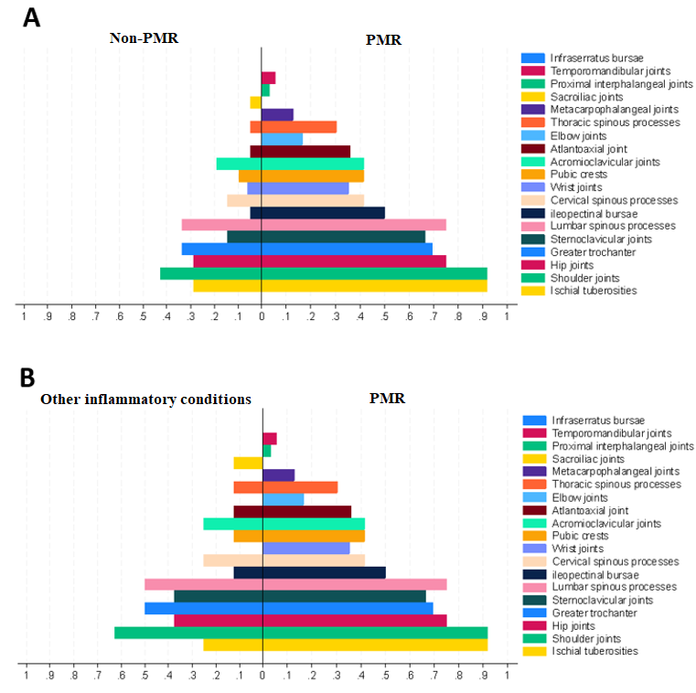
Supplementary Figure S3 – Proportion of suspected PMR patients with bilateral [¹⁸F]FDG uptake – Dutch cohort
A: Bar plot displaying the proportion of bilateral [¹⁸F]FDG uptake above liver for symmetrical sites (visual summed score of 3 or above) and [¹⁸F]FDG uptake above liver in singular sites among patients with PMR and non-PMR B: Bar plot displaying the proportion of bilateral [¹⁸F]FDG uptake above liver for symmetrical sites (visual summed score of 3 or above) and [¹⁸F]FDG uptake above liver in singular sites among PMR and non-PMR patients with other inflammatory condition. [¹⁸F]FDG, 2-[18F]fluoro-2-deoxy-D-glucose; PMR, Polymyalgia rheumatica

Supplementary Table S1 – [¹⁸F]FDG uptake and [¹⁸F]FDG uptake patterns within different anatomical regions for the Danish and Dutch cohorts.
 | Danish cohort |  |  |  |  | Dutch cohort
 |  | Positive FDG uptake | Cylindrical pattern | Circular pattern | Focal pattern | Positive FDG uptake | Cylindrical pattern | Circular pattern | Focal pattern
Temporomandibular joints
Left | PMR, n(%) | 2 (3%) | 0 (0%) | 1 (2%) | 2 (3%) | 2 (6%) | 0 (0%) | 0 (0%) | 2 (6%)
Left | Non-PMR, n(%) | 0 (0%) | 0 (0%) | 0 (0%) | 0 (0%) | 0 (0%) | 0 (0%) | 0 (0%) | 0 (0%)
Right | PMR, n(%) | 2 (3%) | 0 (0%) | 2 (3%) | 1 (2%) | 3 (8%) | 0 (0%) | 0 (0%) | 0 (0%)
Right | Non-PMR, n(%) | 1 (4%) | 0 (0%) | 0 (0%) | 1 (4%) | 0 (0%) | 0 (0%) | 2 (6%) | 2 (6%)
Atlantoaxial joint
 | PMR, n(%) | 16 (24%) | 0 (0%) | 9 (14%) | 7 (11%) | 13 (36%) | 0 (0%) | 8 (22%) | 6 (17%)
 | Non-PMR, n(%) | 2 (7%) | 0 (0%) | 0 (0%) | 2 (7%) | 1 (5%)** | 0 (0%) | 1 (5%) | 0 (0%)
Cervical spinous processes
 | PMR, n(%) | 25 (38%) | 0 (0%) | 0 (0%) | 25 (38%) | 15 (42%) | 0 (0%) | 0 (0%) | 15 (42%)
 | Non-PMR, n(%) | 3 (11%)* | 0 (0%) | 0 (0%) | 3 (11%)* | 3 (14%)* | 0 (0%) | 0 (0%) | 3 (14%)*
Acromioclavicular joints
Left | PMR, n(%) | 18 (27%) | 0 (0%) | 12 (18%) | 14 (21%) | 11 (31%) | 0 (0%) | 7 (19%) | 10 (28%)
Left | Non-PMR, n(%) | 2 (7%)* | 0 (0%) | 1 (4%) | 2 (7%) | 3 (14%) | 0 (0%) | 2 (10%) | 3 (14%)
Right | PMR, n(%) | 21 (32%) | 0 (0%) | 16 (24%) | 17 (26%) | 18 (50%) | 0 (0%) | 15 (42%) | 9 (25%)
Right | Non-PMR, n(%) | 3 (11%)* | 0 (0%) | 1 (4%)* | 3 (11%) | 4 (19%) | 0 (0%) | 2 (10%)* | 4 (19%)
Sternoclavicular joints
Left | PMR, n(%) | 45 (68%) | 26 (39%) | 13 (20%) | 33 (50%) | 25 (69%) | 13 (36%) | 11 (31%) | 19 (53%)
Left | Non-PMR, n(%) | 7 (26%)*** | 3 (11%)** | 1 (4%) | 4 (15%)** | 3 (14%)*** | 1 (5%)** | 1 (5%)* | 3 (14%)**
Right | PMR, n(%) | 46 (70%) | 22 (33%) | 17 (26%) | 39 (59%) | 22 (61%) | 10 (28%) | 12 (33%) | 16 (44%)
Right | Non-PMR, n(%) | 8 (30%)*** | 2 (7%)** | 1 (4%)* | 8 (30%)* | 2 (10%)*** | 1 (5%)* | 1 (5%)* | 2 (10%)**
Infraserratus bursae
Left | PMR, n(%) | 1 (2%) | 0 (0%) | 0 (0%) | 1 (2%) | 1 (3%) | 0 (0%) | 0 (0%) | 1 (3%)
Left | Non-PMR, n(%) | 2 (7%) | 0 (0%) | 0 (0%) | 2 (7%) | 0 (0%) | 0 (0%) | 0 (0%) | 0 (0%)
Right | PMR, n(%) | 1 (2%) | 0 (0%) | 0 (0%) | 1 (2%) | 0 (0%) | 0 (0%) | 0 (0%) | 0 (0%)
Right | Non-PMR, n(%) | 2 (7%) | 0 (0%) | 0 (0%) | 2 (7%) | 0 (0%) | 0 (0%) | 0 (0%) | 0 (0%)

Supplementary Table S1 – continued from previous page
 | Danish cohort |  |  |  |  | Dutch cohort
 |  | Positive FDG uptake | Cylindrical pattern | Circular pattern | Focal pattern | Positive FDG uptake | Cylindrical pattern | Circular pattern | Focal pattern
Elbow joints^
Left | PMR, n(%) | 11 (17%) | 1 (2%) | 0 (0%) | 10 (15%) | 5 (14%) | 0 (0%) | 1 (3%) | 5 (14%)
Left | Non-PMR, n(%) | 4 (15%) | 2 (7%) | 0 (0%) | 2 (7%) | 0 (0%) | 0 (0%) | 0 (0%) | 0 (0%)
Right | PMR, n(%) | 13 (20%) | 1 (2%) | 1 (2%) | 12 (18%) | 5 (14%) | 0 (0%) | 1 (3%) | 5 (14%)
Right | Non-PMR, n(%) | 4 (15%) | 2 (7%) | 1 (4%) | 2 (7%) | 2 (10%) | 0 (0%) | 0 (0%) | 2 (10%)
Wrist joints^^
Left | PMR, n(%) | 11 (23%) | 0 (0%) | 8 (17%) | 11 (23%) | 12 (39%) | 0 (0%) | 6 (19%) | 11 (35%)
Left | Non-PMR, n(%) | 2 (11%) | 0 (0%) | 2 (11%) | 2 (11%) | 1 (6%)* | 0 (0%) | 1 (6%) | 0 (0%)**
Right | PMR, n(%) | 19 (39%) | 0 (0%) | 10 (20%) | 15 (31%) | 11 (35%) | 0 (0%) | 8 (26%) | 10 (32%)
Right | Non-PMR, n(%) | 4 (22%) | 0 (0%) | 3 (17%) | 4 (22%) | 1 (6%)* | 0 (0%) | 1 (6%) | 0 (0%)**
Metacarpophalangeal joint^^^
Left | PMR, n(%) | 7 (15%) | 0 (0%) | 7 (15%) | 6 (13%) | 4 (13%) | 0 (0%) | 1 (3%) | 4 (13%)
Left | Non-PMR, n(%) | 2 (11%) | 0 (0%) | 1 (6%) | 2 (11%) | 0 (0%) | 0 (0%) | 0 (0%) | 0 (0%)
Right | PMR, n(%) | 11 (22%) | 0 (0%) | 6 (12%) | 9 (18%) | 4 (13%) | 0 (0%) | 2 (6%) | 4 (13%)
 | Non-PMR, n(%) | 3 (17%) | 0 (0%) | 1 6%) | 3 (17%) | 0 (0%) | 0 (0%) | 0 (0%) | 0 (0%)
Proximal interphalangeal joints^^^^
Left | PMR, n(%) | 1 (2%) | 0 (0%) | 1 (2%) | 1 (2%) | 1 (3%) | 0 (0%) | 0 (0%) | 1 (3%)
Left | Non-PMR, n(%) | 1 (7%) | 0 (0%) | 1 (7%) | 1 (7%) | 0 (0%) | 0 (0%) | 0 (0%) | 0 (0%)
Right | PMR, n(%) | 3 (6%) | 0 (0%) | 1 (2%) | 3 (6%) | 1 (3%) | 0 (0%) | 1 (3%) | 0 (0%)
Right | Non-PMR, n(%) | 1 (7%) | 0 (0%) | 1 (7%) | 1 (7%) | 1 (6%) | 0 (0%) | 0 (0%) | 1 (6%)
Thoracic spinous processes
 | PMR, n(%) | 11 (17%) | 0 (0%) | 0 (0%) | 11 (17%) | 11 (31%) | 0 (0%) | 0 (0%) | 11 (31%)
 | Non-PMR, n(%) | 2 (7%) | 0 (0%) | 0 (0%) | 2 (7%) | 1 (5%)* | 0 (0%) | 0 (0%) | 1 (5%)*
Sacroiliac joints
Left | PMR, n(%) | 1 (2%) | 0 (0%) | 0 (0%) | 1 (2%) | 0 (0%) | 0 (0%) | 0 (0%) | 0 (0%)
Left | Non-PMR, n(%) | 0 (0%) | 0 (0%) | 0 (0%) | 0 (0%) | 1 (5%) | 0 (0%) | 0 (0%) | 1 (5%)
Right | PMR, n(%) | 3 (5%) | 0 (0%) | 0 (0%) | 3 (5%) | 0 (0%) | 0 (0%) | 0 (0%) | 0 (0%)
Right | Non-PMR, n(%) | 0 (0%) | 0 (0%) | 0 (0%) | 0 (0%) | 1 (5%) | 0 (0%) | 0 (0%) | 1 (5%)

Supplementary Table S1 – continued from previous page
 | Danish cohort |  |  |  |  | Dutch cohort
 |  | Positive FDG uptake | Cylindrical pattern | Circular pattern | Focal pattern | Positive FDG uptake | Cylindrical pattern | Circular pattern | Focal pattern
Ileopectinal bursae
Left | PMR, n(%) | 44 (67%) | 0 (0%) | 0 (0%) | 44 (67%) | 15 (42%) | 0 (0%) | 0 (0%) | 15 (42%)
Left | Non-PMR, n(%) | 8 (30%)** | 0 (0%) | 0 (0%) | 8 (30%)** | 1 (5%)** | 0 (0%) | 0 (0%) | 1 (5%)**
Right | PMR, n(%) | 46 (70%) | 0 (0%) | 0 (0%) | 46 (70%) | 17 (47%) | 0 (0%) | 0 (0%) | 17 (47%)
Right | Non-PMR, n(%) | 8 (30%)*** | 0 (0%) | 0 (0%) | 8 (30%)*** | 1 (5%)** | 0 (0%) | 0 (0%) | 1 (5%)**
Greater trochanter
Left | PMR, n(%) | 44 (67%) | 38 (58%) | 0 (0%) | 41 (62%) | 23 (64%) | 14 (39%) | 0 (0%) | 23 (64%)
Left | Non-PMR, n(%) | 7 (26%)*** | 4 (15%)*** | 0 (0%) | 7 (26%)** | 6 (29%)* | 2 (10%)* | 0 (0%) | 6 (29%)*
Right | PMR, n(%) | 41 (62%) | 33 (50%) | 0 (0%) | 38 (58%) | 21 (58%) | 13 (36%) | 0 (0%) | 21 (58%)
Right | Non-PMR, n(%) | 8 (30%)** | 6 (22%)* | 0 (0%) | 8 (30%)* | 5 (24%)* | 2 (10%)* | 0 (0%) | 5 (24%)*
Pubic crests
Left | PMR, n(%) | 23 (35%) | 11 (17%) | 0 (0%) | 13 (20%) | 17 (47%) | 9 (25%) | 0 (0%) | 9 (25%)
Left | Non-PMR, n(%) | 4 (15%) | 2 (7%) | 0 (0%) | 2 (8%) | 2 (10%)** | 2 (10%) | 0 (0%) | 0 (0%)*
Right | PMR, n(%) | 24 (36%) | 14 (21%) | 0 (0%) | 13 (20%) | 15 (42%) | 8 (22%) | 0 (0%) | 8 (22%)
 | Non-PMR, n(%) | 2 (7%)** | 0 (0%)** | 0 (0%) | 2 (7%) | 2 (10%)* | 2 (10%) | 0 (0%) | 0 (0%)*
Lymph node uptake
 | PMR, n(%) | 36 (55%) |  |  |  | 27 (75%)
 | Non-PMR, n(%) | 14 (52%) |  |  |  | 15 (71%)
A positive [¹⁸F]FDG uptake was defined as uptake equal to or above liver uptake. The proportion of positive [¹⁸F]FDG uptake and different PET patterns for the PMR and non-PMR groups were compared using chi-square statistics or Fisher’s exact test. *p<0.05, **p-value <0.01, ***p-value<0.001. Lymph nodes with [¹⁸F]FDG uptake were categorized based on their respective regions (such as cervical, axillary, mediastinal, etc.), yet no significant associations were observed across any of the regions (details not provided). ^Missing value of 1 PMR patient in the Danish cohort and 1 non-PMR patients in the Dutch cohort. ^^Missing value of 18 patients with PMR and 9 non-PMR patients in the Danish cohort and 5 patients with PMR and 4 non-PMR patients in the Dutch cohort. ^^^Missing value of 19 patients with PMR and 9 non-PMR patients in the Danish cohort and 5 patients with PMR and 4 non-PMR patients in the Dutch cohort. ^^^^Missing value of 20 patients with PMR and 12 non-PMR patients in the Danish cohort and 6 patients with PMR and 4 non-PMR patients in the Dutch cohort. FDG, 2-[18F]fluoro-2-deoxy-D-glucose; PMR, Polymyalgia rheumatica.

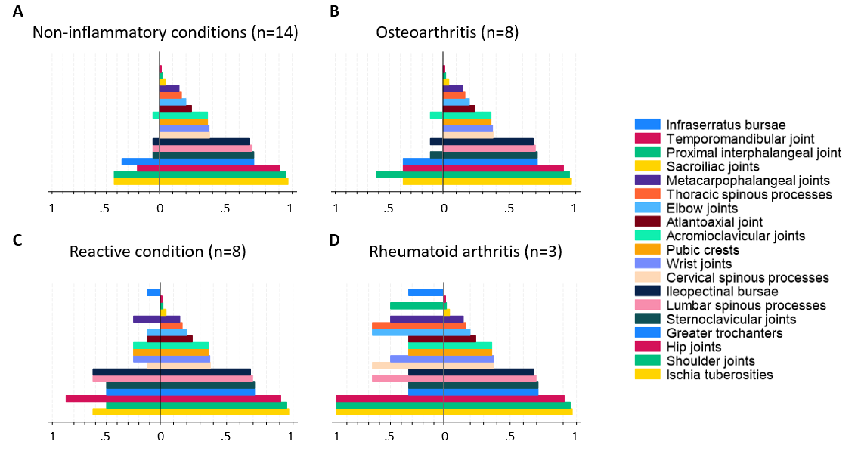Supplementary Figure S4– Proportion of suspected PMR patients with avid symmetrical [18F]FDG-uptake – Danish cohort
Bar plots displaying the proportion of patients with bilateral [18F]FDG uptake above liver for symmetrical sites and [18F]FDG uptake above liver in singular sites, with patients with PMR shown on the right side of the y-axis and those with non-inflammatory conditions (A), osteoarthritis (B), reactive conditions (C), and rheumatoid arhritis (D) on the left side. [18F]FDG, 2-[18F]fluoro-2-deoxy-D-glucose; PMR, Polymyalgia rheumatica

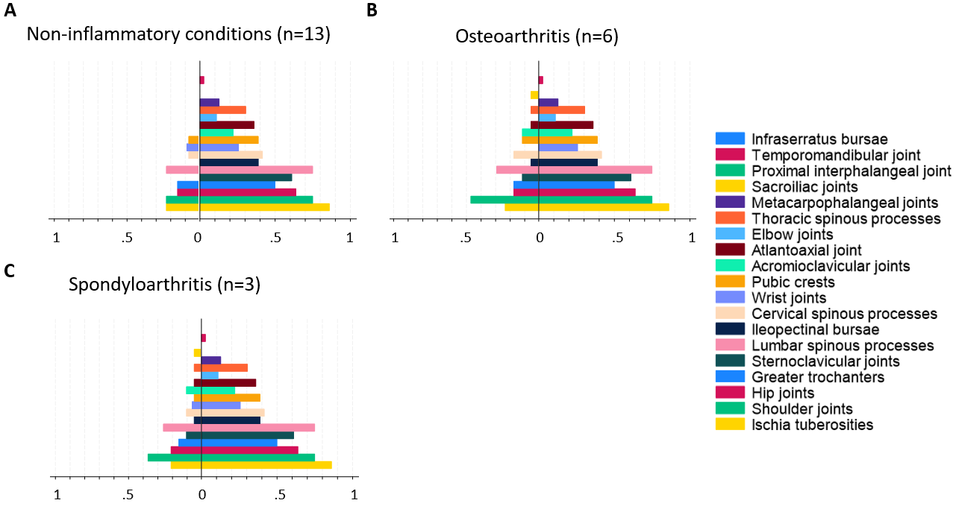
Supplementary Figure S5– Proportion of suspected PMR patients with avid symmetrical [18F]FDG-uptake – Dutch cohort
Bar plots displaying the proportion of patients with bilateral [18F]FDG uptake above liver for symmetrical sites and [18F]FDG uptake above liver in singular sites, with patients with PMR shown on the right side of the y-axis and those with non-inflammatory conditions (A), osteoarthritis (B), and spondyloarthrtis (C). [18F]FDG, 2-[18F]fluoro-2-deoxy-D-glucose; PMR, Polymyalgia rheumatica

Supplementary Table S2 – Interrater agreement for different [¹⁸F]FDG uptake patterns in the Danish cohort
 | Fleiss’ Kappa coefficient
 | Cylindrical | Circular | Focal
Above the diaphragm
Temporomandibular joints | N/A | 1 | 1
Atlantoaxial joint | N/A | 0.64 | 0.44
Cervical spinous processes | 0.18 | N/A | 0.93
Acromioclavicular joints | N/A | -0.39 | -0.38
Shoulder joints | 0.38 | 0.02 | 0.10
Sternoclavicular joints | 0.08 | 0.18 | 0.08
Infraserratus bursae | N/A | N/A | 1
Elbow joints | 0.06 | -0.09 | 0.03
Wrist joints | -0.36 | -0.28 | -0.36
Metacarpophalangeal joints | N/A | -0.22 | -0.38
Proximal interphalangeal joints | N/A | -0.15 | 0.09
Below the diaphragm
Thoracic spinous processes | -0.29 | N/A | 0.94
Lumbar spinous processes | -0.04 | N/A | 0.55
Sacroiliac joints | 0 | N/A | 0
Ileopectinal bursae | -0.16 | N/A | -0.13
Hip joints | -0.06 | 0.08 | -0.12
Greater trochanter | 0.51 | 0.30 | -0.08
Pubic crests | 0.02 | N/A | -0.17
Ischial tuberosities | 0.11 | N/A | -0.15
The interrater agreement between the 3 raters was established using Fleiss kappa statistics. Anatomical sites without a rating of a distinct pattern are indicated with N/A. Symmetrical sites were assessed together. Kappa coefficients were applied according to the following agreement scale: <0, Poor; 0.0-0.2, Slight; 0.21-0.40, Fair; 0.41-0.60, Moderate; 0.61-0.80, Substantial; 0.81-1.0, Almost perfect. [¹⁸F]FDG, 2-[18F]fluoro-2-deoxy-D-glucose; N/A, Not applicable.

Supplementary Table S3 – Interrater agreement among the two raters from the same department for different [¹⁸F]FDG uptake patterns in the Danish cohort
 | Cohen’s Kappa coefficient
 | Cylindrical | Circular | Focal
Above the diaphragm
Temporomandibular joints | N/A | 1 | 1
Atlantoaxial joint | N/A | 0.33 | 0.0
Cervical spinous processes | 0 | N/A | 0.90
Acromioclavicular joints | N/A | 0.04 | 0
Shoulder joints | 0.56 | 0.19 | 0.04
Sternoclavicular joints | 0.27 | 0.08 | -0.04
Infraserratus bursae | N/A | N/A | 1
Elbow joints | 0.29 | -0.04 | 0.08
Wrist joints | 0 | 0.15 | 0.37
Metacarpophalangeal joint | N/A | 0.10 | 0
Proximal interphalangeal joints | N/A | 0 | 1
Below the diaphragm
Thoracic spinous processes | 0 | N/A | 0.82
Lumbar spinous processes | 0 | N/A | 0.39
Sacroiliac joints | 1 | N/A | N/A
Ileopectinal bursae | 0 | N/A | 1
Hip joints | 0 | 0.21 | 0.04
Greater trochanter | 0.44 | 0 | -0.04
Pubic crests | 0.18 | N/A | 0.04
Ischial tuberosities | 0.34 | N/A | -0.01
The interrater agreement between the two raters from the same department (LG and AWN) was established using Cohen’s kappa statistics. Anatomical sites without a rating of a distinct pattern are indicated with N/A. Kappa coefficients were applied according to the following agreement scale: <0, Poor; 0.0-0.2, Slight; 0.21-0.40, Fair; 0.41-0.60, Moderate; 0.61-0.80, Substantial; 0.81-1.0, Almost perfect. [¹⁸F]FDG, 2-[18F]fluoro-2-deoxy-D-glucose; N/A, Not applicable.

Supplementary Table S4 – Categorizing the [¹⁸F]FDG uptake location along the spinal processes for the Danish and Dutch cohorts.
 | Danish cohort |  |  |  |  | Dutch cohort
 |  | Positive FDG uptake | Posterior | Caudal | Intervertebral foramina | Positive FDG uptake | Posterior | Caudal | Intervertebral foramina
Cervical spinal processes
 | PMR, n(%) | 25 (38%) | 25 (38%) | 2 (3%) | 0 (0%) | 15 (42%) | 15 (42%) | 1 (3%) | 0 (0%)
 | Non-PMR, n(%) | 3 (11%)* | 3 (11%)* | 0 (0%) | 0 (0%) | 3 (14%)* | 3 (14%)* | 1 (5%) | 0 (0%)
Fleiss Kappa coefficient |  | 0.60 | 0.73 | -0.06 | N/A
Cohen’s Kappa coefficient |  | 0.85 | 0.85 | 0 | N/A
Thoracal spinal processes
 | PMR, n(%) | 11 (17%) | 6 (9%) | 4 (6%) | 1 (2 %) | 11 (31%) | 10 (28%) | 4 (11%) | 1 (3%)
 | Non-PMR, n(%) | 2 (7%) | 1 (4%) | 1 (4%) | 0 (0%) | 1 (5%)* | 1 (5%)* | 0 (0%) | 0 (0%)
Fleiss Kappa coefficient |  | 0.29 | 0.34 | 0.25 | -0.01
Cohen’s Kappa coefficient |  | 0.38 | 0.29 | 0.56 | 0
Lumbar spinal processes
 | PMR, n(%) | 46 (70%) | 41 (62%) | 43 (65%) | 21 (32%) | 27 (75%) | 24 (67%) | 23 (64%) | 11 (31%)
 | Non-PMR, n(%) | 8 (30%)*** | 7 (26%)** | 6 (22%)*** | 2 (7%)* | 7 (33%)** | 4 (19%)** | 7 (33%)* | 3 (14%)
Fleiss Kappa coefficient |  | 0.42 | 0.41 | 0.47 | 0.13
Cohen’s Kappa coefficient |  | 0.60 | 0.57 | 0.74 | 0.13
A positive [¹⁸F]FDG uptake was defined as uptake equal to or above liver uptake. The proportion of positive [¹⁸F]FDG uptake and [¹⁸F]FDG uptake in different locations along the spine for the PMR and non-PMR groups were compared using chi-square statistics or Fisher’s exact test. *p<0.05, **p-value <0.01, ***p-value<0.001.
The interrater agreement between the 3 raters was established using Fleiss kappa statistics. The interrater agreement between the two raters from the same department (LG and AWN) was established using Cohen’s kappa statistics. Locations without a distinct rating are indicated with N/A. Kappa coefficients were applied according to the following agreement scale: <0, Poor; 0.0-0.2, Slight; 0.21-0.40, Fair; 0.41-0.60, Moderate; 0.61-0.80, Substantial; 0.81-1.0, Almost perfect. [¹⁸F]FDG, 2-[18F]fluoro-2-deoxy-D-glucose; N/A, Not applicable; PMR, Polymyalgia rheumatica.

