Supplemental material

Test-retest repeatability of quantitative organ and tissue uptake using 20-minute dynamic multiparametric whole-body [¹⁸F]FDG PET/CT in patients with type 2 diabetes

Authors
Jonathan M. Baier^{1,2}; Kristian L. Funck^{2,3}; Anna Dons-Jensen²; Ole L. Munk^{1,5}; Lars P. Tolbod^{1,5}; Esben Laugesen^{2,4}; Per L. Poulsen^{1,2}; Lars C. Gormsen^{1,5}; André H. Dias⁵

Affiliations
¹ Dept. of Clinical Medicine, Aarhus University, Aarhus, Denmark
² Steno Diabetes Center Aarhus, Aarhus University Hospital, Aarhus, Denmark
³ Dept. of Endocrinology and Internal Medicine, Aarhus University Hospital, Aarhus, Denmark
⁴ Diagnostic Centre, Silkeborg Regional Hospital, Silkeborg, Denmark
⁵ Department of Nuclear Medicine & PET-Centre, Aarhus University Hospital, Aarhus, Denmark

Supplemental Table 1: Study participants: Inclusion and Exclusion criteria
Inclusion criteria
- Diagnosis of type 2 diabetes according to the World Health Organization definition
- HbA1c level of 6,5 % (48 mmol/mol) or more
- Age of 50 years or more with established cardiovascular disease (prior myocardial infarction, prior stroke or prior transient ischemic attack, prior coronary, carotid or peripheral arterial revascularization, more than 50 % stenosis on angiography or imaging of coronary, carotid or lower extremities arteries, history of symptomatic coronary heart disease documented by e.g. positive exercise stress test or any cardiac imaging or unstable angina with electrocardiography changes.
or
Age of 60 years or more with at least one cardiovascular risk factor (persistent microalbuminuria (30-299 mg/g) or proteinuria, hypertension and left ventricular hypertrophy by electrogram or imaging, persistent hypertension despite antihypertensive treatment, left ventricular systolic or diastolic dysfunction by imaging, smoking or ankle/brachial index less than 0.9).
Exclusion criteria
- Previous allergic/hypersensitivity reaction to colchicine
- Colchicine treatment for another cause
- Poorly controlled medical condition, e.g. congestive heart failure (New York Heart Association III-IV), recent stroke or any other condition that in the opinion of the investigator will put the trial participant at risk if participating in the trial
- Estimated glomerular filtration rate (eGFR) < 50 mL/min/1.73 m²
- Anemia, thrombocytopenia, or leucopenia defined as any of the following, measured within the last 3 months:
• Hemoglobin < 7 mmol/L
• Platelet count < 110 x 10⁹/L
• White blood cell count < 3.0 x 10⁹/L
- Inability to give informed consent
- Active cancer diagnosis other than basal cell carcinoma
- Indication of liver disease (serum ALAT above 3 x upper limit of normal)
- Bariatric surgery within the past two years and other gastrointestinal surgeries that induce chronic malabsorption
- Treatment with systemic steroids at time of randomization
- Treatment with potent inhibitors of cytochrome P450 3A4 or P-glycoprotein (Appendix 1)
- Treatment with any biologic drug targeting the immune system (e.g., TNF-alfa inhibitors)
- Vaccination (e.g., against COVID-19) within 14 days prior to inclusion
- Alcohol or drug abuse within 3 months of informed consent that would interfere with trial participation or any ongoing condition leading to decreased compliance with study procedures or study drug intake
- Pregnancy or breastfeeding (see Pregnancy below)
- Chronic inflammatory bowel disease (Crohn’s disease or ulcerative colitis) or chronic diarrhea
- Contraindications to FDG-PET/CT, e.g. allergy toward contrast agent

Supplemental Table 2.: Post hoc power calculations
Organ/percent change | 10 % (N) | 20 % (N) | 40 % (N)
Aortic wall
SUV_{mean} | 13 | 5 | 3
MR_{FDG-mean} | 42 | 11 | 5
Myocardium
SUV_{mean} | 45 | 12 | 5
MR_{FDG-mean} | 107 | 26 | 7
Kidney Right
SUV_{mean} | 20 | 7 | 4
MR_{FDG-mean} | 113 | 27 | 7
Liver
SUV_{mean} | 9 | 4 | 3
MR_{FDG-mean} | 28 | 8 | 4
Lungs
SUV_{mean} | 15 | 6 | 3
MR_{FDG-mean} | 41 | 11 | 4
Pancreas
SUV_{mean} | 9 | 4 | 3
MR_{FDG-mean} | 64 | 16 | 5
Spleen
SUV_{mean} | 23 | 7 | 4
MR_{FDG-mean} | 38 | 10 | 4
Vertebra (L3)
SUV_{mean} | 13 | 5 | 3
MR_{FDG-mean} | 75 | 19 | 6
Sample size calculations for a change of 10 %, 20 %, and 40 % in both SUV(60-80)_{mean} and MR_{FDG}-_{mean} for different organs.

Supplemental Table 3: Reliability and variability results for SUV(60-70)_{mean} and Patlak intercept (DV_{mean}) values
Organ/metric |  | ICC | %RPC | %wCV
Aortic wall | SUV_{mean} | 0.70 | 18 | 6.4
Aortic wall | DV_{FDG-mean} | 0.41 | 28 | 9.7
Myocardium | SUV_{mean} | 0.94 | 41 | 14.3
Myocardium | DV_{FDG-mean} | 0.60 | 84 | 29.8
Kidney (right) | SUV_{mean} | 0.70 | 25 | 8.6
Kidney (right) | DV_{FDG-mean} | 0.54 | 54 | 18.7
Liver | SUV_{mean} | 0.59 | 16 | 5.6
Liver | DV_{FDG-mean} | 0.41 | 28 | 12.1
Lungs | SUV_{mean} | 0.81 | 23 | 8.6
Lungs | DV_{FDG-mean} | 0.52 | 58 | 20.2
Pancreas | SUV_{mean} | 0.89 | 13 | 5.5
Pancreas | DV_{FDG-mean} | 0.73 | 42 | 15.2
Spleen | SUV_{mean} | 0.72 | 27 | 9.6
Spleen | DV_{FDG-mean} | 0.27 | 73 | 29,1
Vertebra (L3) | SUV_{mean} | 0.70 | 20 | 8.0
Vertebra (L3) | DV_{FDG-mean} | 0.45 | 96 | 34.1
Liver (Geometric) | SUV_{mean} | 0.61 | 17 | 6.0
Liver (Geometric) | DV_{FDG-mean} | 0.47 | 32 | 12.9
Spleen (Geometric) | SUV_{mean} | 0.61 | 44 | 15.6
Spleen (Geometric) | DV_{FDG-mean} | 0.52 | 61 | 23.6
Lung (Geometric) | SUV_{mean} | 0.85 | 26 | 9.4
Lung (Geometric) | DV_{FDG-mean} | 0.57 | 77 | 26.7
ICC: Interclass correlation coefficients; RPC: Repeatability coefficients; wCV: Within-subject coefficient of variation

Supplemental Table 4: Reliability and variability results for SUV_{glc}, SUL and SUL_{glc}
Organ/metric |  | ICC | %RPC | %wCV
Aortic wall | SUV_{glc} | 0.73 | 36.63 | 13.21
Aortic wall | SUL | 0.81 | 19.68 | 7.10
Aortic wall | SUL_{glc} | 0.70 | 37.22 | 13.43
Myocardium | SUV_{glc} | 0.96 | 35.96 | 12.97
Myocardium | SUL | 0.95 | 39.69 | 14.32
Myocardium | SUL_{glc} | 0.96 | 36.04 | 13.00
Kidney (right) | SUV_{glc} | 0.76 | 34.94 | 12.60
Kidney (right) | SUL | 0.78 | 25.07 | 9.05
Kidney (right) | SUL_{glc} | 0.75 | 35.19 | 12.69
Liver | SUV_{glc} | 0.81 | 32.59 | 11.76
Liver | SUL | 0.79 | 15.35 | 5.54
Liver | SUL_{glc} | 0.78 | 33.13 | 11.95
Lungs | SUV_{glc} | 0.80 | 38.17 | 13.77
Lungs | SUL | 0.89 | 20.75 | 7.49
Lungs | SUL_{glc} | 0.79 | 38.53 | 13.90
Pancreas | SUV_{glc} | 0.88 | 28.21 | 10.18
Pancreas | SUL | 0.89 | 15.08 | 5.44
Pancreas | SUL_{glc} | 0.86 | 29.12 | 10.50
Spleen | SUV_{glc} | 0.69 | 36.22 | 13.07
Spleen | SUL | 0.81 | 27.39 | 9.88
Spleen | SUL_{glc} | 0.68 | 36.78 | 13.27
Vertebra (L3) | SUV_{glc} | 0.83 | 31.22 | 11.26
Vertebra (L3) | SUL | 0.82 | 19.02 | 6.86
Vertebra (L3) | SUL_{glc} | 0.81 | 31.71 | 11.44
Liver (Geometric) | SUV_{glc} | 0.83 | 31.41 | 11.33
Liver (Geometric) | SUL | 0.78 | 15.35 | 5.54
Liver (Geometric) | SUL_{glc} | 0.80 | 31.91 | 11.51
Spleen (Geometric) | SUV_{glc} | 0.57 | 49.54 | 17.87
Spleen (Geometric) | SUL | 0.70 | 44.37 | 16.01
Spleen (Geometric) | SUL_{glc} | 0.58 | 49.94 | 18.02
Lung (Geometric) | SUV_{glc} | 0.80 | 39.38 | 14.21
Lung (Geometric) | SUL | 0.90 | 24.02 | 8.66
Lung (Geometric) | SUL_{glc} | 0.81 | 39.44 | 14.23
ICC: Interclass correlation coefficients; RPC: Repeatability coefficients; wCV: Within-subject coefficient of variation
SUV_{glc}: Plasma glucose corrected SUV, [SUV_{glc} = SUV × Plasma Glucose Concentration]
SUL: lean body mass (LBM) corrected SUV, [SUL = SUV × (BW/LBM)]
SUL_{glc}: Plasma glucose corrected lean body mass corrected SUV, [SUL_{glc} = SUV_{glc}/LBM]
LBM can be calculated from body weight (BW) and body mass index (BMI = BW/height²), [LBM= (6.68×10³ + 216×BMI)/(9.27×10³×BW)]

Supplemental Figures

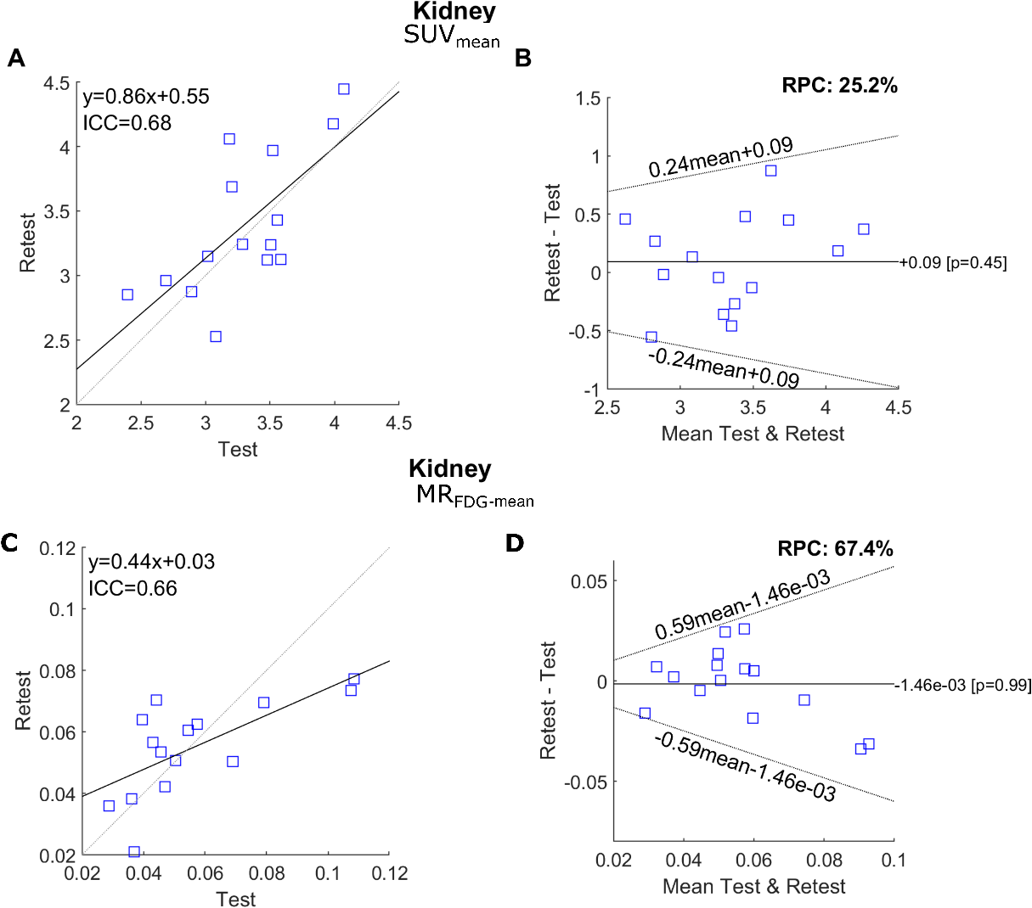
Supplemental Figure 1. Correlation plots (A and C) and Bland–Altman plots (B and D) demonstrating the repeatability of SUV(60-80)_{mean} (A and B) and MR_{FDG-mean} (C and D) in the right kidney. In the correlation plots, the dashed lines indicate the lines of identity, wheras the solid lines represent the linear regression fit. In the Bland–Altman plots, the solid line marks the mean difference between the test and retest results, while the dashed lines represent the 95% upper and lower limits of agreement. The limits of agreement of log-transformed data are transformed back to original scale.

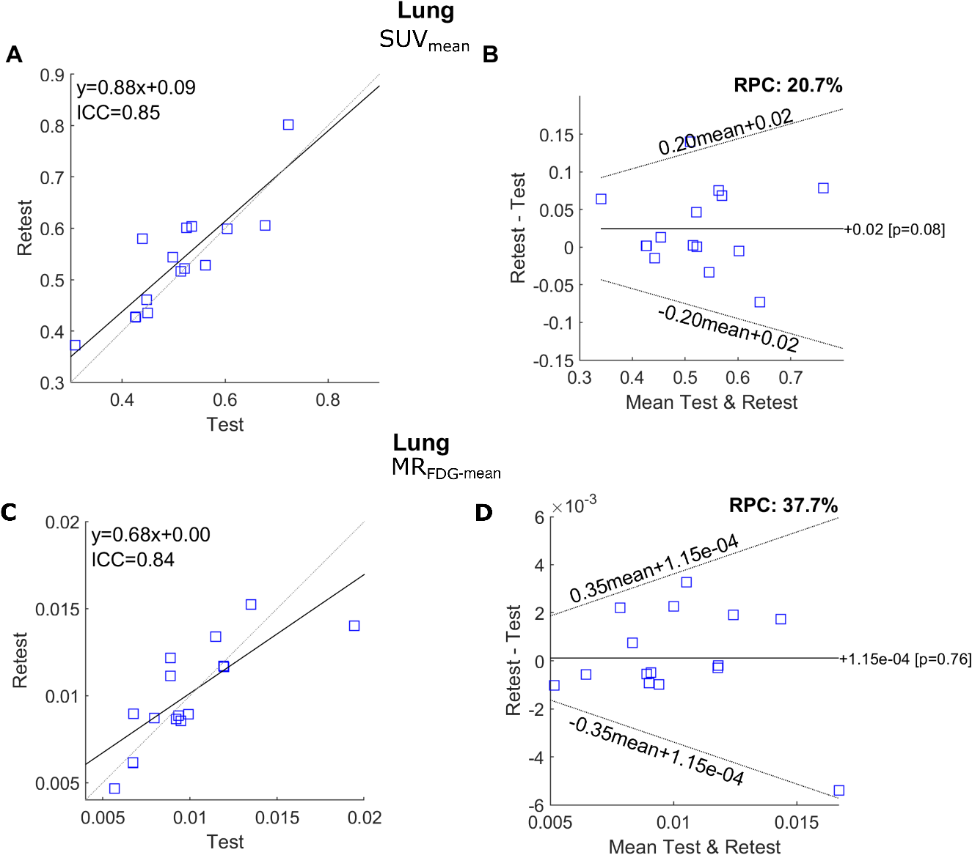
Supplemental Figure 2. Correlation plots (A and C) and Bland–Altman plots (B and D) demonstrating the repeatability of SUV(60-80)_{mean} (A and B) and MR_{FDG-mean} (C and D) in the lungs. In the correlation plots, the dashed lines indicate the lines of identity, wheras the solid lines represent the linear regression fit. In the Bland–Altman plots, the solid line marks the mean difference between the test and retest results, while the dashed lines represent the 95% upper and lower limits of agreement. The limits of agreement of log-transformed data are transformed back to original scale.

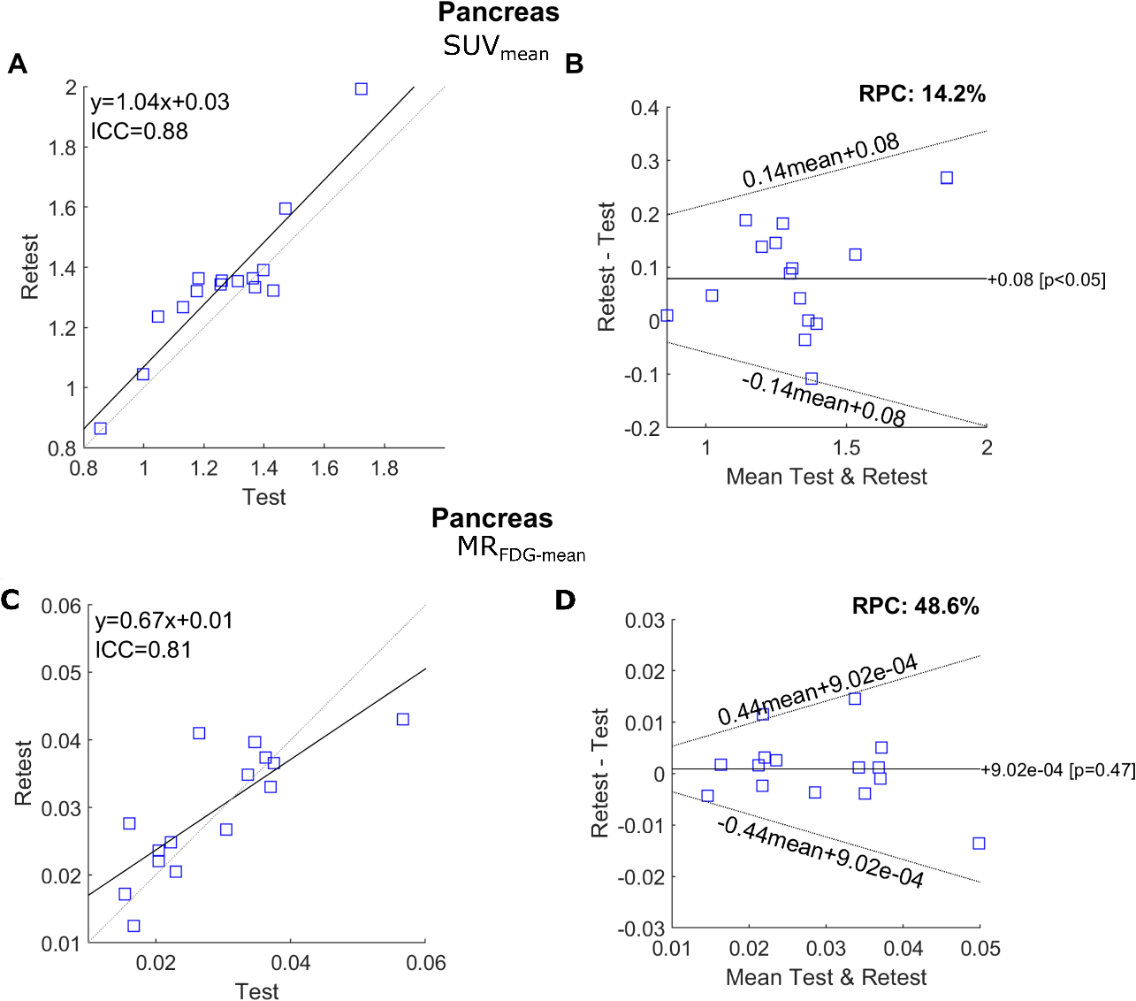
Supplemental Figure 3. Correlation plots (A and C) and Bland–Altman plots (B and D) demonstrating the repeatability of SUV(60-80)_{mean} (A and B) and MR_{FDG-mean} (C and D) in the pancreas. In the correlation plots, the dashed lines indicate the lines of identity, wheras the solid lines represent the linear regression fit. In the Bland–Altman plots, the solid line marks the mean difference between the test and retest results, while the dashed lines represent the 95% upper and lower limits of agreement. The limits of agreement of log-transformed data are transformed back to original scale.

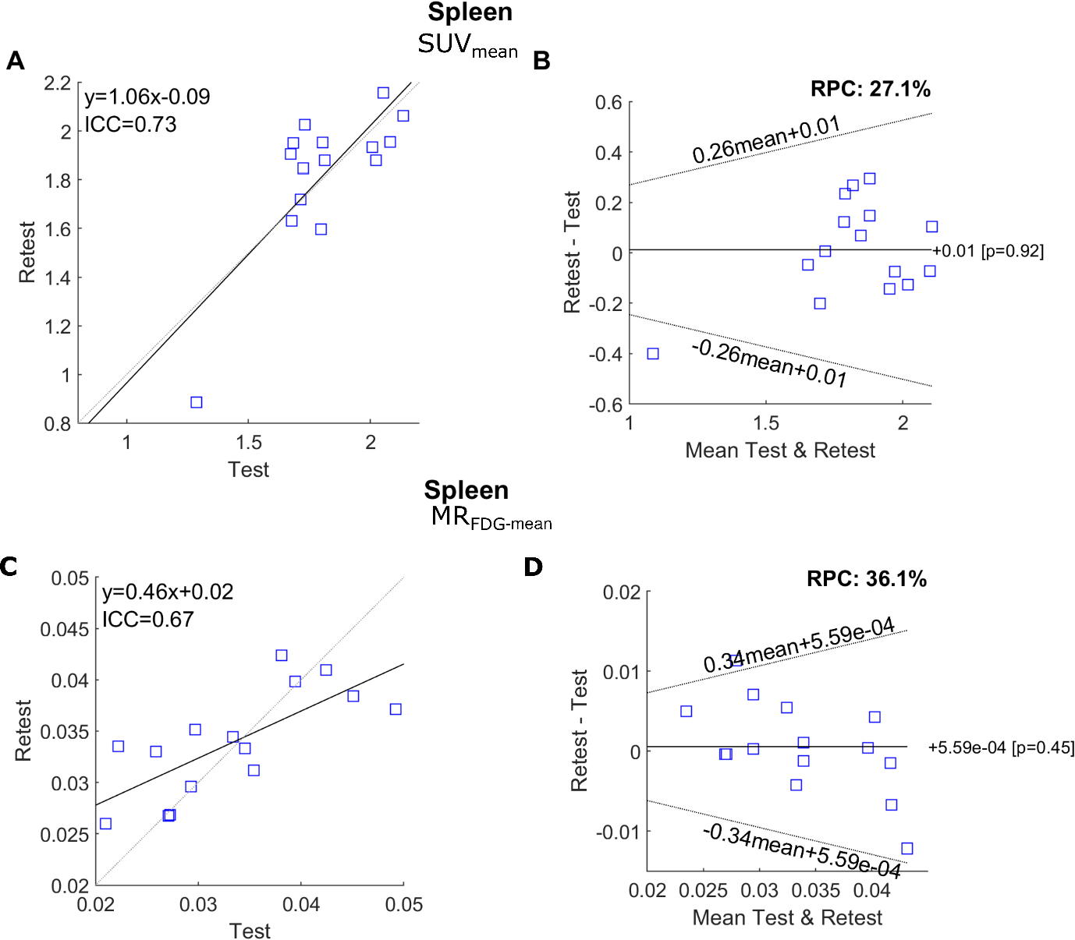
Supplemental Figure 4. Correlation plots (A and C) and Bland–Altman plots (B and D) demonstrating the repeatability of SUV(60-80)_{mean} (A and B) and MR_{FDG-mean} (C and D) in the spleen. In the correlation plots, the dashed lines indicate the lines of identity, wheras the solid lines represent the linear regression fit. In the Bland–Altman plots, the solid line marks the mean difference between the test and retest results, while the dashed lines represent the 95% upper and lower limits of agreement. The limits of agreement of log-transformed data are transformed back to original scale.

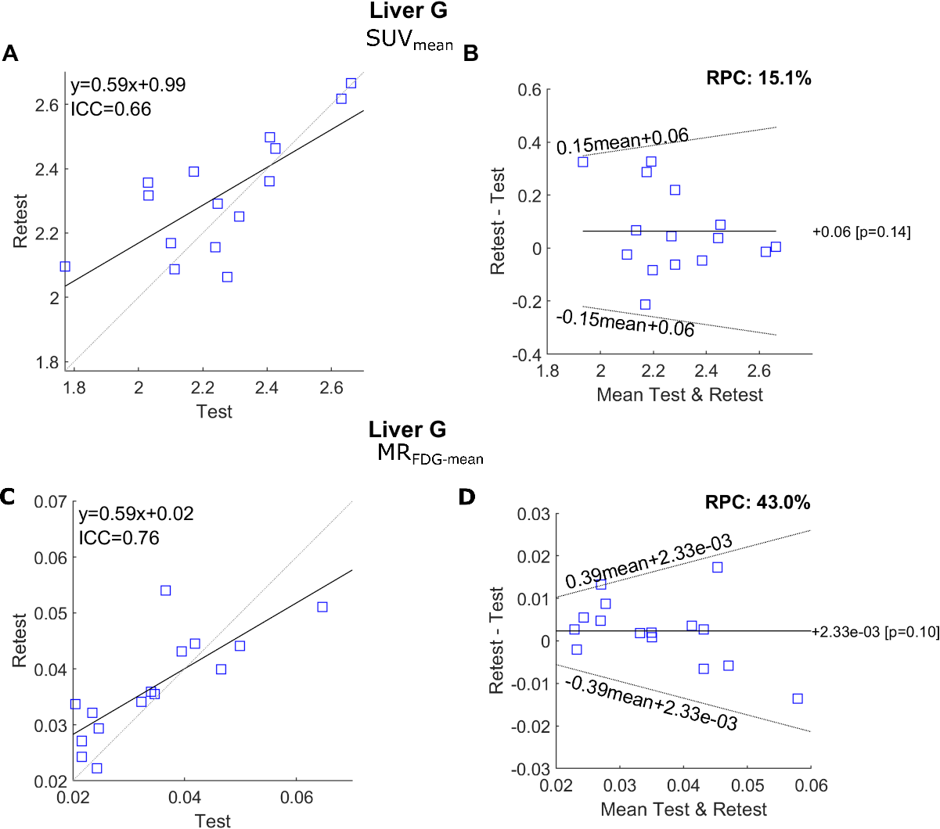

Supplemental Figure 5. Correlation plots (A and C) and Bland–Altman plots (B and D) demonstrating the repeatability of SUV(60-80)_{mean} (A and B) and MR_{FDG-mean} (C and D) in the Liver geometric region (sphere, 30 mm radius). In the correlation plots, the dashed lines indicate the lines of identity, wheras the solid lines represent the linear regression fit. In the Bland–Altman plots, the solid line marks the mean difference between the test and retest results, while the dashed lines represents the 95% upper and lower limits of agreement. The limits of agreement of log-transformed data are transformed back to original scale.
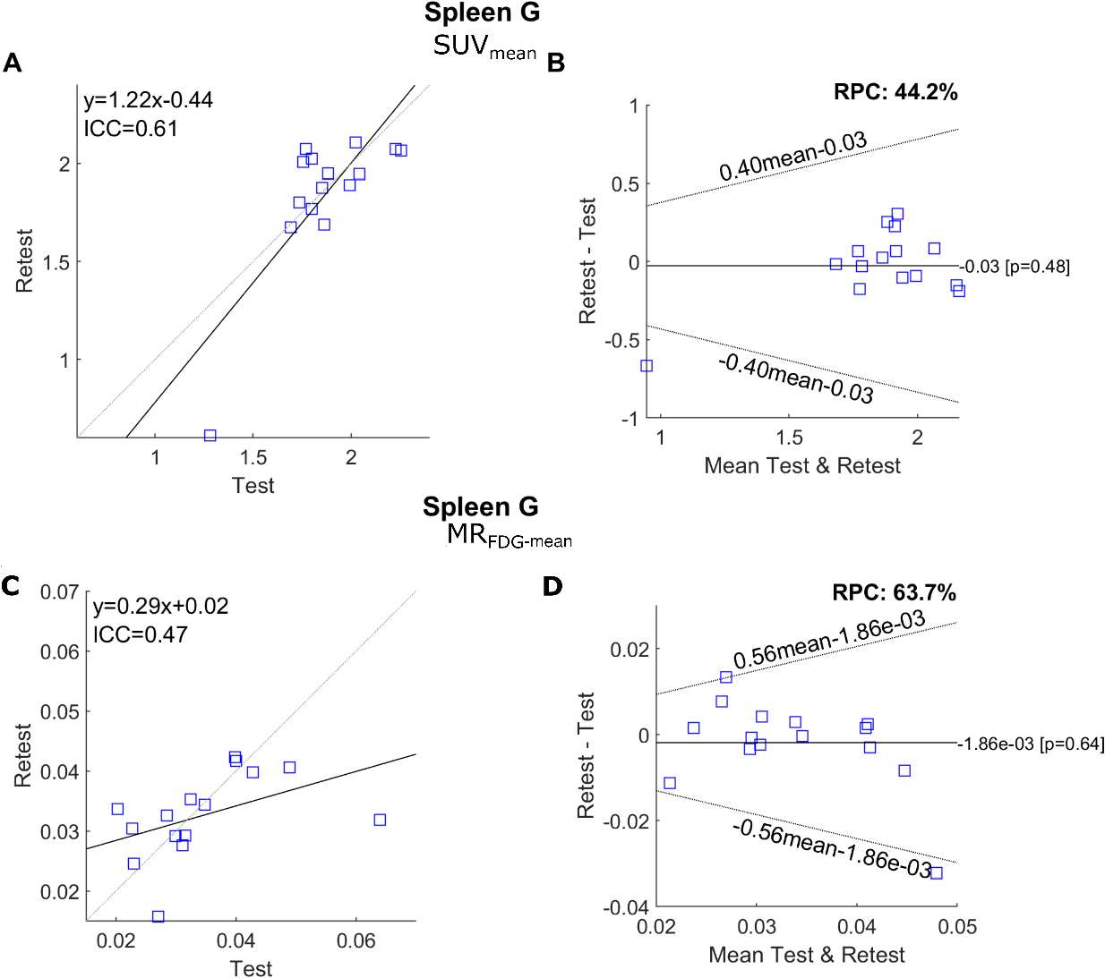

Supplemental Figure 6. Correlation plots (A and C) and Bland–Altman plots (B and D) demonstrating the repeatability of SUV(60-80)_{mean} (A and B) and MR_{FDG-mean} (C and D) in the spleen geometric region (sphere, 20 mm radius). In the correlation plots, the dashed lines indicate the lines of identity, wheras the solid lines represent the linear regression fit. In the Bland–Altman plots, the solid line marks the mean difference between the test and retest results, while the dashed lines represents the 95% upper and lower limits of agreement. The limits of agreement of log-transformed data are transformed back to original scale.

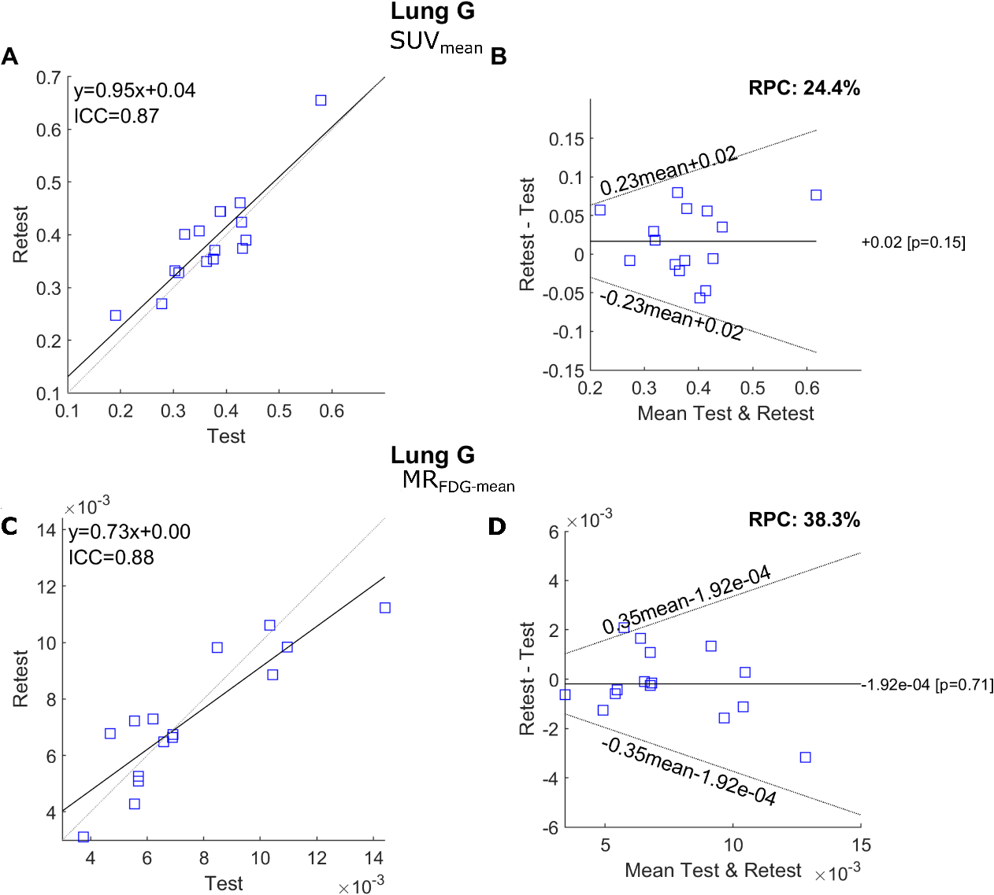
Supplemental Figure 7. Correlation plots (A and C) and Bland–Altman plots (B and D) demonstrating the repeatability of SUV(60-80)_{mean} (A and B) and MR_{FDG-mean} (C and D) in the lung geometric region (sphere, 20 mm radius). In the correlation plots, the dashed lines indicate the lines of identity, wheras the solid lines represent the linear regression fit. In the Bland–Altman plots, the solid line marks the mean difference between the test and retest results, while the dashed lines represents the 95% upper and lower limits of agreement. The limits of agreement of log-transformed data are transformed back to original scale.

