Supplementary Figures:
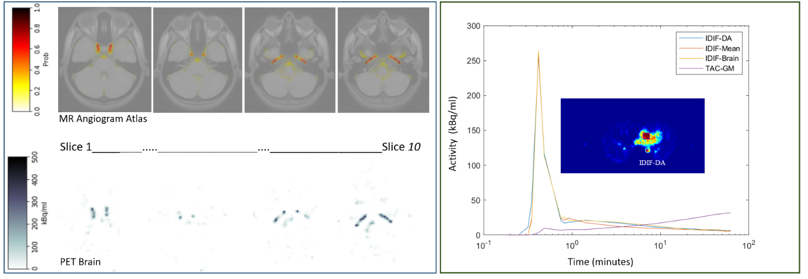
Figure 1s: Representation of the MRA brain images with arterial probability, input function extracted from brain slices and location for estimation of IDIF-DA in heart.

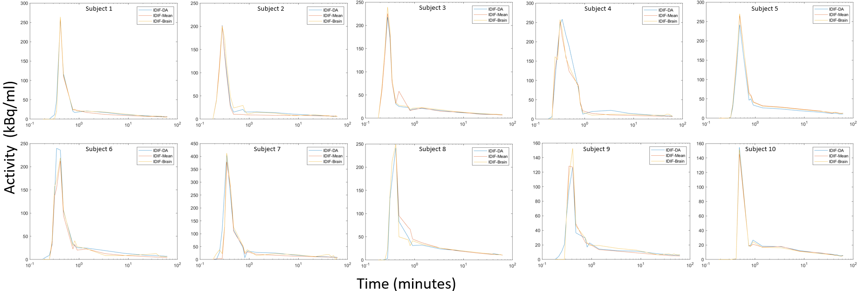
Figure 2s: Comparisons between IDIF-DA, IDIF-Mean and IDIF-Brain for the 10 subjects.

