Supplementary materials:
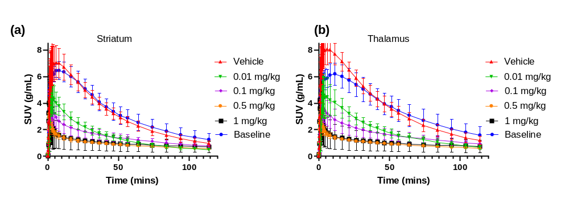
Supplementary Figure 1: Time activity curves for striatum (a) and thalamus (b) at the different dose levels.
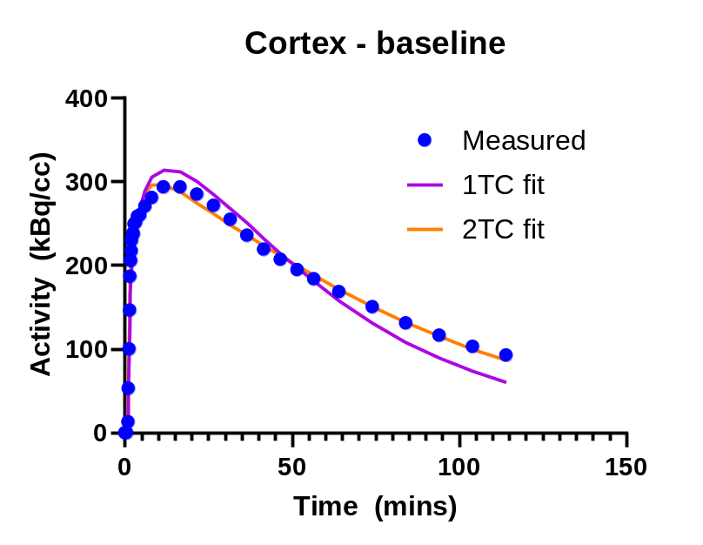
Supplementary Figure 2: 1TC and 2TC fits of a cortex TAC from one representative baseline scan

