SUPPLEMENTARY INFORMATION

Tissue-specific and whole-body insulin sensitivity by integrated imaging and hyperinsulinemic euglycemic clamp. A repeatability study in people with T2DM and overweight/obesity

Iina Laitinen¹, Helena Litorp^{2,3}, Folke Sjöberg², Simon Ekström⁴, Henrik Haraldsson¹, Stefan Pierrou¹, Alexander Korenyushkin⁴, Joel Kullberg^{4,5}, Sudeepti Southekal⁶, Ming Lu⁶, Tamer Coskun⁷, Zvonko Milicevic⁷, Lars Johansson¹

1) Antaros Medical, Mölndal, Sweden
2) Clinical Trial Consultants AB, Uppsala, Sweden
3) Department of Global Public Health, Karolinska Institutet, Stockholm, Sweden.
4) Antaros Medical, Uppsala, Sweden
5) Dept of Surgical Sciences, Section of Radiology, Uppsala University
6) Avid Radiopharmaceuticals Inc, Philadelphia, PA, USA
7) Eli Lilly, Indianapolis, IN, USA

Corresponding author:
Dr. Iina Laitinen
Antaros Medical
Förändringens gata 10, 431 53 Mölndal, Sweden
Phone: +46 7 303 77 112
E-mail: iina.laitinen@antarosmedical.com
ORCiD: 0000-0002-1362-7625

Image analysis
Arterialised venous samples were collected for radioactivity measurement after the thoracic, and after each of the whole-body PET scans (n=6 samples). Samples were weighed and radioactivity were measured with a cross-calibrated gamma counter as whole blood and plasma radioactivity, and decay corrected to the start of the injection.
Plasma input curves were prepared by combining image derived and blood sample data. A volume of interest was placed in the ascending aorta in the dynamic PET scan and data collected from the hottest connecting pixel (n=10) as Bq/cc. The image derived activity was corrected using plasma to whole blood ratio, which was derived individually from the collected blood and plasma samples. The image derived and the plasma sample values were combined to a time activity curve and saved for use in kinetic modelling.
The automatic segmentations were created using in-house developed and validated software which performs automatic segmentation of fat-water MRI data. This segmentation is based on multi-atlas segmentation, where multiple pre-segmented reference images (atlases) are registered against the target (image to segment). The already known segmentations of all atlases are spatially transformed to the target space producing multiple suggested segmentation maps. The suggested segmentations are fused together using majority voting to produce a single segmentation map for the target image. The segmentations were created for each subject each visit.
The automated segments were displayed on the corresponding whole body MRAC and PET images in PMOD v4.204 (PMOD Technologies LLC, Zurich, Switzerland). Outlines were manually inspected and corrected where needed, and further corrected for spillover activity or movement on PET merged dataset. The automated segments of Quadriceps left, Quadriceps right and Liver were delineating the whole volume and avoiding large vessels. The SAT segment covered a large area on abdomen (ca 40 cm centred to the L4-L5) excluding the breast.
Myocardium was segmented on PET images in PMOD. First, a summation image of the merged whole body PET dataset was created, and a dynamic isocontour with a threshold of 50% over the space was used to delineate the left myocardial wall. Similarly, an isocontour segment of Brain highest 65% activity was created from the summation images and using the isocontour (cutoff 35%) tool. The segments for VAT were manually drawn in PMOD onto the posterior lower part of the abdomen, avoiding intestines and kidney. This segment was used for VAT due to challenges of automatic whole segment approach being affected by bowel movement and spill over in non-motion corrected dynamic dataset.
Sequential MR imaging as part of PET imaging for attenuation correction allows MRI-based opportunities for motion correction over the dynamic measurement time, manually or by using automated motion correction methods. No general motion correction to the was applied to the dataset, but when larger movement between frames was observed, a manual correction for the VOI location was applied in all affected segments.
The regional kinetic readouts were calculated using the Patlak model [1] in PMOD PKIN. The plasma activity curve, and corresponding tissue specific lumped constant (LC) [2-6] and the plasma glucose value (mean glucose) were added and Patlak fit was performed fitting all five datapoints and original plasma data. Metabolic rate of glucose uptake is obtained from formula
MRGlu = (1/LC) * slope Ki * plasma glucose (mean) * 100 * 1/1.04
where unit conversions to 100g and soft tissue density conversion factor 1.04g/cc for all tissues was applied.
The analysis was performed using internally validated methods and trained analyst, in agreement with experienced imaging scientist. Reference segmentations for automated segmentation programme were performed by experienced radiologist. Reproducibility of the image analysis was assessed in a subset of analysed data, with r²=1 for the automated segmentations and for manual analysis r²= 0.9998 (myocardium, isocontour).

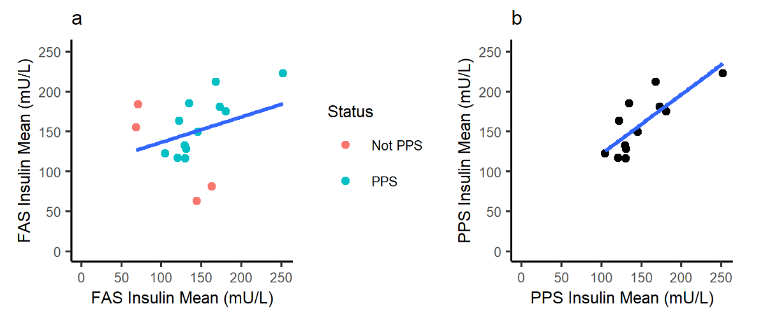
Supplement Figure 1: Mean plasma insulin during HEC on Visit 2 and Visit 3. A) Full analysis subset (FAS), the excluded from per protocol set (PPS) in red. r²=0.098, p=0.237 b) PPS r²=0.637, p= 0.0019.

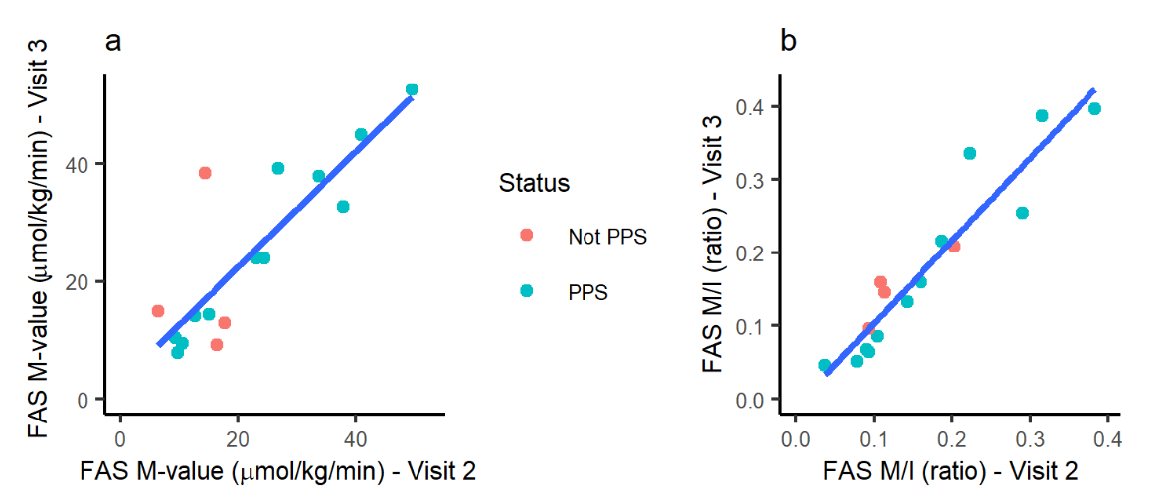

Supplement Figure 2: M-value and M-value /plasma insulin ratio on repeated visits. a) M-value r2= 0.7323, p=0.00002 and b) M-value divided by mean plasma insulin (M/I) r2= 0.892, p<0.0000 on Visit 2 and Visit 3, (FAS, PPS population in green).

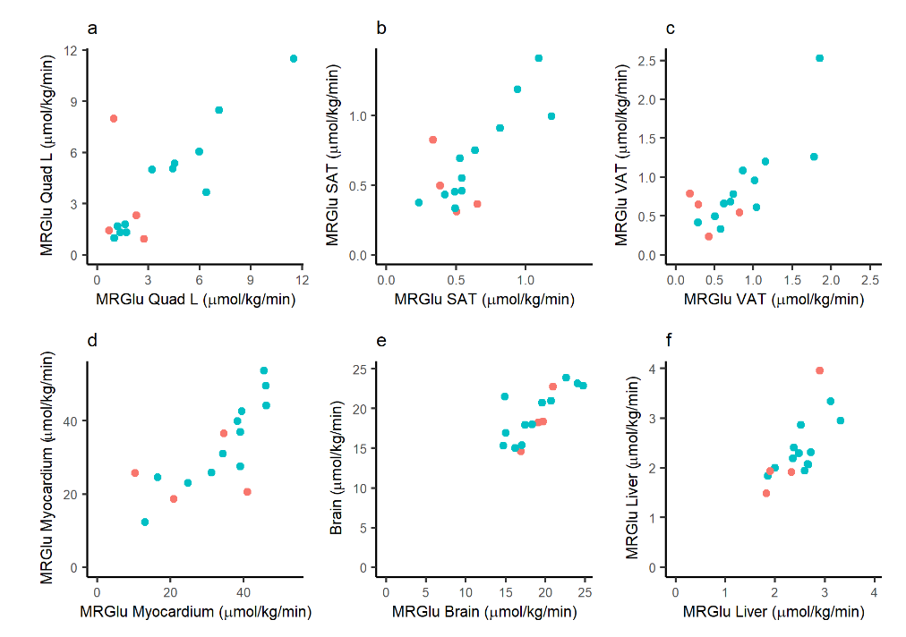
Supplement Figure 3. Metabolic rate of glucose uptake in tissues (MRGlu) on repeated visits. Visit 2 on x-axis, and Visit 3 on y-axis (FAS, with PPS population in green).

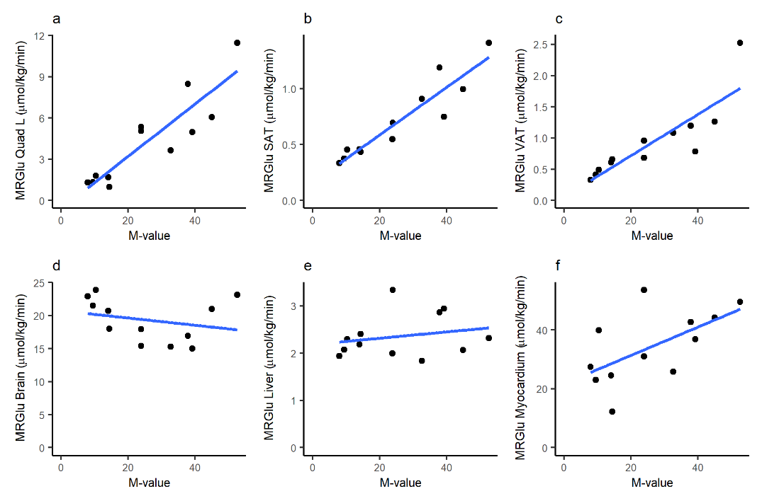
Supplement Figure 4 Associations between M-value (µmol/kg/min) and MRGlu (µmol/100g/min) of tissues. Data from Visit 3 (PPS). Linear regression M-value vs a) MRGlu Quad L r2= 0.83, p <0.00001 b) MRGlu SAT r2= 0.85, p <0.00001, c) vs MRGlu VAT r2= 0.71, p <0.00001, d) MRGlu Brain r2= -0.04, p=0.48, e) MRGlu Liver r2= 0.02 p=0.56, f) MRGlu Myocardium r2= 0.33 p=0.0031

Supplement Table 1 Clamp parameters

 | Mean (SD) V2  FAS | Mean (SD) V3  FAS | Mean V2 and V3
Duration of HEC before imaging (min) | 149.63 (25.45) | 122.63 (19.33) | 136.13 (16.55)
Duration of PET/MR Imaging (min) | 70.94 (23.52) | 63.44 (8.11) | 67.19 (12.44)
Fraction of glucose samples in target range | 0.87 (0.15) | 0.88 (0.23)

Supplement Table 2 Total body glucose utilisation M-value per body weight, M-value per lean body weight (LBW) (µmol/kg/min), metabolic rate of glucose uptake in tissues (MRGlu, µmol/100g/min); the mean (SD) value on visit 2 and visit 3 and corresponding ICC and intra-individual CV% for the FAS population (n=16).

Parameter | Mean (SD) V2  FAS | Mean (SD) V3  FAS | ICC | 95% CI | Intra-individual CV%
M-value (µmol/kg/min) | 21.81 (12.85) | 24.17 (14.70) | 0.84 | (0.63-0.94) | 17.62
LBW M-value (µmol/kg/min) | 32.37 (17.37) | 36.37 (21.70) | 0.79 | (0.51-0.92) | 17.14
MRGlu (µmol/100g/min)
Quadriceps Left | 3.55 (2.98) | 4.05 (3.19) | 0.78 | (0.50-0.91) | 24.17
Quadriceps Right | 3.37 (2.71) | 3.93 (2.99) | 0.74 | (0.42-0.89) | 25.10
SAT | 0.61 (0.27) | 0.66 (0.33) | 0.77 | (0.47-0.91) | 19.81
VAT | 0.81 (0.48) | 0.83 (0.54) | 0.80 | (0.54-0.92) | 24.50
Myocardium | 32.50 (11.84) | 32.05 (11.77) | 0.77 | (0.48-0.91) | 14.56
Brain | 18.89 (3.14) | 19.10 (3.19) | 0.78 | (0.50-0.91) | 5.85
Liver | 2.48 (0.44) | 2.35 (0.63) | 0.68 | (0.31-0.87) | 9.58

Supplement Table 3 Linear regressions on parameters Visit 2 vs Visit 3

Parameter | Intercept | Slope | r2 | p-value | Status
Insulin_mean | 104.9102082 | 0.3173370 | 0.0984166 | 0.2367170 | FAS
M-value | 2.8047837 | 0.9796977 | 0.7327338 | 0.0000233 | FAS
M/I | -0.0093437 | 1.1293698 | 0.8923719 | 0.0000000 | FAS
Insulin_mean | 47.8263135 | 0.7433891 | 0.6366304 | 0.0018707 | PPS
M-value | -0.4479167 | 1.0762620 | 0.9246169 | 0.0000006 | PPS
M/I | -0.0216693 | 1.1698642 | 0.9057631 | 0.0000019 | PPS

Suppl. Table 4 Linear regressions between parameters, PPS, Visit 3

Formula | Slope | r2 | p-value | Population
MRGlu Quadriceps Left ~ Insulin | -0.0210175 | 0.0637257 | 0.2340186 | PPS
MRGlu SAT ~ Insulin | -0.0022289 | 0.0727114 | 0.2025738 | PPS
MRGlu VAT ~ Insulin | -0.0044402 | 0.1019365 | 0.1283238 | PPS
MRGlu Brain ~ Insulin | 0.0065244 | 0.0054343 | 0.7321028 | PPS
MRGlu Liver ~ Insulin | 0.0006838 | 0.0034900 | 0.7839290 | PPS
MRGlu Myocardium ~ Insulin | -0.0208010 | 0.0047394 | 0.7492432 | PPS
MRGlu Quadriceps Left ~ M-value | 0.2026553 | 0.8321942 | 0.0000000 | PPS
MRGlu SAT ~ M-value | 0.0203143 | 0.8483933 | 0.0000000 | PPS
MRGlu VAT ~ M-value | 0.0312511 | 0.7092807 | 0.0000002 | PPS
MRGlu Brain ~ M-value | -0.0356633 | 0.0228070 | 0.4811818 | PPS
MRGlu Liver ~ M-value | 0.0038463 | 0.0155080 | 0.5620683 | PPS
MRGlu Myocardium ~ M-value | 0.4658457 | 0.3338855 | 0.0031053 | PPS
MRGlu SAT ~ MRGlu Quadriceps Left | 0.0878157 | 0.7823982 | 0.0000000 | PPS
MRGlu VAT ~ MRGlu Quadriceps Left | 0.1416849 | 0.7194917 | 0.0000002 | PPS
MRGlu Brain ~ MRGlu Quadriceps Left | -0.0130112 | 0.0001498 | 0.9547335 | PPS
MRGlu Liver ~ MRGlu Quadriceps Left | 0.0206687 | 0.0220998 | 0.4881388 | PPS
MRGlu Myocardium ~ MRGlu Quadriceps Left | 2.4471848 | 0.4547137 | 0.0003021 | PPS
MRGlu VAT ~ MRGlu SAT | 1.5162447 | 0.8121448 | 0.0000000 | PPS
MRGlu Brain ~ MRGlu SAT | 0.1392842 | 0.0001692 | 0.9518949 | PPS
MRGlu Liver ~ MRGlu SAT | 0.1537547 | 0.0120541 | 0.6095610 | PPS
MRGlu Myocardium ~ MRGlu SAT | 22.2151713 | 0.3693347 | 0.0016326 | PPS

Suppl. Table 5 Linear regressions between parameters, FAS, Visit 3
Formula | Slope | r2 | p-value | Population
MRGlu Quadriceps Left ~ Insulin | 0.0050860 | 0.0053041 | 0.6920169 | FAS
MRGlu SAT ~ Insulin | 0.0004967 | 0.0053645 | 0.6903541 | FAS
MRGlu VAT ~ Insulin | 0.0004424 | 0.0014617 | 0.8354258 | FAS
MRGlu Brain ~ Insulin | 0.0037312 | 0.0027309 | 0.7763740 | FAS
MRGlu Liver ~ Insulin | 0.0030612 | 0.0614112 | 0.1714660 | FAS
MRGlu Myocardium ~ Insulin | 0.0506929 | 0.0362896 | 0.2963242 | FAS
MRGlu Quadriceps Left ~ M-value | 0.2066952 | 0.8553343 | 0.0000000 | FAS
MRGlu SAT ~ M-value | 0.0200267 | 0.8516255 | 0.0000000 | FAS
MRGlu VAT ~ M-value | 0.0309748 | 0.6997545 | 0.0000000 | FAS
MRGlu Brain ~ M-value | -0.0452829 | 0.0392735 | 0.2769149 | FAS
MRGlu Liver ~ M-value | 0.0125003 | 0.0999811 | 0.0778883 | FAS
MRGlu Myocardium ~ M-value | 0.5255162 | 0.3807839 | 0.0001687 | FAS
MRGlu Quadriceps Right ~ MRGlu Quadriceps Left | 0.9173402 | 0.9829376 | 0.0000000 | FAS
MRGlu SAT ~ MRGlu Quadriceps Left | 0.0861181 | 0.7865804 | 0.0000000 | FAS
MRGlu VAT ~ MRGlu Quadriceps Left | 0.1377623 | 0.6913750 | 0.0000000 | FAS
MRGlu Brain ~ MRGlu Quadriceps Left | -0.0958636 | 0.0087915 | 0.6097516 | FAS
MRGlu Liver ~ MRGlu Quadriceps Left | 0.0582321 | 0.1083751 | 0.0657933 | FAS
MRGlu Myocardium ~ MRGlu Quadriceps Left | 2.5640134 | 0.4527642 | 0.0000245 | FAS
MRGlu Quadriceps Left ~ MRGlu SAT | 9.1337455 | 0.7865804 | 0.0000000 | FAS
MRGlu VAT ~ MRGlu SAT | 1.5441860 | 0.8190258 | 0.0000000 | FAS
MRGlu Brain ~ MRGlu SAT | -0.1409166 | 0.0001791 | 0.9420462 | FAS
MRGlu Liver ~ MRGlu SAT | 0.4241924 | 0.0542221 | 0.1996521 | FAS
MRGlu Myocardium ~ MRGlu SAT | 23.9886195 | 0.3736692 | 0.0002019 | FAS

REFERENCES

1. Patlak CS, Blasberg RG, Fenstermacher JD. Graphical evaluation of blood-to-brain transfer constants from multiple-time uptake data. J Cereb Blood Flow Metab. 1983;3:1-7. doi:10.1038/jcbfm.1983.1.
2. Peltoniemi P, Lönnroth P, Laine H, Oikonen V, Tolvanen T, Grönroos T, et al. Lumped constant for [(18)F]fluorodeoxyglucose in skeletal muscles of obese and nonobese humans. Am J Physiol Endocrinol Metab. 2000;279:E1122-30. doi:10.1152/ajpendo.2000.279.5.E1122.
3. Virtanen KA, Peltoniemi P, Marjamäki P, Asola M, Strindberg L, Parkkola R, et al. Human adipose tissue glucose uptake determined using [(18)F]-fluoro-deoxy-glucose ([(18)F]FDG) and PET in combination with microdialysis. Diabetologia. 2001;44:2171-9. doi:10.1007/s001250100026.
4. Wu HM, Bergsneider M, Glenn TC, Yeh E, Hovda DA, Phelps ME, et al. Measurement of the global lumped constant for 2-deoxy-2-[18F]fluoro-D-glucose in normal human brain using [15O]water and 2-deoxy-2-[18F]fluoro-D-glucose positron emission tomography imaging. A method with validation based on multiple methodologies. Mol Imaging Biol. 2003;5:32-41. doi:10.1016/s1536-1632(02)00122-1.
5. Ng CK, Soufer R, McNulty PH. Effect of hyperinsulinemia on myocardial fluorine-18-FDG uptake. J Nucl Med. 1998;39:379-83.
6. Kalliokoski T, Nuutila P, Virtanen KA, Iozzo P, Bucci M, Svedstrom E, et al. Pancreatic glucose uptake in vivo in men with newly diagnosed type 1 diabetes. J Clin Endocrinol Metab. 2008;93:1909-14. doi:10.1210/jc.2006-2533.

