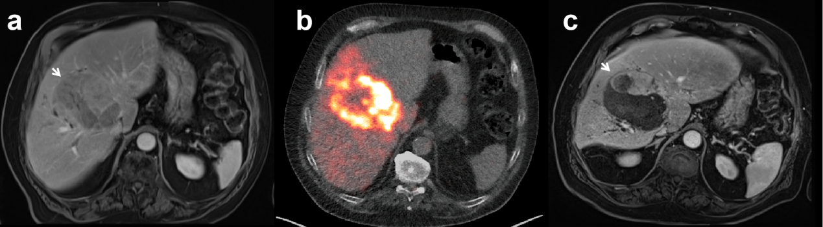
Supplementary Figure 1. Representative case of hepatocellular carcinoma (HCC) treated with Y-90 resin microspheres.
A 79-year-old male with a large HCC (maximum diameter 104 mm) in liver segment V and VIII. (a) Baseline contrast-enhanced MRI shows a large heterogeneously enhancing mass (white arrow). (b) Post-treatment Y-90 PET/CT after lobar infusion of 2.0 GBq resin microspheres into the right hepatic artery demonstrates predominant microsphere activity within the tumour with some peripheral distribution. (c) Follow-up MRI at 4 months shows decreased enhancement and partial intralesional necrosis, indicating a treatment response with residual viable tumour (white arrow). Mild right-lobe atrophy and compensatory hypertrophy of the left lobe are also observed.

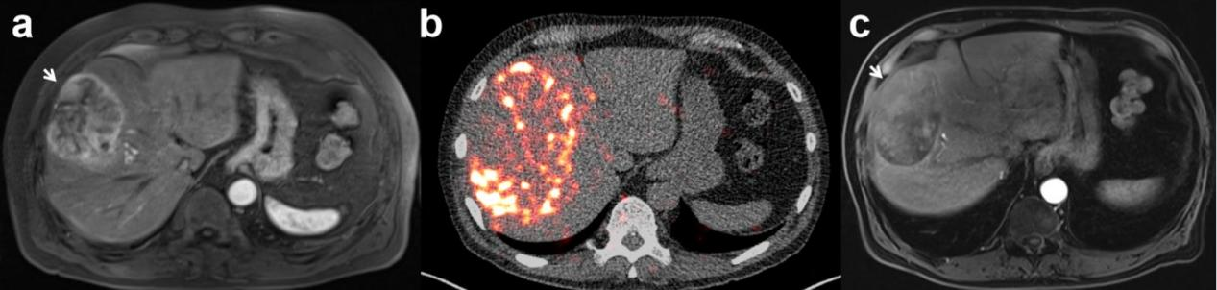
Supplementary Figure 2. Representative case of hepatocellular carcinoma (HCC) treated with Y-90 glass microspheres.
A 74-year-old male with a large HCC lesion (maximum diameter 98 mm) in liver segments V and VIII. (a) Baseline contrast-enhanced MRI shows a large enhancing mass (white arrow). (b) Post-treatment Y-90 PET/CT demonstrates non-homogeneous deposition within the tumour, lacking uniform intratumoural accumulation.(c) Follow-up MRI at 4 months shows a slight increase in overall lesion size with minimal intralesional necrosis, consistent with stable disease (white arrow).
Supplemental Table 1. Tumour response outcomes following lobar Y-90 SIRT with glass versus resin microspheres
Response | Glass-based (n = 15) | Resin-based (n = 22) | P value
CR | 1 | 3 | 0.633
PR | 3 | 11 | 0.091
SD | 4 | 1 | 0.136
PD | 7 | 7 | 0.493
ORR | 4 | 14 | 0.045
DCR | 8 | 15 | 0.493
CR, complete response; PR, partial response; SD, stable disease; PD, progressive disease; ORR, objective response rate (CR + PR); DCR, disease control rate (CR + PR + SD).

Supplemental Table 2. Tumour necrosis among patients stratified by tumour response
Response | Glass-based with necrosis / total (%) | Resin-based with necrosis / total (%)
CR | 1/1 (100%) | 3/3 (100%)
PR | 3/3 (100%) | 11/11 (100%)
SD | 3/4 (75%) | 1/1 (100%)
PD | 5/7 (71.4%) | 4/7 (57.1%)
Overall | 12/15 (80.0%) | 19/22 (86.4%)
CR, complete response; PR, partial response; SD, stable disease; PD, progressive disease.

Supplemental Table 3. Changes in maximum tumour diameter of the largest target lesion from baseline to 4 months after lobar Y-90 SIRT
Response | Group | n | Baseline median (mm) | After 4m median (mm) | Δmm median | %Δ median | Δmm mean±SD | %Δ mean±SD
CR | All | 4 | 36.5 | 30.0 | -4.5 | -13.5 | -5.5±7.0 | -13.3±16.7
PR | All | 14 | 63.5 | 51.0 | -8.0 | -12.0 | -12.4±13.3 | -18.8±16.8
SD | All | 5 | 28.0 | 41.0 | 0.0 | 0.0 | 7.4±19.6 | 19.0±44.9
PD | All | 14 | 35.5 | 40.5 | 0.0 | 0.0 | 4.1±10.8 | 12.5±26.8
ORR (CR+PR) | All | 18 | 55.0 | 42.5 | -6.5 | -12.0 | -10.9±12.4 | -17.6±16.5
ORR (CR+PR) | Glass | 4 | 38.0 | 31.5 | -8.0 | -25.5 | -11.2±14.1 | -23.1±25.2
ORR (CR+PR) | Resin | 14 | 60.5 | 51.0 | -6.5 | -11.4 | -10.7±12.4 | -16.0±14.0
DCR (CR+PR+SD) | All | 23 | 45.0 | 40.0 | -1.0 | -3.3 | -6.3±15.2 | -9.8±28.2
DCR (CR+PR+SD) | Glass | 8 | 38.0 | 37.0 | -3.0 | -6.2 | -0.4±20.3 | 2.7±43.9
DCR (CR+PR+SD) | Resin | 15 | 58.0 | 46.0 | -6.0 | -11.5 | -10.4±12.1 | -16.2±13.5
CR, complete response; PR, partial response; SD, stable disease; PD, progressive disease; ORR, objective response rate (CR + PR); DCR, disease control rate (CR + PR + SD).
Δmm = after–baseline; %Δ = 100 × (after–baseline)/baseline. Response categories (CR, PR, SD, PD) were determined according to mRECIST, based on the arterial-enhancing (viable) component, whereas the changes shown here were calculated using the maximum diameter of the largest target lesion (whole tumour, including non-enhancing areas) to describe overall tumour shrinkage.

Supplemental Table 4. Adverse Events Status Post Lobar Y-90 SIRT per Common Terminology Criteria for Adverse Events (CTCAE) Version 5.0
Outcome | Number
Outcome | <1 month |  |  | 1-4 month |  |  | >4 month
Outcome | Total | Glass-based Group | Resin-based Group | Total | Glass-based Group | Resin-based Group | Total | Glass-based Group | Resin-based Group
Any albumin AE | 0 | 0 | 0 | 1 | 1 | 0 | 0 | 0 | 0
Any total bilirubin AE | 7 | 4 | 3 | 3 | 2 | 1 | 5 | 3 | 2
Any aspartate aminotransferase AE | 2 | 1 | 1 | 1 | 1 | 0 | 2 | 1 | 1
Any alanine aminotransferase AE | 1 | 0 | 1 | 0 | 0 | 0 | 0 | 0 | 0
Any thrombocytopenia AE | 0 | 0 | 0 | 0 | 0 | 0 | 0 | 0 | 0
Any fatigue AE | 5 | 0 | 5 | 5 | 2 | 3 | 5 | 2 | 3
Any abdominal pain AE | 4 | 1 | 3 | 2 | 1 | 1 | 1 | 1 | 0
Any nausea AE | 3 | 0 | 3 | 0 | 0 | 0 | 1 | 1 | 0
Any vomiting AE | 0 | 0 | 0 | 0 | 0 | 0 | 1 | 1 | 0
Any anorexia AE | 2 | 0 | 2 | 0 | 0 | 0 | 0 | 0 | 0
Any weight loss AE | 1 | 0 | 1 | 1 | 0 | 1 | 1 | 0 | 1
Any constipation AE | 0 | 0 | 0 | 0 | 0 | 0 | 0 | 0 | 0
Any ascites AE | 0 | 0 | 0 | 9 | 6 | 3 | 11 | 5 | 6
Any encephalopathy AE | 0 | 0 | 0 | 2 | 2 | 0 | 3 | 1 | 2
Any fever AE | 0 | 0 | 0 | 0 | 0 | 0 | 0 | 0 | 0
Any infectious AE | 0 | 0 | 0 | 1 | 1 | 0 | 1 | 1 | 0
Any esophageal varices hemorrhage AE | 0 | 0 | 0 | 0 | 0 | 0 | 2 | 1 | 1
Any gastritis AE | 0 | 0 | 0 | 0 | 0 | 0 | 0 | 0 | 0
Any grade AE | 29 | 10 | 19 | 28 | 19 | 9 | 37 | 20 | 17
Any grade clinical AE | 15 | 5 | 14 | 23 | 15 | 8 | 30 | 16 | 14
Any grade laboratory AE | 10 | 5 | 5 | 5 | 4 | 1 | 7 | 4 | 3
Any grade of ≥3 AE | 0 | 0 | 0 | 0 | 0 | 0 | 3 | 2 | 1
Radiation pneumonitis | 0 | 0 | 0 | 0 | 0 | 0 | 1 | 0 | 1
Total patients (no. of AEs) | 24(29) | 9(10) | 15(19) | 19(25) | 10(16) | 8(9) | 25(34) | 9(17) | 16(17)

Supplemental Table 5. Univariate Cox Regression Analysis for Predictors of Survival
Variables | PFS |  |  |  | OS
Variables | HR | 95% confidence interval | P value |  | HR | 95% confidence interval | P value
Age (y)
< 70 | Reference |  |  |  | Reference
≥ 70 | 0.886 | 0.439–1.787 | 0.734 |  | 0.423 | 0.165–1.086 | 0.074
Sex
Male | Reference |  |  |  | Reference
Female | 0.634 | 0.244–1.648 | 0.350 |  | 0.462 | 0.136–1.57 | 0.216
Cirrhosis status
No | Reference |  |  |  | Reference
Yes | 0.713 | 0.314–1.617 | 0.418 |  | 1.122 | 0.403–3.122 | 0.825
WHO performance
0 | Reference |  |  |  | Reference
1 | 0.945 | 0.455–1.962 | 0.879 |  | 0.896 | 0.371–2.16 | 0.806
Group
Glass-based | Reference |  |  |  | Reference
Resin-based | 0.476 | 0.231–0.979 | 0.044 |  | 0.397 | 0.166–0.952 | 0.038
BCLC stage
A | Reference |  |  |  | Reference
B | 3.616 | 1.443–9.064 | 0.006 |  | 4.227 | 1.229–14.53 | 0.022
Child Pugh class
A | Reference |  |  |  | Reference
B | 1.083 | 0.521–2.251 | 0.830 |  | 1.658 | 0.666–4.13 | 0.277
Pattern of tumour manifestation
Solitary | Reference |  |  |  | Reference
Multifocal | 3.152 | 1.195–8.312 | 0.020 |  | 4.050 | 1.185–13.84 | 0.026
Portal hypertension
Absence | Reference |  |  |  | Reference
Presence | 1.052 | 0.523–2.115 | 0.887 |  | 1.652 | 0.701–3.891 | 0.251
Ascites
Absence | Reference |  |  |  | Reference
Presence | 1.923 | 0.813–4.549 | 0.136 |  | 2.373 | 0.840–6.704 | 0.103
Estimated relative liver tumour burden
< 25% | Reference |  |  |  | Reference
≥ 25% | 2.940 | 1.096–7.884 | 0.032 |  | 4.842 | 1.500–15.63 | 0.008
Maximum tumour diamete
< 5 cm | Reference |  |  |  | Reference
≥ 5 cm | 0.876 | 0.427–1.793 | 0.716 |  | 0.563 | 0.218–1.451 | 0.234
BCLC, Barcelona Clinic Liver Cancer; OS, overall survival; PFS, progression-free survival; WHO, World Health Organization.

