Supplement 1
The activity concentration (kBq/mL) was converted to the percentage of injected dose (%ID) using Equation 1 for each VOI.
$\%ID=\frac{A_{voxel}×V}{A_{inj}}×100\%$ (1)
where A_{voxel} denote the activity concentration (Bq/mL), V is the VOI volume (mL), and A_{inj} is the total injected activity (Bq). All %ID values were corrected for photon attenuation and radionuclide decay. The following organs were analyzed: brain, salivary glands, heart, lungs, stomach, spleen, liver, gallbladder, pancreas, kidneys, colon, and prostate (male) or uterus (female).
Time-activity curves (TACs) for these target organs and the whole body were fitted using a mono-exponential function (Equation 2).
$\%ID\left(t\right)=A∙e^{-at}$ (2)
Time-integrated activity coefficients (TIACs) were calculated by integrating the fitted curves from t = 0 to t → ∞. For the urinary bladder, TIAC was estimated using the bladder voiding model provided by OLINDA/EXM 1.1 software [16]. Radioactivity in the lower legs and feet was considered negligible (<1% of total injected dose) and excluded from dosimetry analysis.
The TIAC for the remainder of the body was derived using the residual subtraction method (Equation 3):
${TIAC}_{rest}={TIAC}_{WB}-{TIAC}_{KO}$ (3)
where TIAC_{rest} denote the time-integrated activity coefficient for the residual tissues, TIAC_{WB} is the whole-body TIAC, and TIAC_{KO} is the sum of TIACs for all target organs and the bladder.

Supplement 2
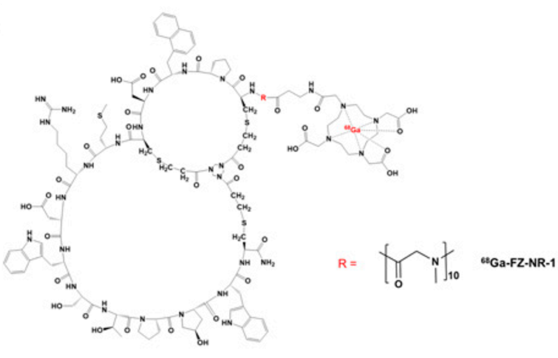
Fig. 1 Radiochemical structure of 68Ga-labeled radiotracers

