Supplementary: Dual-time-point [¹⁸F] FDG-PET/CT as a prognostic biomarker in pleural mesothelioma undergoing immunotherapy

Fig. S1
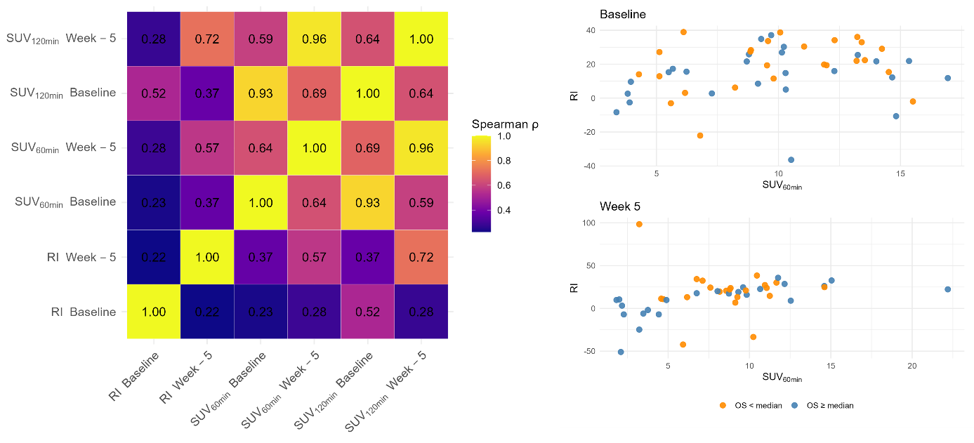
Correlation between PET metrics and survival grouping. Left: Spearman correlation matrix (ρ) for RI, SUV_{60min}, and SUV_{120min} measured at baseline and week-5; cells display ρ values. Right: Scatterplots of RI versus SUV_{60min} at baseline (top) and week-5 (bottom). Points are coloured by overall survival relative to the panel-specific median (OS ≥ median vs OS < median); no trend lines are shown. SUV_{60min} and SUV_{120min} denote [¹⁸F]FDG uptake 60 and 120 minutes post-injection. Abbreviations: SUV, standardised uptake value; RI, retention index; OS, overall survival; FDG, fluorodeoxyglucose.
Fig. S2 Kaplan–Meier curves at baseline stratified by SUV_{60min} and RI tertiles, demonstrated no difference in survival. Panel A: SUV_{60min} tertiles; Panel B: RI tertiles. Within each panel, PFS (left) and OS (right) are shown with risk tables. Groups are labelled T1 (Low), T2 (Intermediate), and T3 (High), defined by ascending rank tertiles across the week-5 cohort for each biomarker separately. Log-rank p-values compare all three tertiles. SUV_{60min} denotes [¹⁸F]FDG uptake at 60 minutes post-injection. Abbreviations: SUV, standardised uptake value; RI, retention index; PFS, progression-free survival; OS, overall survival; FDG, fluorodeoxyglucose. For context, survival analyses for SUV from a larger baseline-imaging cohort are reported in Thunold et al.(2024), based on a broader cohort with available baseline imaging, regardless of dual-time-point scan availability.

Table S1 Kaplan–Meier medians and pairwise log-rank comparisons for PFS and OS at week-5

A
 | Endpoint | Group | N | Events | Median [95% CI] | Overall_logrank_p
SUV_{60min} — Week 5 | OS | T1 (Low) | 15 | 12 | 20.2 [7.0–27.7] | 0.042
SUV_{60min} — Week 5 | OS | T2 (Intermediate) | 15 | 14 | 6.9 [4.2–14.6]
SUV_{60min} — Week 5 | OS | T3 (High) | 15 | 13 | 17.3 [6.2–23.0]
SUV_{60min} — Week 5 | PFS | T1 (Low) | 15 | 14 | 7.1 [1.6–15.4] | 0.043
SUV_{60min} — Week 5 | PFS | T2 (Intermediate) | 15 | 15 | 3.4 [1.8–5.5]
SUV_{60min} — Week 5 | PFS | T3 (High) | 15 | 15 | 2.7 [1.4–5.4]
RI | OS | T1 (Low) | 15 | 11 | 23.6 [6.5–30.5] | 0.038
RI | OS | T2 (Intermediate) | 15 | 14 | 13.6 [4.2–17.7] | .
RI | OS | T3 (High) | 15 | 14 | 7.2 [5.3–14.8]
RI | PFS | T1 (Low) | 15 | 14 | 7.0 [1.7–15.4] | 0.031
RI | PFS | T2 (Intermediate) | 15 | 15 | 2.9 [1.6–7.1]
RI | PFS | T3 (High) | 15 | 15 | 3.9 [1.4–5.4]

B
 | Endpoint | T2 (Intermediate) vs T1 (Low) | T3 (High) vs T1 (Low) | T3 (High) vs T2 (Intermediate)
SUV_{60min} | OS | 0.020 | 0.221 | 0.144
SUV_{60min} | PFS | 0.028 | 0.041 | 0.961
RI | OS | 0.044 | 0.016 | 0.610
RI | PFS | 0.072 | 0.014 | 0.349
Panel A: Kaplan–Meier curves with medians (95% CI), N/events, and overall three-group log-rank p-values for PFS and OS. Panel B: Unadjusted pairwise log-rank comparisons between tertiles. The overall log-rank test was significant for both SUV_{60min} and RI and endpoints. Unadjusted pairwise tests showed significant differences for SUV_{60min} (OS: T2 vs T1; PFS: T2 vs T1 and T3 vs T1) and for RI (OS: T2 vs T1 and T3 vs T1; PFS: T3 vs T1), with no other pairs significant. Tertiles T1 (Low), T2 (Intermediate), and T3 (High) were defined by ascending rank tertiles for SUV_{60min} and RI, separately. SUV_{60min} denotes [¹⁸F]FDG uptake at 60 minutes post-injection. Abbreviations: SUV, standardized uptake value; RI, retention index; PFS, progression-free survival; OS, overall survival; FDG, fluorodeoxyglucose.

Fig. S3
Univariable Proportional Hazards models at week-5 for SUV_{60min,} SUV_{120min,} and RI tertiles. For each marker, T2 and T3 are compared with T1 (reference). Points show hazard ratios with 95% CIs (circles = T2 vs T1; triangles = T3 vs T1); colours distinguish OS (red) and PFS (green). The dashed vertical line marks HR = 1. P-values are Wald tests from the Cox models. Groups are labelled T1 (Low), T2 (Intermediate), and T3 (High), defined by ascending rank tertiles across the week-5 cohort for SUV_{60min,} SUV_{120min,} and RI separately. SUV_{60min} and SU_{V120min} denote [¹⁸F]FDG uptake at 60 and 120 minutes post-injection, respectively. Abbreviations: SUV, standardised uptake value; RI, retention index; PFS, progression-free survival; OS, overall survival; FDG, fluorodeoxyglucose.

Table S2 Objective response distribution across week-5 PET tertiles and baseline-to-week-5 changes
SUV_{60min} tertile | Change from baseline | SD+PD | PR
T1 (Low) | decrease | 4 | 7
T1 (Low) | increase | 2 | 0
T2 (Intermediate) | decrease | 9 | 1
T2 (Intermediate) | increase | 4 | 0
T3 (High) | decrease | 6 | 1
T3 (High) | increase | 8 | 0
RI tertile
T1 (Low) | decrease | 8 | 5
T1 (Low) | increase | 0 | 1
T2 (Intermediate) | decrease | 4 | 0
T2 (Intermediate) | increase | 7 | 3
T3 (High) | decrease | 3 | 0
T3 (High) | increase | 11 | 0

Distribution of objective response (PR vs SD+PD) across week-5 PET tertiles and baseline-to-week-5 change direction (increase vs decrease) for SUV_{60min} and RI. Abbreviations: PR, partial response; SD, stable disease, PD, progressive disease; SUV_{60min}, Standardised Uptake Value at 60 minutes; RI; retention index; PET, positron emission tomography.

Figure S4

Kaplan–Meier curves from a week-5 landmark analysis, with survival time calculated from the date of the week-5 PET scan, stratified by SUV60min and RI tertiles. Panel A: SUV_{60min} tertiles; Panel B: RI tertiles. Within each panel, PFS (left) and OS (right) are shown with risk tables. Groups are labelled T1 (Low), T2 (Intermediate), and T3 (High), defined by ascending rank tertiles across the week-5 cohort for SUV60min and RI separately. Log-rank p-values compare all three tertiles. SUV_{60min} denotes [¹⁸F]FDG uptake at 60 minutes post-injection. Abbreviations: SUV, standardised uptake value; RI, retention index; PFS, progression-free survival; OS, overall survival; FDG, fluorodeoxyglucose.

Figure S5
Univariable Cox proportional hazards models from a week-5 landmark analysis, with survival time calculated from the date of the week-5 PET scan, for SUV_{60min}, SUV_{120min}, and RI tertiles. For each marker, T2 and T3 are compared with T1 (reference). Points show hazard ratios with 95% CIs (circles = T2 vs T1; triangles = T3 vs T1); colours distinguish OS (red) and PFS (green). The dashed vertical line marks HR = 1. P-values are Wald tests from the Cox models. Groups are labelled T1 (Low), T2 (Intermediate), and T3 (High), defined by ascending rank tertiles across the week-5 cohort for SUV_{60min}, SUV_{120min}, and RI separately. For PFS analyses, patients with progression prior to the week-5 PET scan were excluded. SUV_{60min} and SUV_{120min} denote [¹⁸F]FDG uptake at 60 and 120 minutes post-injection, respectively. Abbreviations: SUV, standardised uptake value; RI, retention index; PFS, progression-free survival; OS, overall survival; FDG, fluorodeoxyglucose.

