Supplementary Files

Supplementary Methods
Scan acquisition and reconstruction
The [¹⁸F]F-AraG PET/CT-scans were acquired on the 106 cm long axial field of view Biograph Vision Quadra PET/CT system (Siemens Healthineers, Erlangen, Duitsland). First, a low dose CT (120 kV, 30mAs) was made for attenuation correction and anatomical correlation and reconstructed in 3 mm coupes. Then 185 MBq ±10% of [¹⁸F]F-AraG was automatically injected with a MEDRAD (Bayer, Leverk usen, Germany) system in two phases (phase 1 0.8 ml/sec, phase 2 2.0 ml/sec). Simultaneously with tracer administration we started the 90 min dynamic PET acquisition.
The [¹⁸F]F-AraG PET acquisitions were corrected for detector normalization, decay, dead time, attenuation, randoms and scatter. The data was iteratively reconstructed with an ordered-subset expectation maximization algorithm with 4 iterations and 5 subsets, using time of flight and point spread function modeling, and application of a 4 mm Gaussian filter for smoothing (EARL2 compliant reconstruction). Scans were reconstructed in 31 frames as 6x20, 6x30, 5x60, 5x240, 6x300, 3x600 second frames. One static reconstruction of the dynamic timeframes between 60 and 70 min was generated for visual assessment of the lesions and calculation of simplified uptake metrics. The final images had a voxel size of 3.3x3.3x2 mm³ and a spatial resolution of about 5 mm full width at half maximum. All PET/CT-scans were acquired and reconstructed according to the guidelines of the European Association of Nuclear Medicine (EARL2). (1)
Adjusted scatter correction
In all three [¹⁸F]F-AraG PET-scans of patient D, a strong discrepancy was observed between the whole blood activity concentration measured in the aorta and the blood samples. No differences in acquisition, reconstruction protocol, sampling or sample analysis method were identified that could account for this mismatch. To match the image-derived whole blood activity concentration with the measured blood sample activity concentration, the three scans of patient D were re-reconstructed using prototype research software (E7, Siemens Healthineers, Erlangen, Germany) with absolute scatter correction and an adjusted scatter correction factor, which were subsequently used for further analysis.
Blood sampling and measurements
Arterial blood samples were manually drawn from either the arteria radialis or the arteria ulnaris at 5, 10, 15, 25, 35, 45, 60, 75 and 90 minutes p.i.
Each blood sample was measured for radioactivity concentration in whole-blood and in plasma using a well-counter. The well-counter, injection syringe, dose-calibrator and PET-camera were cross-calibrated. Plasma samples were analyzed for polar radiolabeled metabolites of [¹⁸F]F-AraG by solid-phase extraction as described previously. (2)
Calibrating the blood input function
To generate the image derived input function (IDIF) for the pharmacokinetic modeling, the mean activity concentration measured in the ascending aorta was fitted using an exponential function and scaled based on the mean activity concentration found in the arterial whole blood samples. This was then corrected for the time difference between activity arriving in the ascending aorta and the radial or ulnar arteries. The whole blood IDIF was further corrected for the bi-exponential fit of the plasma-to-blood ratio and the Hill function fit of the parent fraction, excluding any false data points (3).
Region delineations
Uptake in the tumor lesions and organs was determined on the dynamic [¹⁸F]F-AraG PET-scans using software for quantitative oncological molecular analysis ACCURATE (4). The screening [¹⁸F]F-FDG PET-scan, de diagnostic CT and the within ACCURATE available low dose CT-scan were used for anatomical reference. When tumor lesions or lymph nodes could not be recognized based on the [¹⁸F]F-AraG PET-uptake, delineation was done on the low-dose CT-scan.
Tumor lesions
A selection of the tumor lesions was delineated on the dynamic [¹⁸F]F-AraG PET/CT-scans. This selection was determined by visual assessment of the tumor lesions on the 60-70 min p.i. time frame. Selection criteria were positive uptake on at least one time point, lesion size ≥ 1cm and reliable demarcation of the tumor lesion on the low dose CT or [¹⁸F]F-AraG PET-scan. Tumor lesions were delineated either by automatic contouring or by manually placing a sphere-shaped volume of interest (VOI) of at least 1 cm diameter (=0.5 mL) in the center of a tumor lesion or in the border when the center was photopenic. For heterogeneous tumor lesions, multiple regions were defined separately.
Organs
Organs were delineated manually or semi-automatically in ACCURATE on the low dose CT with the dynamic [¹⁸F]F-AraG PET-uptake as reference. Vessels, tumor lesions and other structures that do not encompass the tissue of interest are avoided when possible.
Manual delineation was done by one of the two methods: The first was placement of a spherical VOI within the organ: adipose tissue (abdominal region), grey matter of the brain, white matter of the brain, pineal gland, lungs (one sphere in both lungs), the liver, non-tumor draining lymph nodes, the spleen, and the muscle (gluteus maximus and medius muscle). For the second manual method several circle shaped VOIs were placed on multiple adjacent axial slices. This applied for the adenoid tonsils, the myocard (left ventricle), the adrenal gland (only left), the bone marrow (lumbal vertebra 3, 4 and 5).
A semi-automatic delineation method has been applied for high uptake regions with clear demarcation with the background: the choroid plexus, pituitary gland, parotid gland (left), the thyroid (left), the pancreas and the kidneys. Erosion was performed to prevent misalignment in case of internal or external motion. An example VOI per organ is visualised in Suppl. Fig 1.
Blood pool
The activity concentration in the blood was derived by manually placing a circle-shaped VOI with 1cm diameter in 5 adjacent axial coupes in the ascending aorta, resulting in a volume of 0.5 mL.
Semi-automatic delineation
For the semi-automatic delineation, the majority vote 3 (MV3) method, available in ACCURATE, was used. The MV3 delineation includes all voxels selected by at least three of the four following delineation methods:
- SUV2.5: Includes all voxels with an SUV greater than 2.5
- SUV4.0: Includes all voxels with an SUV larger than 4.0
- 41Max: Includes all voxels with an SUV exceeding 41% of the maximum SUV within the VOI.
- A50P: Includes all voxels with an SUV higher than 50% of the sum of the maximum SUV within the delineated VOI and the background. The background is defined as a 1-voxel-thick spherical shell located 2.5 cm from the border of the 70% isocontour of the SUVpeak. (5)
To minimize the effects of potential movement, the (semi-)automatically derived VOIs were eroded at least once, and up to twice, following their generation.
TAC generation
All delineations (tumor lesions, organs) were checked for both internal as external motion and the delineations were adjusted accordingly in case of motion. For each delineations region, the measured mean activity concentrations over time were derived to generate time-activity curves (TACs).
The TACs were visually assessed and in case of severe motion, the delineations were checked and corrected. When the motion could not be corrected for, the lesion was excluded from analysis. This was the case for 16 benign lymph nodes and 12 organs: one adipose tissue, one bone marrow, two grey matter brain regions, six white matter brain regions and two adenoid tonsils. Organ delineations with a size smaller than 1 mL were excluded for quantitative analysis, except for the benign lymph nodes, which were all 0.5 mL. The organ TACs can be found in Suppl. Fig. 3.

Pharmacokinetic modelling, parameters and simplified uptake measures
Pharmacokinetic modeling was performed with an in-house software tool developed in MATLAB (MATLAB version 7.04, The MathWorks, Inc., Natick, Massachusetts, United States). The model was utilized to fit the TACs with the corresponding IDIFs using a non-linear least squares algorithm. This was performed with both weighted (tumor regions) and unweighted (organ regions) approaches, incorporating constraints on the pharmacokinetic rate constants.
Up to 4 rate constants were estimated per model fit and additionally the fraction of blood volume (V_{b}).
- K₁ indicates the extravasation rate of [¹⁸F]F-AraG and the transport into the cell via nucleoside transporters (perfusion and extraction)
- k₂ indicates the reverse process of [¹⁸F]F-AraG efflux out the cells into the capillaries.
- k₃ is the rate constant resulting from the phosphorylation of [¹⁸F]F-AraG either by dGk (in the mitochondria) or dCk (in the cytoplasm).
- k₄ represent the dephosphorylation of [¹⁸F]F-AraGTP by SAMHD1.
The following macro parameters were calculated based on the estimated rate constants. The V_{T} for the regions that could be described with a reversible model and the K_{i} for the regions described with an irreversible model.
$$V_{T}= \frac{K_{1}}{k_{2}}\left(1+\frac{k_{3}}{k_{4}} \right)$$
$${ K}_{i}=\frac{K_{1}*k_{3}}{k_{2}+k_{3}}$$

The simplified uptake measure standardized uptake value (SUV) was calculated as
$$SUV=\frac{AC_{peak}}{IA*BW}$$
With IA representing the injected activity and BW denoting body weight, expressed either as lean body mass (SUV_{LBM}) calculated using the Janmahasatian equation (6), the total body weight (SUV_{BW}), or the body surface area (SUV_{BSA}) derived from the Du Bois formula (7). AC_{peak} is defined as the highest mean activity concentration per 1 mL within the entire VOI.

Supplementary Figures

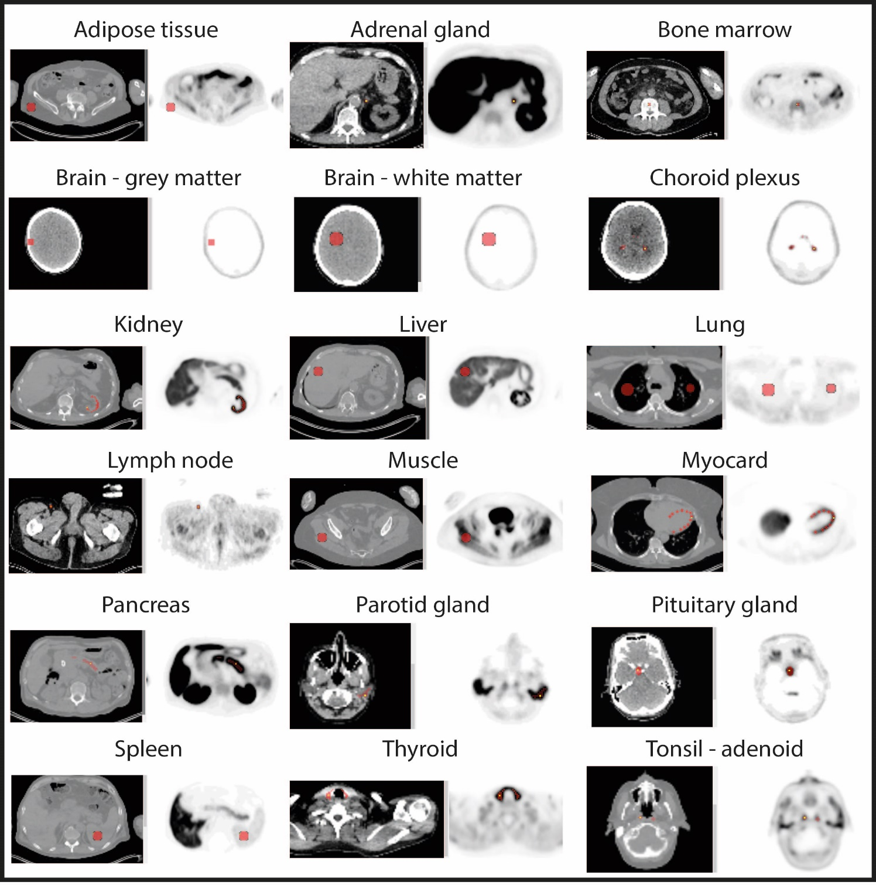

Supplementary Figure 1 organ delineation method; Per organ an example is visualized of the delineation on the axial slice of both the low dose CT-scan (left) and a static frame of the [¹⁸F]F-AraG PET (right). The VOI is indicated in red. The yellow spots represent the SUV_{max}; the voxel with the highest uptake. Volumes ≤ 1mL were excluded from quantitative analysis. SUV: standardized uptake value.

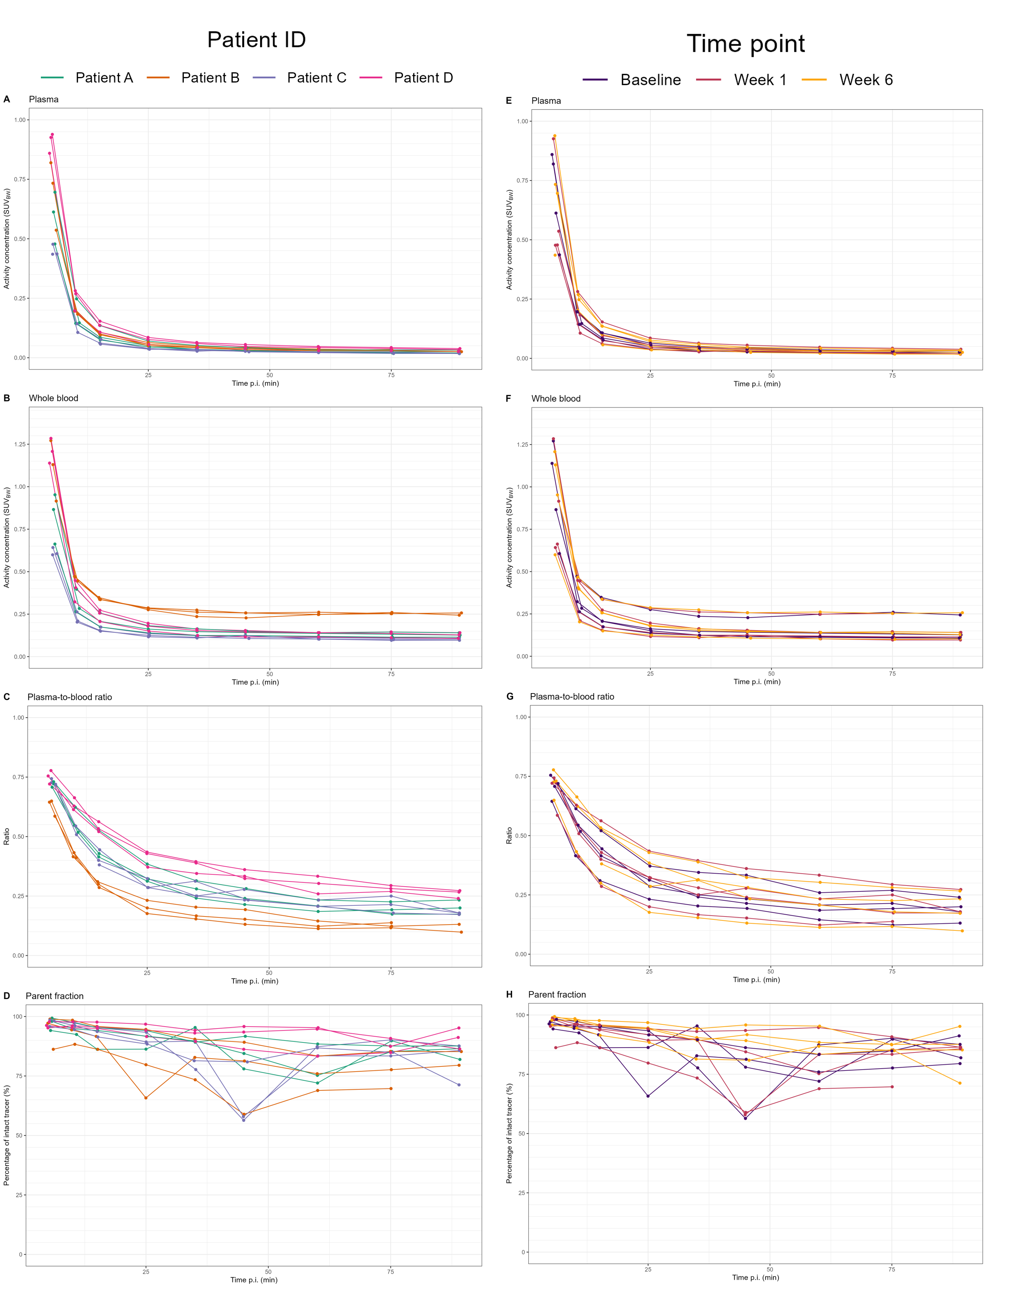
Supplementary Figure 2 [¹⁸F]F-AraG in blood; Pharmacokinetics of [¹⁸F]F-AraG in plasma and blood studied per patient (A-D) and per time point (E-H). For each color patient (left column), three time points are visualized and for each color time point (right column) four patients are visualized. SUV_{BW} = standardized uptake value normalized for body weight, p.i. = post injection, min = minutes.
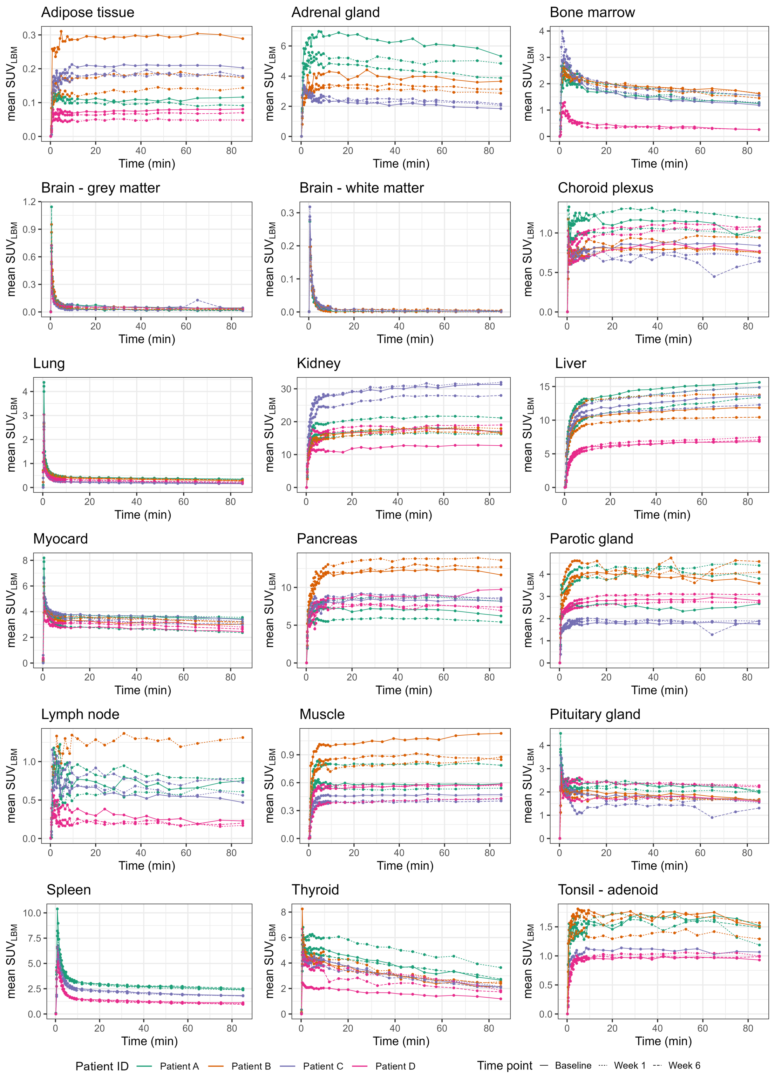

Supplementary Figure 3 Organ TACs; Organ uptake over time for the three time points. No uptake data in the spleen was available for patient B, due to a splenectomy in the medical history. For clarity, only one lymph node per patient was visualized. SUV_{LBM}: standardized uptake value normalized for lean body mass.
 |  | Vb |  | K1 |  | k2 |  | k3 |  | k4 |  | K_{i} |  |  |  | V_{T}
Organ | Model | Med | IQR | Med | IQR | Med | IQR | Med | IQR | Med | IQR | Med | IQR | CoV | Med |  | IQR | CoV
Adipose tissue | 2T3K | 0 | 0-0.01 | 0.01 | 0.01-0.01 | 0.14 | 0.09-0.34 | 0.33 | 0.21-0.38 |  |  | 0.01 | 0-0.01 | 0.49 | 7.46 |  | 2.66-32.76 | 1.31
Left adrenal gland | 2T3K | 0.11 | 0.11-0.11 | 0.34 | 0.29-0.35 | 0.02 | 0.01-0.02 | 0.03 | 0.01-0.06 |  |  | 0.18 | 0.17-0.18 | 0.38 | 57.94 |  | 51.71-89.65 | 0.37
Bone marrow | 2T4K | 0.04 | 0.03-0.06 | 0.20 | 0.17-0.25 | 0.35 | 0.29-0.4 | 0.23 | 0.18-0.29 | 0.01 | 0.01-0.01 | 0.08 | 0.07-0.08 | 0.41 | 16.10 |  | 13.17-17.37 | 0.32
Grey matter | 1T2K | 0.03 | 0.03-0.04 | 0.00 | 0-0 | 0.01 | 0.01-0.01 |  |  |  |  | 0.00 | 0-0 | 0.49 | 0.23 |  | 0.14-0.35 | 0.52
Choroid plexus | 2T3K | 0.04 | 0.03-0.05 | 0.05 | 0.05-0.06 | 0.00 | 0-0 | 0.01 | 0-1.24 |  |  | 0.04 | 0.03-0.04 | 0.22 | 91.58 |  | 59.25-99.48 | 0.41
White matter | 1T2K | 0.01 | 0.01-0.02 | 0.00 | 0-0 | 0.07 | 0.04-0.18 |  |  |  |  | 0.00 | 0-0 | 1.57 | 0.01 |  | 0-0.01 | 1.00
Parotid gland | 2T3K | 0.06 | 0.06-0.09 | 0.18 | 0.13-0.2 | 0.00 | 0-0.01 | 0.02 | 0-0.06 |  |  | 0.15 | 0.1-0.17 | 0.33 | 70.52 |  | 45.7-89.02 | 0.41
Kidneys | 2T3K | 0.12 | 0.1-0.15 | 1.06 | 0.98-1.68 | 0.06 | 0.04-0.13 | 0.62 | 0.35-1.29 |  |  | 0.91 | 0.82-1.37 | 0.49 | 100.00 |  | 100-100 | 0.00
Liver | 2T3K | 0 | 0-0 | 0.54 | 0.41-0.63 | 0.00 | 0-0 | 1.51 | 1.09-1.72 |  |  | 0.54 | 0.41-0.63 | 0.29 | 98.47 |  | 86.87-100 | 0.11
Lungs | 1T2K | 0.12 | 0.1-0.15 | 0.02 | 0.02-0.02 | 0.01 | 0.01-0.01 |  |  |  |  | 0.01 | 0.01-0.01 | 0.27 | 2.76 |  | 2.24-3.1 | 0.27
Lymph nodes | 2T3K | 0.01 | 0.01-0.02 | 0.06 | 0.03-0.08 | 0.27 | 0.06-0.48 | 0.25 | 0.12-0.55 |  |  | 0.03 | 0.02-0.04 | 0.46 | 9.00 |  | 4.75-20.16 | 1.31
Muscle | 2T3K | 0 | 0-0.01 | 0.04 | 0.03-0.04 | 0.04 | 0.01-0.09 | 0.14 | 0.06-0.22 |  |  | 0.03 | 0.02-0.03 | 0.23 | 49.70 |  | 27.53-66.45 | 0.55
Myocard | 2T3K | 0.25 | 0.18-0.28 | 0.32 | 0.28-0.36 | 0.11 | 0.07-0.17 | 0.18 | 0.12-0.24 |  |  | 0.19 | 0.17-0.25 | 0.24 | 59.31 |  | 36.2-83.23 | 0.43
Pancreas | 2T3K | 0.15 | 0.13-0.17 | 0.58 | 0.51-0.63 | 0.00 | 0-0.02 | 0.04 | 0-0.6 |  |  | 0.49 | 0.37-0.61 | 0.32 | 99.68 |  | 98.55-100 | 0.12
Pituitary gland | 2T3K | 0.13 | 0.09-0.17 | 0.17 | 0.13-0.19 | 0.12 | 0.02-0.23 | 0.19 | 0.04-0.32 |  |  | 0.11 | 0.08-0.12 | 0.28 | 43.38 |  | 32.87-71.98 | 0.58
Spleen | 2T4K | 0.18 | 0.16-0.21 | 0.90 | 0.74-0.98 | 0.86 | 0.8-0.97 | 0.21 | 0.16-0.25 | 0.01 | 0.01-0.01 | 0.15 | 0.09-0.16 | 0.31 | 28.39 |  | 18.82-32.19 | 0.33
Thyroid | 2T4K | 0.26 | 0.25-0.28 | 0.38 | 0.35-0.44 | 0.10 | 0.07-0.21 | 0.49 | 0.17-0.75 | 0.04 | 0.03-0.04 | 0.11 | 0.09-0.13 | 0.27 | 30.89 |  | 26.91-33.83 | 0.34
Adenoid tonsils | 2T3K | 0.02 | 0.01-0.04 | 0.08 | 0.07-0.09 | 0.01 | 0-0.08 | 0.04 | 0.02-0.21 |  |  | 0.06 | 0.05-0.06 | 0.20 | 47.09 |  | 19.52-89.13 | 0.64
Supplementary Table 1 Organ pharmacokinetic parameters; Parameters as derived from the selected pharmacokinetic model. The cases where no adequate fit could be obtained were excluded. Red values indicate the parameters as derived from the non-selected model: For the organs where the irreversible model is selected, the 2T4K-derived V_{T} is displayed and for the organs where a reversible model is selected the 2T3K derived K_{i} is displayed in red. Med: median, IQR: interquartile range, CoV=coefficient of variation (standard deviation/mean)

Supplementary figure 4 Non-specific focal [¹⁸F]F-AraG accumulation; Patient A displayed non-specific tracer accumulation on the baseline PET/CT-scan.
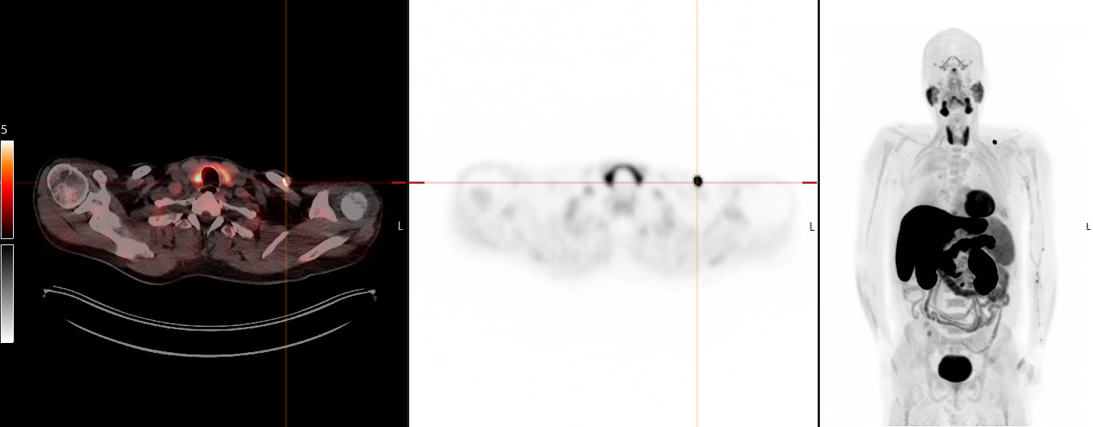

Supplementary figure 5 Example fits for two tumor regions per patient
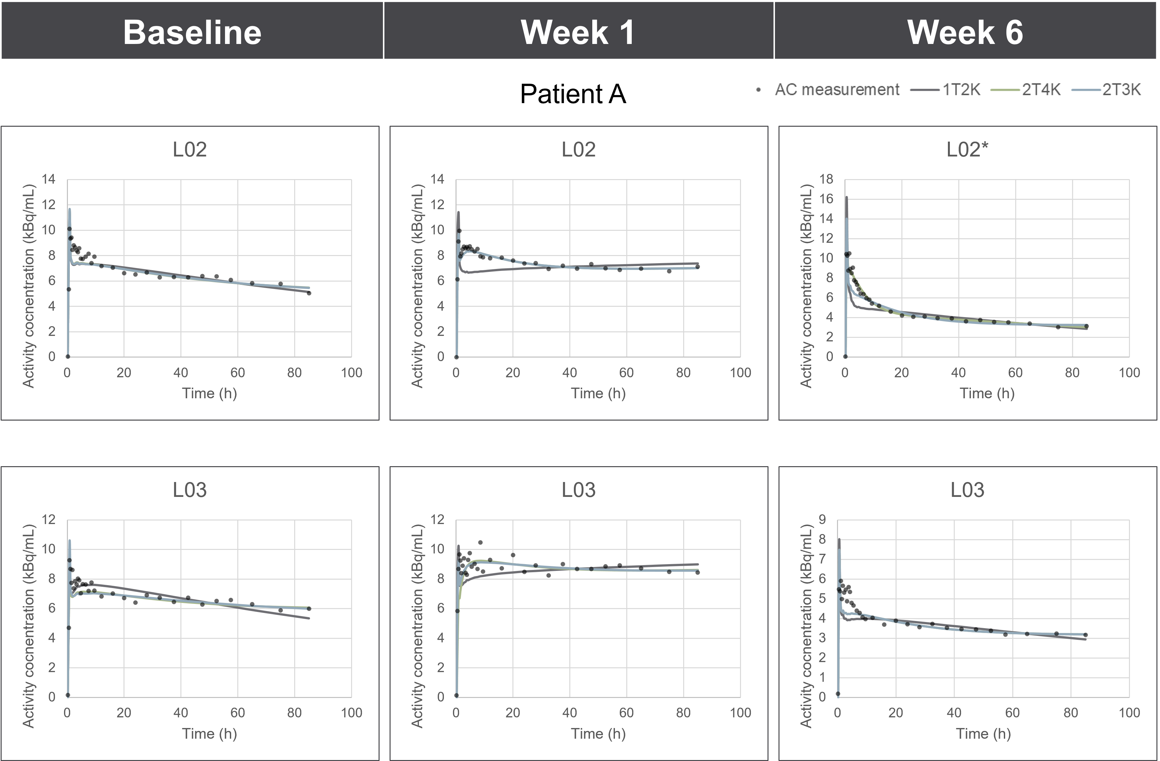

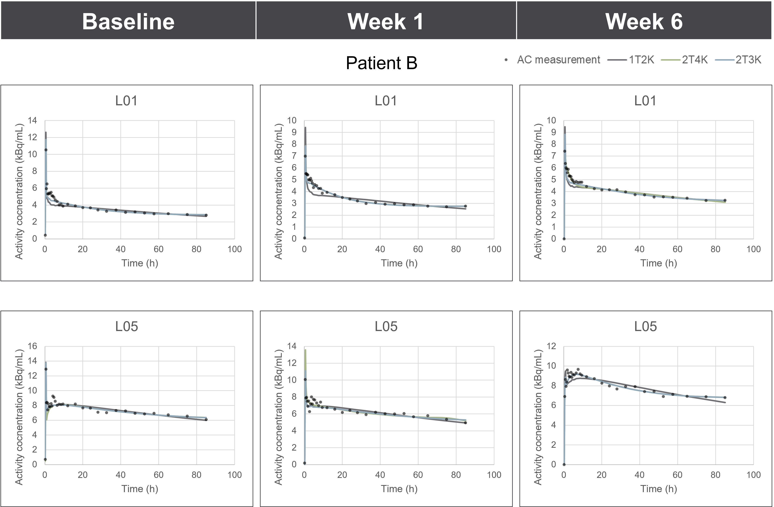
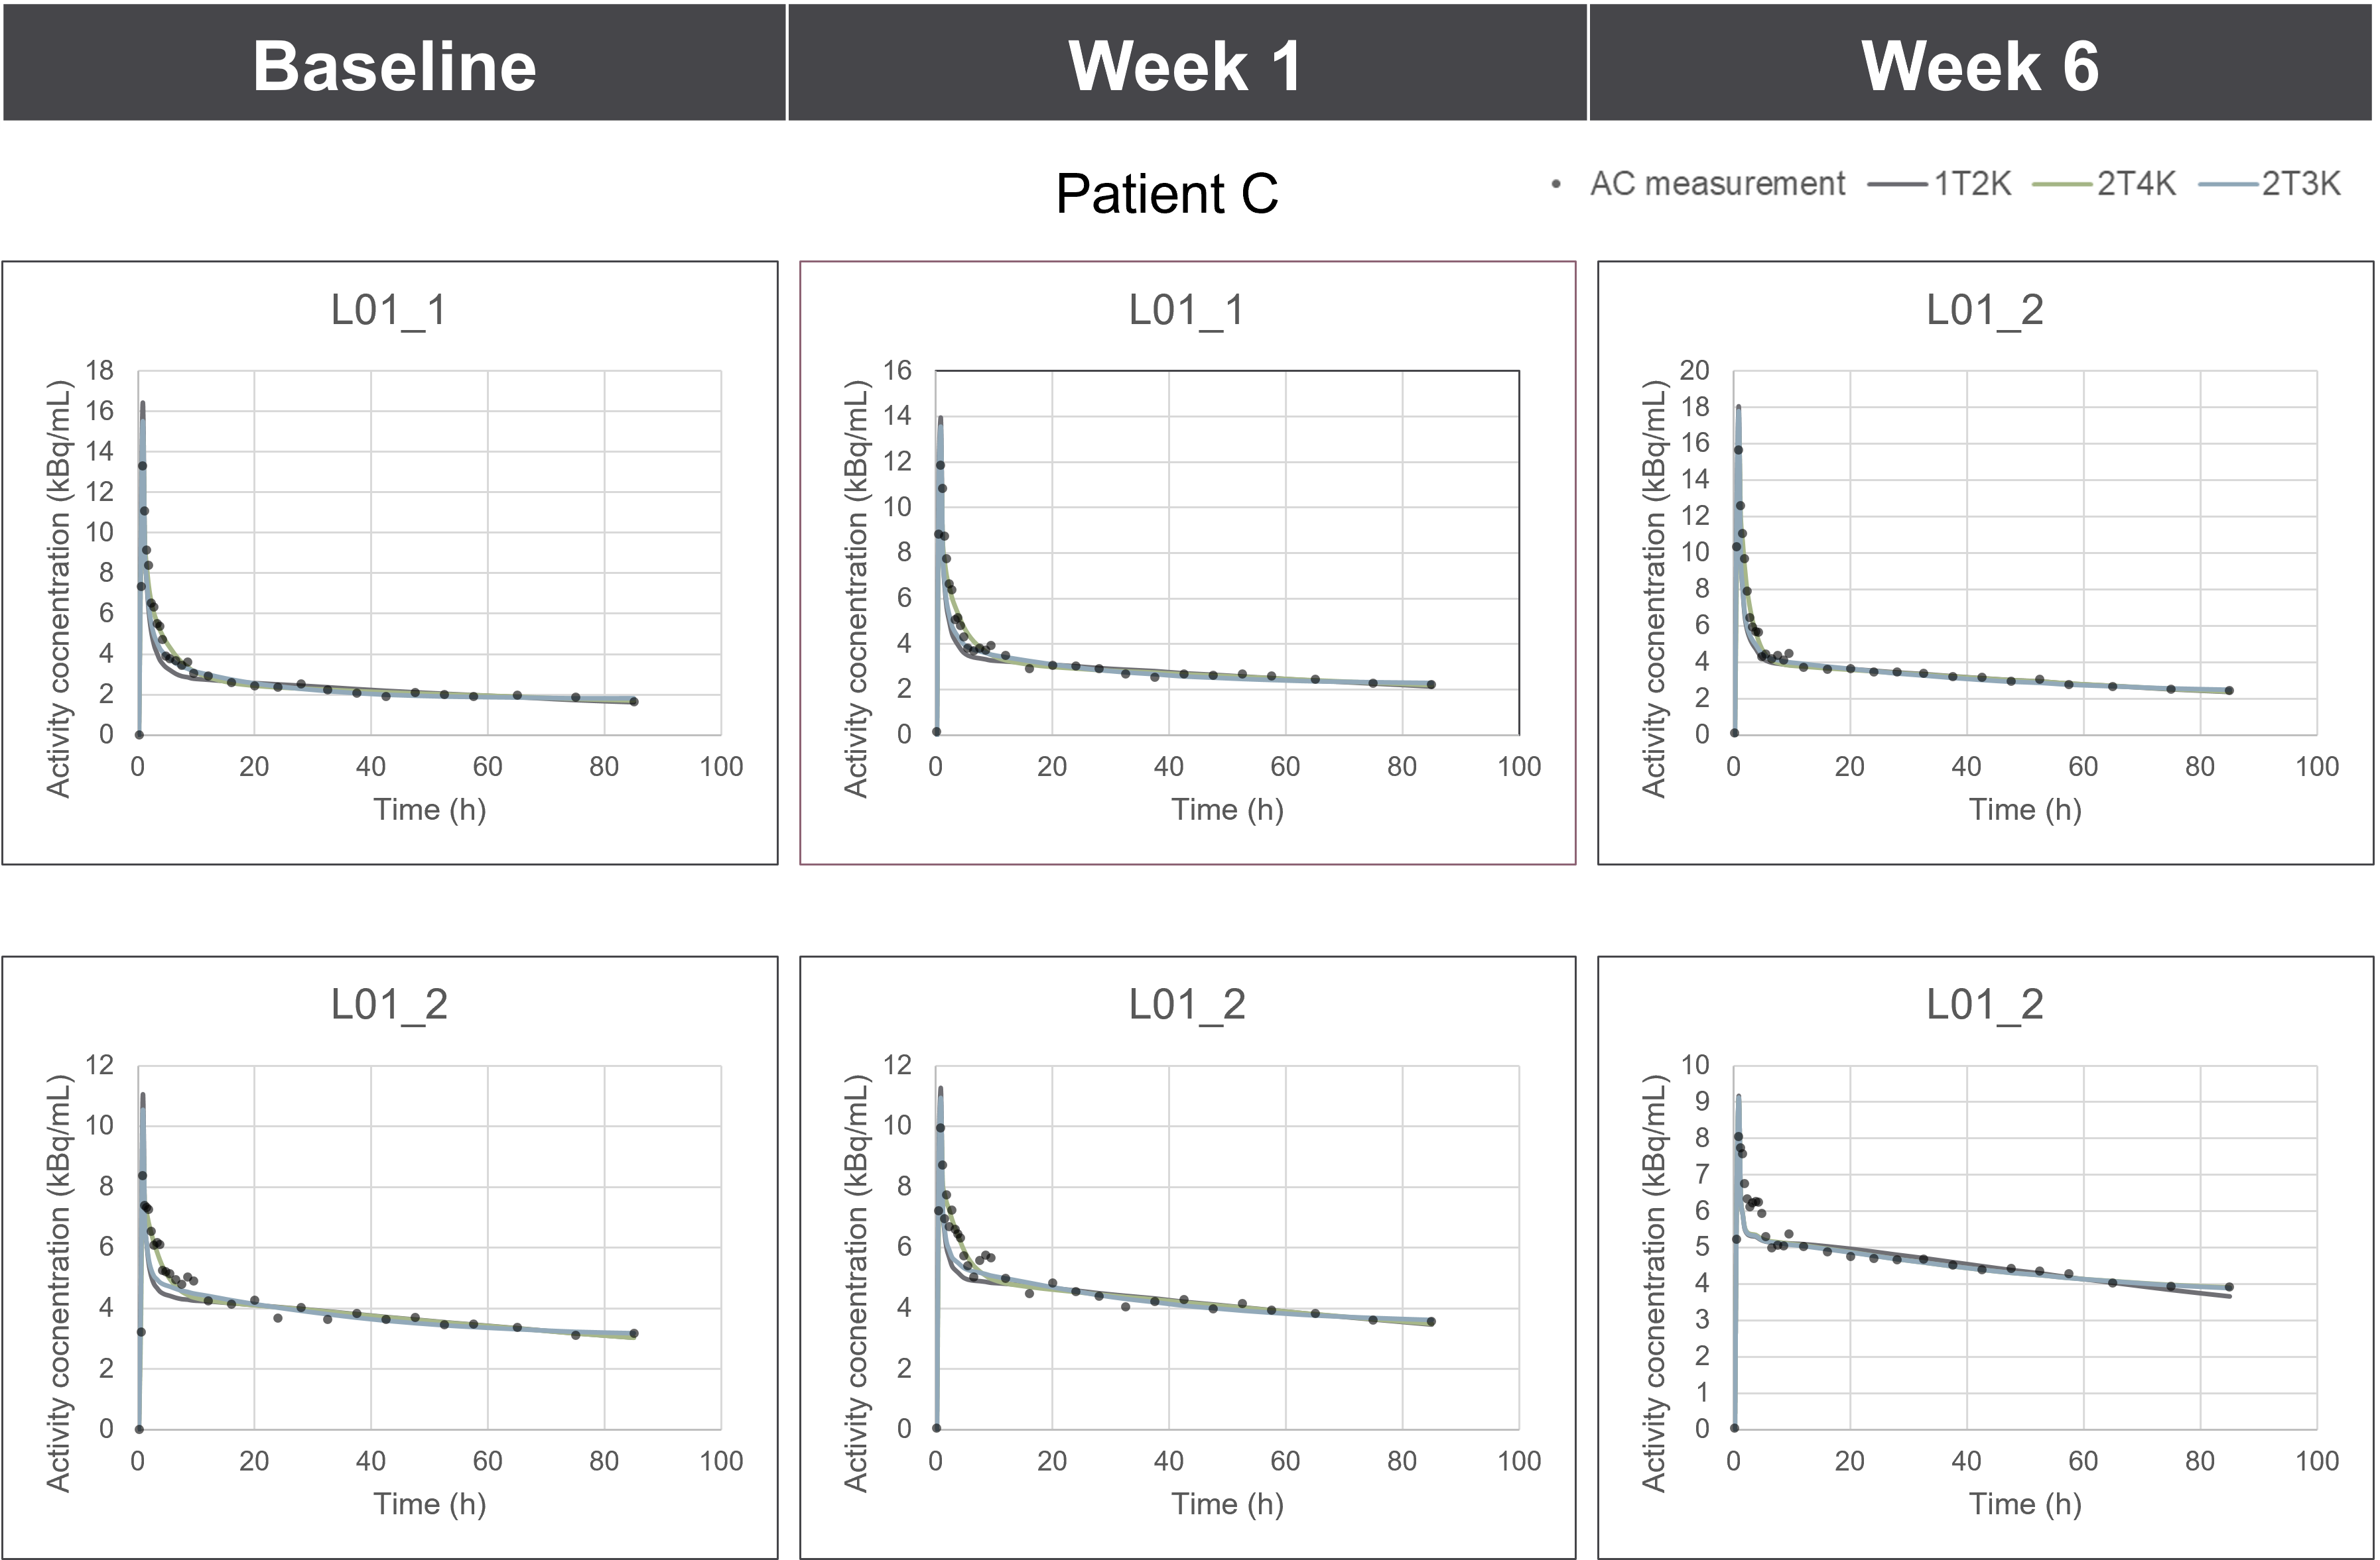
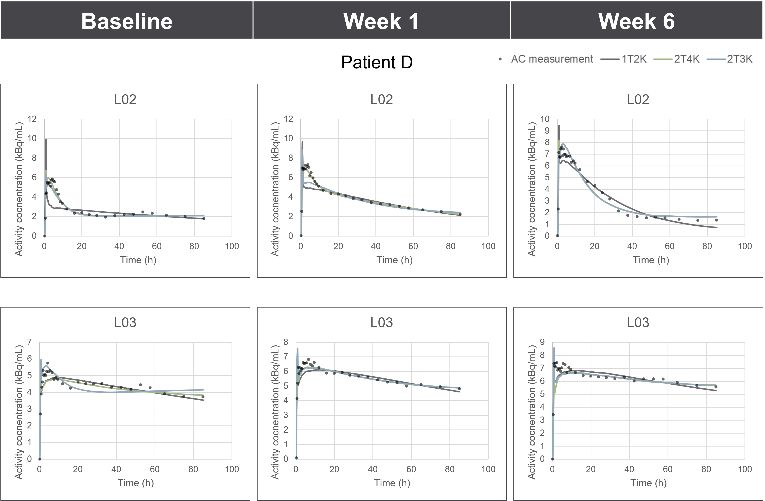
Supplemental Table 2 Tumor pharmacokinetic parameters; Fitted pharmacokinetic rate constants, V_{b}, V_{T} and K_{i} for the 19 tumor regions modeled: six tumor lesions for patient A, eight tumor lesions for patient B, three regions in two tumor lesions for patient C and two tumor lesions of patient D. Notably, one tumor lesion (the primary esophageal tumor of patient A) was irradiated between week 1 and week 6 and therefore excluded at the week 6 time point. Additionally, one lesion (the sigmoid lesion of patient D at baseline) was excluded due to severe motion. CoV: coefficient of variance (standard deviation/mean).

 | 2T3K |  |  |  |  | 2T4K
Parameter | V_{b} | K₁ | k₂ | k₃ | K_{i} | V_{b} | K₁ | k₂ | k₃ | k₄ | V_{T}
Median | 0.12 | 0.11 | 0.01 | 0.01 | 0.06 | 0.11 | 0.13 | 0.01 | 0.02 | 0.00 | 45.50
25% percentile | 0.08 | 0.09 | 0.01 | 0.01 | 0.05 | 0.08 | 0.10 | 0.01 | 0.01 | 0.00 | 18.43
75% percentile | 0.16 | 0.14 | 0.02 | 0.02 | 0.08 | 0.16 | 0.16 | 0.05 | 0.07 | 0.01 | 75.92
CoV | 0.46 | 0.33 | 2.12 | 1.26 | 0.46 | 0.43 | 0.43 | 1.94 | 2.05 | 1.21 | 0.63

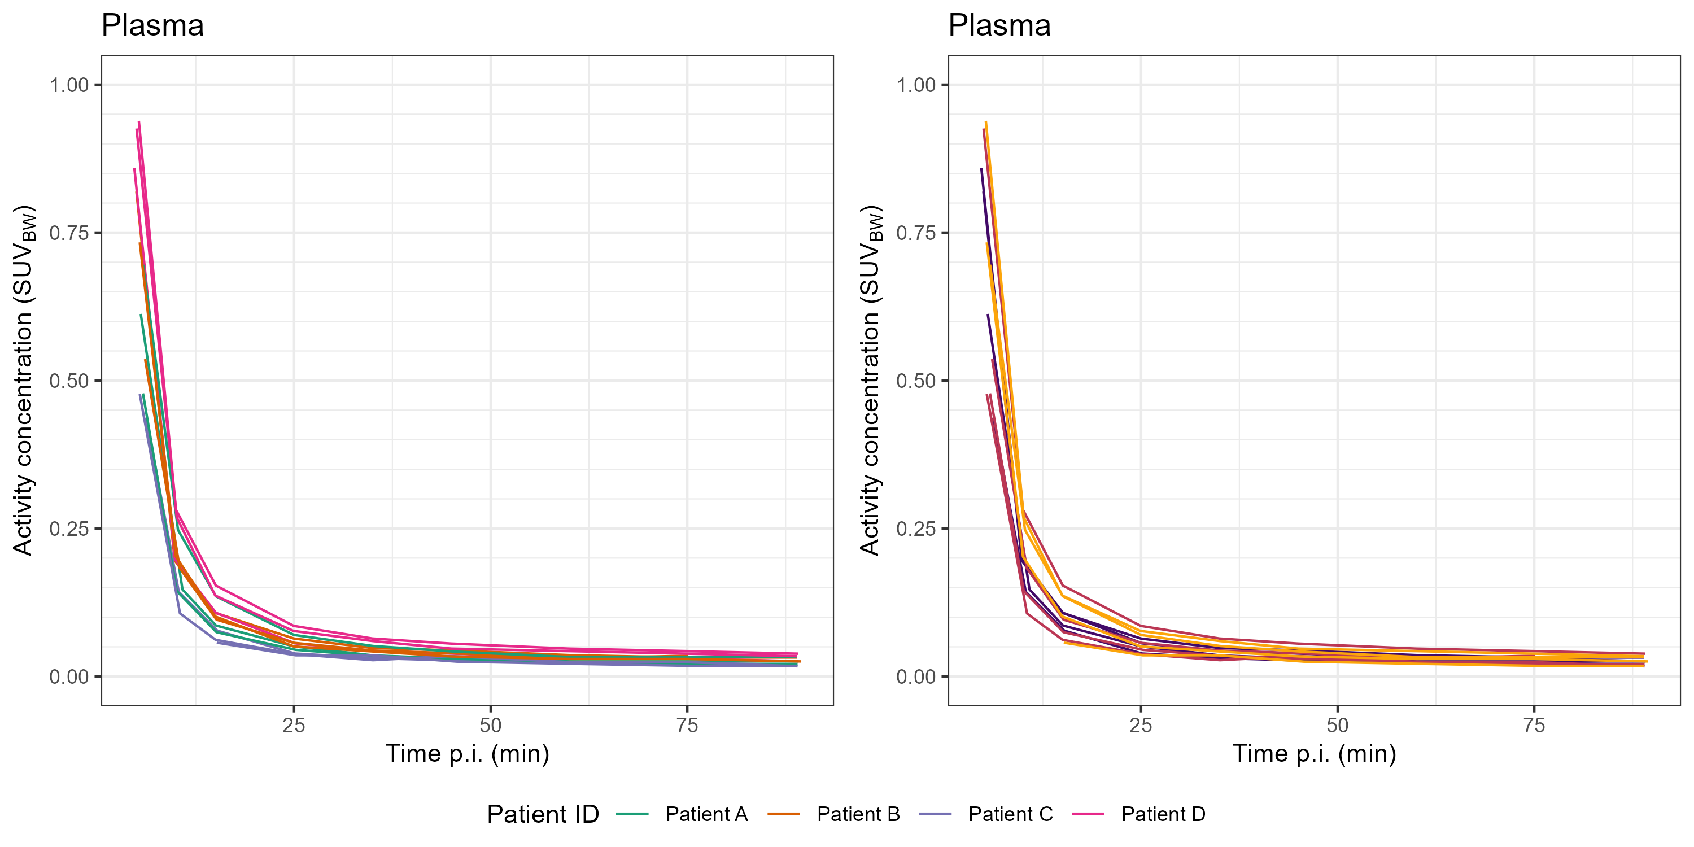

Supplemental Figure 6 Relationship of tumor lesion kinetic parameters with simplified uptake metrics for the 2T3K-derived K_{i} (A-F) and the 2T4K-derived V_{T} (F-K). All six studied simplified uptake measures tend to correlate well with the K_{i} but not with the V_{T}. SUV: standardized uptake value, normalized for _{LBM:} lean body mass, _{BW}: body weight, _{BSA}: body surface area, TBR: tumor-to-blood ratio, TP_{P}R: tumor-to-plasma corrected for parent fraction ratio, TPR: tumor-to-plasma ratio.

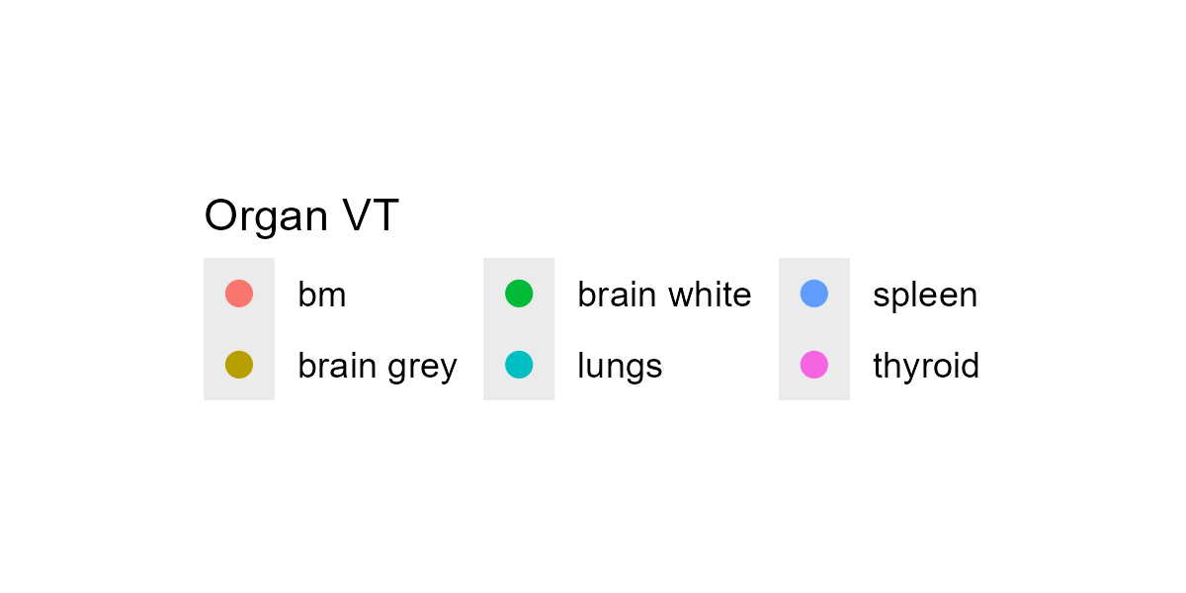

Supplementary Figure 7 Relationship of organ kinetic parameters with simplified uptake metrics; For the organs for which the 2T3K model was selected (see Table 2), the K_{i} values are used for comparison (A-E); for the organs for which the 2T4K model was selected, the V_{T} values are used (G-L). All six studied simplified uptake measures tend to correlate well with the selected kinetic parameter. SUV: standardized uptake value, normalized for _{LBM:} lean body mass, _{BW}: body weight, _{BSA}: body surface area, TBR: tumor-to-blood ratio, TP_{P}R: tumor-to-plasma corrected for parent fraction ratio, TPR: tumor-to-plasma ratio. gl parotis: glandula parotis, ton adenoid: adenoid tonsils, bm: bone marrow
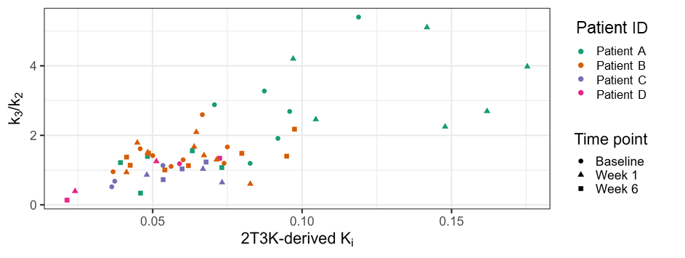Supplementary Figure 8; Visual interpretation of the relationship between the tumor’s k3:k2 ratio and the 2T3K-derived K_{i} suggests that the K_{i} is influenced by perfusion.

References
1. Boellaard R, Delgado-Bolton R, Oyen WJ, Giammarile F, Tatsch K, Eschner W, et al. FDG PET/CT: EANM procedure guidelines for tumour imaging: version 2.0. Eur J Nucl Med Mol Imaging. 2015;42(2):328-54.
2. Wijngaarden JE, Slebe M, Pouw JEE, Oprea-Lager DE, Schuit RC, Dickhoff C, et al. Pharmacokinetic analysis and simplified uptake measures for tumour lesion [(18)F]F-AraG PET imaging in patients with non-small cell lung cancer. Eur J Nucl Med Mol Imaging. 2025;52(2):719-29.
3. Somvanshi PR, Venkatesh KV. Hill Equation. In: Dubitzky W, Wolkenhauer O, Cho K-H, Yokota H, editors. Encyclopedia of Systems Biology. New York, NY: Springer New York; 2013. p. 892-5.
4. Boellaard R. Quantitative oncology molecular analysis suite: ACCURATE. Journal of Nuclear Medicine. 2018;59(supplement 1):1753.
5. Cheebsumon P, Yaqub M, van Velden FH, Hoekstra OS, Lammertsma AA, Boellaard R. Impact of [(1)(8)F]FDG PET imaging parameters on automatic tumour delineation: need for improved tumour delineation methodology. Eur J Nucl Med Mol Imaging. 2011;38(12):2136-44.
6. Janmahasatian S, Duffull SB, Ash S, Ward LC, Byrne NM, Green B. Quantification of lean bodyweight. Clin Pharmacokinet. 2005;44(10):1051-65.
7. Burton RF. Estimating body surface area from mass and height: theory and the formula of Du Bois and Du Bois. Ann Hum Biol. 2008;35(2):170-84.

