Appendix
Supplementary Table 1: MTV vs MRI-volume
Patient Nr. 1
Volume meningioma (PET vs MRI in mL)
50% isocontour | 1.10 vs 4.86
SUV_{min} 4 | 0.02 vs 4.86
SUV_{max} | 4.1
Patient Nr. 2
Volume meningioma (PET vs MRI in mL)
50% isocontour | 16.48 vs 20.77
SUV_{min} 4 | 24.46 vs 20.77
SUV_{max} | 15.4
Patient Nr. 3
Volume meningioma 1 (PET vs MRI in mL)
50% isocontour | 20.05 vs 24.15
SUV_{min} 4 | 0.04 vs 24.15
SUV_{max} | 4.2
Volume meningioma 2 (PET vs MRI in mL)
50% isocontour | 4.16 vs 4.86
SUV_{min} 4 | * SUV_{max} < 4* vs 4.86
SUV_{max} | 3.3
Patient Nr. 4
Not visible on MRI, detected on PET (n) | 1
Volume meningioma (PET vs MRI in mL)
50% isocontour | 1.99 vs 2.08
SUV_{min} 4 | 6.43 vs 2.08
SUV_{max} | 17.3
Patient Nr. 5
Not visible on MRI, detected on PET (n) | 1
Volume meningioma 1 (PET vs MRI in mL)
50% isocontour | 0.78 vs 0.80
SUV_{min} 4 | 1.38 vs 0.80
SUV_{max} | 12.0
Volume meningioma 2 (PET vs MRI in mL)
50% isocontour | 5.04 vs 5.22
SUV_{min} 4 | 4.66 vs 5.22
SUV_{max} | 7.6
Patient Nr. 6
Not visible on MRI, detected on PET (n) | 1
Volume meningioma (PET vs MRI in mL)
50% isocontour | 0.65 vs 0.81
SUV_{min} 4 | 1.17 vs 0.81
SUV_{max} | 11.7
Patient Nr. 7
Volume meningioma (PET vs MRI in mL)
50% isocontour | 2.87 vs 1.16
SUV_{min} 4 | 0.54 vs 1.16
SUV_{max} | 5.2
Patient Nr. 8
Volume meningioma (PET vs MRI in mL)
50% isocontour | 2.72 vs 47.51
SUV_{min} 4 | 31.60 vs 47.51
SUV_{max} | 19.1
Patient Nr. 9
Volume meningioma (PET vs MRI in mL)
50% isocontour | 17.02 vs 29.15
SUV_{min} 4 | 32.26 vs 29.15
SUV_{max} | 15.1
Patient Nr. 10
Volume meningioma (PET vs MRI in mL)
50% isocontour | 0.24 vs 0.34
SUV_{min} 4 | 0.15 vs 0.34
SUV_{max} | 6.7
Patient Nr. 11
Not visible on MRI, detected on PET (n) | 2
Volume meningioma 1 (PET vs MRI in mL)
50% isocontour | 1.43 vs 1.38
SUV_{min} 4 | 2.77 vs 1.38
SUV_{max} | 11.9
Volume meningioma 2 (PET vs MRI in mL)
50% isocontour | 0.58 vs 0.20
SUV_{min} 4 | 0.39 vs 0.20
SUV_{max} | 7.2
Volume meningioma 3 (PET vs MRI in mL)
50% isocontour | 0.37 vs 0.13
SUV_{min} 4 | 0.40 vs 0.13
SUV_{max} | 8.4
Volume meningioma 4 (PET vs MRI in mL)
50% isocontour | 1.12 vs 1.12
SUV_{min} 4 | 2.05 vs 1.12
SUV_{max} | 10.9
Volume meningioma 5 (PET vs MRI in mL)
50% isocontour | 1.65 vs 0.03
SUV_{min} 4 | 5.42 vs 0.03
SUV_{max} | 8.7
Volume meningioma 6 (PET vs MRI in mL)
50% isocontour | 0.89 vs 0.47
SUV_{min} 4 | * SUV_{max} < 4* vs 0.47
SUV_{max} | 3.5
Patient Nr. 12 | Not evaluable in MRI due to artifacts

Supplementary Table 2: non-parametric vs. parametric test (in the case of a normal distribution)
SUV_{mean} and IRS
Pearson-Correlation
50% isocontour (r; [95%-CI]; p) | 0.80; [0.42 - 0.94]; 0.002
SUV_{min} 4 (r; [95%-CI]; p) | 0.797; [0.41 - 0.94]; 0.002
Spearman-Correlation
50% isocontour (r; [95%-CI]; p) | 0.82; [0.46 - 0.95]; 0.002
SUV_{min} 4 (r; [95%-CI]; p) | 0.81; [0.43 - 0.95]; 0.002
TBPR and IRS
Pearson-Correlation
50% isocontour (r; [95%-CI]; p) | 0.78; [0.37 - 0.93]; 0.003
SUV_{min} 4 (r; [95%-CI]; p) | 0.66; [0.14 - 0.89]; 0.02
Spearman-Correlation
50% isocontour (r; [95%-CI]; p) | 0.83; [0.49 - 0.95]; 0.001
SUV_{min} 4 (r; [95%-CI]; p) | 0.72; [0.23 - 0.92]; 0.01
SUV 50% isocontour vs SUV_{min} 4
t-test
Difference; [95%-CI]; p | 0.63; [-0.37 - 1.64]; 0.19
Wilcoxon test
Difference; [95%-CI]; p | 0.88; [-1.06 - 1.75]; 0.18
SUV_{mean} depending on high and low SSTR-expressing groups
t-test
50% isocontour  (difference; [95%-CI]; p) | 5.11; [1.79 - 8.44]; 0.006
SUV_{min} 4  (difference; [95%-CI]; p) | 2.60; [0.74 - 4.45]; 0.01
Mann-Whitney U test
50% isocontour  (ΔHL difference; [96.36%-CI]; p) | 5.20; [1.65 - 8.38]; 0.009
SUV_{min} 4  (ΔHL difference; [96.36%-CI]; p) | 2.42; [0.90 - 5.01]; 0.009

Supplementary Figure 1:
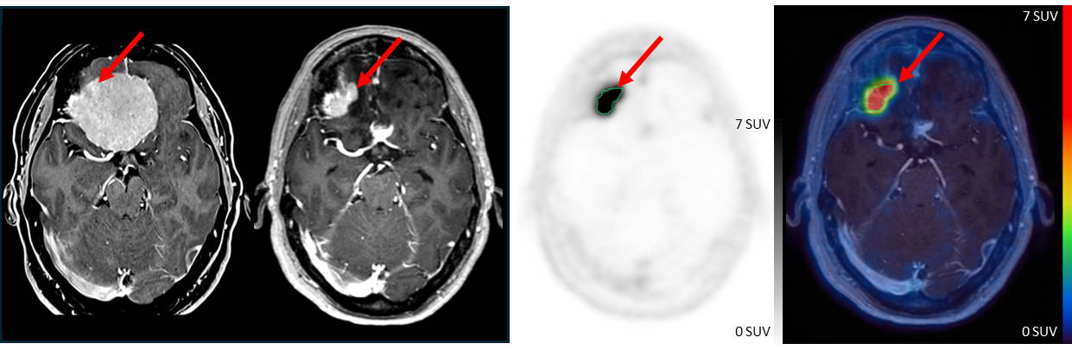
Supplementary Figure 1: Preoperative MRI (T1-weighted, post-contrast) of patient 11 is shown on the right, followed by postoperative MRI (T1-weighted, post-contrast, center right), PET (center left), and fused PET/MRI images (left). Red arrows indicate the meningioma components. The volume of interest (VOI) used for tracer uptake analysis is placed around an R2 residual tumor adjacent to the resected meningioma and demonstrating similar MRI morphological characteristics.

