Supplementary Figure 1. Exploratory ROC analysis of baseline PTH for imaging positivity
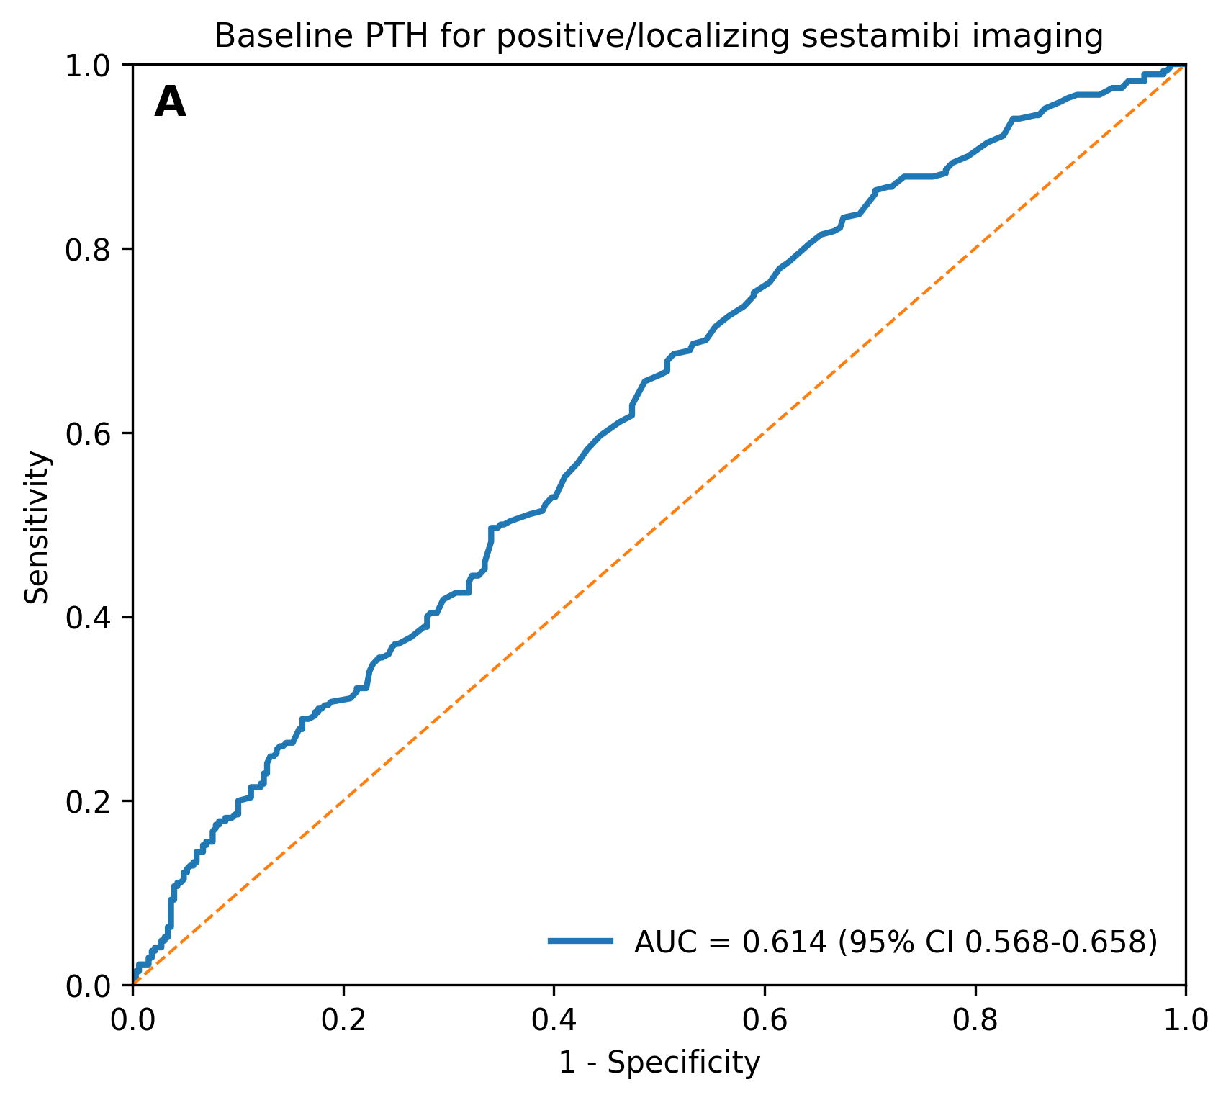
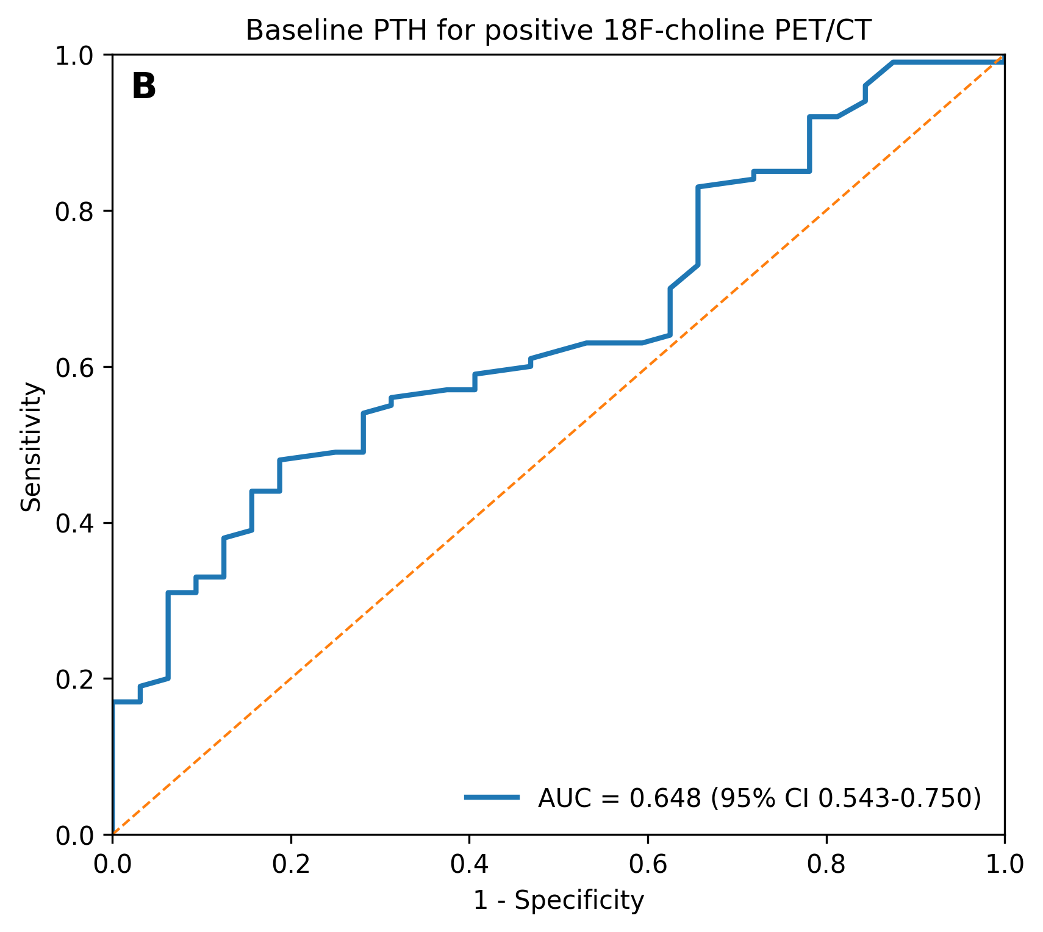
Caption. Exploratory ROC analysis of baseline PTH for imaging positivity. Receiver operating characteristic (ROC) curves were generated to assess the discriminative ability of baseline parathyroid hormone (PTH) levels for imaging positivity. A) ROC curve for prediction of positive/localizing ^99mTc-sestamibi imaging in the overall cohort. Baseline PTH showed modest discriminative ability, with an AUC of 0.614 (95% CI 0.568-0.658). The exploratory Youden-derived cutoff was 106.0, with 68.5% sensitivity and 48.6% specificity. B) ROC curve for prediction of positive ^18F-choline PET/CT in the PET/CT subgroup. Baseline PTH showed an AUC of 0.648 (95% CI 0.543-0.750). The exploratory Youden-derived cutoff was 123.0, with 48.0% sensitivity and 81.2% specificity. ROC-derived cutoffs were considered exploratory and were not intended for clinical decision-making. AUC, area under the curve; CI, confidence interval; PET/CT, positron emission tomography/computed tomography; PTH, parathyroid hormone; ROC, receiver operating characteristic.

