Appendixes
Table A.1: Heteroscedasticity Test
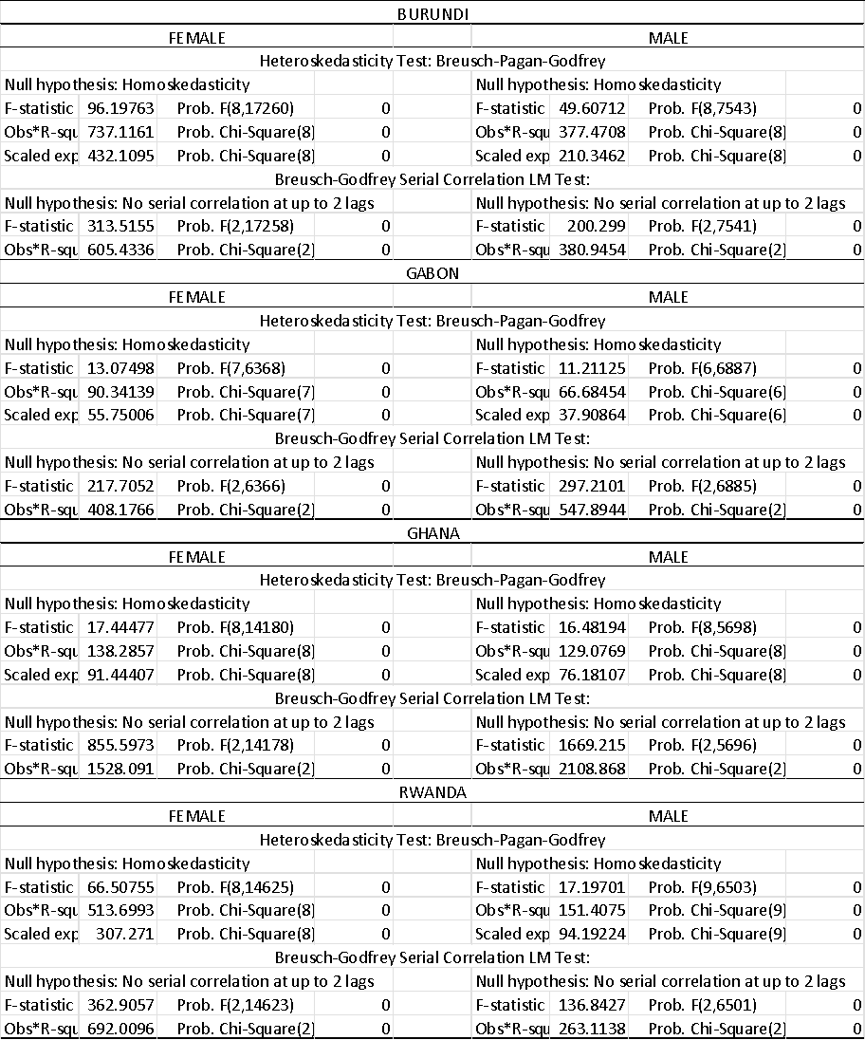

Table A.2: Heckman Test
Heckman Test
 | Coef. | St.Err. | t-value | p-value | [95% Conf | Interval] | Sig
 | Gabon
athrho | -0.072 | 0.131 | -0.55 | 0.582 | -0.329 | 0.185
lnsigma | 0.28 | 0.011 | 26.53 | 0 | 0.259 | 0.301 | ***
Burundi
athrho | -0.118 | 0.094 | -1.25 | 0.211 | 0 | 0.067
lnsigma | 0.19 | 0.007 | 25.63 | 0 | 0 | 0.205 | ***
Ghana
athrho | -0.097 | 0.097 | -0.99 | 0.321 | -0.288 | 0.094
lnsigma | 0.185 | 0.007 | 26.44 | 0 | 0.171 | 0.199 | ***
Rwanda
athrho | 0.793 | 0.065 | 12.27 | 0 | 0.667 | 0.92 | ***
lnsigma | 0.335 | 0.016 | 21.59 | 0 | 0.305 | 0.366 | ***

