Supplementary Materials
Table A1: Variable descriptions, NGHS 2023/2024.
Variables | Description
Outcome variable
Vulnerability_1 | Binary: Yes 1, No 0, if a household is vulnerable to poverty in the future based on the international poverty line of $2.15 per person per day at 2017 PPP
Vulnerability_2 | Binary: Yes 1, No 0, if a household is vulnerable to poverty in the future based on the international poverty line of $2.48 per person per day at 2017 PPP
Independent variable
Health shock | Binary: Yes 1, No 0, if one or more household member experienced health shock in the last 4 weeks prior to the survey
Household characteristics
Household size | Number of individuals in the household
Dependency ratio | The ratio of the number of household members aged less than 15 and greater than 64 to the number of household members aged 15 to 64 years
Sex of household head | Binary: Male 0, Female 1, sex/gender of the household head
Age of household head | Age of head of household (years)
Education of household head | Binary: 1 if education of household head is primary education or less, 0 if the education of household head is secondary or higher
Employment of household head | Binary: 1 if household head is unemployed, and 0 if employed
Household wealth quintile** | PCA summary scores for household assets categorized into five quintiles: Poorest 0, Poor 1, Middle 2, Rich 3, and Richest 4.
Health insurance | Binary: Yes 0, No 1, for health insurance for members of the household
Housing condition | Binary: Good 0, Poor 1, for the housing construction material of the house
Community characteristics
Residence | Binary: 1 for rural residents; 0 for urban residents, for the setting of the household
Region/Zone | Variables for geopolitical region/zone of the country: North Central 0, North East 1, North West 2, South East 3, South South 4, and South West 5.
State | Dummy variables for State
Local government area (LGA) | Dummy variables for LGA
Socioeconomic infrastructure index | PCA summary scores for socioeconomic infrastructure: schools, health facilities, markets, banks, and microfinance institutions available in the community.
Utilities infrastructure index | PCA summary scores for index that includes availability of cell phone distributors (as a proxy for the availability of mobile telecommunication), post offices, police stations, fire stations, community centres, and religious centres.
Transportation index | PCA summary score of presence of bus stops and paved access roads.
Interactions terms
Health shock # Household wealth interaction | Interaction term for health shock and household wealth quintile
Health shock # Health insurance interaction | Interaction term for health shock and if the household has health insurance
**We used raw PCA summary scores for PSM.

Box A2: Lists of household assets used in computing the household wealth index*, NGHS 2023/2024
- Furniture (sofa set) | - Generator
- Furniture (chairs) | - Fan
- Furniture (table) | - Radio
- Plastic chairs | - Cassette recorder
- Mattress | - Hi-Fi (Sound System)
- Bed | - Microwave
- Mat | - Iron
- Bed nets (including baby nets) | - TV Set
- Sewing machine | - Desktop computer
- Gas cooker | - Laptop computer
- Stove (electric) | - Tablet
- Stove gas (table) | - DVD Player
- Stove (kerosene) | - Satellite Dish
- Fridge | - Satellite Antenna
- Freezer | - Musical Instrument
- Air conditioner | - Smart phone
- Washing Machine | - Feature phone
- Electric Clothes Dryer | - Basic mobile phone
- Bicycle | - Landline telephone
- Motorbike | - Inverter
- Cars and other vehicles

*We computed the household wealth index using principal component analysis (PCA) of the response (yes or no) to these household assets.

Table A3: Covariate balance before and after matching for rural households, NGHS 2023/2024
Variable | Unmatched/Matched | Exposed households | Control households | % Bias*
Household size, mean | U | 7.87 | 7.06 | 19.0
 | M | 7.84 | 7.73 | 2.5
Dependency ratio, mean | U | 1.36 | 1.37 | -1.1
 | M | 1.36 | 1.36 | -0.2
Gender of household head, % | U | 0.24 | 0.22 | 5.9
 | M | 0.24 | 0.24 | 1.6
Age of household head, mean | U | 54.77 | 53.33 | 9.6
 | M | 54.75 | 54.40 | 2.3
Education of household head, % | U | 0.21 | 0.20 | 2.9
 | M | 0.21 | 0.23 | -3.3
Employment of household head, % | U | 0.88 | 0.87 | 3.9
 | M | 0.88 | 0.90 | -5.1
Household wealth index score, mean | U | -0.74 | -0.95 | 11.9
 | M | -0.75 | -0.69 | -3.4
Health insurance, % | U | 0.99 | 0.99 | 11.9
 | M | 0.99 | 1.00 | -2.1
Housing condition, % | U | 0.50 | 0.48 | 4.7
 | M | 0.50 | 0.50 | -0.3
Access to safe water, % | U | 0.42 | 0.39 | 7.2
 | M | 0.42 | 0.41 | 2.4
Adequate sanitation, % | U | 0.44 | 0.55 | -21.9
 | M | 0.44 | 0.43 | 1.7
Socioeconomic infrastructure index, mean | U | -0.69 | -0.66 | -1.6
 | M | -0.70 | -0.75 | 2.7
Utilities infrastructure index, mean | U | -0.42 | -0.31 | -8.6
 | M | -0.42 | -0.42 | 0.5
Transportation infrastructure index, mean | U | -0.16 | -0.27 | 9.2
 | M | -0.16 | -0.16 | 0.2
Sample | Mean Bias | Med Bias | Rubin’s B | Rubin’s R
Unmatched | 8.5 | 7.9 | 43.8 | 0.84
Matched | 2.0 | 2.2 | 9.1 | 1.08
*This column presents the standardized percentage bias, both before and after matching.

Table A4: Covariate balance before and after matching for urban households, NGHS 2023/2024
Variable | Unmatched/Matched | Exposed households | Control households | % Bias*
Household size, mean | U | 6.55 | 6.00 | 15.0
 | M | 6.50 | 6.76 | -6.9
Dependency ratio, mean | U | 1.14 | 1.15 | -1.3
 | M | 1.14 | 1.02 | 11.6
Gender of household head, % | U | 0.21 | 0.24 | -8.5
 | M | 0.21 | 0.20 | 2.6
Age of household head, mean | U | 53.65 | 52.89 | 5.1
 | M | 53.56 | 53.01 | 3.7
Education of household head, % | U | 0.23 | 0.23 | 0.5
 | M | 0.23 | 0.24 | -3.5
Employment of household head, % | U | 0.89 | 0.90 | -4.7
 | M | 0.89 | 0.90 | -3.5
Household wealth index score, mean | U | 1.40 | 1.74 | -12.2
 | M | 1.42 | 1.56 | -5.3
Health insurance, % | U | 0.97 | 0.95 | 9.7
 | M | 0.97 | 0.96 | 7.6
Own house, % | U | 0.46 | 0.52 | -11.4
 | M | 0.46 | 0.45 | 2.9
Housing condition, % | U | 0.81 | 0.79 | 4.4
 | M | 0.81 | 0.78 | 5.4
Access to safe water, % | U | 0.21 | 0.16 | 14.0
 | M | 0.21 | 0.19 | 3.7
Adequate sanitation, % | U | 0.21 | 0.19 | 5.4
 | M | 0.21 | 0.18 | 8.1
Socioeconomic infrastructure index, mean | U | 1.31 | 1.45 | -6.4
 | M | 1.31 | 1.17 | 6.1
Utilities infrastructure index, mean | U | 0.68 | 0.83 | -8.7
 | M | 0.68 | 0.66 | 1.0
Transportation infrastructure index, mean | U | 0.40 | 0.55 | -16.5
 | M | 0.40 | 0.39 | 0.9
Sample | Mean Bias | Med Bias | Rubin’s B | Rubin’s R
Unmatched | 8.2 | 8.5 | 31.2 | 1.19
Matched | 4.9 | 3.7 | 22.7 | 1.04
*This column presents the standardized percentage bias, both before and after matching.

Figure A5: Love plot of standardized percentage bias before and after propensity score matching for rural households, NGHS 2023/2014
. 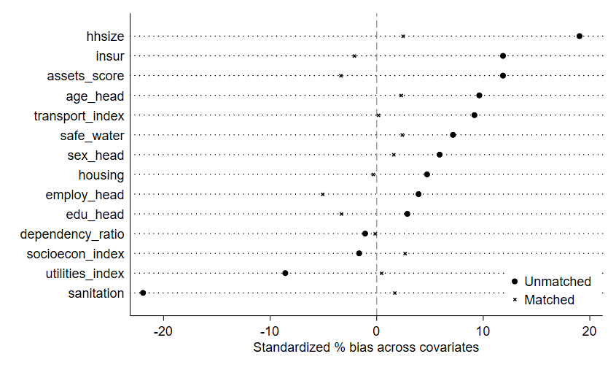

Figure A6: Matching graph of the propensity score before and after propensity score matching for rural households, NGHS 2023/2014.
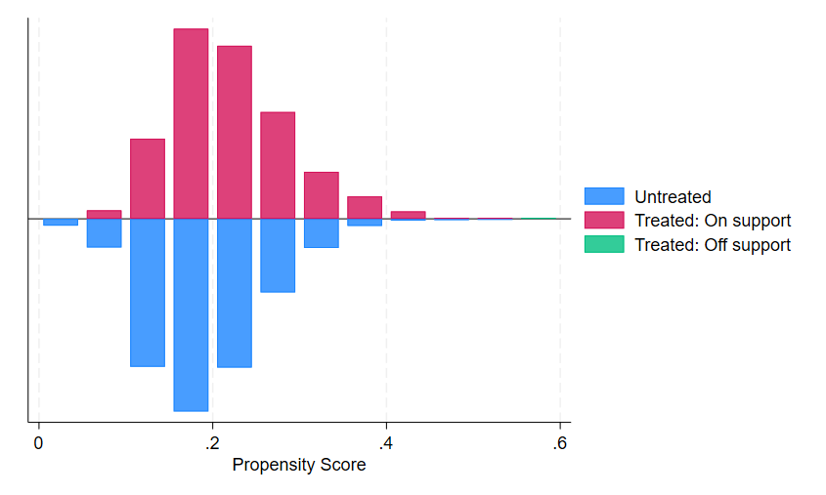

Figure A7: Covariate balance with propensity scores for rural households, NGHS 2023/2014.
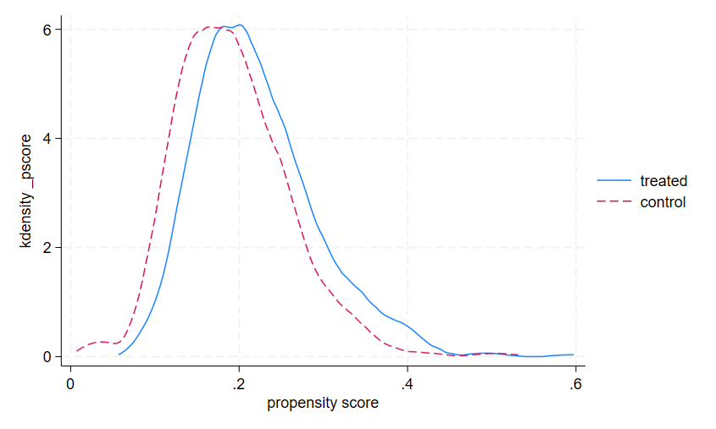

Figure A8: Love plot of standardized percentage bias before and after propensity score matching for urban households, NGHS 2023/2014.
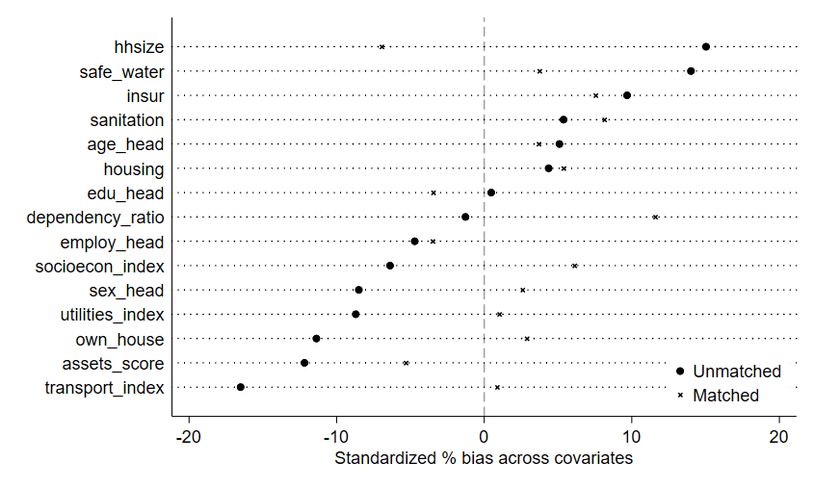

Figure A9: Matching graph of the propensity score before and after propensity score matching for urban households, NGHS 2023/2014.
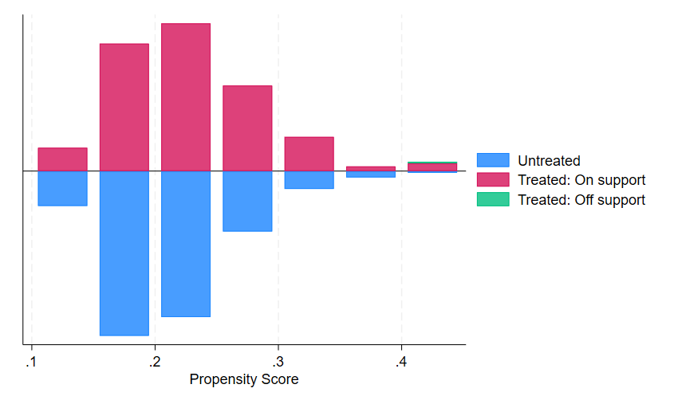

Figure A10: Covariate balance with propensity scores for urban households, NGHS 2023/2014.



