Appendix:
Degrees of freedom of the t-test in the case of multiple imputation
When using multiple imputation, it is advised to perform the t-tests of effects using the statistic T = $\frac{\hat{β}-β_{0}}{\sqrt{\hat{Var(\hat{β})}}}$, where $\hat{β}$ and $\hat{Var(\hat{β})}$ are computed as in Eq. (1). If H₀: $β=β_{0}$ holds, T has a student distribution, with degree of freedom
$$ν=Inv\left(\frac{FMI²}{M-1}+\frac{df+3}{\left(1-FMI\right)df(df+1)}\right),$$
Where df is the number of degrees of freedom of the residuals in the model, FMI is the fraction of missing information computed as in Eq. (2), M is the number of imputations, and Inv denotes the Inverse function.
The choice of the number of imputations (M)
The question of the choice of the number of imputations, is still open among statisticians. Schafer (1997) assumes that in most cases, 5 imputations are sufficient, while other researchers advocate for M = 20 or more. After simulating missingness on otherwise complete data, we found that the results were as good with M = 10 as with M = 50, in terms of bias reduction and variance of the estimates, for various proportions of missing data. For the sake of computation simplicity, we thus used M = 10 in this paper.
Graph 2: Current health expenditure per capita by countries
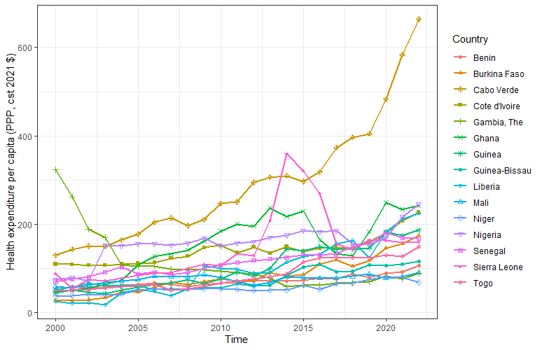
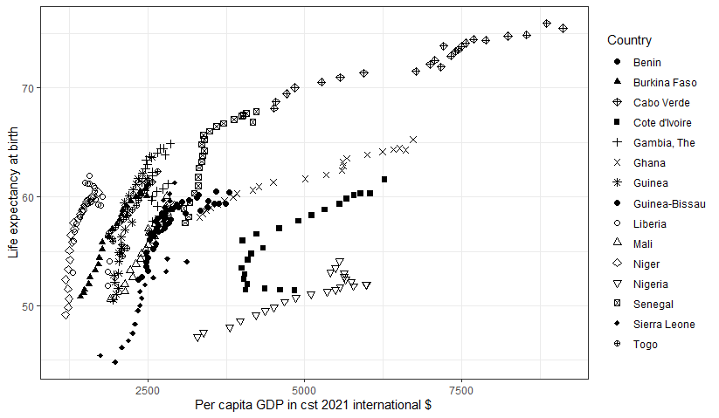
Graph 3: Scatter plot of life expectancy and GDP per capita.

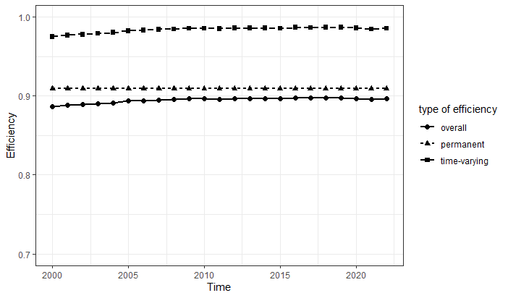
Graph 4: Global regional trend of overall temporal, permanent and total mean efficiencies between 2000 and 2022

Table 6. Efficiency estimation and ranking when taking as dependent variable the life expectancy minus 20 or 35 years, an indicator of Avoided child mortality under age 5
OUTPUT  Country | Life exp. – 20 yr |  | Life exp. – 35 yr |  | 0.25 – X₅
OUTPUT  Country | mean OTE | rank | mean OTE | rank | mean OTE | rank
Niger | 0.970 | 1 | 0.935 | 1 | 0.677 | 9
Liberia | 0.968 | 2 | 0.932 | 2 | 0.770 | 2
Togo | 0.932 | 3 | 0.883 | 3 | 0.816 | 1
Gambia | 0.924 | 4 | 0.846 | 4 | 0.768 | 3
Senegal | 0.900 | 5 | 0.816 | 6 | 0.747 | 5
Guinea | 0.898 | 6 | 0.827 | 5 | 0.739 | 6
Cabo Verde | 0.868 | 8 | 0.726 | 10 | 0.623 | 11
Burkina Faso | 0.886 | 7 | 0.803 | 7 | 0.728 | 7
Benin | 0.861 | 9 | 0.770 | 8 | 0.753 | 4
Guinea-Bissau | 0.841 | 10 | 0.744 | 9 | 0.706 | 8
Mali | 0.821 | 11 | 0.712 | 11 | 0.620 | 12
Ghana | 0.781 | 12 | 0.641 | 12 | 0.655 | 10
Sierra Leone | 0.738 | 13 | 0.578 | 13 | 0.449 | 14
Cote d'Ivoire | 0.705 | 14 | 0.547 | 14 | 0.584 | 13
Nigeria | 0.600 | 15 | 0.413 | 15 | 0.439 | 15
ECOWAS | 0.846 |  | 0.745 |  | 0.672

Table 7: Regression Results and Fraction of Missing Information (FMI) for the models with life expectancy or “avoided child mortality” as the outcome.
outcome : | Life expectancy (Model 3) |  |  |  | Avoided child mortality
 | Estimate mean | p_value | FMI | VIF | Estimate mean | p_value | FMI | VIF
VARIABLES
LCEXP_PC | 0.05*** | 0.000 | 0.108 | 4.58 | 0.366*** | 0.00 | 0.103 | 4.58
 | (0.004) |  |  |  | (0.021)
LGDP_PC | 0.124*** | 0.000 | 0.387 | 3.13 | 0.269* | 0.029 | 0.243 | 3.13
 | (0.014) |  |  |  | (0.057)
LOPEXP_PC | -0.014 | 0.211 | 0.119 | 2.84 | -0.131* | 0.031 | 0.081 | 2.84
 | (0.004) |  |  |  | (0.016)
LPhysi | -0.005 | 0.369 | 0.77 | 1.55 | -0.046 | 0.205 | 0.79 | 1.55
 | (0.005) |  |  |  | (0.029)
LLiteracyR | 0.026** | 0.031 | 0.75 | 1.93 | 0.152* | 0.027 | 0.751 | 1.93
 | (0.009) |  |  |  | (0.051)
LPovtyG_3 | -0.016* | 0.013 | 0.713 | 1.29 | -0.067* | 0.011 | 0.518 | 1.29
 | (0.005) |  |  |  | (0.017)
LPoli_Stab | -0.023 | 0.137 | 0.4 | 1.75 | -0.187* | 0.025 | 0.349 | 1.75
 | (0.009) |  |  |  | (0.046)
LVoice_Account | 0.063** | 0.005 | 0.434 | 1.79 | 0.188 | 0.08 | 0.31 | 1.79
 | (0.013) |  |  |  | (0.056)
Constant | 2.809*** | 0.000
 | (0.123)
Observations | 345*10 |  |  |  | 345*10
Number of Id | 15 |  |  |  | 15
R-squared | 0.653 |  |  |  | 0.546
Standard errors in parentheses; *** p<0.01, ** p<0.05, * p<0.1; VIF = variance inflation factors

