Table S1 Consolidated Health Economic Evaluation Reporting Standards (CHEERS) 2022 checklist
Section/Topic | Item No. | Guidance for reporting | Reported on page N/
Title and abstract
Title | 1 | Identify the study as an economic evaluation and specify the interventions being compared. | Yes
Abstract | 2 | Provide a structured summary that highlights context, key methods, results, and alternative analyses. | Yes
Introduction
Background and objectives | 3 | Give the context for the study, the study question, and its practical relevance for decision making in policy or practice. | Yes
Methods
Health economic analysis plan | 4 | Indicate whether a health economic analysis plan was developed and where available. | No
Study population | 5 | Describe characteristics of the study population (such as age range, demographics, socioeconomic, or clinical characteristics) | Yes
Setting and location | 6 | Provide relevant contextual information that may influence findings. | Yes
Comparators | 7 | Describe the interventions or strategies being compared and why chosen. | Yes
Perspective | 8 | State the perspective(s) adopted by the study and why chosen. | Yes
Time horizon | 9 | State the time horizon for the study and why appropriate. | Yes
Discount rate | 10 | Report the discount rate(s) and reason chosen. | Yes
Selection of outcomes | 11 | Describe what outcomes were used as the measure(s) of benefit(s) and harm(s). | Yes
Measurement of outcomes | 12 | Describe how outcomes used to capture benefit(s) and harm(s) were measured. | Yes
Valuation of outcomes | 13 | Describe the population and methods used to measure and value outcomes. | Yes
Measurement and valuation of resources and costs | 14 | Describe how costs were valued. | Yes
Currency, price date, and conversion | 15 | Report the dates of the estimated resource quantities and unit costs, plus the currency and year of conversion. | Yes
Rationale and description of model | 16 | If modeling is used, describe in detail and why used. Report if the model is publicly available and where it can be accessed. | Yes
Analytics and assumptions | 17 | Describe any methods for analysing or statistically transforming data, any extrapolation methods, and approaches for validating any model used. | Yes
Characterizing heterogeneity | 18 | Describe any methods used for estimating how the results of the study vary for subgroups. | No
Characterizing distributional effects | 19 | Describe how impacts are distributed across different individuals or adjustments made to reflect priority populations. | Yes
Characterizing uncertainty | 20 | Describe methods to characterize any sources of uncertainty in the analysis. | Yes
Approach to engagement with patients and others affected by the study | 21 | Describe any approaches to engage patients or service recipients, the general public, communities, or stakeholders (such as clinicians or payers) in the design of the study | No
Results
Study parameters | 22 | Report all analytic inputs (such as values, ranges, references) including uncertainty or distributional assumptions. | Yes
Summary of main results | 23 | Report the mean values for the main categories of costs and outcomes of interest and summarize them in the most appropriate overall measure | Yes
Effect of uncertainty | 24 | Describe how uncertainty about analytic judgments, inputs, or projections affect findings. Report the effect of choice of discount rate and time horizon, if applicable. | Yes
Effect of engagement with patients and others affected by the study | 25 | Report on any difference patient/service recipient, general public, community, or stakeholder involvement made to the approach or findings of the study | No
Discussion
Study findings, limitations, generalizability, and current knowledge | 26 | Report key findings, limitations, ethical or equity considerations not captured, and how these could affect patients, policy, or practice. | Yes
Other relevant information
Source of funding | 27 | Describe how the study was funded and any role of the funder in the identification, design, conduct, and reporting of the analysis | Yes
Conflicts of interest | 28 | Report authors conflicts of interest according to journal or International Committee of Medical Journal Editors requirements. | Yes

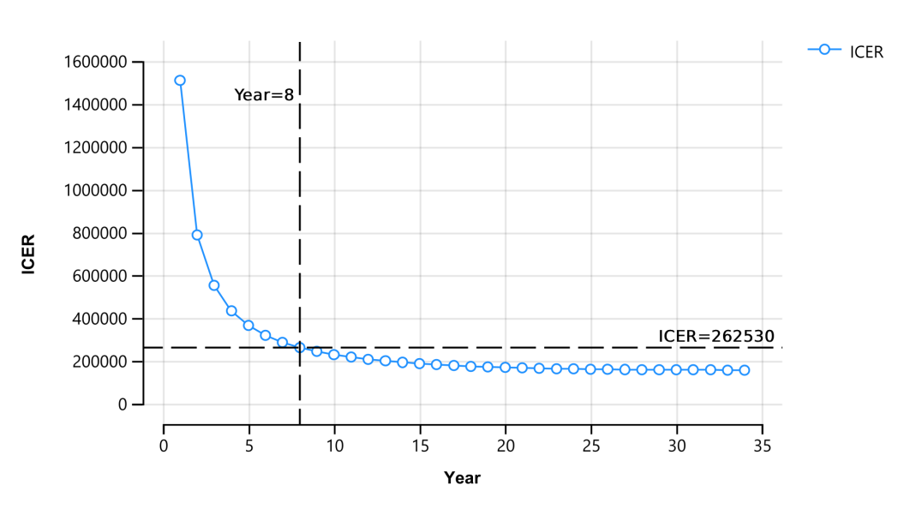
Figure S1. The ICER values varied over time. ICER: incremental cost-effectiveness ratio.

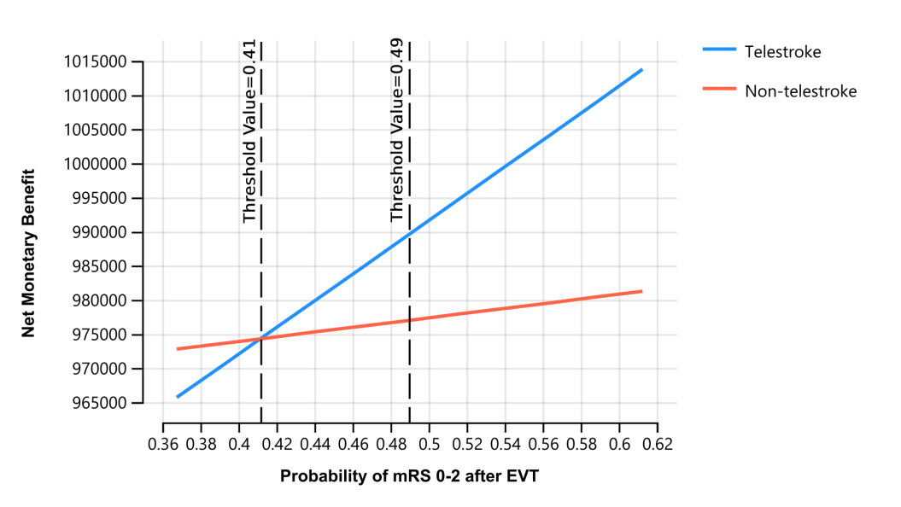
Figure S2. One-Way Sensitivity Analysis Varing Probability of mRS0-2 after EVT. EVT: endovascular treatment; mRS: modified Rankin Scale.

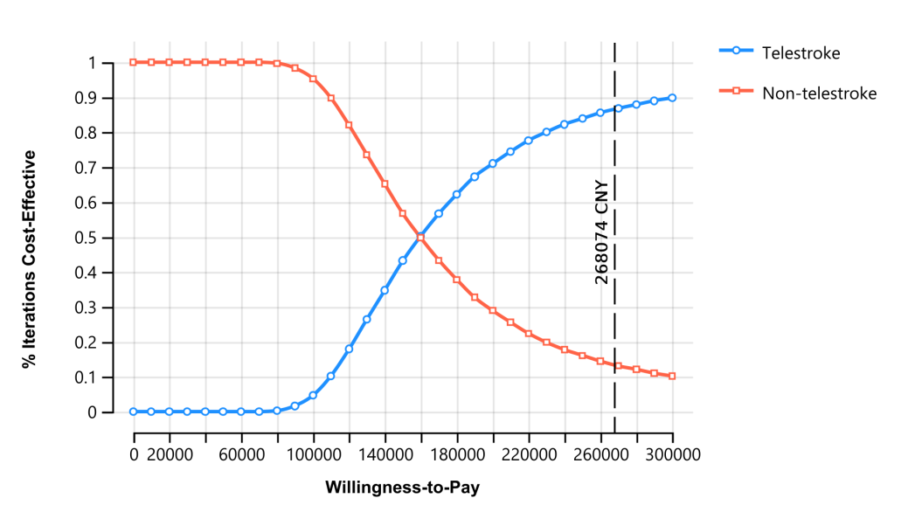
Figure S3. Cost-effectiveness acceptability curve. CNY: Chinese yuan renminbi.

