Appendix Figure A1. Timeline of behavioral health parity policies in the U.S.
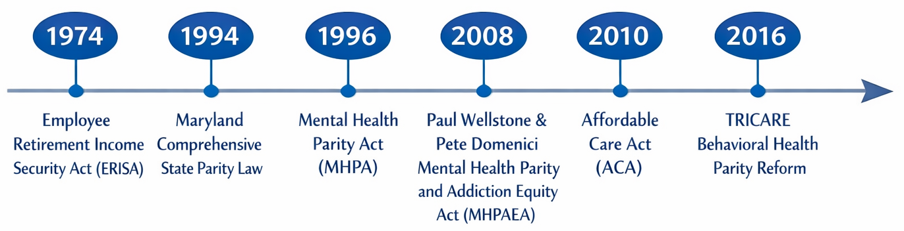

Appendix Table A1. Summary of the TRICARE behavioral health parity reform
Policy dimension |  | Pre-parity (Before Q4 2016) | Post-parity (After Q4 2016)
Demand | Quantitative treatment limits (QTLs) | Visit caps in place; strict day limits for partial hospitalization; inpatient admission restrictions. | Elimination of QTLs for behavioral health, equalizing limits with medical/surgical care.
Demand | Non-quantitative treatment limits (NQTLs) | Limited coverage for intensive outpatient programs (IOPs) and medication-assisted treatment (MAT). | Expanded coverage of IOPs, MAT, and comprehensive opioid use disorder services.
Demand | Cost-sharing | Higher out-of-pocket costs (e.g., $25 standard outpatient copay for non-active-duty beneficiaries). | Reduced copayments (e.g., lowered to $12 for certain outpatient visits) to match medical/surgical levels.
Supply | Provider network adequacy | Cumbersome certification processes for civilian providers; narrower TRICARE-authorized networks. | Streamlined certification and administrative requirements to increase civilian provider participation.

Appendix Table A2. Results from the FE-DL model: coefficient estimates.
Variables | Active-duty service members | Retirees | Dependents
Post-parity year-quarters
1st | –0.000088** | –0.000079*** | –0.000178***
 | (0.000028) | (0.000020) | (0.000018)
2nd | –0.000052 | –0.000095*** | –0.000157***
 | (0.000031) | (0.000020) | (0.000019)
3rd | –0.000025 | –0.000082*** | –0.000128***
 | (0.000031) | (0.000021) | (0.000019)
4th | –0.000044 | –0.000073*** | –0.000160***
 | (0.000031) | (0.000021) | (0.000018)
5th | –0.000117** | –0.000154*** | –0.000240***
 | (0.000037) | (0.000026) | (0.000024)
6th | –0.000030 | –0.000129*** | –0.000244***
 | (0.000042) | (0.000029) | (0.000026)
7th | –0.000015 | –0.000138*** | –0.000266***
 | (0.000042) | (0.000029) | (0.000026)
8th | 0.000013 | –0.000133*** | –0.000230***
 | (0.000042) | (0.000029) | (0.000026)
9th | –0.000080 | –0.000255*** | –0.000414***
 | (0.000049) | (0.000034) | (0.000030)
10th | –0.000071 | –0.000229*** | –0.000370***
 | (0.000054) | (0.000037) | (0.000034)
11th | –0.000035 | –0.000235*** | –0.000407***
 | (0.000054) | (0.000037) | (0.000034)
12th | 0.000012 | –0.000216*** | –0.000444***
 | (0.000053) | (0.000037) | (0.000033)
13th | –0.000024 | –0.000288*** | –0.000578***
 | (0.000061) | (0.000042) | (0.000038)
14th | –0.000015 | –0.000304*** | –0.000539***
 | (0.000066) | (0.000046) | (0.000042)
Quarter indicators (reference: Q1 (January-March))
Q2 (April-June) | –0.000024 | –0.000009 | –0.000038***
 | (0.000017) | (0.000011) | (0.000010)
Q3 (July-September) | –0.000039* | –0.000025* | –0.000115***
 | (0.000019) | (0.000012) | (0.000011)
Q4 (October-December) | –0.000023 | 0.000044** | 0.000042**
 | (0.000021) | (0.000015) | (0.000013)
Time trend | 0.000046*** | 0.000019*** | 0.000041***
 | (0.000005) | (0.000003) | (0.000003)
Age | –0.000025*** | –0.000005 | 0.000026**
 | (0.000015) | (0.000009) | (0.000008)
Military rank (reference: Senior officer)
Junior officer | 0.000315***
 | (0.000020)
Senior enlisted | 0.000479***
 | (0.000035)
Junior enlisted | 0.000502***
 | (0.000041)
Missing | 0.000539***
 | (0.000055)
Intercept | 0.000724 | 0.000495 | –0.000170
 | (0.000411) | (0.000473) | (0.000231)
n | 29,068,577 | 23,805,674 | 80,932,582

Notes. All regression models include individual fixed-effects. Cluster-robust standard errors are in parentheses.
*p<0.05; **p<0.01; ***p<0.001.

