Vaccination program evaluation with a Multi-Criteria Decision Analysis (MCDA) tool in China: from evidence to policy
Supplementary Appendix

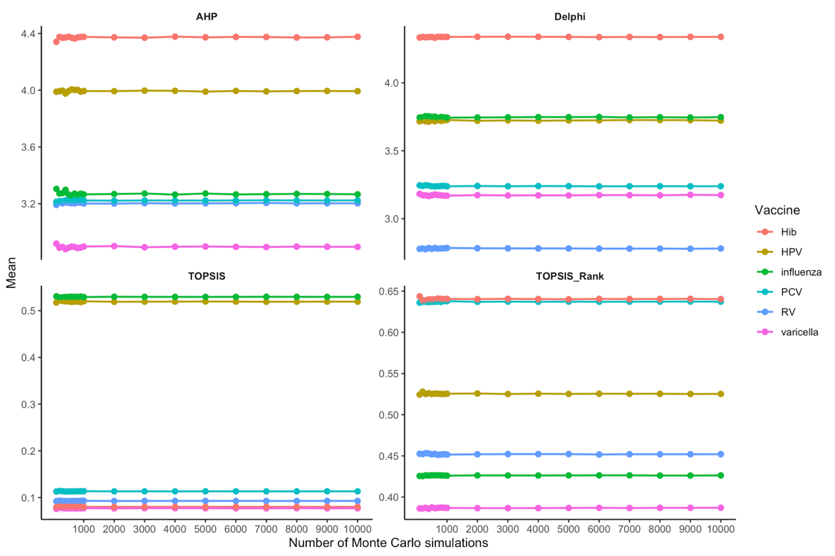
Figure A1. Convergence assessment of the probabilistic sensitivity analysis across increasing numbers of Monte Carlo simulations.
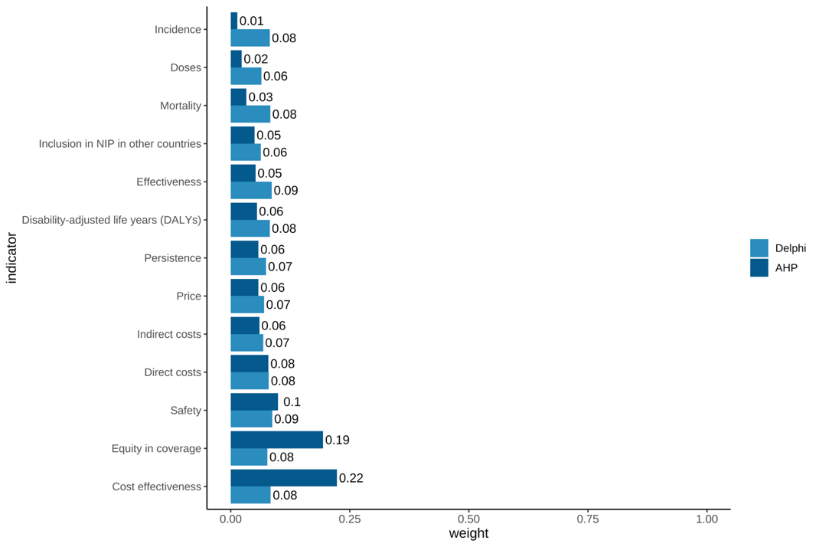
Figure A2. The weights of indicators in the MCDA framework.

Table A1. Demographic characteristics of the experts.
characteristic | level | number | (%)
Gender | Female | 3 | 25
 | Male | 9 | 75
Working department | Colleges | 8 | 66.7
 | Research institutes | 1 | 8.3
 | Centers for disease control | 2 | 16.7
 | Industries | 1 | 8.3
Research field | Clinical research | 1 | 8.3
 | Disease control | 1 | 8.3
 | Health economic and policy | 3 | 25
 | Epidemiology and health statistics | 4 | 33.3
 | vaccination | 2 | 16.7
 | Implementation science | 1 | 8.3
Highest educational degree | Master | 3 | 25
 | Doctor | 9 | 75
Work experience (years) | 0-10 | 2 | 16.7
 | 11-20 | 4 | 33.3
 | 21-30 | 5 | 41.7
 | 31-40 | 1 | 8.3
Title | Middle | 1 | 8.3
 | Deputy senior | 2 | 16.7
 | Senior | 9 | 75

Table A2. Reliability and representation of expert consultation.
 | Ca | Cs | Cr
Expert 1 | 0.9 | 1 | 0.95
Expert 2 | 0.9 | 0.8 | 0.85
Expert 3 | 1 | 0.8 | 0.9
Expert 4 | 1 | 1 | 1
Expert 5 | 0.9 | 1 | 0.95
Expert 6 | 1 | 0.8 | 0.9
Expert 7 | 0.9 | 1 | 0.95
Expert 8 | 0.7 | 0.5 | 0.6
Expert 9 | 1 | 1 | 1
Expert 10 | 0.9 | 1 | 0.95
Expert 11 | 1 | 0 | 0.5
Expert 12 | 1 | 0.8 | 0.9
Mean | 0.93 | 0.81 | 0.87
The authority coefficient (Cr), calculated as Cr = (Cs + Ca)/2, where Ca and Cs are means of experts’ familiarity scores and their sources of knowledge scores, were used to assess experts’ perceived degree of authority.

Table A3. Importance score of indicators in round one Delphi survey.
 |  | Means | Variances | Standard deviations | Coefficients of variation | Operation
Epidemic characteristics | Incidence | 4.67 | 0.24 | 0.49 | 0.11
 | Mortality | 4.83 | 0.15 | 0.39 | 0.08
 | Disability-adjusted life years (DALYs) |  |  |  |  | added
Economic burden | Direct costs | 4.75 | 0.20 | 0.45 | 0.10
 | Indirect costs | 4.42 | 0.27 | 0.51 | 0.12
Vaccine characteristics | Effectiveness | 4.92 | 0.08 | 0.29 | 0.06
 | Safety | 4.92 | 0.08 | 0.29 | 0.06
 | Persistence | 4.33 | 0.42 | 0.65 | 0.15
 | Doses |  |  |  |  | added
Vaccine cost effectiveness | Price | 4.17 | 0.52 | 0.72 | 0.17
 | Cost effectiveness | 4.67 | 0.24 | 0.49 | 0.11
Vaccine coverage status | Coverage | 3.92 | 1.72 | 1.31 | 0.33 | deleted
 | Inclusion in NIP in other countries | 3.58 | 0.63 | 0.79 | 0.22
 | Equity in coverage |  |  |  |  | added

Table A4. Importance score of indicators in round two Delphi survey.
 |  | Mean | Variance | Standard deviation | Coefficients of variation
Epidemic characteristics | Incidence | 4.67 | 0.42 | 0.65 | 0.14
 | Mortality | 4.75 | 0.2 | 0.45 | 0.1
 | Disability-adjusted life years (DALYs) | 4.67 | 0.24 | 0.49 | 0.11
Economic burden | Direct costs | 4.58 | 0.27 | 0.51 | 0.11
 | Indirect costs | 3.92 | 0.45 | 0.67 | 0.17
Vaccine characteristics | Effectiveness | 4.92 | 0.08 | 0.29 | 0.06
 | Safety | 5 | 0 | 0 | 0
 | Persistence | 4.25 | 0.2 | 0.45 | 0.11
 | Doses | 3.67 | 0.42 | 0.65 | 0.18
Vaccine cost effectiveness | Price | 4 | 0.36 | 0.6 | 0.15
 | Cost effectiveness | 4.83 | 0.15 | 0.39 | 0.08
Vaccine coverage status | Inclusion in NIP in other countries | 3.58 | 0.45 | 0.67 | 0.19
 | Equity in coverage | 4.42 | 0.45 | 0.67 | 0.15

Table A5. MCDA scores and ranking results of vaccines.
 | all AHP indicators |  | TOP 3 AHP indicators
 | vaccine | score | Vaccine | score
1 | Hib | 4.251 | HPV | 2.267
2 | HPV | 4.152 | Hib | 2.014
3 | influenza | 3.263 | RV | 1.956
4 | PCV | 3.231 | influenza | 1.656
5 | RV | 3.211 | PCV | 1.540
6 | varicella | 2.852 | varicella | 1.404

Table A6. Summary of the data source and strengths & limitations.
Category | Subgroup | Meta-analysis | Cohort Study | Descriptive Study | Review / Expert Consensus / Policy | Strengths | Limitations
China-specific studies | National-level data | 22, 35 | 23, 25, 29, 34, 43, 47, 48, 49 | 32, 33, 38, 40, 46 |  | Nationally representative; reflects overall population patterns | May be affected by reporting bias
 | Regional/provincial data |  | 37, 39 | 26, 30, 31, 36 | 44, 45 | Reflect real-world population characteristics; provide detailed local data | Limited generalizability to the national level; geographic heterogeneity
International studies | Multi-country studies | 24, 41, 42 |  |  |  | Broad external validity; allows cross-country comparison | Heterogeneity across countries; may not reflect China-specific context
 | Single-country studies |  | 27 | 28 |  | Provide detailed evidence; useful when local data are unavailable | Limited representativeness; results may not be generalizable to other settings

