Additional file 1: Experimental instructions and decision interface
This file provides the participant-facing instructions used in the experiment. Formatting has been adapted for supplementary presentation; the substantive decision rules, payment information, comprehension questions, and decision interface are retained.
Overview
Participants took part in an economic experiment on medical decision-making. In the experiment, participants made decisions and selected quantities of healthcare services for different patient types under different payment schemes. Their decisions determined their experimental payoff and the patient benefit generated in the experiment.
The experiment consisted of two parts. In Part I, participants made decisions under capitation. In Part II, participants made decisions under capitation plus performance pay. Detailed instructions for the performance-pay condition were provided only after Part I had been completed.
Decision rounds
In each part of the experiment, participants completed nine decision rounds. In each round, they selected the quantity of healthcare services to provide to one standardized patient profile. Patient profiles were defined by one of three illness types (A, B, and C) and one of three illness-severity levels: mild (x), intermediate (y), and high (z). Each possible illness-type and severity combination appeared once in each part of the experiment. The order of patient profiles was randomized.
For each patient profile, participants selected an integer quantity of healthcare services from 0 to 10. Decisions for different patient profiles were independent of one another.
Part I: Capitation
In Part I, participants received a lump-sum remuneration for treating each patient. This remuneration did not depend on the quantity of healthcare services provided. Participants also incurred costs that increased with the quantity of services provided. The payoff for each decision round was calculated as lump-sum remuneration minus treatment costs.
Part II: Capitation plus performance pay
In Part II, participants again received the lump-sum remuneration for treating each patient and incurred quantity-dependent treatment costs. In addition, they could receive a performance bonus if the selected quantity of healthcare services was equal to the patient-optimal quantity or deviated from it by no more than one service unit. The payoff for each decision round was calculated as lump-sum remuneration plus any performance bonus minus treatment costs.
The performance bonus varied by assigned bonus condition and illness severity. Full payment parameters, bonus values, and threshold rules are provided in Additional file 3.
Patient benefit
Each quantity of healthcare services generated a specific patient benefit, which depended on the patient’s illness type and illness severity. Participants were informed that their decisions affected both their own payoff and the patient benefit generated in the experiment.
Experimental payment and donation
All monetary amounts in the experiment were presented in Talers, with 1 Taler equal to 1 Chinese yuan. At the end of the experiment, one decision from Part I and one decision from Part II were randomly selected for calculating the participant’s experimental payoff. Participants also received a fixed participation payment.
Although the patient profiles were hypothetical, patient benefits were made consequential. The monetary equivalent of the patient benefits generated by selected decisions was donated to the Red Cross Society of China.
Comprehension questions
Before the main decision rounds, participants completed comprehension questions using the information displayed on the decision screen. The questions were designed to confirm that participants understood the decision task, payment information, and patient-benefit information. Participants proceeded to the experiment only after answering the comprehension questions correctly.
- For the patient shown on the screen, which quantity of healthcare services yields the lowest patient benefit?
- For the patient shown on the screen, which quantity of healthcare services yields the highest payoff for you?
- For the patient shown on the screen, which quantity of healthcare services yields the highest patient benefit?
- For the patient shown on the screen, which quantity of healthcare services yields the lowest payoff for you?
Decision interface example
The decision interface displayed the patient type, quantity of healthcare services, lump-sum remuneration, bonus payment, treatment costs, physician payoff, and patient benefit for each possible service quantity.
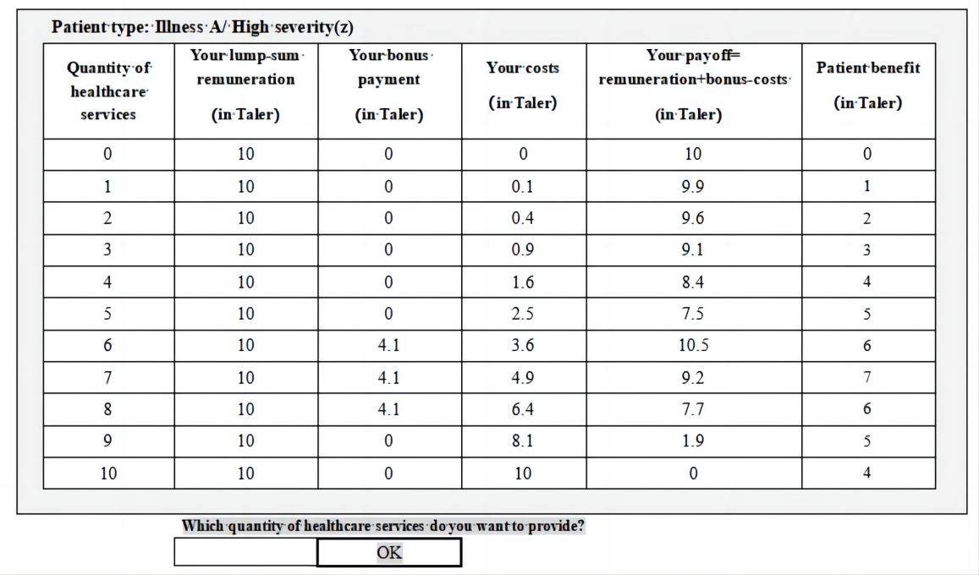
Figure S1. Example decision screen shown to participants.

