Additional file 6
A: ESTs in the spleen library of Chinese giant salamanders hit to the RIG-I-like receptor signaling pathway.
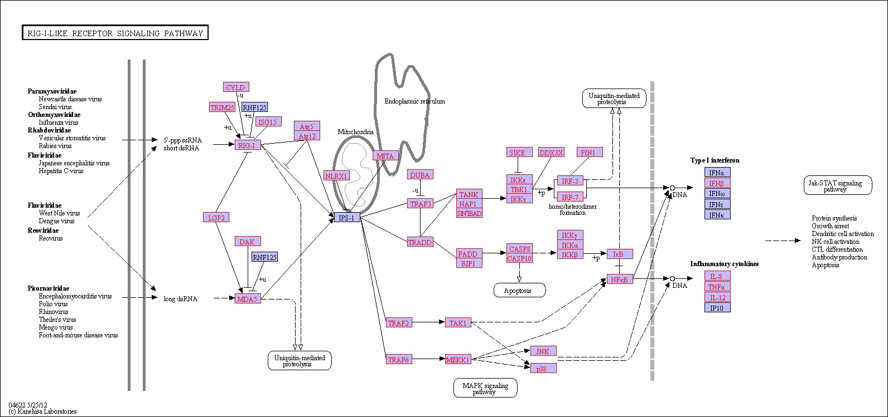

B: ESTs in the spleen library of Chinese giant salamanders hit to the complement and coagulation cascades.
