D
C
B
A
E
F
G
H
I
J
K
L

late necrotic (1.01%)
late necrotic (0.86%)
late necrotic (5.54%)
late necrotic (2.36%)
late necrotic (4.45%)
late necrotic (0.54%)
late necrotic (0.86%)
late necrotic (1.09%)
late necrotic (7.42%)

0

late apoptotic (2.03%)
late apoptotic (2.53%)
late apoptotic (1.11%)
late apoptotic (10.96%)
late apoptotic (48.72%)
late apoptotic (0.81%)
late apoptotic (1.26%)
late apoptotic (1.90%)
late apoptotic (5.43%)
Negative control | 500 µg F. gastrosuis lysate, 36h | 500 µg F. gastrosuis lysate, 48h | 500 µg F. gastrosuis lysate, 72h
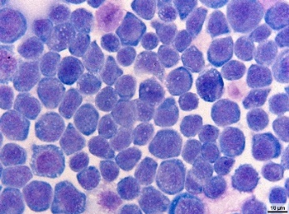 | 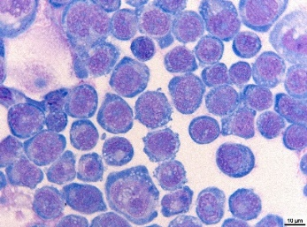 | 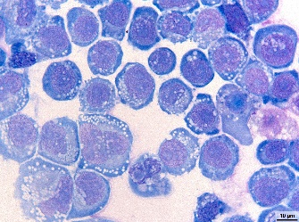 | 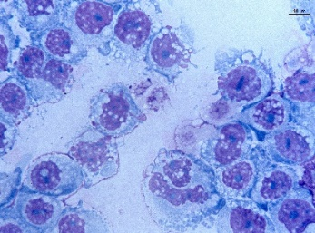
Negative control | 500 µg F. gastrosuis lysate, 24h | 500 µg F. gastrosuis lysate, 36h | 500 µg F. gastrosuis lysate, 48h
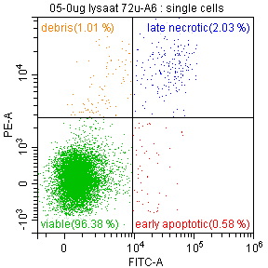 | 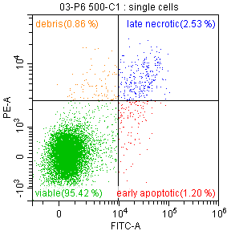 | 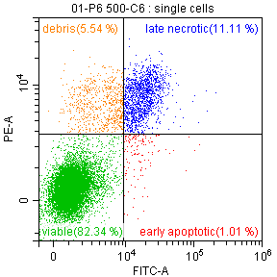 | 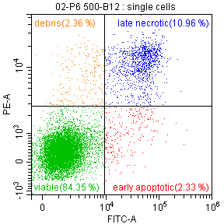
500 µg F. gastrosuis lysate, 72h | Negative control | 50 MOI F. gastrosuis bacteria, 2h | 50 MOI F. gastrosuis bacteria, 6h
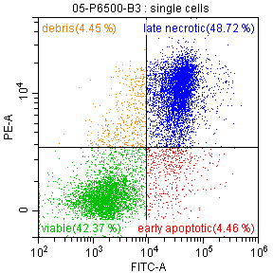 | 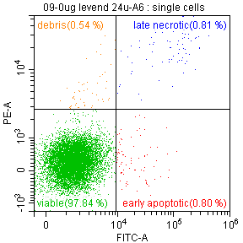 | 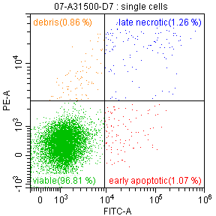 | 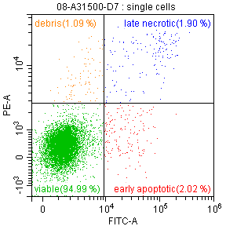
50 MOI F. gastrosuis lysate, 12h
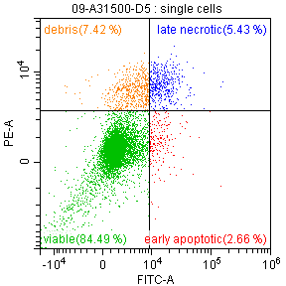
M

