Additional file 4. Alignment of pathotyping target gene sequences and the corresponding amino acid sequences
A

B

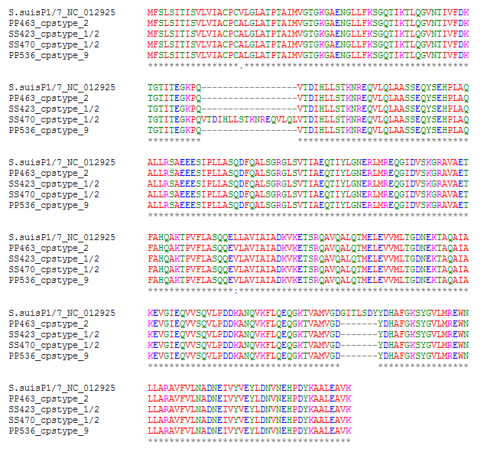
C

D
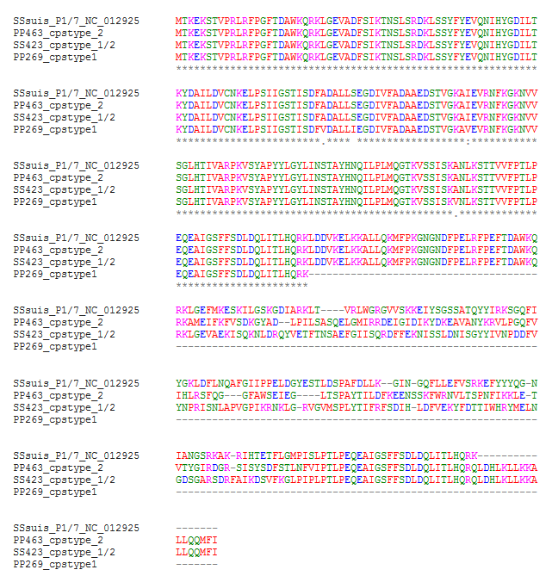

Sequence alignment of copper ATPase 1-gene (A and B) and partial gene sequence alignment of type I RM system S protein-gene (C and D) of invasive disease-associated isolates of Swiss S. suis in comparison to the highly virulent reference strain P1/7 are shown visualizing different gene variants and its corresponding protein sequences. Conserved, matching nucleotide residues are illustrated as blue dots, whereas red represents differences of nucleotide sequences. (A) Copper ATPase 1-gene sequences of S. suis PP463 (cps type 2, ST28), SS470 (cps type 1/2, ST28), PP423 (cps type 1/2, ST1133), and PP536 (cps type 9, ST1105) are represented. Primer sequences of the pathotyping tool are indicated in green. A duplication of a 54 bp long DNA segment in isolate SS470 and a deletion of a 21 bp fragment in all represented Swiss isolates could be observed, illustrating a high genetic variability. (B) Corresponding amino acid sequence alignment of Copper ATPase 1 is shown. (C) RM system S protein gene sequences of S. suis PP463 (cps 2, ST28), PP423 (cps 1/2, ST1133), and PP269 (cps 1, ST13) are represented. The forward primer is indicated in green, whereas the reverse primer could not be shown since illustrated Swiss isolates are truncated. (D) Corresponding amino acid sequence alignment of RM systems S protein is shown.

