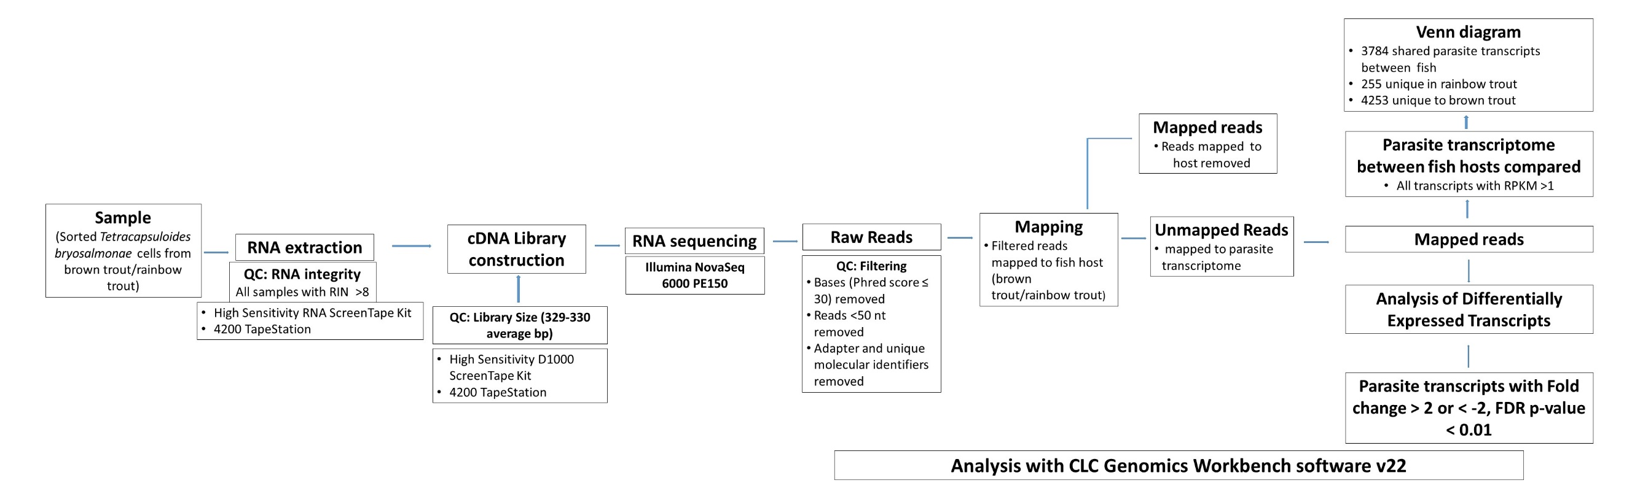
Additional file 1: Quality control pipeline applied in the analysis of RNA-seq data

