Additional file 1. The prediction of concentrated epitope of T-cell from four common antigens using DNAStar Protean software.

Additional file 1A: The prediction of concentrated epitope of T-cell from 14-3-3
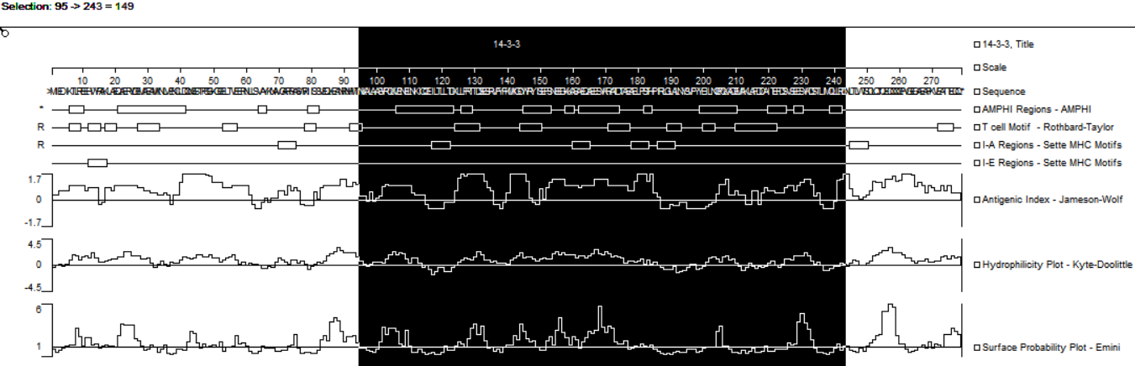

Additional file 1B: The prediction of concentrated epitope of T-cell from GAPDH
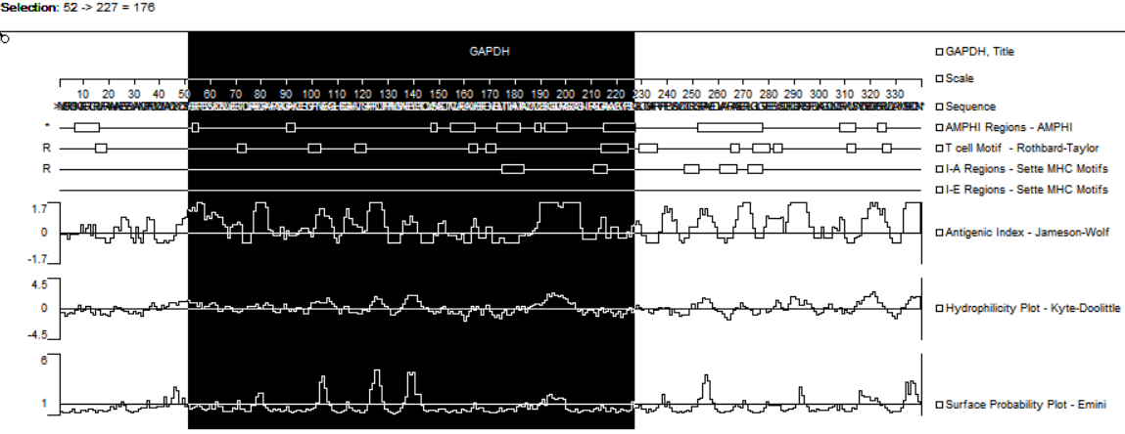

Additional file 1C: The prediction of concentrated epitope of T-cell from EF2
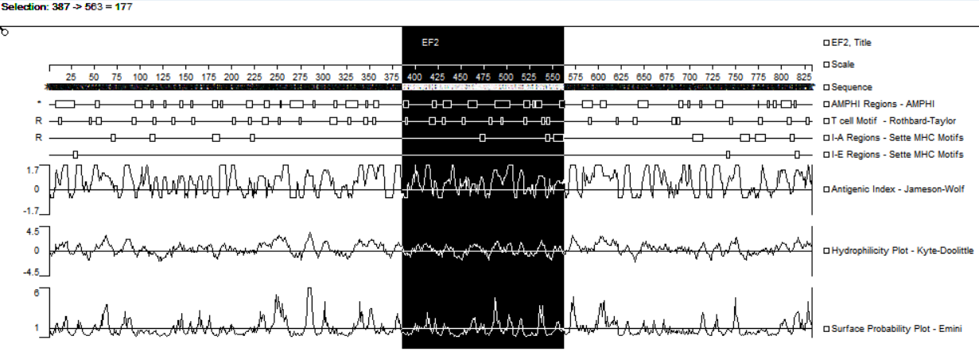

Additional file 1D: The prediction of concentrated epitope of T-cell from transhydrogenase
