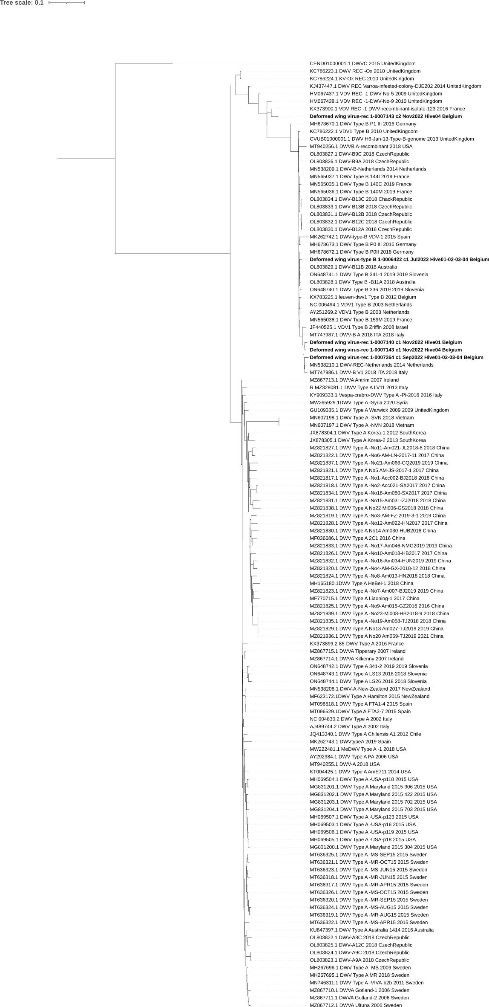
DWV type A
DWV type B
DWV rec
DWV rec

