Additional file 4 Differentially expressed genes among groups.
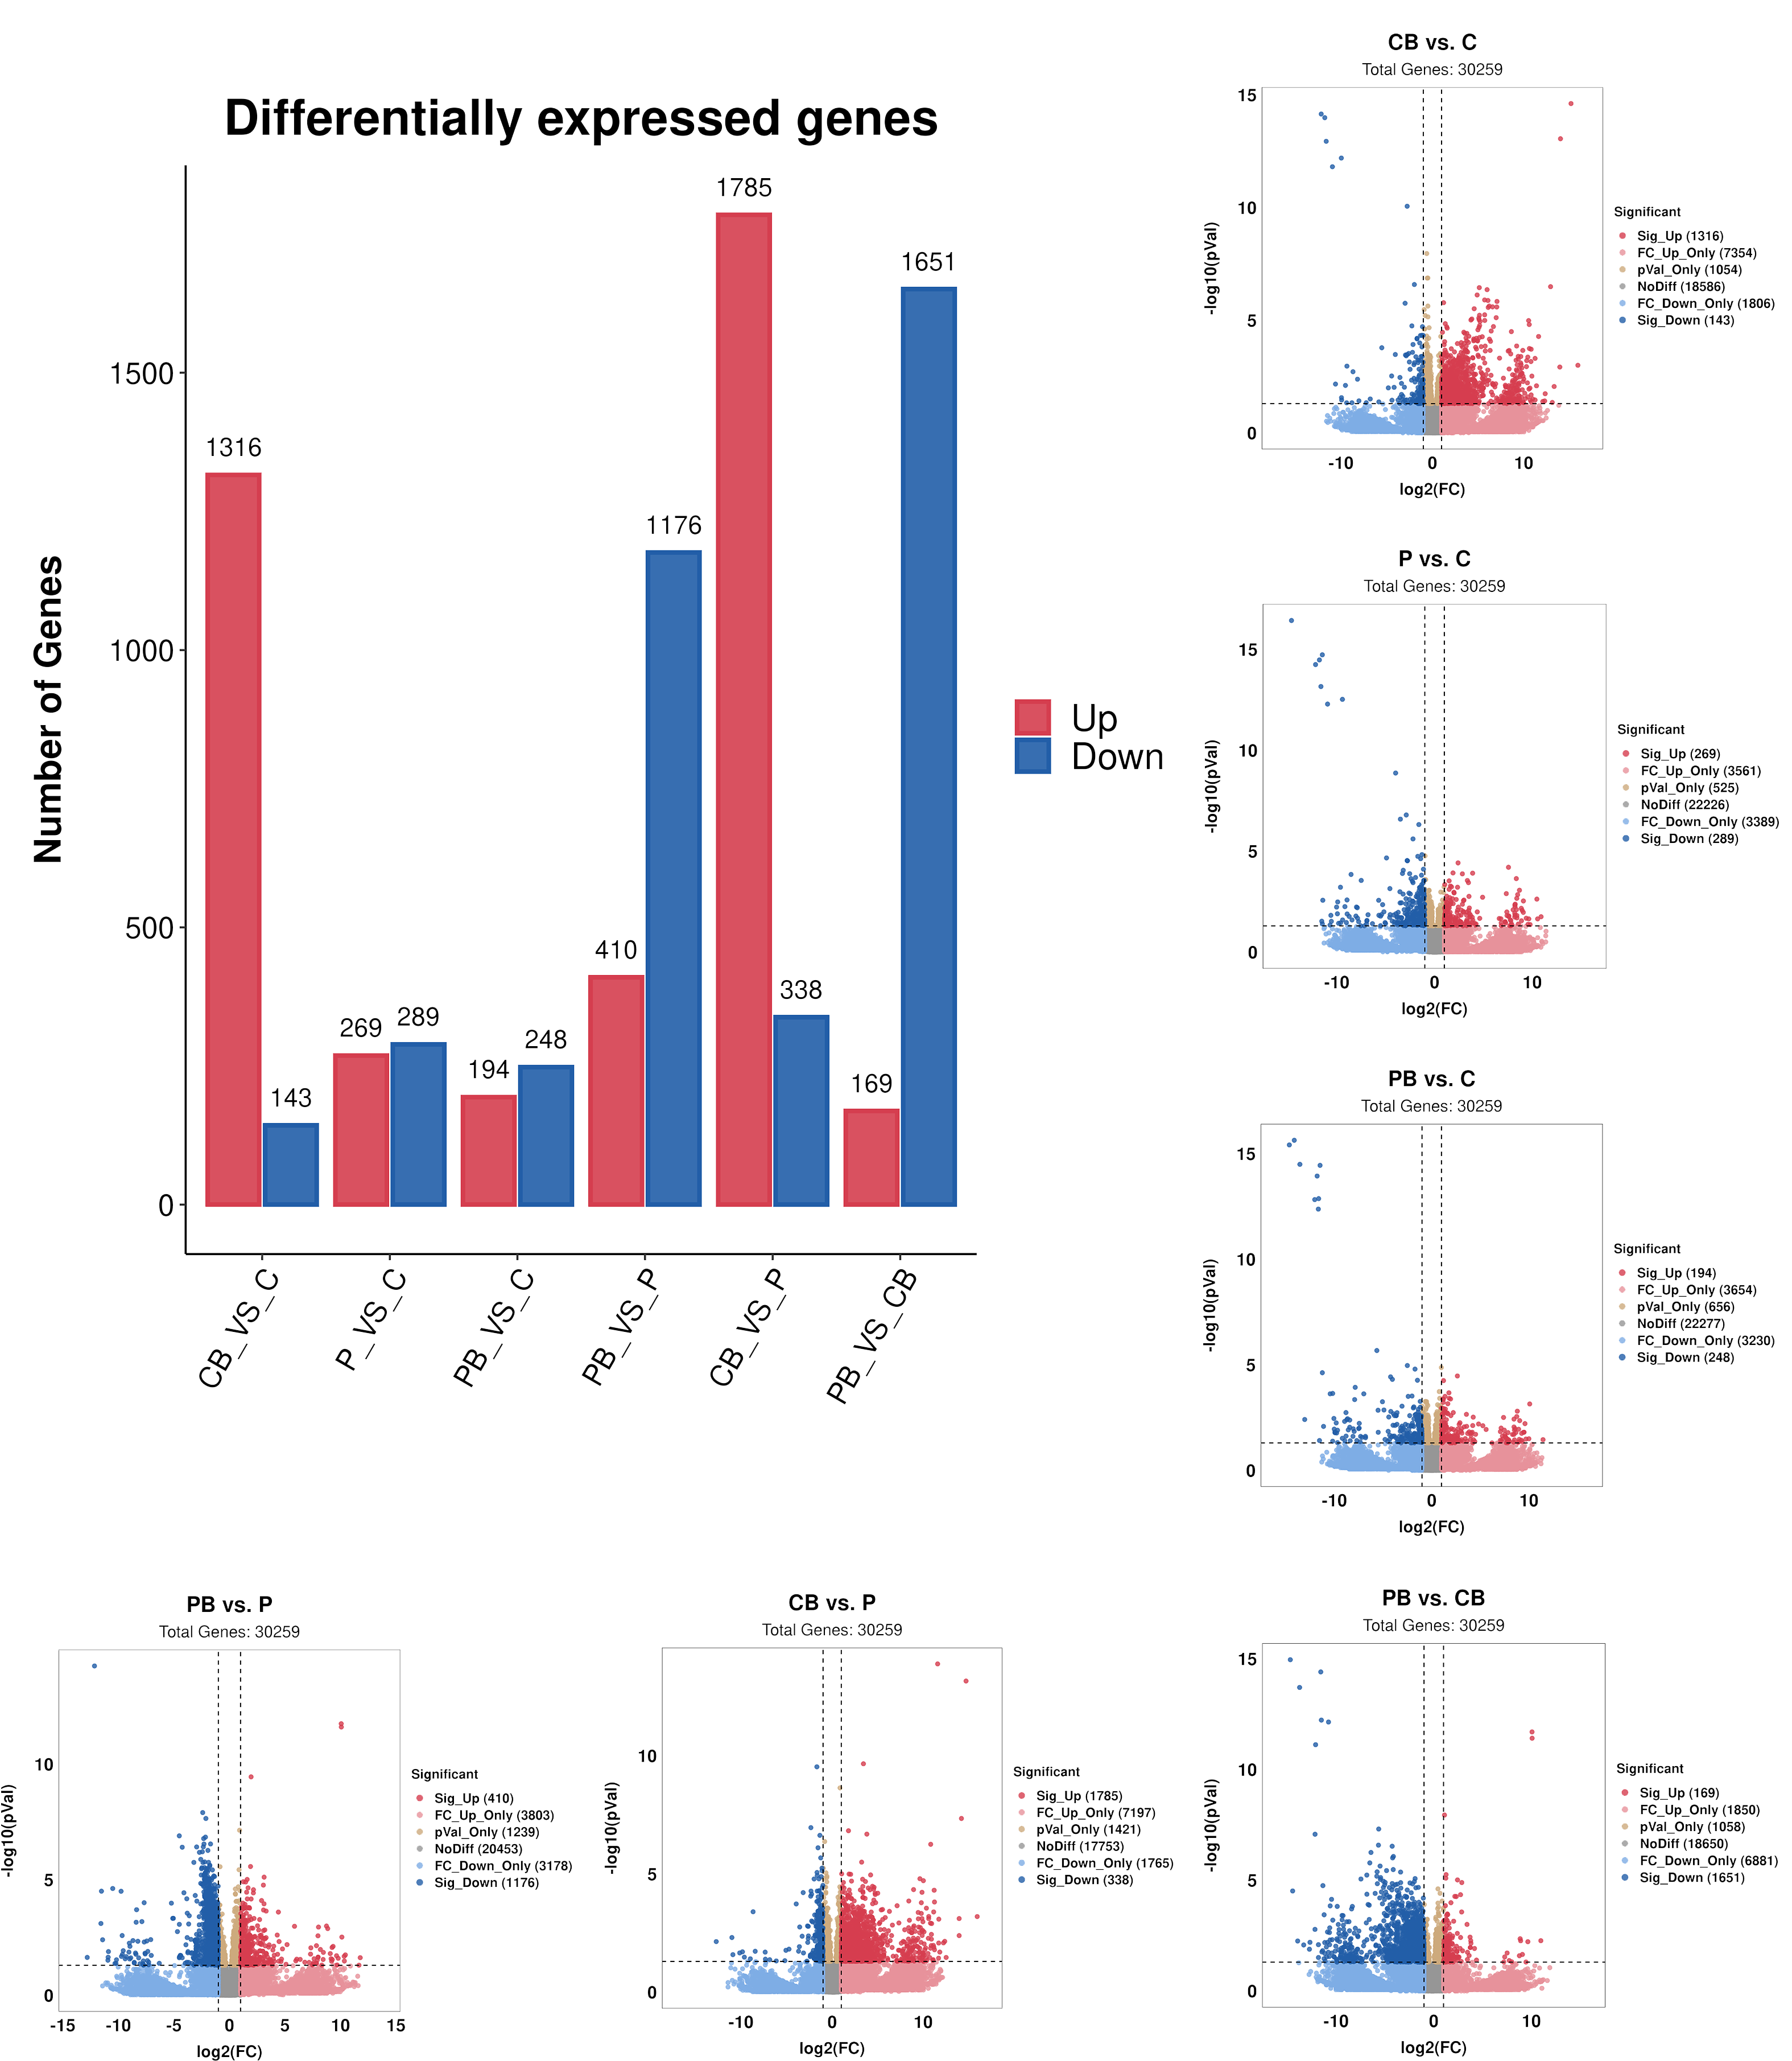
(B)
(C)
(D)
(G)
(F)
(E)
(A)
Differentially expressed genes among groups. (A) summary of differentially expressed genes in different comparisons. (B-G) Volcano plots representing differentially expressed genes of Con + Bac vs. Con (B); Pep vs. Con (C); Pep + Bac vs. Con (D); Pep + Bac vs. Pep (E); Con + Bac vs. Pep (F); Pep + Bac vs. Con + Bac (G). CB: Con + Bac, PB: Pep + Bac, CB: Con + Bac, PB: Pep + Bac

