Additional file 5 Go and KEGG enrichment of differentially expressed genes between treatments
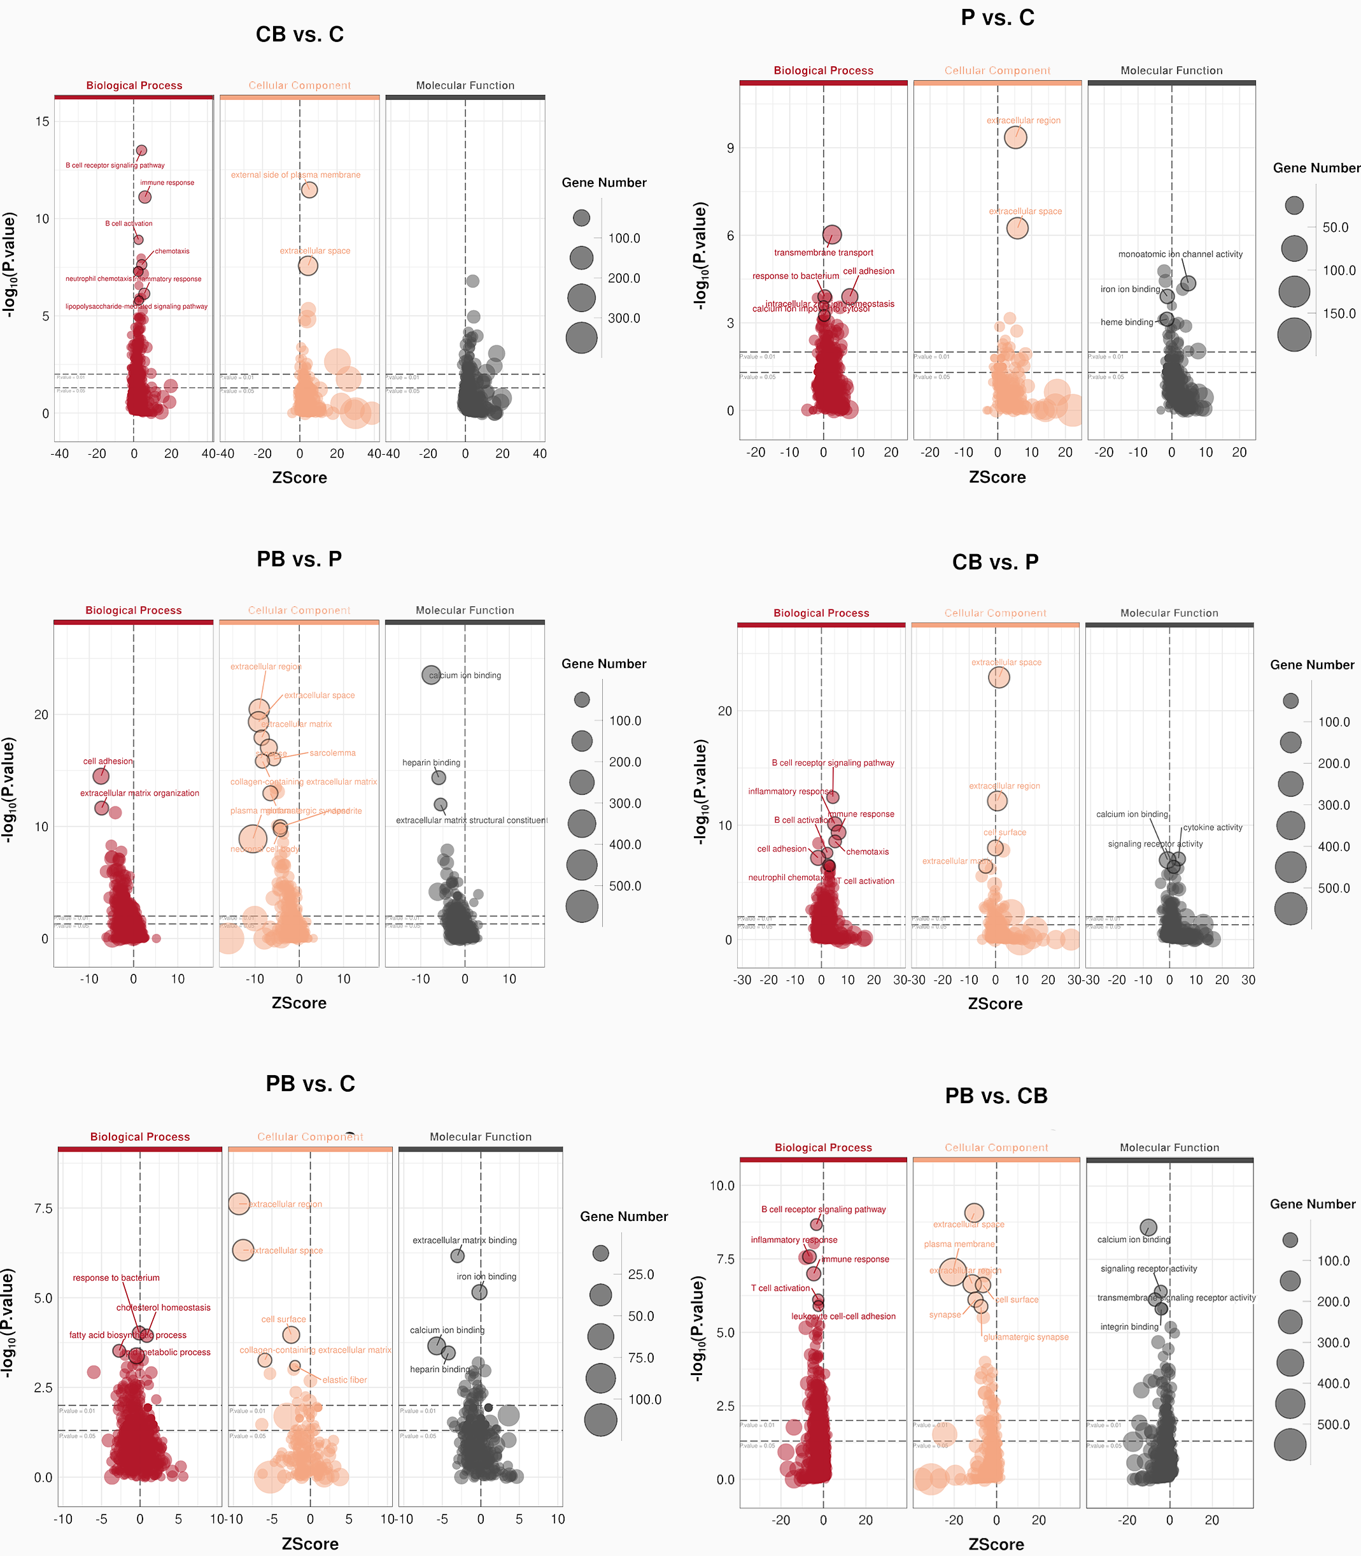
Go enrichment of differentially expressed genes between treatments. CB: Con + Bac, PB: Pep + Bac, CB: Con + Bac, PB: Pep + Bac
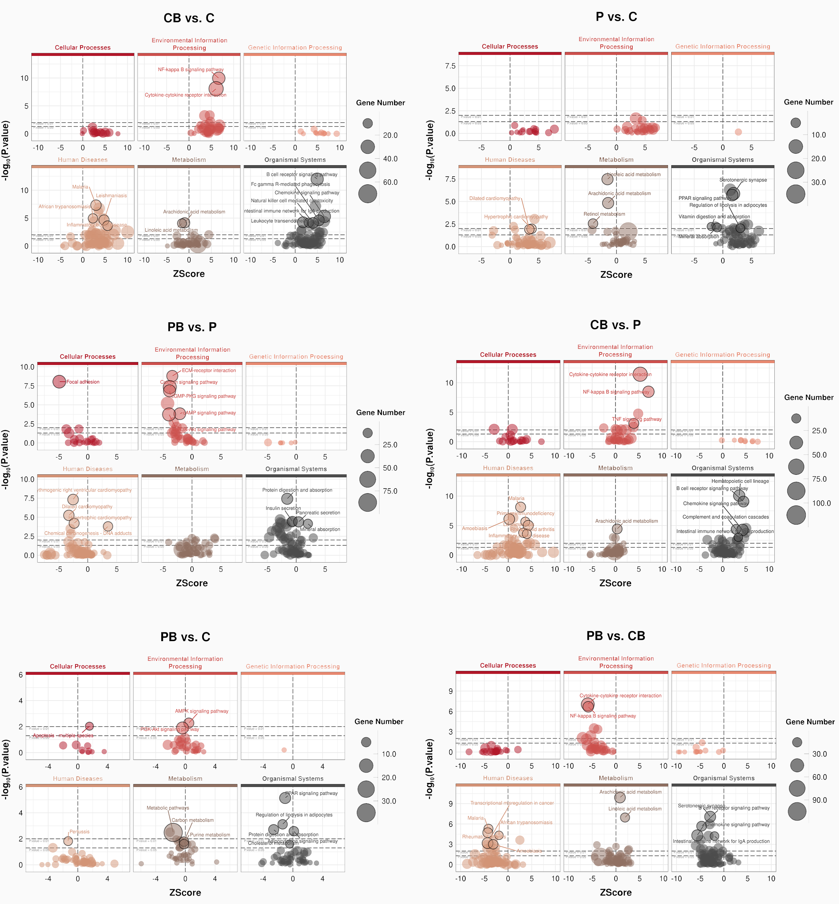
KEGG enrichment of differentially expressed genes between treatments. CB: Con + Bac, PB: Pep + Bac, CB: Con + Bac, PB: Pep + Bac

