Additional file 6 Venn diagram of differently expressed genes in Pep + Bac vs. Pep and Pep vs. Con, and KEGG analysis based on the genes in subsets of Venn diagram.
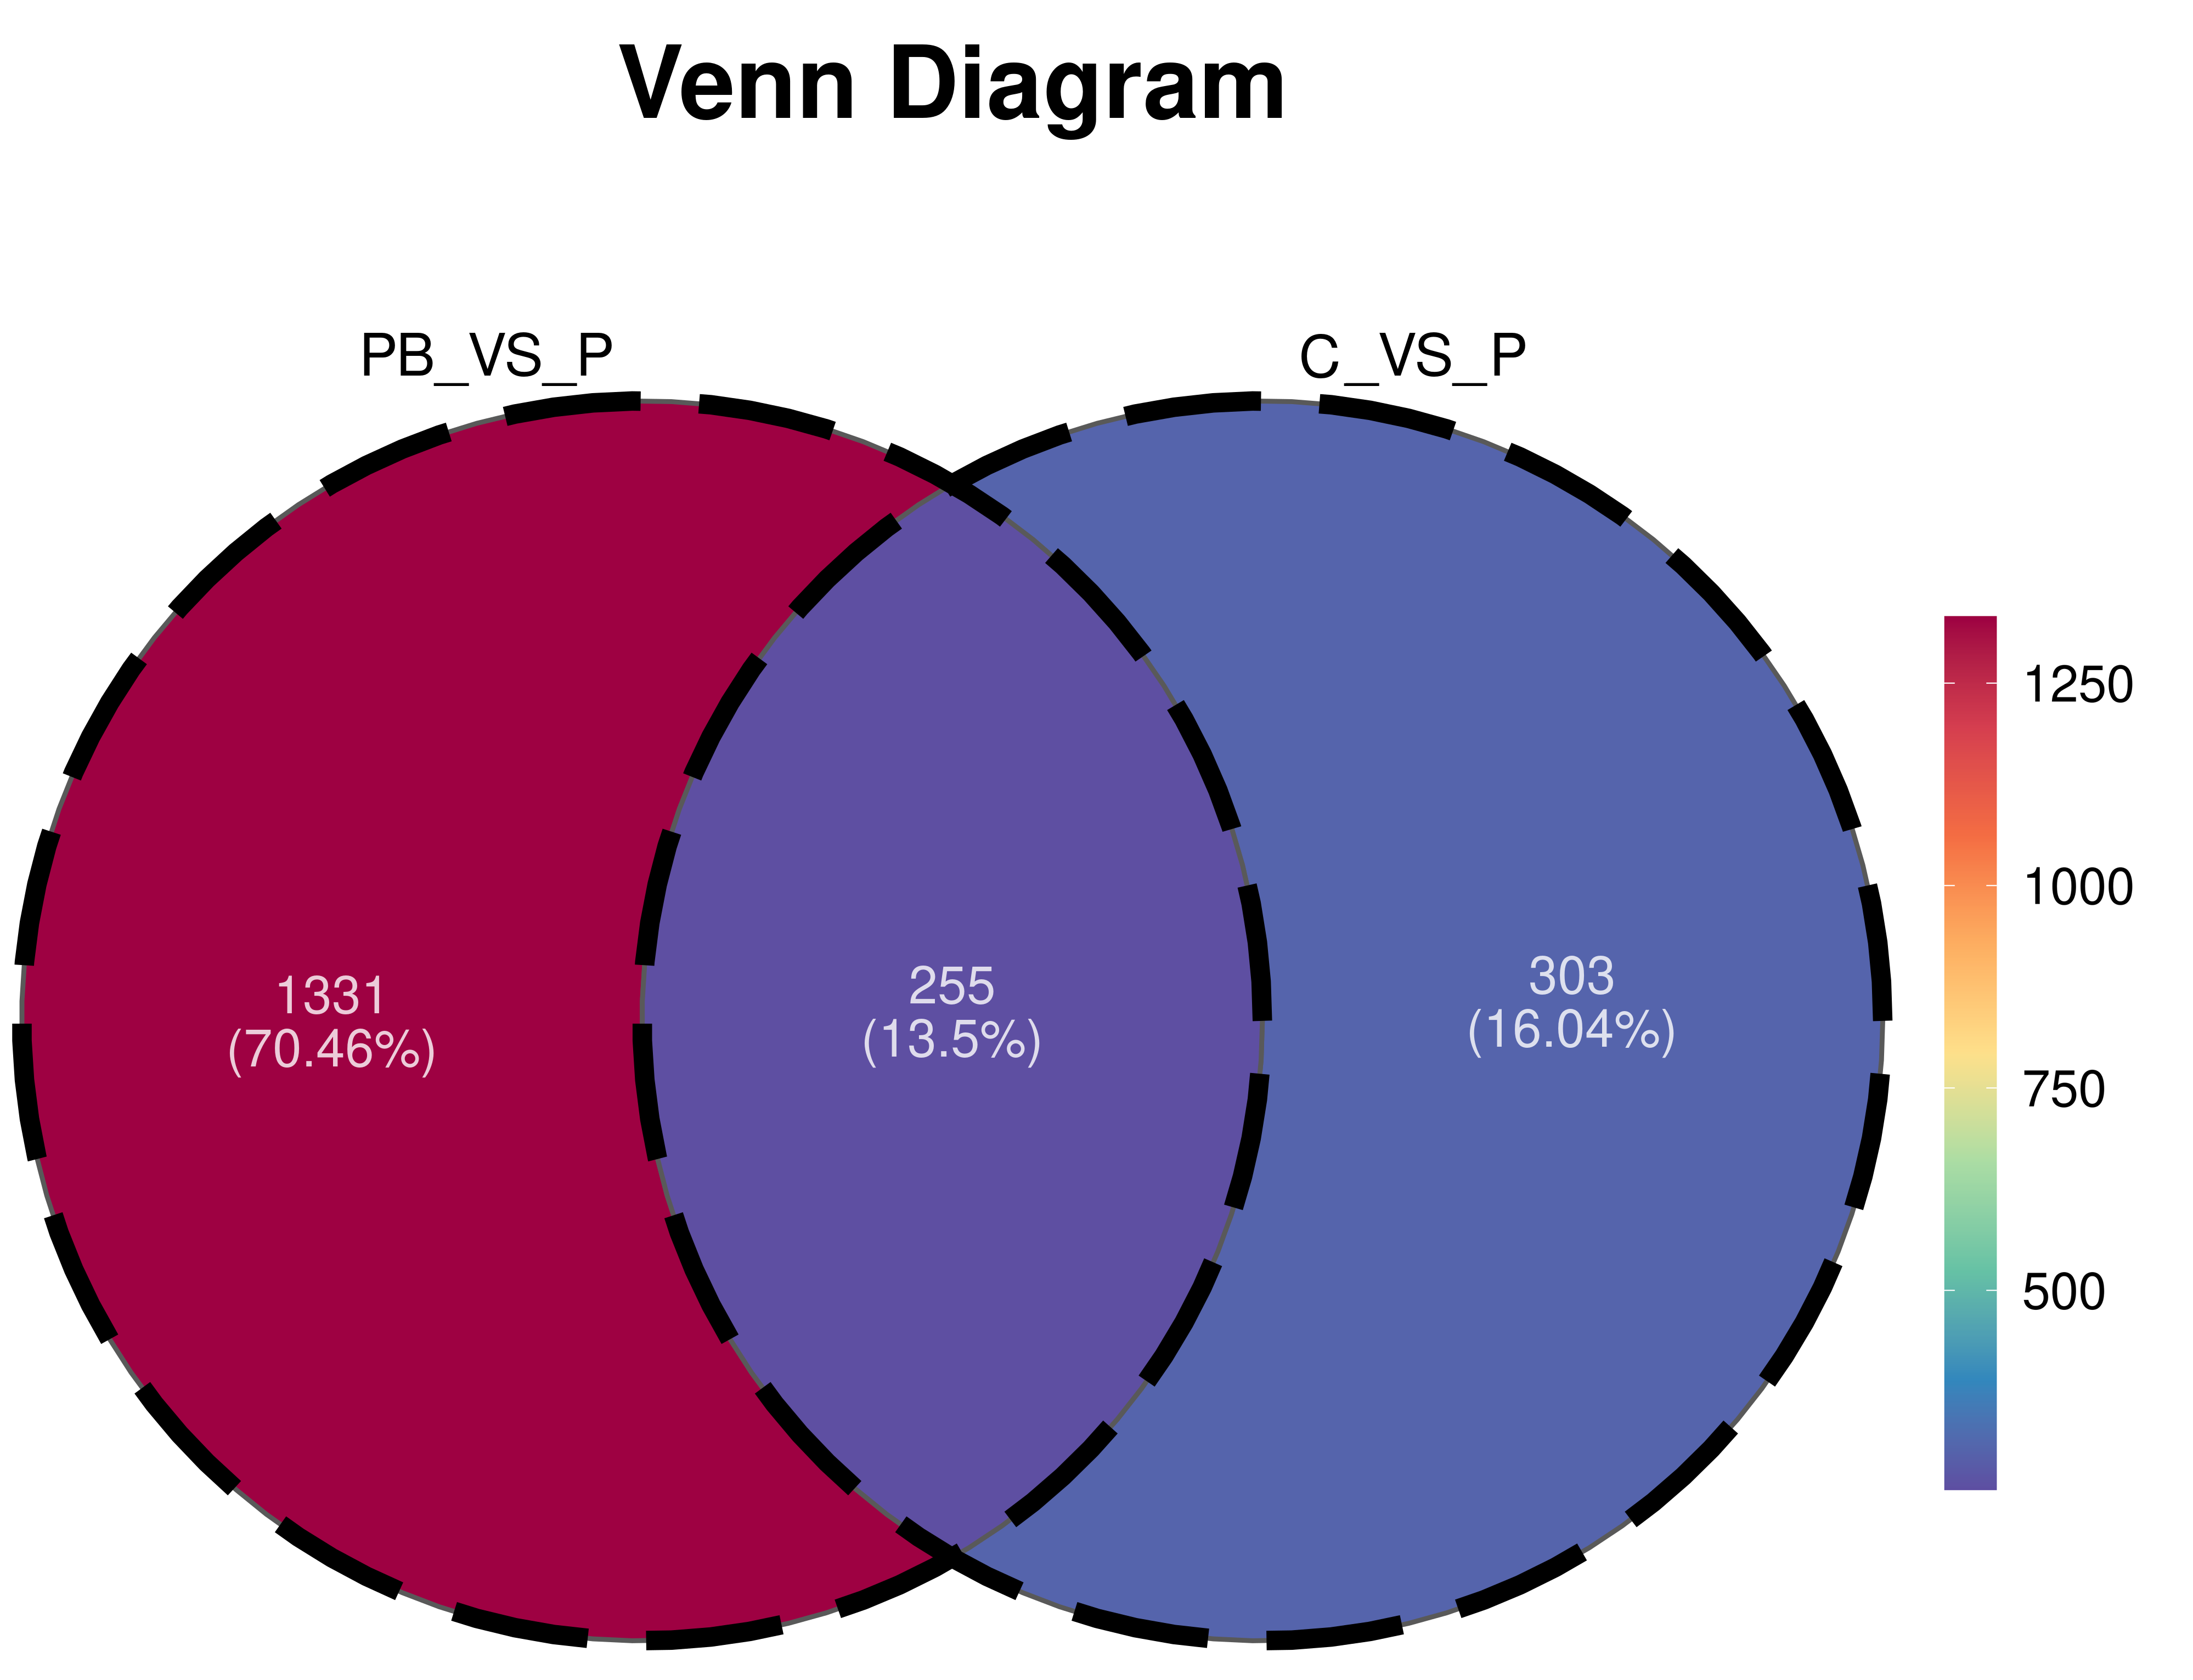
Venn diagram of differently expressed genes in Pep + Bac vs. Pep and Pep vs. Con. PB: Pep + Bac; C: Con; P: Pep
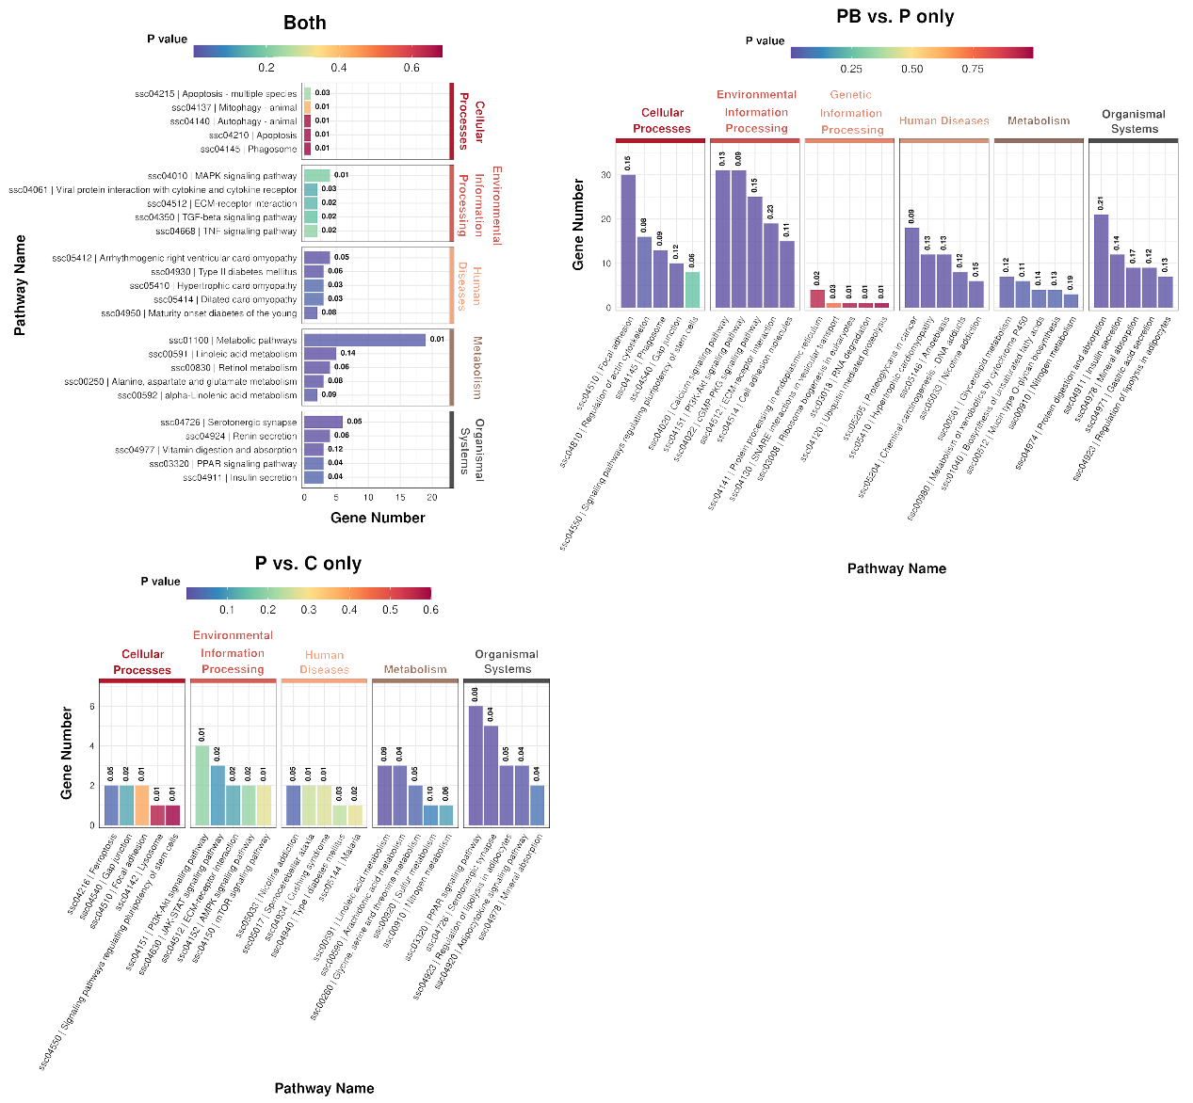
(C)
(B)
(A)
KEGG analysis based on the genes in subsets of Venn diagram. KEGG analysis for genes differently expressed in both Pep + Bac vs. Pep and Con vs. Pep (A); Pep vs. Con (B), and Pep + Bac vs. Pep (C). Number above column showing the rich factor of the genes in the column. PB: Pep + Bac; C: Con; P: Pep

