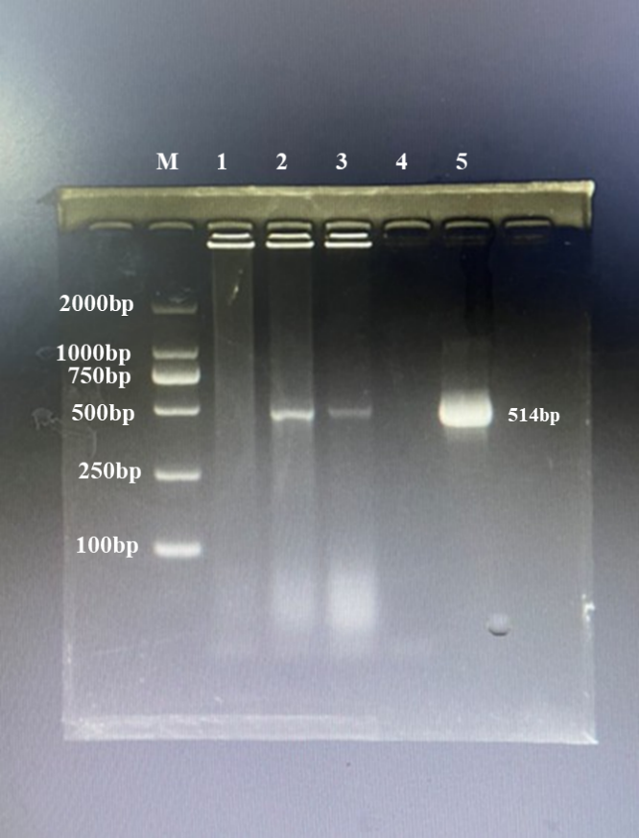
Additional file 1: Uncropped agarose gel image of Figure 1A. M: DNA marker; lane 1: blood of an ORFV-negative kid; lane 2: blood of an ORFV-positive kid; lane 3: blood of an ORFV-positive maternal goat; lane 4: double-distilled water as negative control (no DNA template); lane 5: DNA from ORFV-infected cells as positive control.

