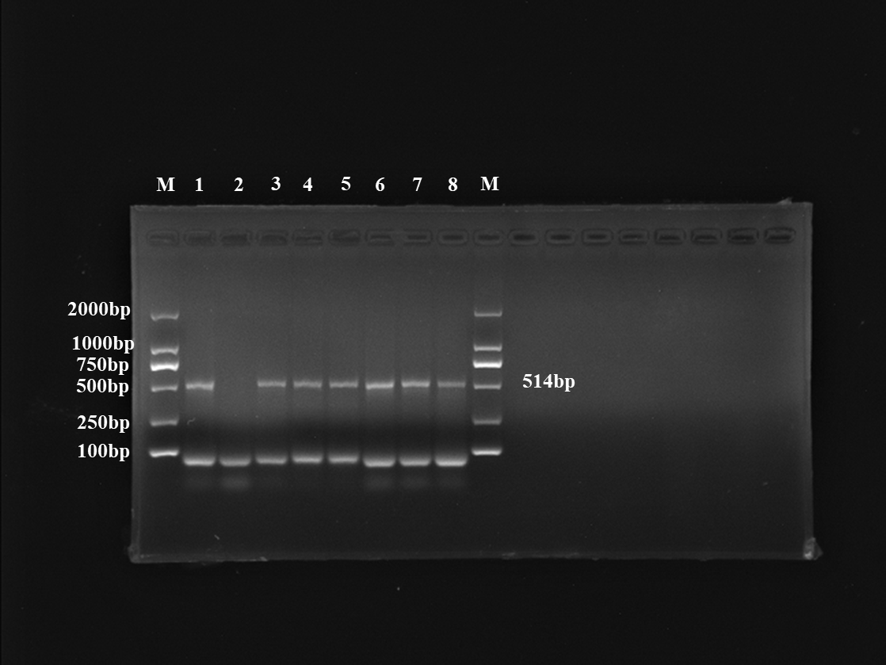
Additional file 2: Uncropped agarose gel image of Figure 2A. Lane 1: DNA from ORFV-infected cells as a positive control; lane 2: double-distilled water as negative control (no DNA template); lane 3-8: representative ORFV-positive samples, including the blood of a maternal goat (lane 3), amniotic fluid (lane 4), umbilical cord (lane 5), placenta (lane 6), saliva of a newborn kid (lane 7), and blood of a newborn kid (lane 8).

