Supplementary material:
Artificial oxidative stress-tolerant Corynebacterium glutamicum

Joo-Young Lee¹, Hyo Jung Lee¹, Jiyoon Seo¹, Eung-Soo Kim², Heung-Shick Lee³, and Pil Kim^{1*}

¹Department of Biotechnology, The Catholic University of Korea, Bucheon, Gyeonggi 420-743, Korea
²Department of Biological Engineering, Inha University, Inchon 402-751, Korea
³Department of Biotechnology and Bioinformatics, Korea University, Jochiwon, Chungnam 339-700, Korea

Running title: Artificial oxidative stress-tolerant C. glutamicum

Present address: J. Seo, ST Pharm Co., Siheung, Gyeonggi 429-912, Korea.

Corresponding Author
Pil Kim, Ph.D., Asso. Prof.
Dept. of Biotechnology, the Catholic Univ. of Korea,
Bucheon, Gyeonggi, Korea
T. +82-2-2164-4922; F. +82-2-2164-4865
Email: kimp@catholic.ac.kr

Kinetics of DPPH radical scavenging activity of C. glutamicum strains
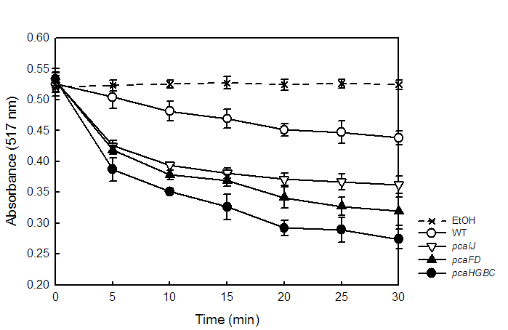
Figure S1. Kinetics of DPPH radical scavenging activity of cell free extracts of Corynebacterium glutamicum.
Assay was performed as described in Materials and methods.

The GC/MS chromatogram of the methanolic extracts of C. glutamicum strains

Method
Sample preparation. To compare the intracellular metabolite profile, actively growing cells in MCGC minimal medium were harvested by centrifugation (4 °C, 3,600 rpm). Cells were disrupted using a Retsch MM400 Mixer mill (Retsch GmbH & Co, Haan, Germany) at 30 HZ s⁻¹ for 10 min. The disrupted cells were then extracted with 1 mL methanol and were centrifuged at 4 °C and 12000 rpm for 5 min. The supernatant (100 μL) was completely dried using a speed vacuum concentrator (Biotron, Seoul, Korea). The remained solute was oximated with 50 µL methoxyamine hydrochloride (20 mg mL⁻¹ in pyridine) at 30 °C for 90 min, and silylated with 50 µL MSTFA at 37 °C for 30 min. 1 µL of sample was injected into the GC-TOF-MS (Leco, St. Joseph, MI, USA) analysis. Each peak was assigned based on the database (NIST05 MS Library, Wiley mass spectral database).
GC-TOF-MS Analysis. An Agilent 7890A GC system (Palo Alto, CA) equipped with an Agilent 7693 autosampler was connected to a time-of-flight Pegasus III mass spectrometer (Leco, St. Joseph, MI, USA), operating in electron ionization (EI) mode (70 eV). A HP-5MS column (30 m length×0.25 mm i.d. × 0.25 m film thickness, J & W Scientific, Folsom, CA, USA) was used with helium as a carrier gas at a constant flow of 1.5 mL/min. 1µL of the derivatized sample was injected with a splitless mode. The oven temperature was maintained at 75ºC for 2 min, increased to 300 º C at 15 º C/min, and then held at 300 º C for 3 min. The acquisition rate was set to 20 scans s−1 with a mass scan range of m/z = 50–1000. The injector and ion source temperatures were 250 º C and 230 º C, respectively

Result

Figure S2. The GC chromatogram of the methanolic extracts of C. glutamicum strains.
Each peak was verified by MS analysis (data not shown).

Li et al., “Study on the determination of polyphenols in tobacco by HPLC coupled with ESI-MS after solid-phase extraction”, J Chromatogr Sci 41: 36-40 (2003)
Siebenhandl et al., “Phytochemical profile of main antioxidants in different fractions of purple and blue wheat, and black barley”, J Agric Food Chem 55:8541-8547 (2007)

