AMB Express - Electronic Supplementary Material

Integrative gene transfer in the truffle Tuber borchii by Agrobacterium tumefaciens-mediated transformation
A. Brenna¹, B. Montanini², E. Muggiano¹, M. Proietto¹, P. Filetici³, S. Ottonello² and P. Ballario^{1,3,*}

¹ Pasteur Cenci Bolognetti Foundation, c/o Department of Biology and Biotechnology “Charles Darwin”, La Sapienza University, 00185 Rome, Italy
² Department of Life Sciences, Biochemistry and Molecular Biology Unit, Laboratory of Functional Genomics and Protein Engineering, University of Parma, 43124 Parma, Italy
³ Institute of Biology and Molecular Pathology, CNR, 00185 Rome, Italy

* To whom correspondence should be addressed:
La Sapienza University, Piaz.le A. Moro 5, 00185 Rome, Italy
Tel.: +39 06 49912392; Fax: +39 06 4440812
E-mail: paola.ballario@uniroma1.it

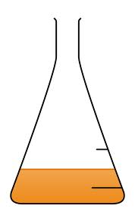
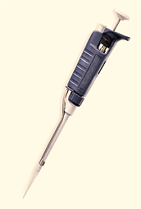

1
2
4
3
5
7days
200 µM AS
200 µM AS
o/n
4h
3days
15-days old T. borchii mycelium transferred to a cellophane membrane-covered PDA plate
Single colony of transformed
A. tumefaciens inoculated at 28°C with shaking in LB + antibiotics
Mycelium transferred to a new PDA + 200 µM AS plate
Dilution of A. tumefaciens culture into fresh medium (OD_{600nm}=0.075) and incubation for 4h at 28°C in LB + antibiotics + 200 uM AS
50 µl of the bacterial culture from step (4) are added to the mycelium and co-cultivation is carried out for 3 days at 22-25°C in the dark

Figure S1. Outline of the ATM-transformation protocol
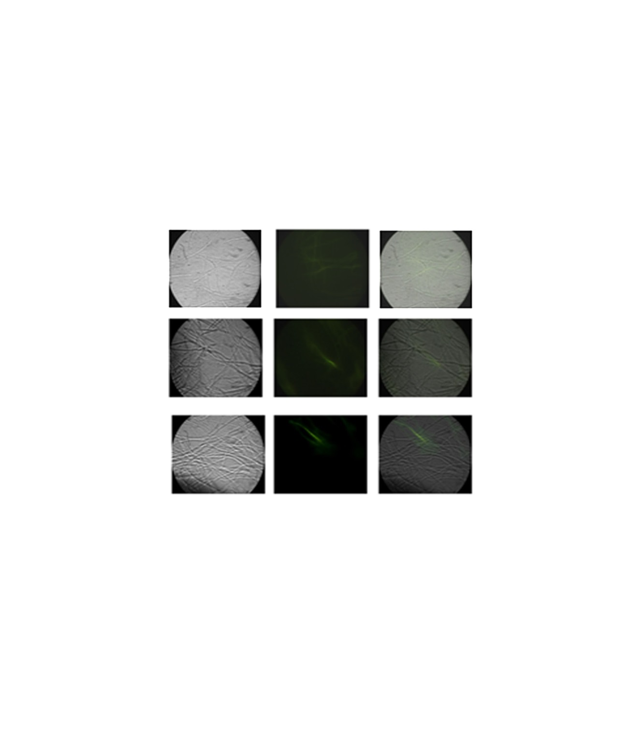
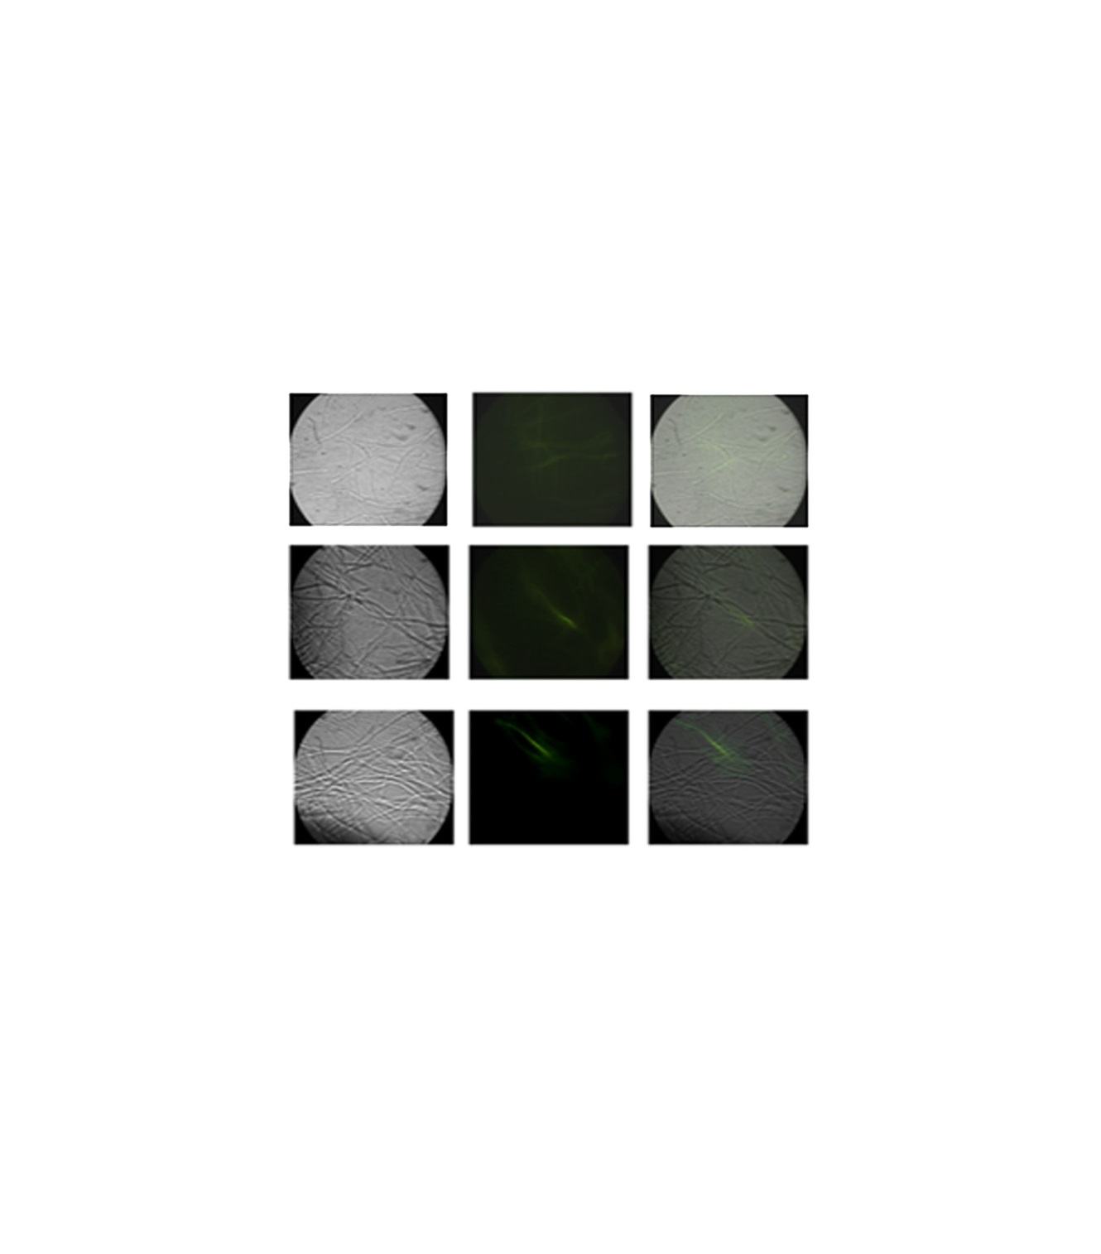
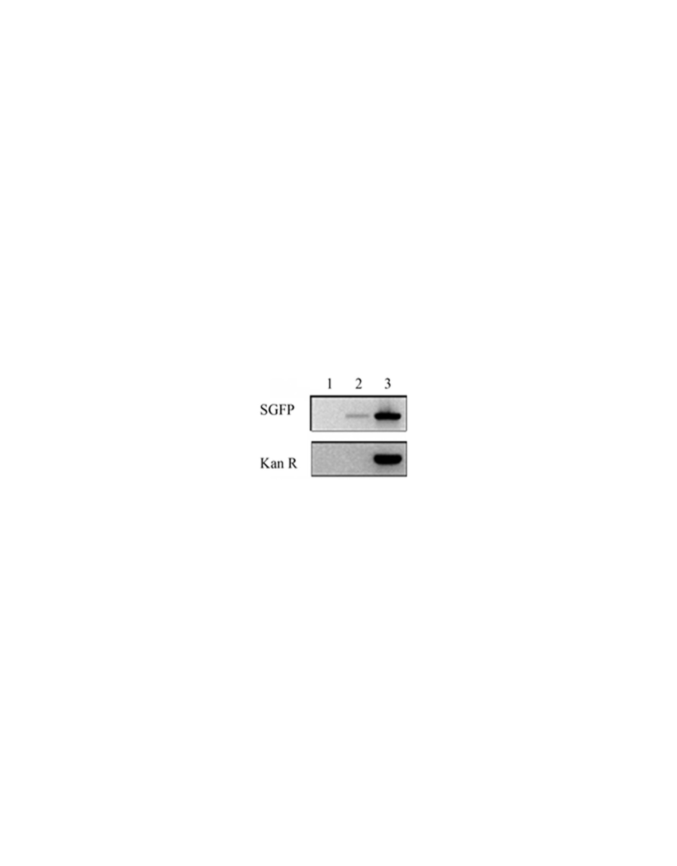
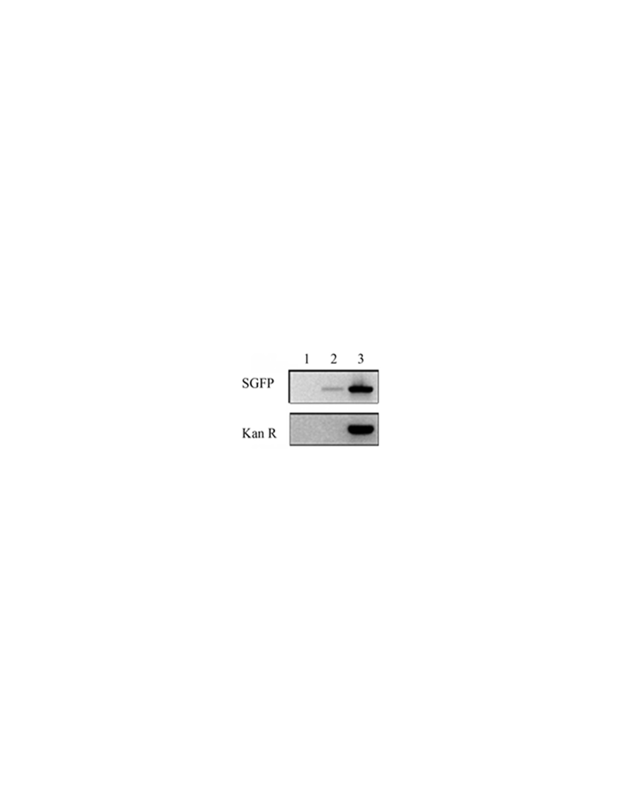
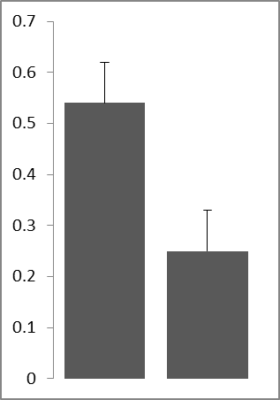
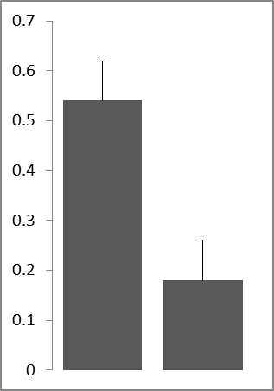
transformed hyphae (%)
pBGgHg
pABr1
a
b
c
d
% of transformed hyphae
GV3101
AGL-1
sgfp

kanR
1 2 3
Nomarski
GFP
merge
mock
pABr1 3 days

pABr1 6 days

Figure S2. ATM-transformation with the pABr1 vector using the recipient strain GV3101 a) Images (100x magnification) of T. borchii hyphae transformed with the pABr1vector obtained by phase-contrast (Nomarski) and GFP fluorescence microscopy. Untransformed, control hyphae are shown at the top (mock). The type of treatment, vector and co-cultivation times are indicated on the left; a merge of the Nomarski and GFP images is shown in the rightmost panels. b) Quantification of transformed hyphae obtained with pABr1/GV3101 and pBGgHg/GV3101 expressed as percentage of fluorescent hyphae with respect to the total number of hyphae (~4500) present in the analyzed sections. Data are the mean ± s.e.m. of at least five independent experiments. c) Same as B for the comparison of pABr1/AGL-1 and pABr-1/GV3101. d) PCR-amplification of DNA obtained from mock-infected mycelia (lane 1), AGL-1/pABr1-transformed mycelia (lane 2), and pABr1/AGL-1 bacterial cells (lane 3) performed with sgfp- (top) and kanR- (bottom) specific primers

