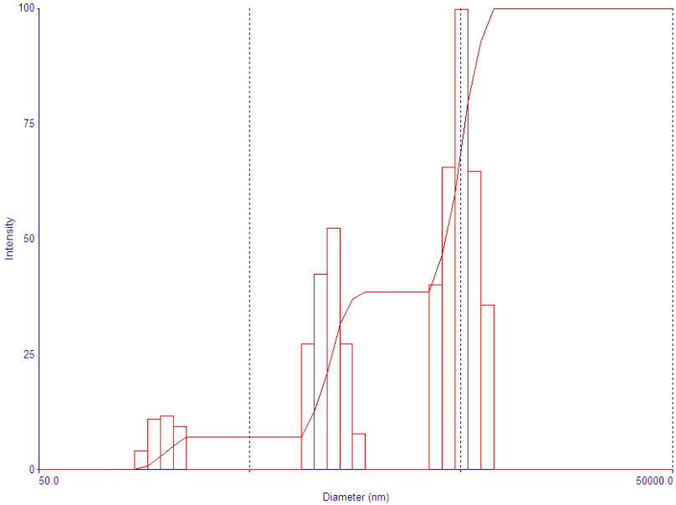
Figure S1. The aggregated particles after normal dilution by dynamic light scattering. The protein samples immediately after normal dilution were diluted 100 times with PBS before sent for dynamic light scattering measurement. The results indicated there were numerous particles of several hundreds of nanometer in diameter.
Figure S2. The aggregates after normal dilution by TEM.

